Creating Catalog Info Entry Points
A Catalog Info Entry Point is used for a single catalog item. If your organization is selling multiple catalog items, use the Agile List: Catalog entry point. Click here for the help desk article.
1. Log into Administration.
2. Select the House Icon.
3. Open the Web folder.
4. Select the Entry Points icon.
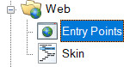
5. Highlight and select the Entry Point Group that you will be creating the URL under.
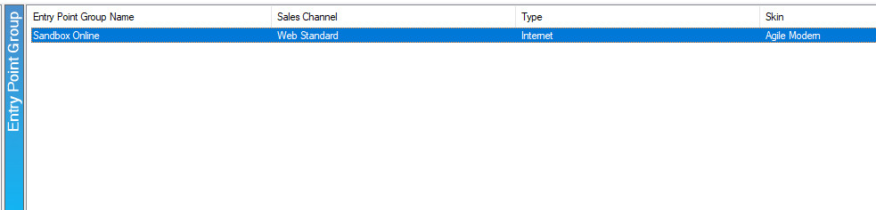

6. In the Entry Point field, right-click, and select New and Catalog Info.
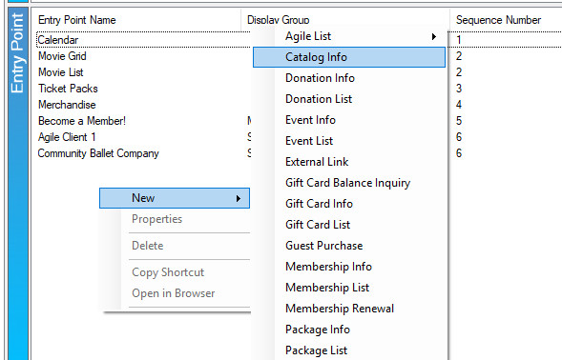

7. Fill out the following areas on the General tab (not all will be applicable to your needs):
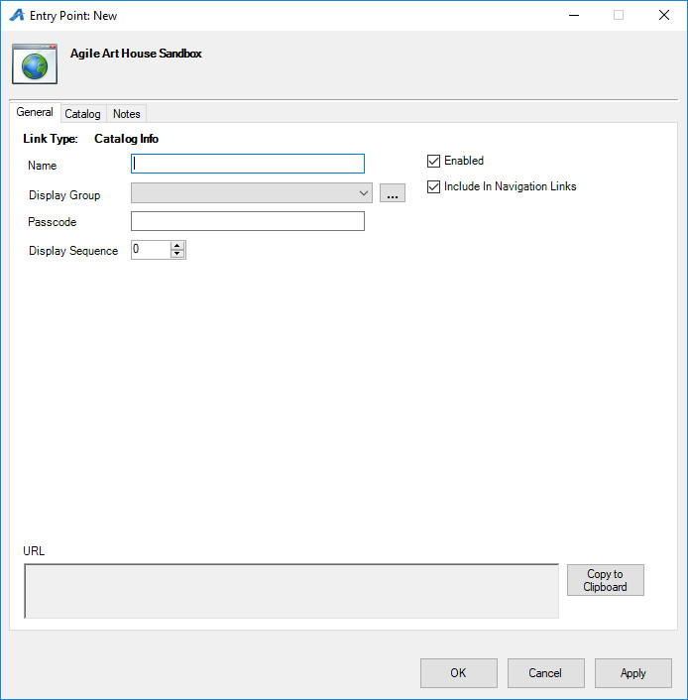
- Name the URL (remember this will show up in your navigation menu. Keep it simple).
- You can select or create a Display Group if you want it to be a part of a specific group on your navigation menu.
- Add a Passcode only if you need the URL to only be available to customers who enter the passcode. Leave blank if the URL can be accessed by the general public.
- Display Sequence sorts what order it appears in online.
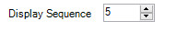

8. The Catalog tab determines which sales folder(s) appear in the list online. (Note: this may need to be updated yearly.) Expand down the top level and choose the Sales Folder where the catalog item is built. Then select the specific catalog item from the list that appears.
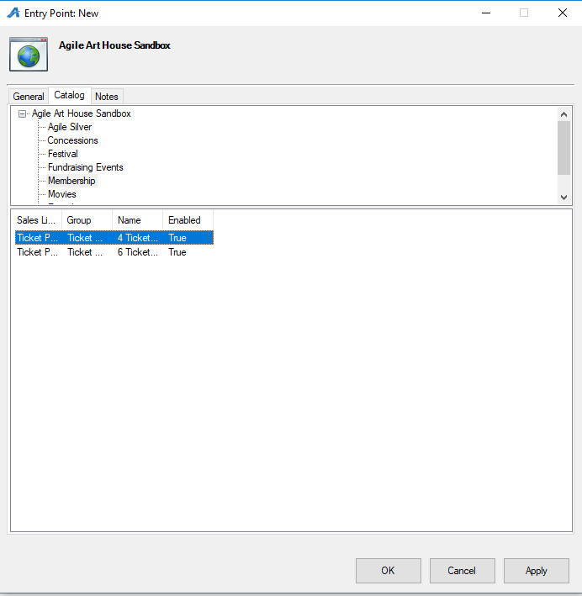

9. The Notes tab is for internal use only. We recommend adding details here about how this URL is being used.
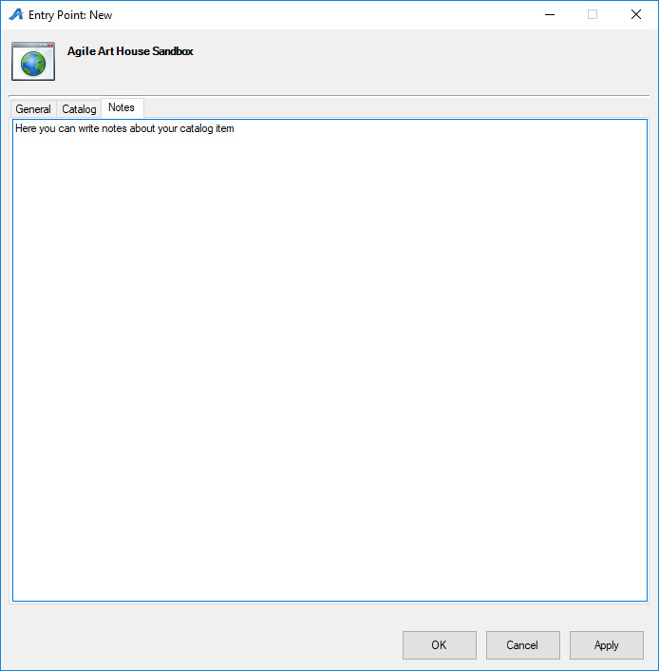

10. Once you have filled out all of the above information, click Apply, and the URL will be generated in the General Tab.

11. Click the Copy to Clipboard button to copy the URL to paste into your website.
