Change The Price Date On An Item
1. Log in to Sales.
2. Add the item you want to sell to the order as per a regular transaction. Click Proceed when all items have been added.
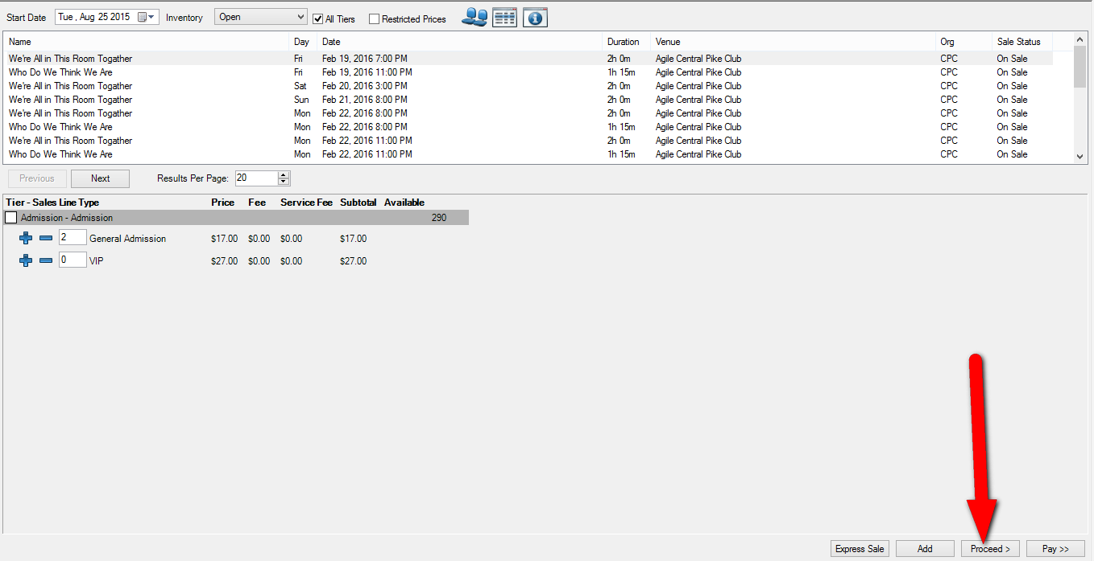
3. In the Item Summary, click the price of the item you want to change.
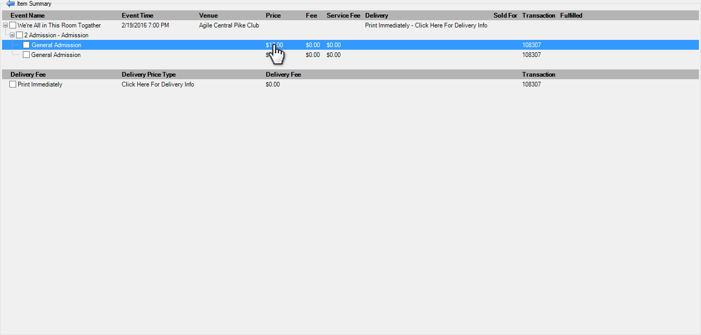

4. In the Change Price pop-up window, click the calendar to change the Effective Sale Date to when the desired price was effective.
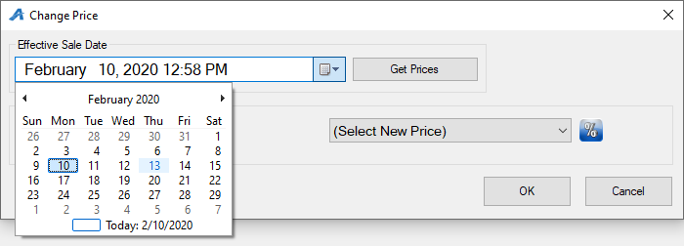
5. Click Get Prices to refresh the list.
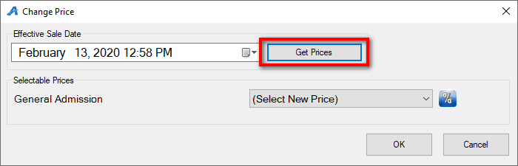
6. Click the Select New Price drop-down menu and select the correct price.
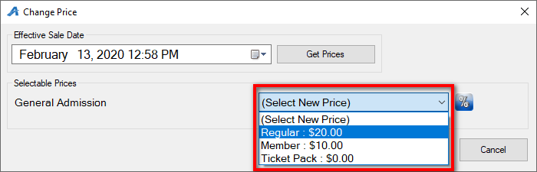

7. If you need to discount the price, select the Percentage icon to create the desired discount.
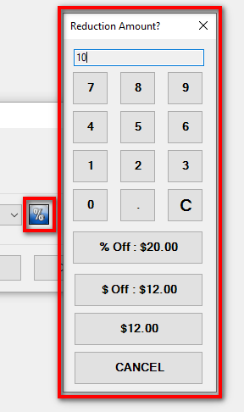
8. Click OK after you’ve selected the correct price.
9. The item should now reflect the new price. Click Proceed to finish processing the order.

