Printing And Reprinting An Entire Order

1. [Log in](https://support.agiletix.com/hc/en-us/articles/200617005-Log-In) to Sales.

2. Select **Maintenance**.



3. Search for the customer by entering the **Order #** or the customer’s **Last Name**. Then, click the appropriate green check mark.

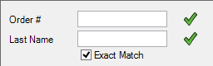

4. Double-click the order you wish to reprint. This will open the **Item Summary** page for this order.

[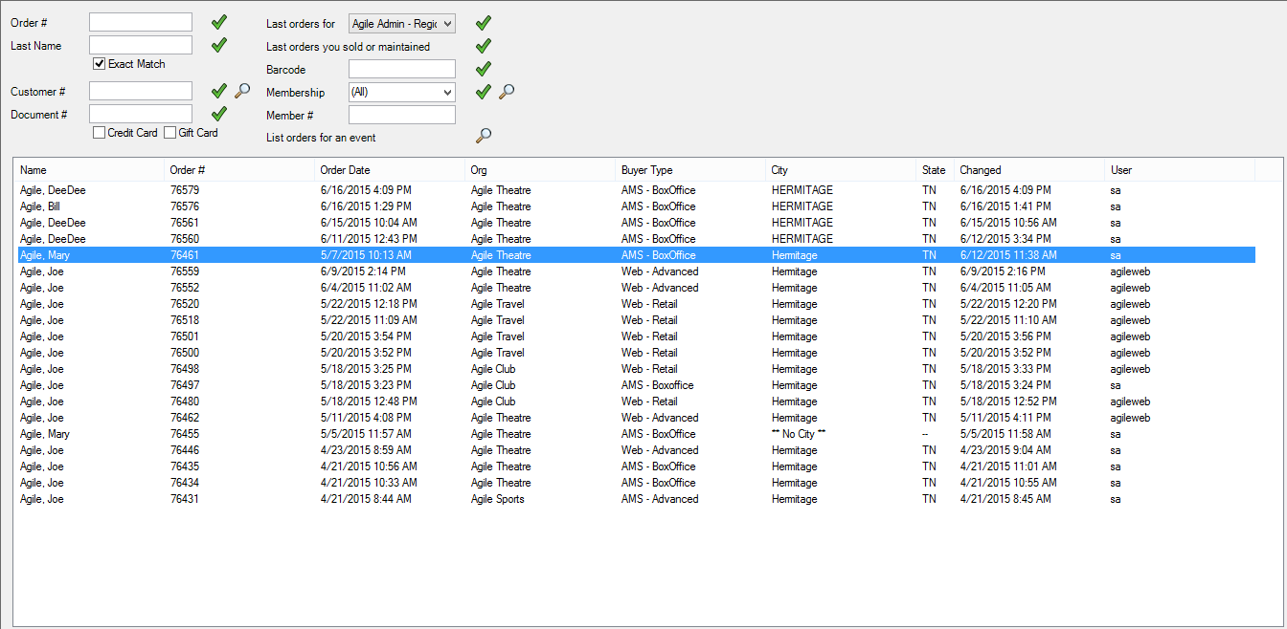](https://support.agiletix.com/hc/en-us/article_attachments/202711560/Image_4.png)

5. Click the  in the bottom left corner to select all the line items in the **Item Summary**. Then, click the **Printer** icon on the bottom toolbar.

[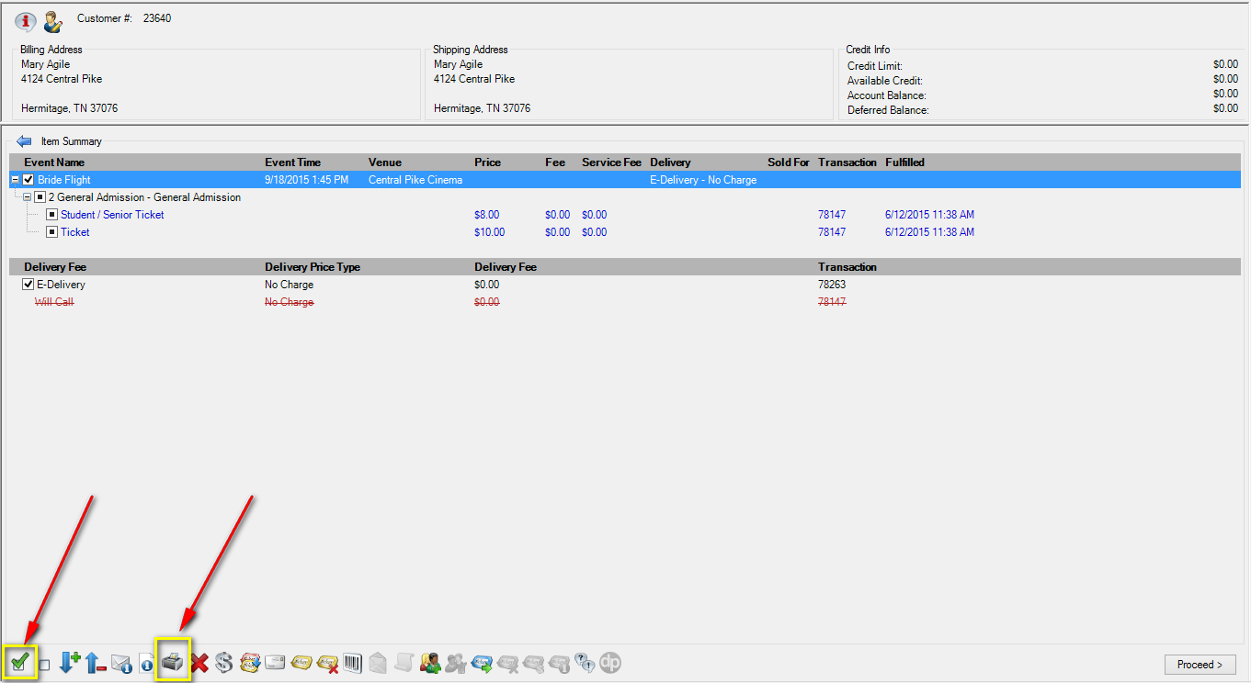](https://support.agiletix.com/hc/en-us/article_attachments/202660344/Image_5.png)

**Note:** If the tickets you are printing have already been printed, a pop-up window will appear stating that the previously printed tickets will be invalidated. To proceed, click **Print All**.

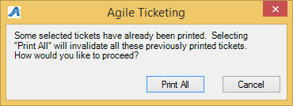

All tickets for this order will now print with new barcodes on each ticket.