Reprinting A Partial Order

At times, you may need to reprint a single ticket from an order.

1. Log in to Sales.
2. Select Maintenance.
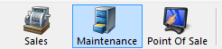

3. Search for the customer by entering the Order # or the customer’s Last Name. Then, click the appropriate green check mark.
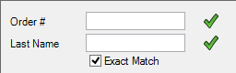

4. Double-click the correct order to bring up the order contents on the Item Summary page.
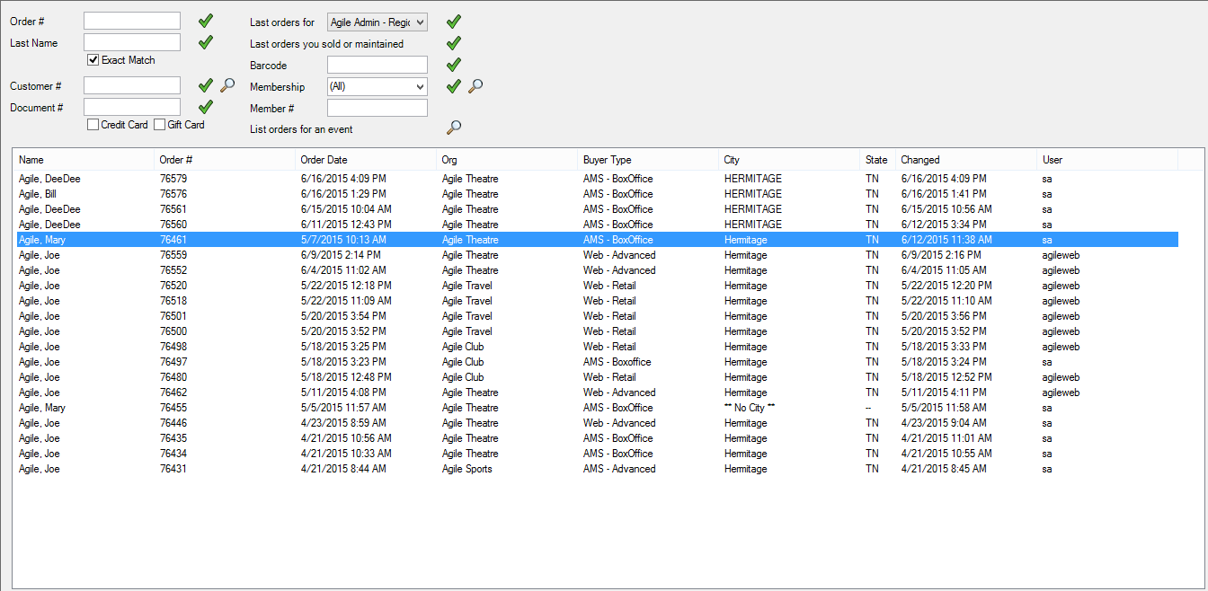
5. Click the box next to the ticket that you are selling or reprinting. Then, select the Ticket icon from the bottom toolbar.
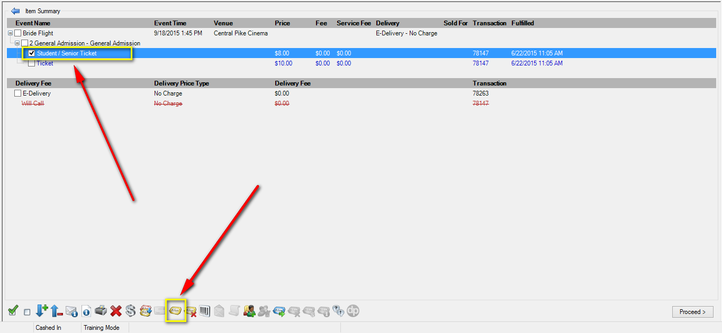

**Note: If the tickets you are printing have already been printed, a pop-up window will appear stating that the previously printed tickets will be invalidated. To proceed, click Print All.
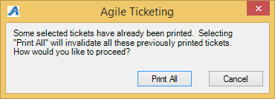

6. The ticket will now print.

