Using the Schedule View
You may add showing times to any show by simply dragging that show onto our schedule view. This schedule view also makes it easy for you to edit your showing times.
1. Log into Administration.
2. Click the House Icon (Corporate Organization).
3. There are two relevant Schedule icons. One is located outside the blue Sales folders, the other is within the blue folder that houses your shows. Select either one to proceed.
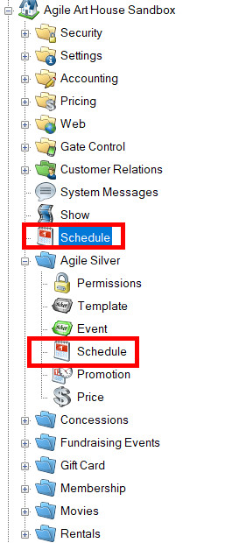
4. You are now able to see every venue and all the shows or events going on in each venue. If you see any shows/events that are grayed-out, they are either not in the folder you are currently viewing or have been disabled.
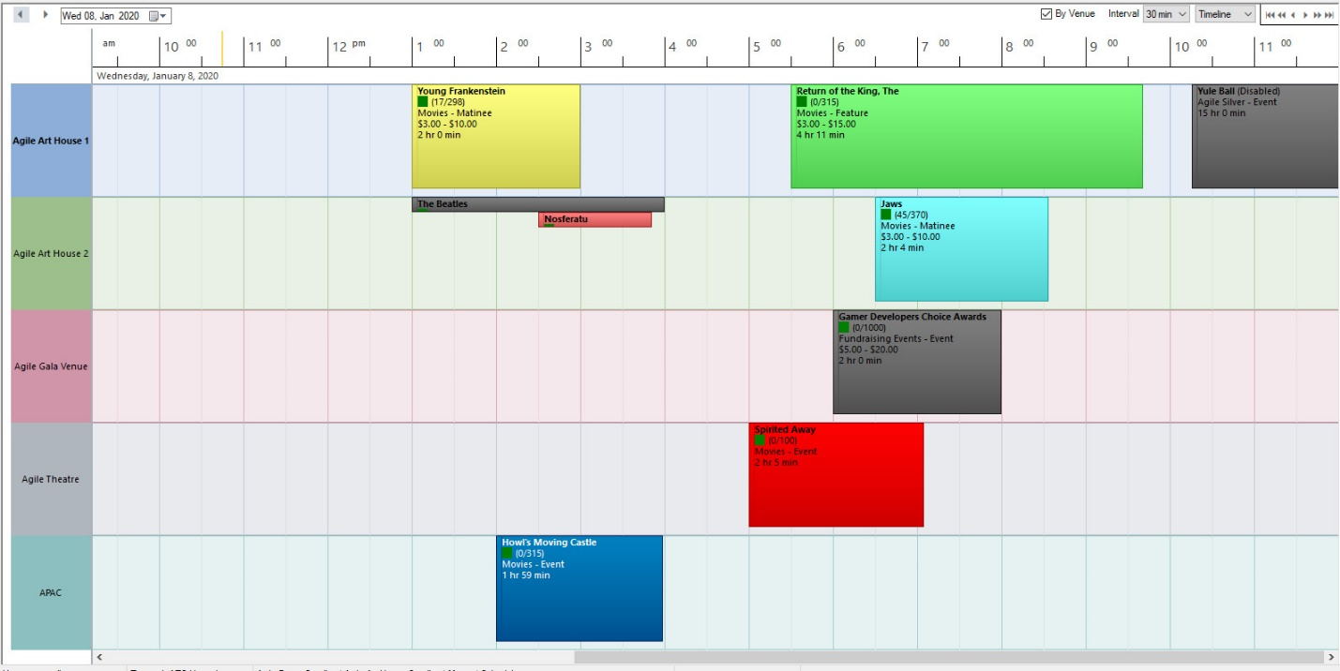
5. If you need to add a showing to the schedule, select the show from the list above the schedule view and drag it to a time slot and venue.
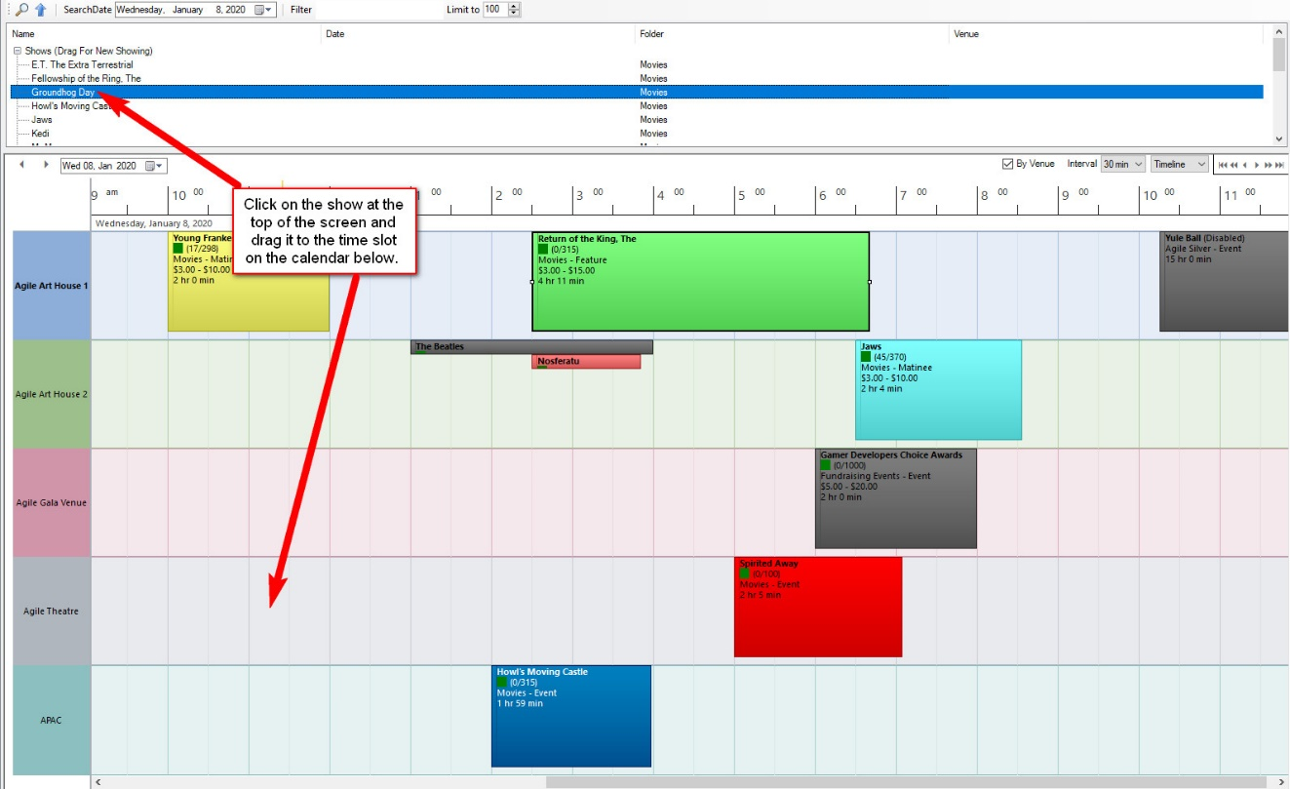
(Please note that in order for the drag and drop feature to work, you must have a venue template set up. For more information on building venue templates, click here.)
6. A Showing: Properties window will appear. You can refine your showing information, such as setting that showing on-sale and checking that you are placing it at the right time. Recurring Every allows you to copy the same Show and Showing Time on the days of the week you choose. Make sure to select the last date that this show and time will be copied to.
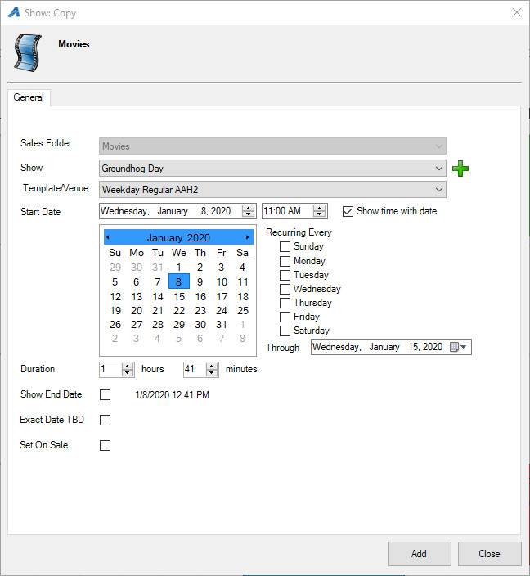
7. Click Add. You have now added your showing.
8. You can view the schedule-view by day, week, and timeline by clicking the drop-down on the right side of the screen. You are also able to change the time intervals that are displayed. If you would like to move from one day to the next, click the arrows on the left side of the screen.
