Getting A WebSales XML Feed URL
Agile Ticketing provides a quick and easy way to integrate the Agile ticket purchase process into your website. In order to start this process, you will need to get a WebSales XML Feed URL that will provide an XML formatted list of your events. Follow the instructions below to find out how to find the URL.
- Open the Web Folder in your organization and select the Entry Points icon.
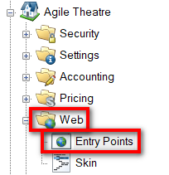
- Find the Entry Point Group and Entry Point for which you want to get an XML Feed. This Entry Point's Type must be some kind of List. Right-click that item and choose Properties from the menu.
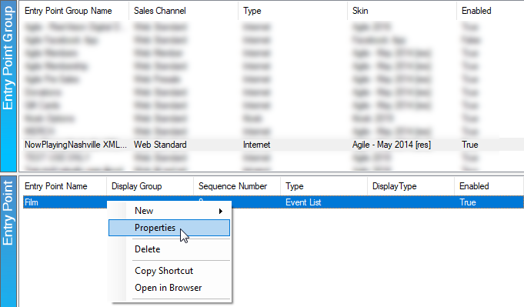
- This will bring up the Entry Point settings. Click the Web Feed tab to find the URL. You can click on the URL to view the current XML Feed or click Copy To Clipboard to get the URL in your clipboard.
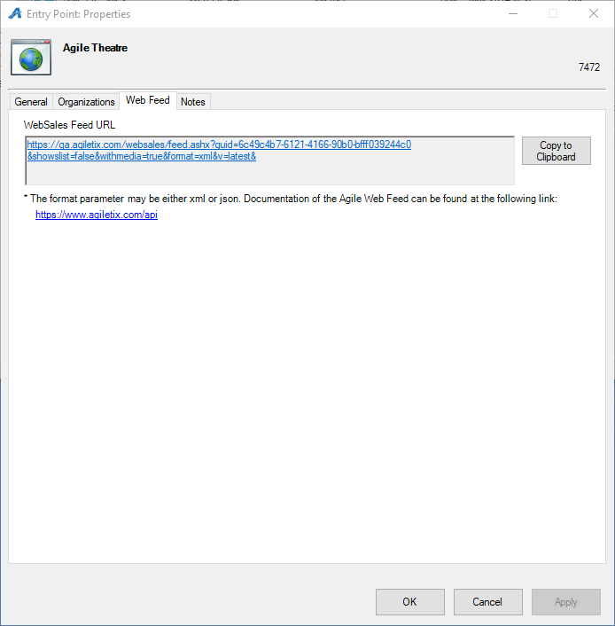
If you need any additional assistance finding out how to use the XML feed, please visit www.agiletix.com/api.

