Order Receipts in AMS
Order Receipt Behaviors
You now have the ability to customize the way a terminal deals with order receipts.
1. In the sale screen, click the Ticket Printer option at the top of the screen.
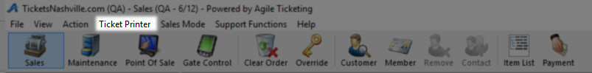
2. Next, hover the mouse over the Order Receipt Behaviors button.
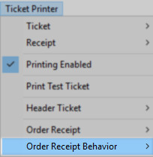
3. There are three options that you can select for your order receipt behaviors:
- The first option is Always Print: this means that you will print an order receipt with every order.
- The second is Prompt at Finalize: this will generate a prompt while you are completing an order that asks whether a receipt should be printed.
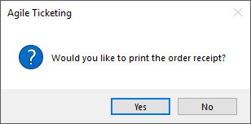
- The third and final is Print Manually: if you select this you will have to print the order receipt manually.
Select the option that works best for your organization.

Reprinting Order Receipts
You may have an instance where you will need to go back to an order and print or reprint the order receipt.
1. Click the Maintenance icon.
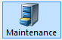
2. Look up and select the order.
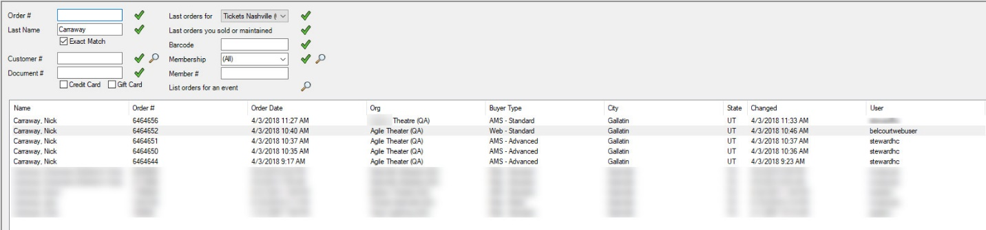
3. In the open order, click the green checkmark at the bottom of the page to select the items in the order.
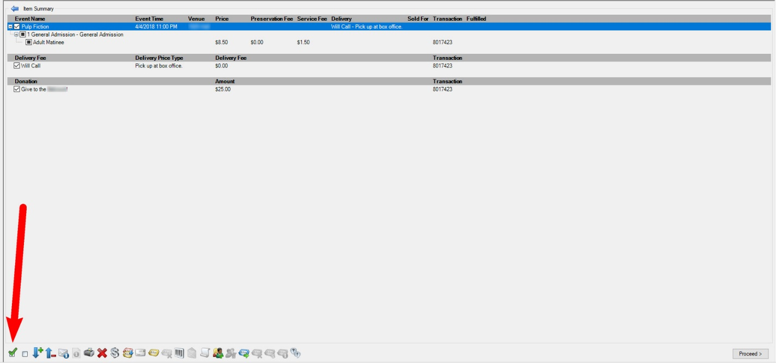

4. At the bottom of the screen, click the Order Receipt icon to print the order receipt.
