Selling A Package In AMS
- Log in to Agile Sales with your username and password. If you have not received your user credentials, please contact your system administrator to set up your username and password.
- Make sure that you are cashed in before starting sales for the day. See How to Cash In and Create a Daily User Batch in AMS Sales for further instructions.

- Click the Customer icon to search for a customer account.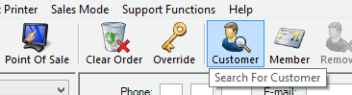

- If the customer has already placed an order in the system, search for their record by last name, email address, or customer number. Double-click their record when it appears.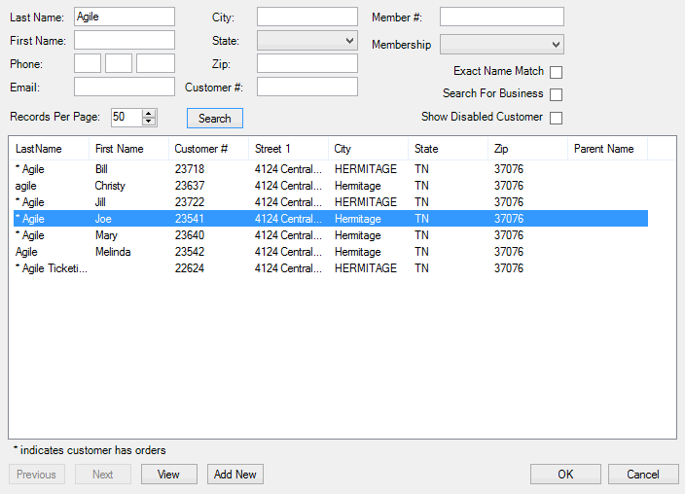

- If the customer has never placed an order into the system, create a new customer account by clicking “Add New.”
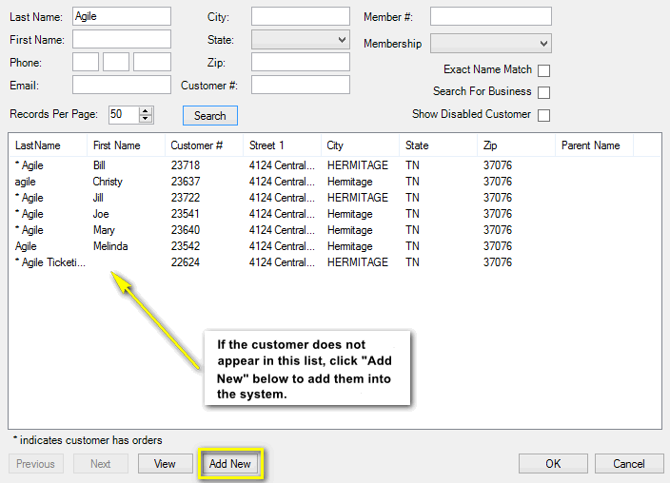

- Once you click “Add New,” the Quick Add Customer window will appear. This is where you will fill in the customer’s information. Once you have captured all the customer’s information, click OK.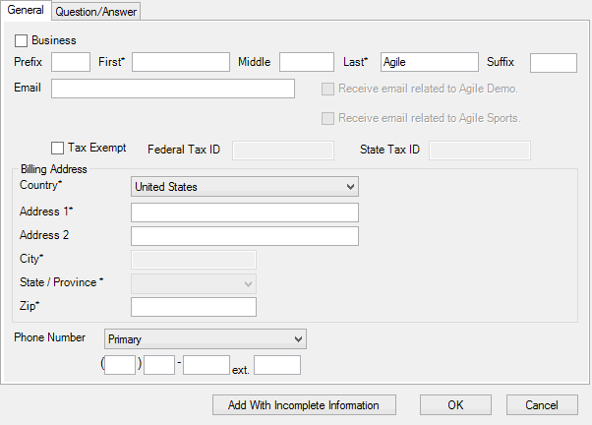

- Once you are in the customer’s account, select the Package tab on the left side of the screen. Select the package program from the list under the Package tab. This will allow you to see all available packages. Choose the relevant package program in the box on the right.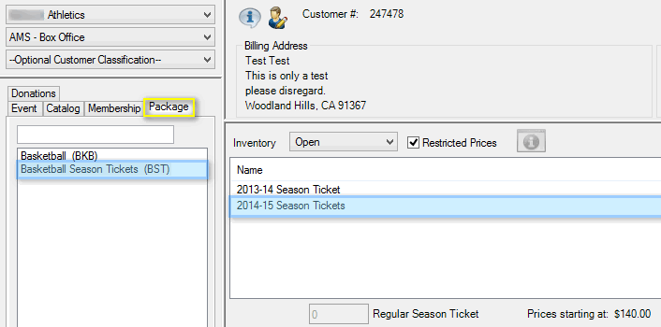

- Select the package you want to sell to the customer. In the box next to Admission, type the quantity of packages to be added to the order.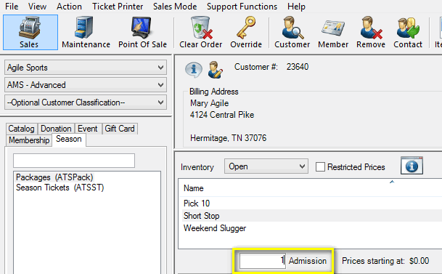

NOTE: In some package setups, all the items are mandatory to purchase, as shown in the first image below. In others, as in the second image below, you may choose the events that are to be included in that package.

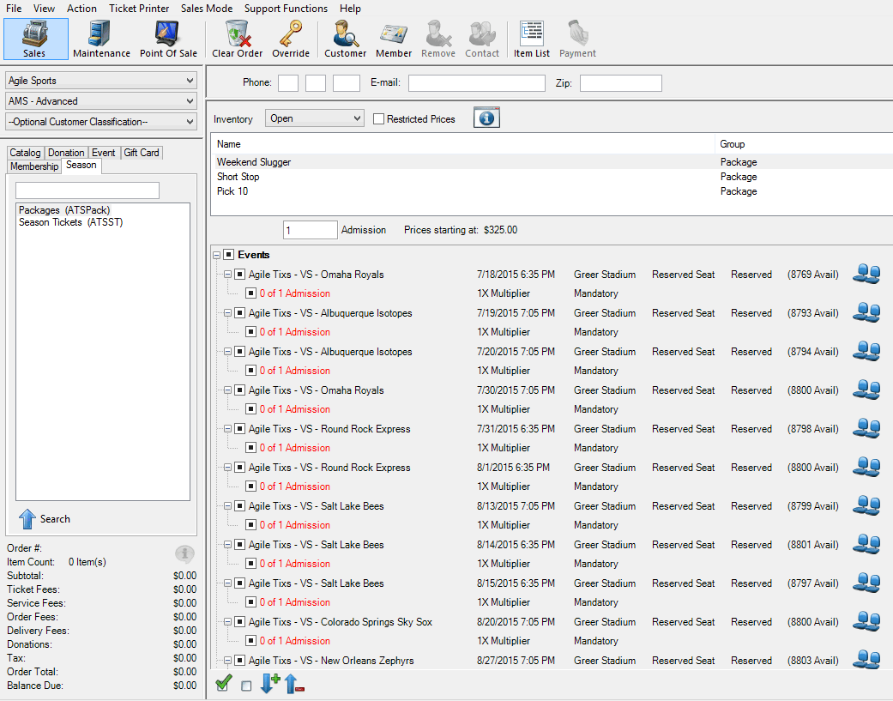
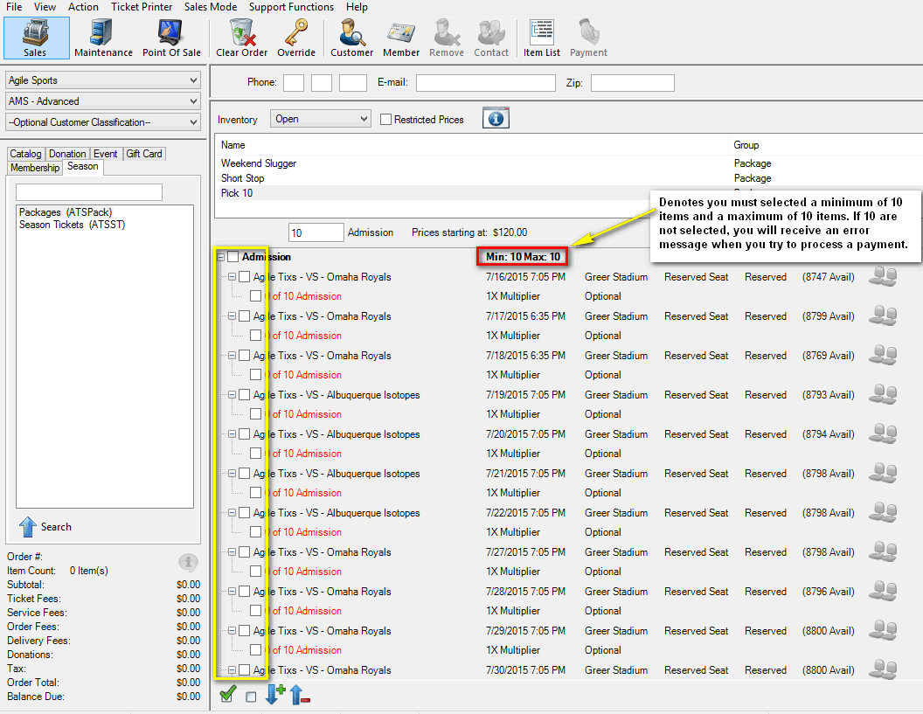

- After selecting the package, click “Proceed” in the lower right-hand corner.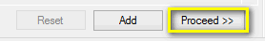

- The next screen is the Item Summary. Here, you can review an order before processing payment.
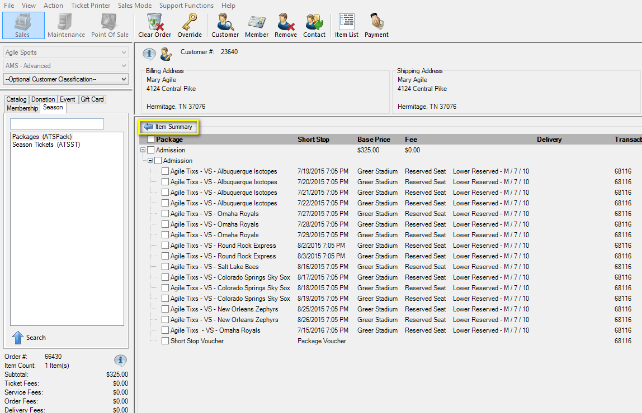

- Once you have confirmed that everything on the Item Summary screen is correct, click “Proceed” in the lower right-hand corner.
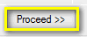
- A “Change Delivery Methods” window will pop up. Select the desired delivery method.
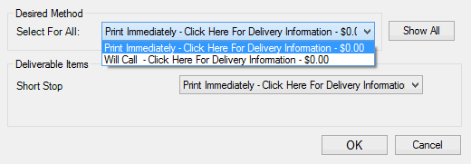
- On the payment screen, select the desired payment method.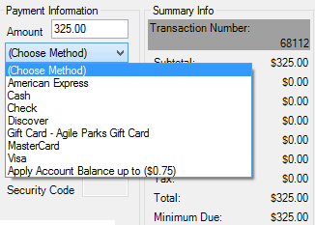
NOTE: If you are using a POS station or have a USB Credit Card swipe attached to your terminal, swiping the credit card will populate all the card’s information and automatically finalize the order.
- Click Apply Payment to complete the order.
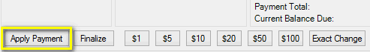
NOTE: If there is no balance due on the order, or if you are processing a comp membership type, then you will only need to click “Finalize” to complete the transaction.

- Once the order has finalized, the Order Confirmation page will pop up.
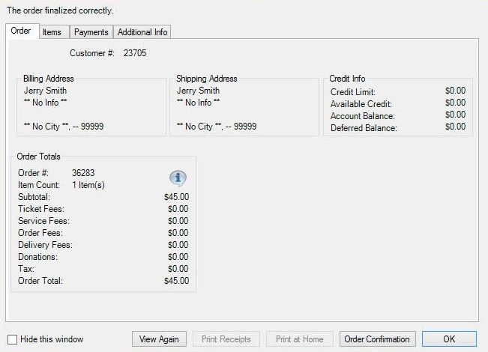

Click Order Confirmation to start the confirmation process.
- Once you click Order Confirmation, the Order Confirmation Options window will pop up. Make sure the email address is correct, add any message you want to appear on the confirmation email, and click Send Confirmation to email the customer their confirmation receipt.
