Copying a Show in Web Portal
Need to copy an event that has already been built? Copying a Show in Web Portal is very easy to do with these simple steps:
1. Go to portal.agiletix.com
2. Enter you Username, Password, and Domain.
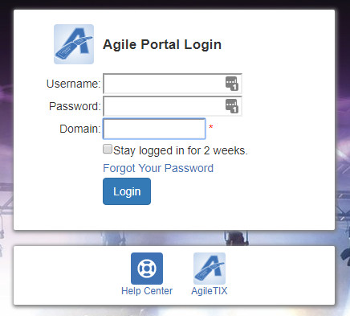
3. Click Events from the menu on the left side of the screen. Then, select Events from the drop-down menu.
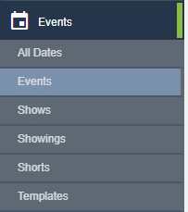
5. Click the Copy button next to the show.
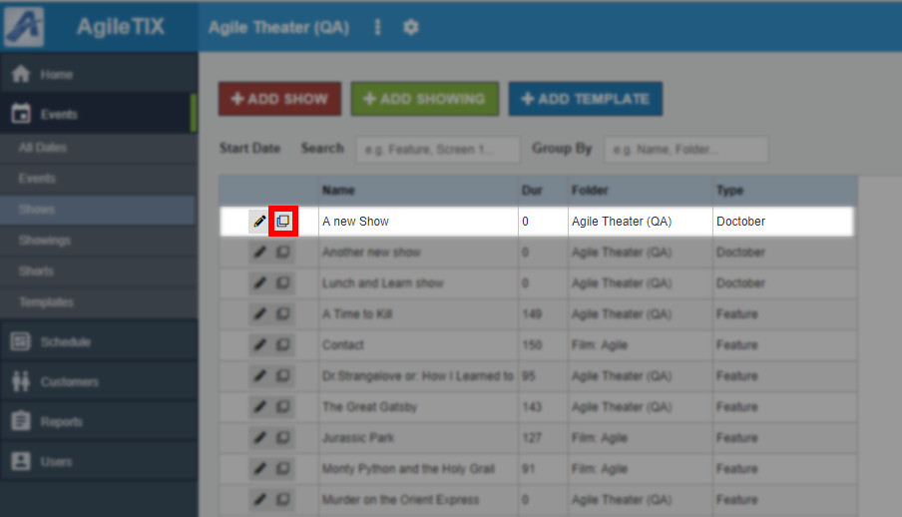
7. In the Show Add window, you can edit the Show's Properties, Media, Custom Properties, and more.
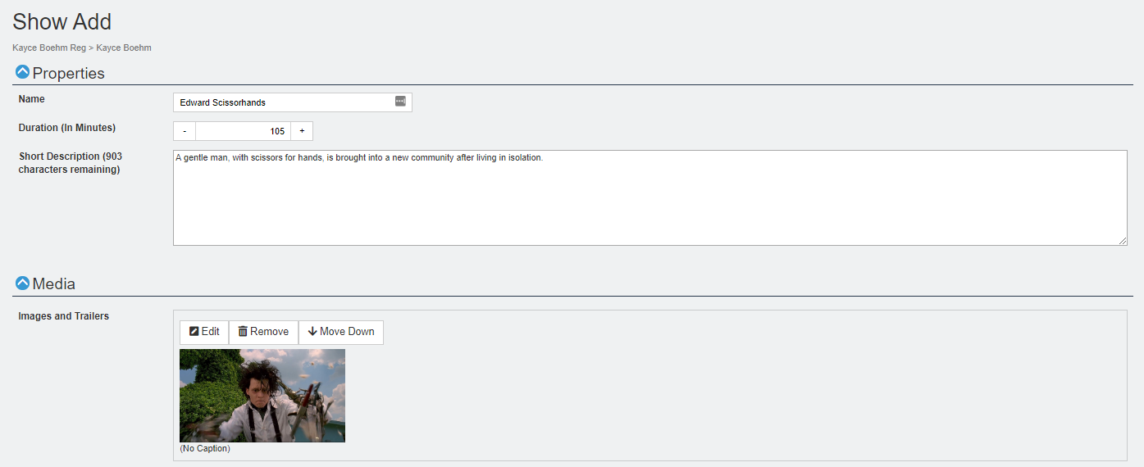

8. Once you have made your changes, click the Save Changes button in the bottom-right corner of the screen.
9. Now you are ready to add Showing Dates and Times. Click here to learn how to add showings.

