Building a Membership Program
1. Log In to Administration.
2. Click the House icon, and then open the Blue sales folder where you will be building your Membership. If you need to build a Membership sales folder, see Creating a Sales Organization Folder in Administration for more instructions.
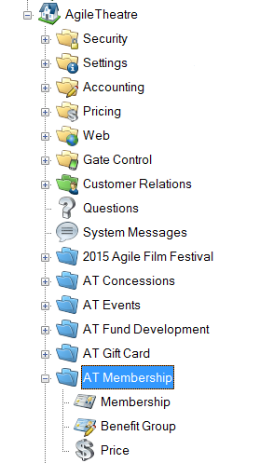
3. Open the Membership folder and click the Membership icon.
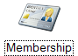
4. In the Membership field, right-click and select New. The Membership: New window will appear.
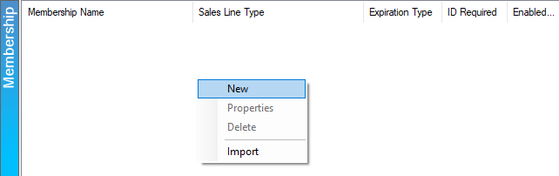

5. In the General tab, fill out the following information:
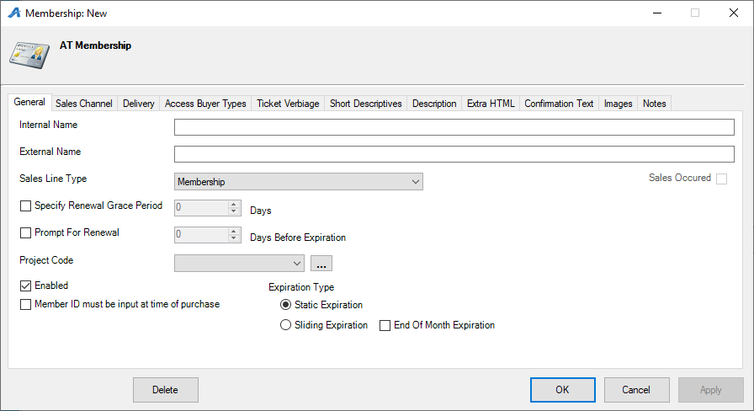

- Internal Name: Required. Name of the membership that will appear in the AMS Sales Screen. Can be a shortened name.
- External Name: Required. Title of the membership program that will appear to customers online.
- Sales Line Type: Required. Defines the actual items being sold (i.e. Membership, Passes, etc.).
- Specify Renewal Grace Period: Allows expired members to renew a certain amount of days after their membership has expired.
- Prompt For Renewal: Will notify the customer (online) and box office staff (in AMS or POS) a certain amount of days before a membership is due to expire.
- Project Code: This can be a customized code that would be used for internal reporting.
- Enable: (required) This needs to be checked to make the membership program is active.
- Membership ID must be input at time of purchase: Requires that you enter the member number in for every order.
- Approval is required for membership activation: Will not allow a customer to access their benefits until a staff member has approved and activated the membership.
- Expiration Type:
- Static Expiration: All memberships will expire on the same day, no matter when they were purchased. Best used for film festivals, fairs, etc. that have static dates.
- Sliding Expiration: No matter when a membership is purchased it will expire a specific number of months later. Best used for year-round theatres.
- End of Month Expiration: Allows the membership to expire at the end of the month instead of the exact date that the membership was purchased. This is only available for Sliding Expiration memberships.

6. Click the Sales Channels tab to place the on-sale dates and times for the membership. NOTE: Make sure to extend your End Date to a future date, so that the membership stays on sale as long as needed. Agile recommends at least a few years.
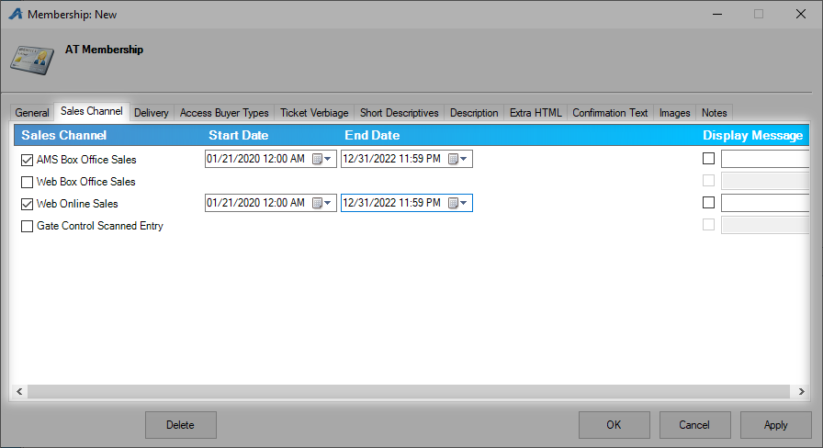

7. The Delivery tab allows you to choose how your members will receive their member cards. Check the box next to the appropriate delivery method(s). NOTE: If your organization has hired Agile to process and fulfill your memberships, please make sure to check the appropriate Agile Fulfilled delivery option and enter the date to start the fulfillment. You can also enter any notes for our fulfillment team. For instructions on how to do this, please see Agile Fulfillment Delivery Switch.
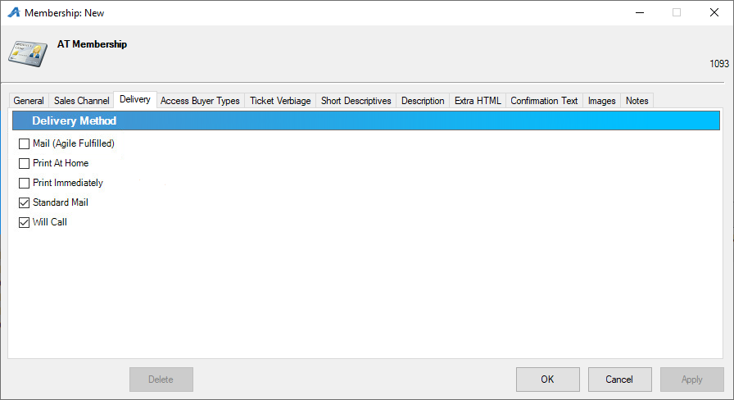
8. Access Buyer Types allows you to choose the different Buyer Types that will be allowed to sell this membership. This is a required function. In most cases, it is best to add all your active buyer types here.
- Select the organization from the drop-down.
- Select the buyer type from the drop-down.
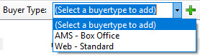
- Click the Green plus sign to add the buyer type to the list below.
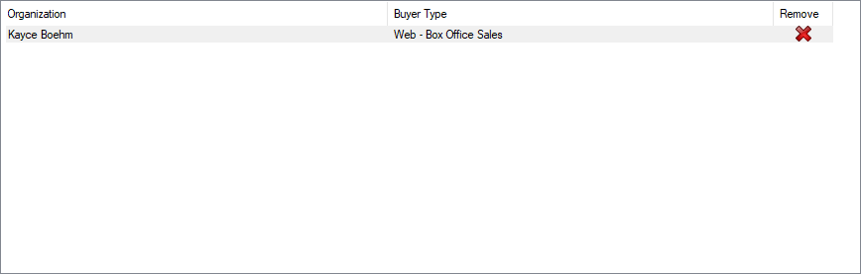

9. The Short Descriptives tab is where you will be able to put a short synopsis or description of what is available through this membership.
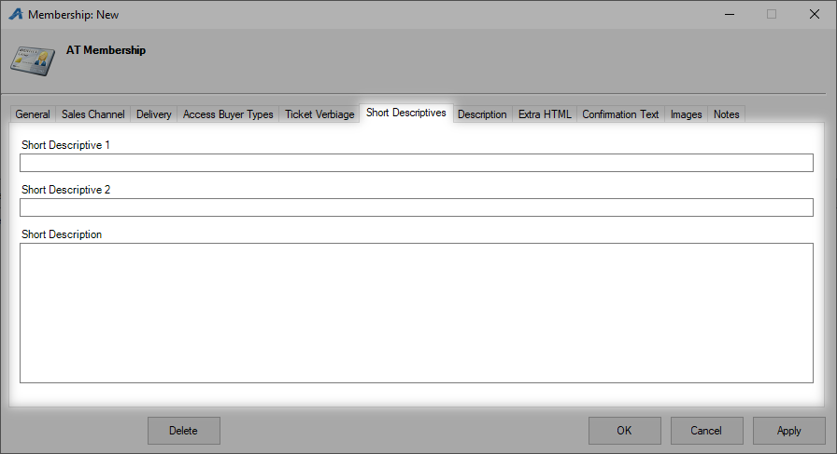
10. The Description tab is where you will place a longer description about the membership.
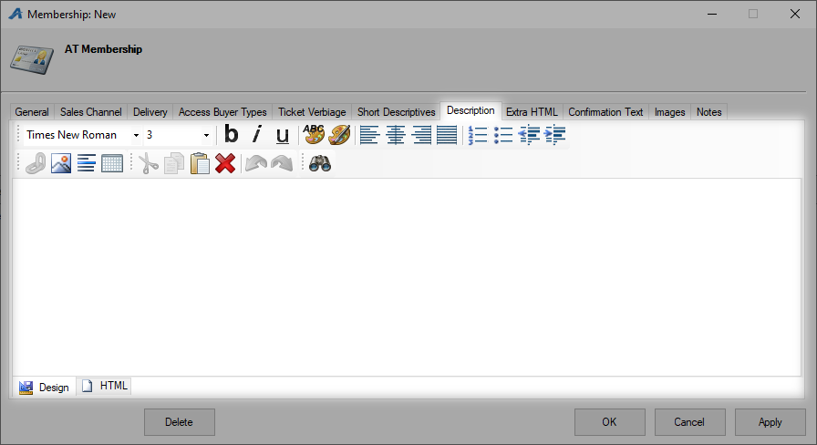
11. The Extra HTML tab allows you to add long, descriptive information for this membership.
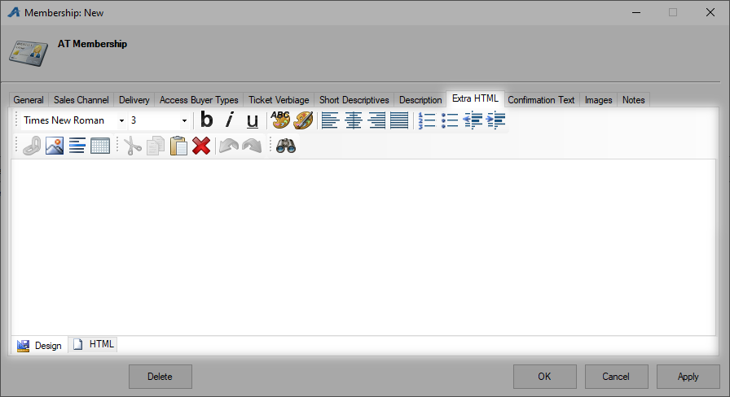
12. The Confirmation tab is where you can add any information that you would like the customer to know when they complete the order (i.e. Thank you for purchasing this Membership. You should receive your membership in the mail within 5 to 10 business days from purchase.)
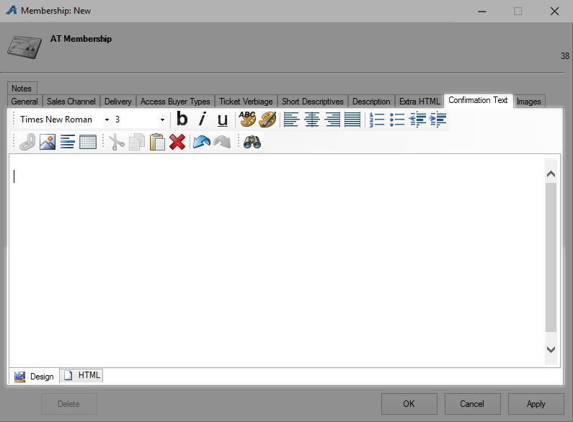
13. Click the Image tab to upload any marketing image for the Membership.
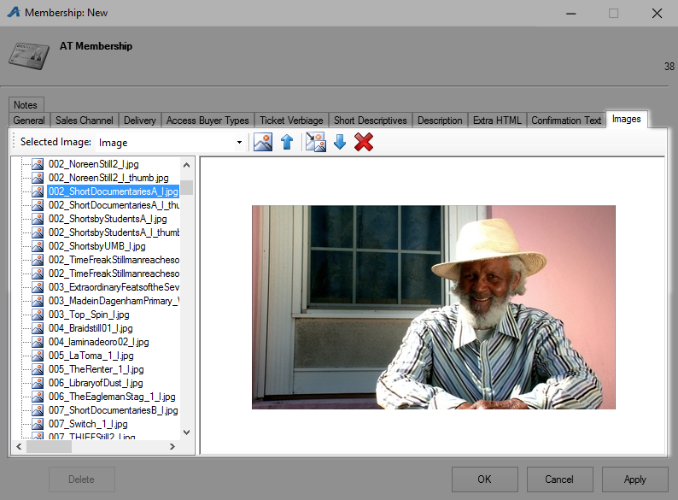
14. Click Apply to save your changes and OK to close the window.

*Note: The next step in building a membership program is to build your Member Benefits Groups. Do not build the membership prices until you have created your Member Benefits Groups.

Setting up Member Benefit Groups
15. In your Membership folder, select Benefit Groups.
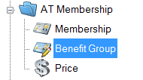
16. Right-click in the Benefit Group field and select New.
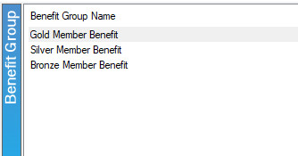
17. Name the Membership Group. This is usually the same name as the membership type or level. If your benefits change from year to year, we strongly suggest adding the year to the benefit name (i.e. 2017 Flex Season Benefit).
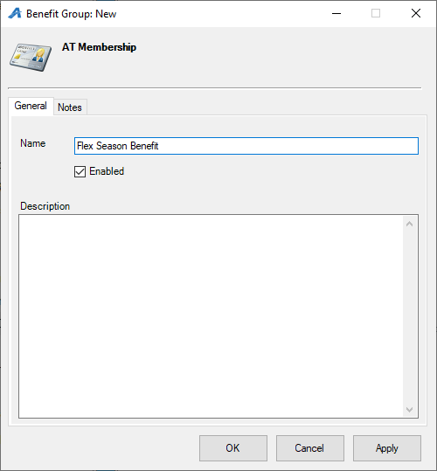
18. Add a description for this Benefit Group that includes a description and list of the benefits that this level receives. This can be used for internal reference as well as a way to merge Member Benefit information onto your Member Welcome Letters.
29. Click Apply and OK.

Building Your Membership Prices
20. In the Membership folder, select the membership program in the Membership area under which the price will be built.
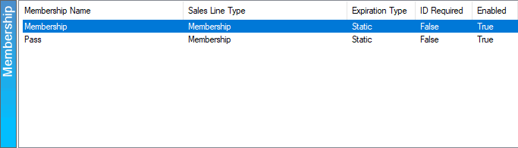

21. In the Membership Prices area, right-click and select New.
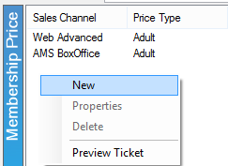
22. In the Membership Price: New window, right-click in the Price box and select New Price.
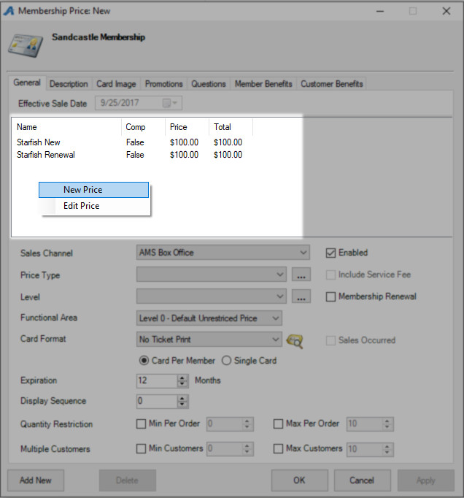
23. The Price: New window will appear.
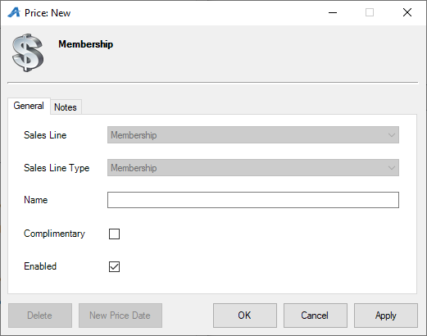
- Choose the applicable Sales Line and Sales Line Type.
- Enter in the Name of the price. This will not be seen by the customer, but it should be easily identifiable for accounting purposes. We recommend being very detailed in the price name (i.e. ABC Venue Adult, Subscription Adult, Gold Member Price, etc.).
- If it is a complimentary price, check the box next to Complimentary.
- The Notes tab is for internal use only and will not be seen by the customer.
24. Click Apply and then OK.
25. In the Price Distribution: New window, right-click and select New.
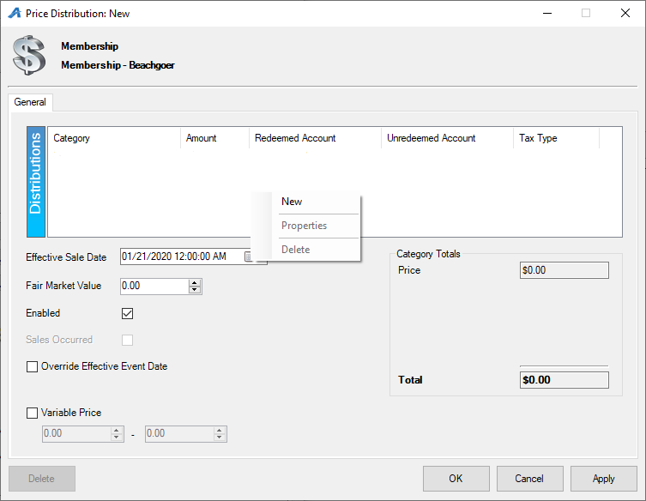
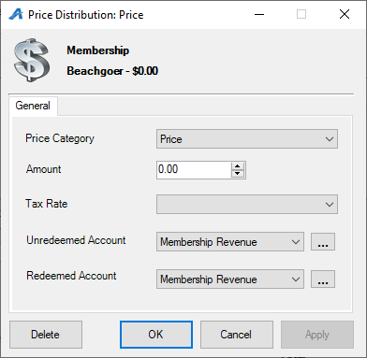
- Price Category: select Price from the drop-down menu.
Amount: enter in the amount of the item being sold.
- Tax Rate: select the correct tax rate, if applicable.
- Unredeemed/Redeemed Account: choose the appropriate Revenue Payment Accounts here from the drop-down.
- Select Apply and then OK.
NOTE: If the price also includes a fee, repeat the above steps but choose Fee in the Price Category.
- Effective Sale Date: choose the date the price should be effective. This can be set in the future and Agile will automatically change the price at the set time.
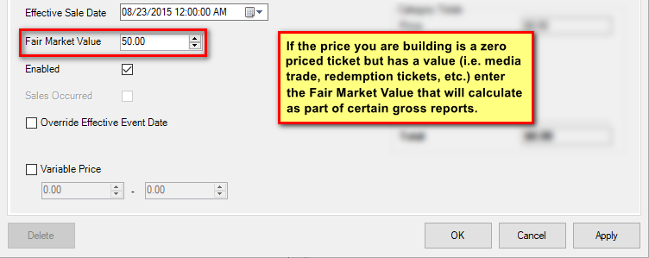
- Fair Market Value: enter in the value of the item being sold.
26. Click Apply and then OK once all the pricing information has been created.
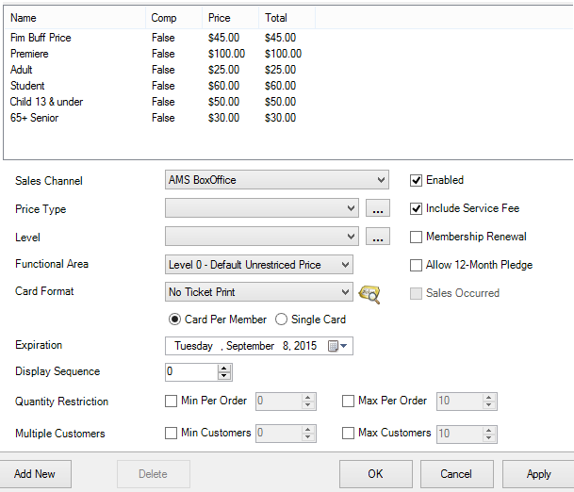
- Select the Sales Channel where this price will be available for purchase.
- Set the Price Type. Customers will see this name, so make sure to choose something that is clear.
- Set the Level. Agile recommends that organizations group all their memberships by level. For example, a student membership and a student complimentary membership would both use "Student" for the Level.
- Select the Functional Area. Select Level 1 - Restricted Price for any price that should not be for sale to the general public.
- Select the Card Format.
- Choose Card Per Member if the membership type allows for multiple cards to be printed OR Single Card if only one card per membership will be printed.
- Set your Expiration Date: This determines the duration of the membership. For Static Expiration memberships, choose the exact date that the membership is due to expire (i.e. Festival Passes expire on Jan 1, 2020). For Sliding Expiration memberships, choose how many months the membership is available (i.e. Membership is valid for 12 months).
- Set your Display Sequence: The display sequence determines in what order the memberships will be displayed online and in AMS.
- Select your Quantity Restriction: Min and Max: This limits how many memberships may be bought at a time.
- Select your Multiple Customers: Min and Max: This limits how many customer names are on a membership (i.e. for dual memberships, set the min and the max to 2).
- Make sure your Price is Enabled.
- If you would like to include a Service Fee, make sure the Include Service Fee box is checked.
- For renewal prices, make sure to check the box next to Membership Renewal.
- Allow 12-Month Pledge: Checking this box allows customers to pay for the membership in monthly installments. This option is for Donor Perfect clients only and must have a Safe Save merchant account.
27. The Description tab allows you to add a description of this Membership Price.
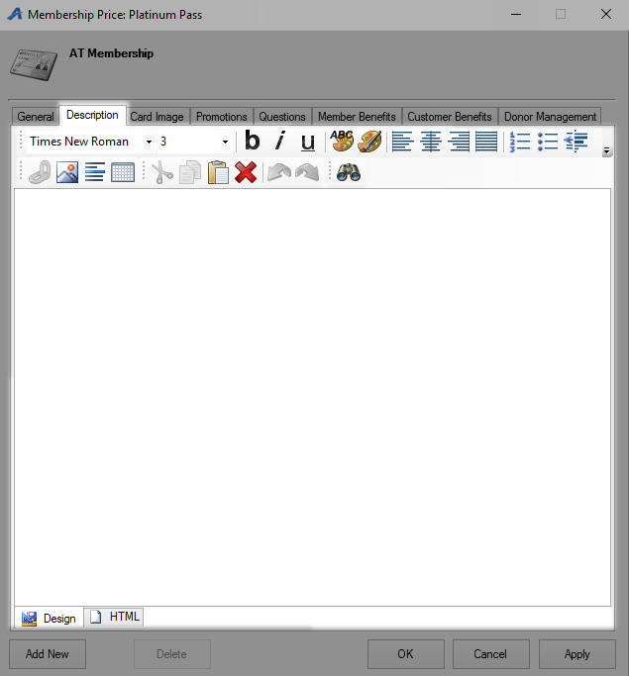
28. Under the Card Image tab you can add the image you want to show up on the card.
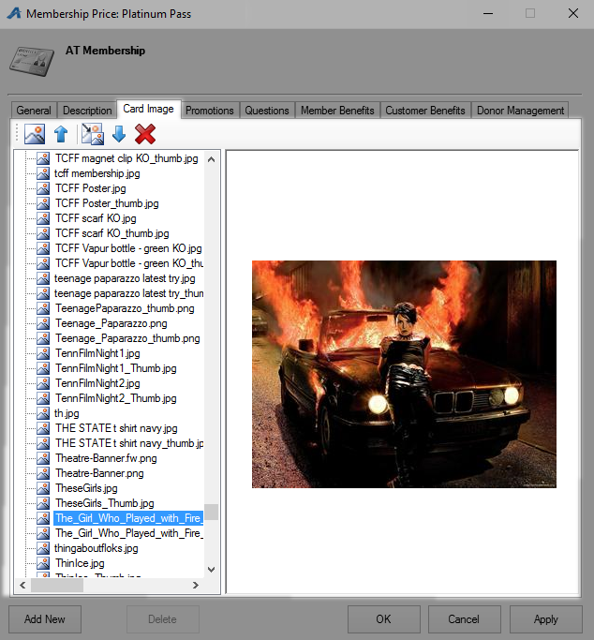

29. If this price should only be accessed via a promotion code, add that code under the Promotion tab. See Promotional Codes: Creating and Attaching Codes to Prices for more information.
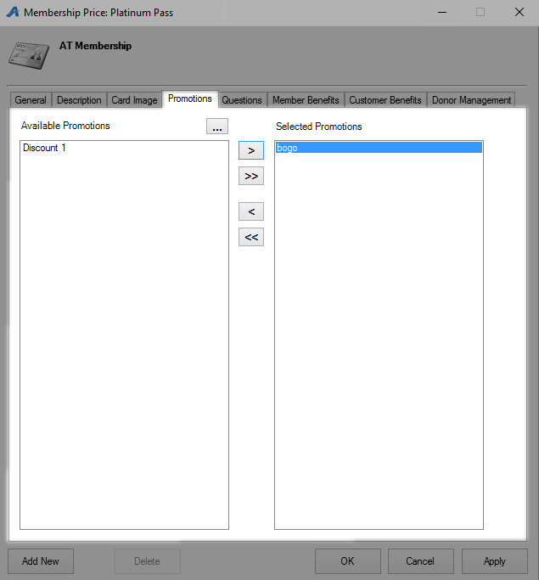

30. The Questions tab allows the client to add order questions for customers to answer before completing checkout. See Creating Order Questions for more information. Move the question from the Available Questions column to the Selected Questions column to activate the questions for this price.
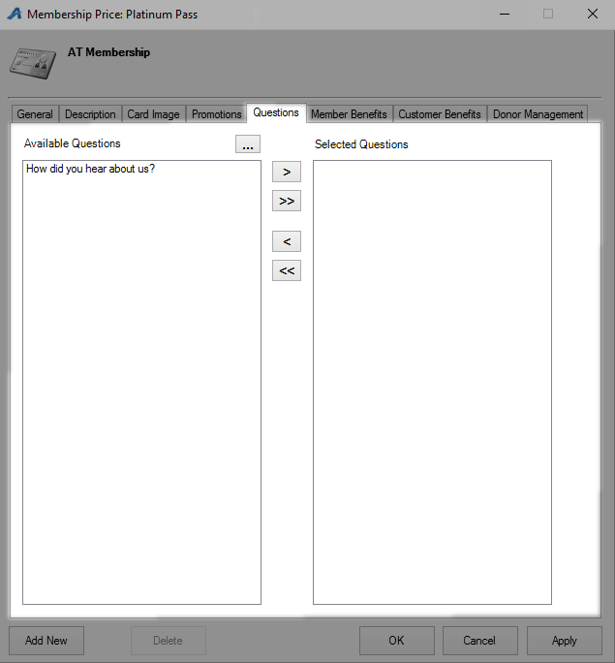

31. The Membership Benefits tab is where you will attach the benefits for this membership level. This step cannot be skipped. If you do not add the Member Benefit Group(s) to the price, members will not be able to access their benefits online or at the box office. Follow the steps below:
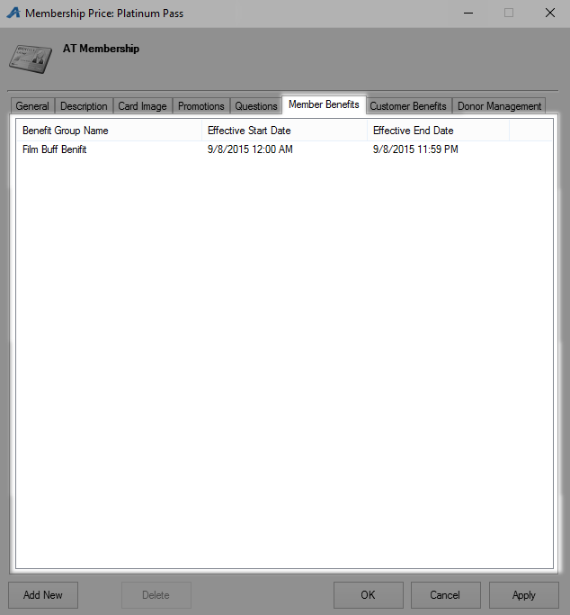
- Right-click in the window and select New.
- Select the correct benefit from the Benefit Group drop-down.
- For a Static Expiration Membership, choose the Effective Start Date and the Effective End Date for the exact dates you want the benefits to be valid for. For a Sliding Expiration Membership, set the Effective End Offset to the number of months the membership benefits will be available.
32. Account Benefits Tab
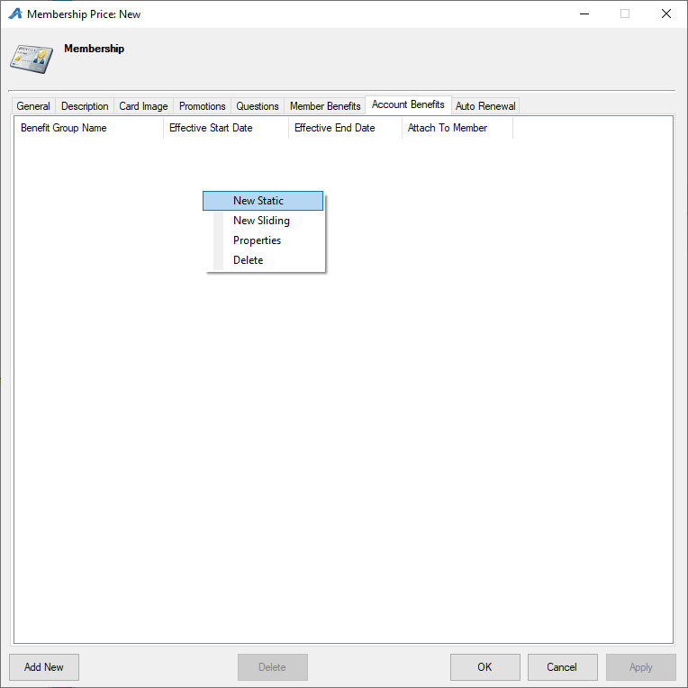
- Right-click in the window and select New Static or New Sliding.
- Select the correct benefit from the Benefit Group drop-down.
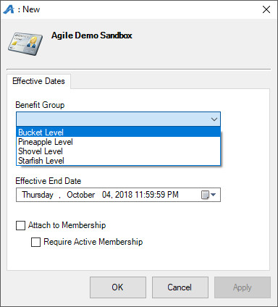
- For a Static Expiration Membership, choose the Effective Start Date and the Effective End Date for the exact dates you want the benefits to be valid. For a Sliding Expiration Membership, set the Effective End Offset to the number of months the membership benefits will be available.
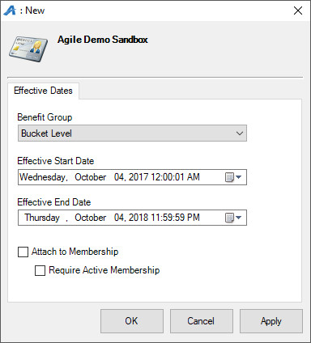
- Check Attach to Membership if all members on the membership should have access to this benefit. If this is unchecked, this benefit will only allow the purchaser of the Catalog item (ticket packs) access to this benefit.
- Check Require Active Membership if the customer's membership must be active for them to receive their benefits.
33. The Donor Management Tab: This is only available for Donor Perfect clients. Select the appropriate items from the dropdowns. See these articles for more details on this tab: Gift Properties and Other Item Properties.
34. The Auto-Renewal Tab: here you can set up this membership price to be available for automatic renewal. Make sure that the Allow Auto Renewal box is checked. Select the renewal price from the drop-down as well as a delivery method. Finally, define the how many days before the renewal the customer will be notified.
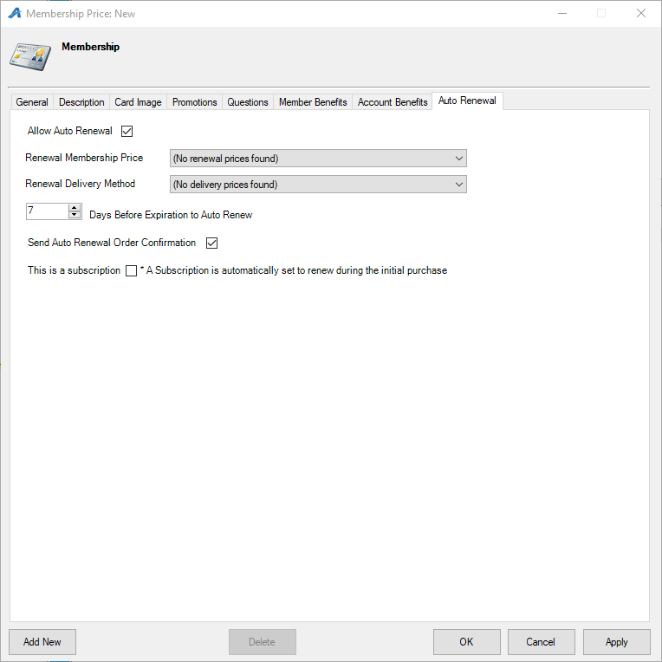
35. Click Apply and then OK. To add multiple sales channels, click Add New and change the sales channel on the General Tab.

Building a Benefit
36. Select the Benefit Group icon. Select the first Benefit Group you created.
37. In the Benefit field, right-click and select New.
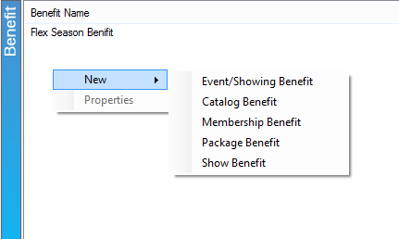
38. Select the type of benefit.
- Event/Showing Benefit: Points to a Showing or Event ticket type (most commonly used).
- Catalog Benefit: Allows to add a Merchandise or Concessions type benefit.
- Membership Benefit: Allows for a benefit for another membership (i.e. if festival passes are built as memberships, use this option).
- Package Benefit: Allow for a benefit of a package.
- Show Benefit: Points to a particular Show ticket type (for example, if the member should have access to all the performances of a particular Show, use this benefit).
39. Once you are in the Benefit window, fill out the following information:
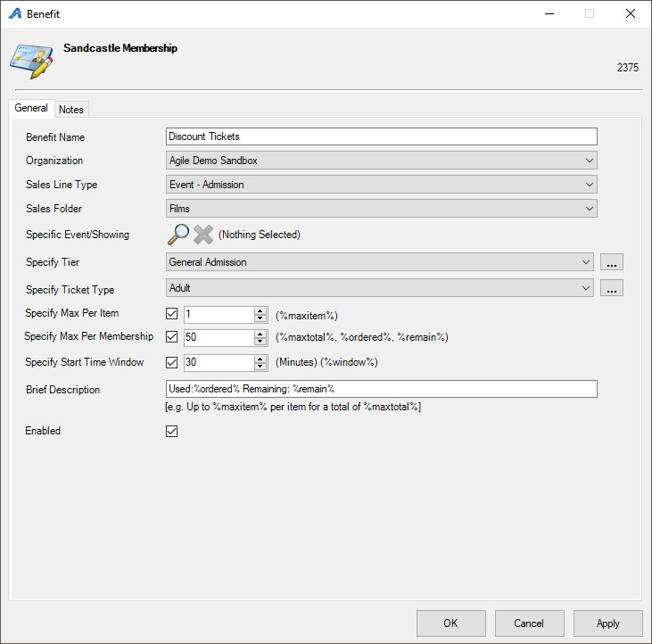
- Benefit Name: Name the Benefit. (i.e. Member Discount)
- Organization: Select your Organization.
- Sales Line Type: This points to the Sales Line Type on the event/show/membership/etc. that the benefit is redeemed for.
- Sales Folder: Choose the specific folder or select All.
- Specific Event/Showing: If a benefit is only valid for a specific event/showing, click the Magnifying Glass icon to select it from a sales folder.
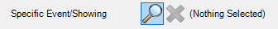
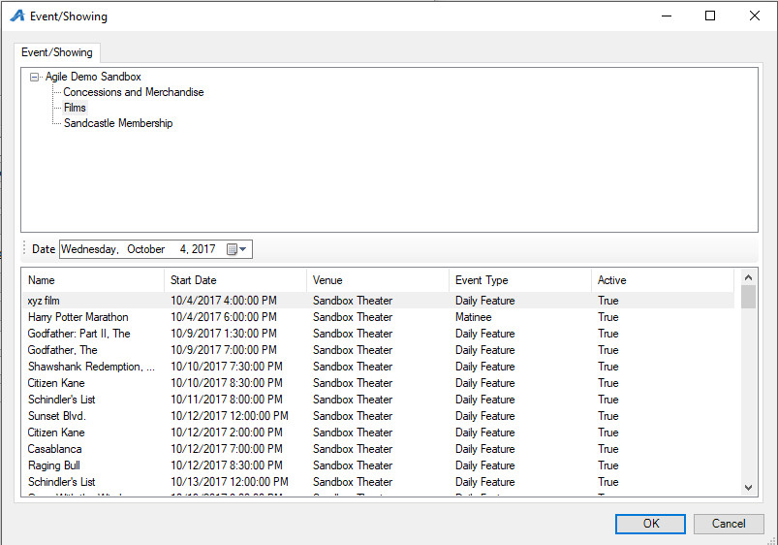
- Specify Tier: Select the inventory for which this benefit should be redeemed. If you keep this blank, it will point to all Tiers.
- Specify Ticket Type: Select the ticket type you built under your events for which the benefit will be redeemed.
- Specify Max Per Item: Set the benefit per item, e.g. customers may buy two tickets per event/show at the membership price.
- Specify Max Per Membership: Set the benefit per membership, e.g. customers may buy two tickets total at the membership price.
- Specify Start Time Window: Enter in the amount of time that must occur between showings. This prevents customers from using their benefits on two concurrent showings.
- Brief Description: For organizations that would like their customers to be able to view to their benefits online, enter the following information into the Brief Description text box so that the information appears in their account area online:
  - "Total %maxitem%" will show the total number of items allowed with this benefit.
  - "Used %ordered%" will show the total number of benefits that have already been used.
  - "Remain %remain%" will show the total number of benefits that they have left to use.

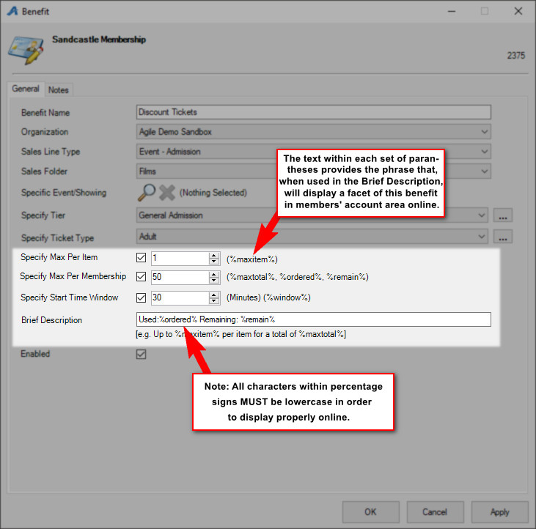

40. Click Apply and OK.
*PLEASE DOUBLE-CHECK THESE STEPS, AS YOUR BENEFITS WILL NOT WORK CORRECTLY IF YOU HAVE POINTED TO THE INCORRECT TICKET TYPE. It is recommended that you test all benefits online and in-house with sample membership levels prior to selling memberships to customers.

