Agile Fulfillment Delivery Switch
Clients that use Agile Ticketing Solution's fulfillment services now may assign a specific delivery method that will allow Agile to differentiate between what Agile will fulfill for the client and what the client will fulfill themselves.
1. Log into Administration.
2. Click the House Icon, and then open the folder where the item you wish Agile to fulfill is.
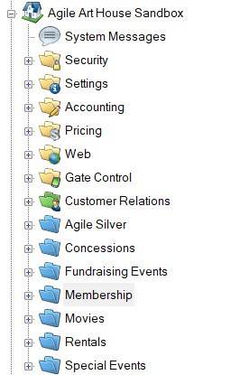
3. Under the Delivery Method tab, you will see all the Delivery Methods that are available to you. Check the box next to the Mail (Agile Fulfilled).
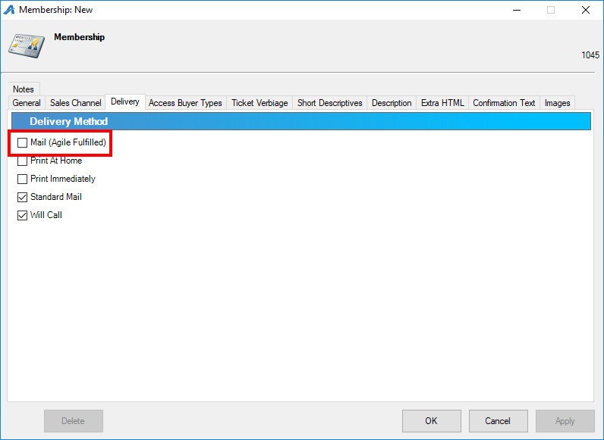
4. Checking the box for Mail (Agile Fulfilled) will make Start Fulfillment appear in the blue header of the window. Underneath the blue header, indicate the Date for Agile to start fulfillment.
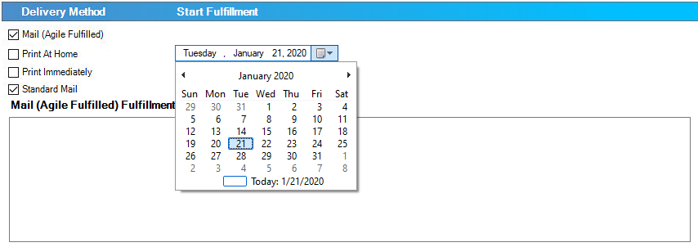
If there are any specific instructions that we will need to know about how to fulfill your item (such as extra brochures, cards, or promotions that need to be included in the envelope), put those instructions in the Mail (Agile Fulfilled) Fulfillment Notes field at the bottom of the window. We recommend that you update the Notes Field as soon as you start making any changes to how you want Agile to fulfill the item.
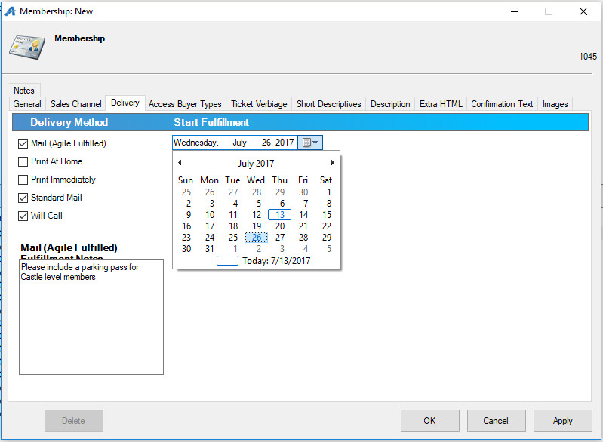
Please note that there is a 24-hour mail hold for Agile Fulfillment. This allows our clients to make any changes to an order 24 hours before we print it. If you want to have this feature removed, please call us.

