Adding Shorts in Web Portal
1. Log into Web Portal.
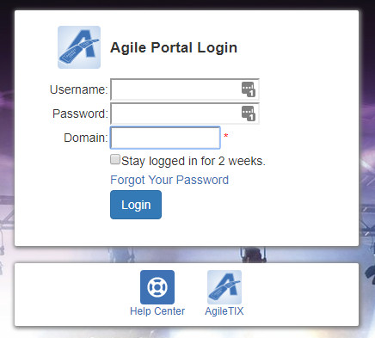
2. Click Events on the menu on the left side of the page.
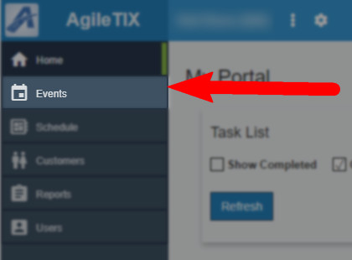

3. Click the Shorts button.
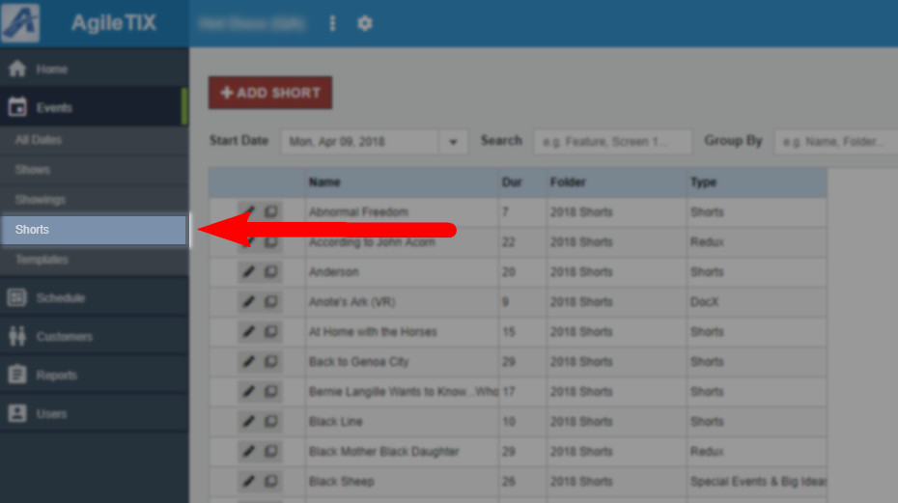
4. Click the +Add Shorts button at the top of the page.
5. Enter in the Short's Properties:
- Name
- Duration
- Include Until: This will determine the date when the Short's page will be taken offline. We recommend that you put the day after your festival, as this will keep the information page available for each short online until after your festival is over.
- Brief Description
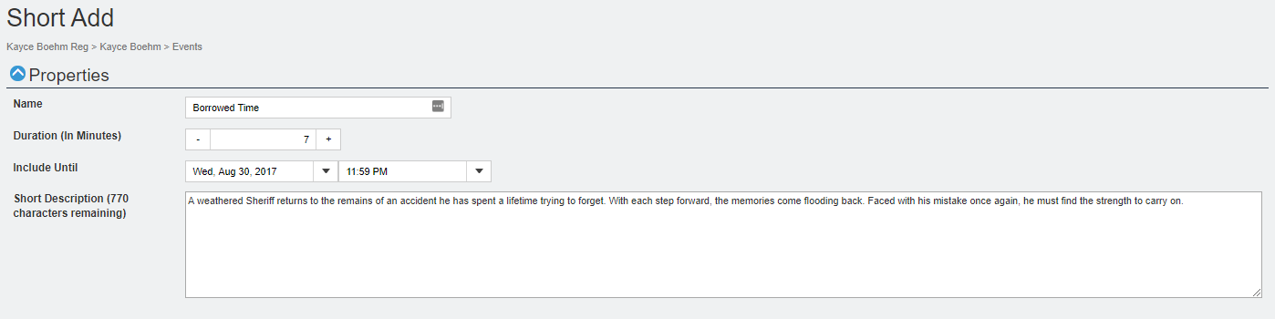
6. Close the Properties tab and open the Media tab.
7. The Media section allows you to upload images and trailers. The ideal image size should be 560 pixels wide by 315 pixels high at 72 dpi. To upload your media content:
- Click the Add Media button.
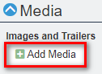
- Select the Type of Media you will be uploading.
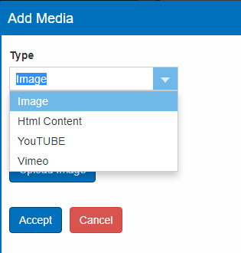
- Add a Caption that will appear on the Image.
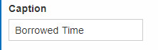
- For images, click the Upload Image button and select the image file from your computer.
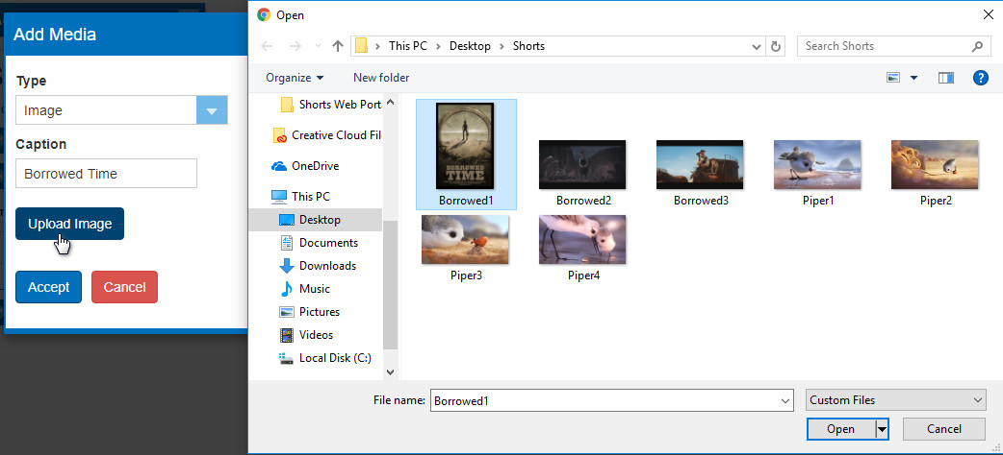
- Click the Accept button once you have uploaded your image.
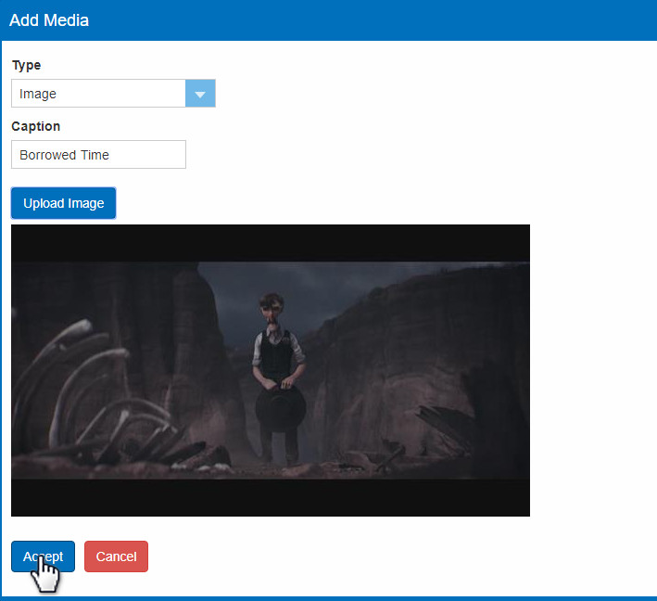
- When uploading a Video or Trailer, select the Media Type from the drop-down. Videos must be either YouTube or Vimeo formats.
- Add a Caption that will appear as a title for the Trailer.
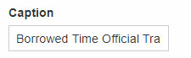
- Copy the YouTube or Vimeo link and add it to the Paste Trailer Link Here field.
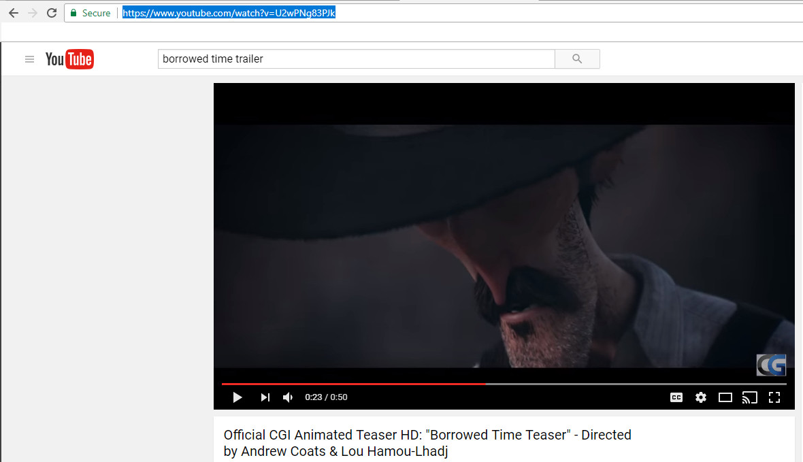
- Click the Accept button once you have uploaded all videos/trailers.
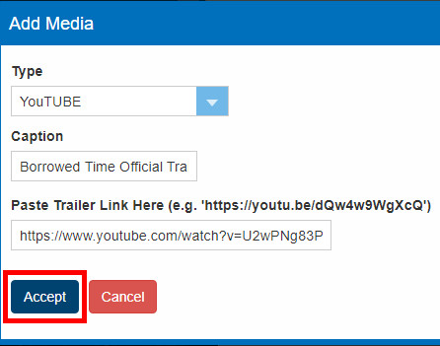
- Repeat the process to add additional images or videos.
- You can reorder your images and trailers by clicking on the Move Up or Move Down buttons.
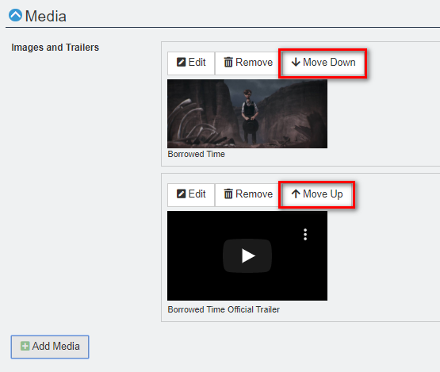
8. Once you have added all the media content, close the Media tab and open the Custom Properties tab.
9. Click Custom Properties to begin adding any additional content for your show. Custom Properties are where you can add specific information about your show (i.e. Rating, Release Year, Cast & Crew, etc.).
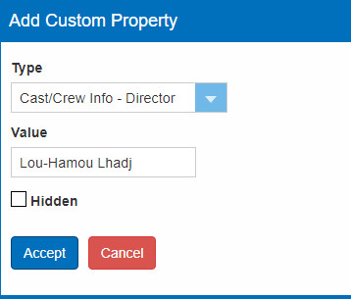
Note: If you do not have information for specific Custom Property fields, you can leave the category blank.
10. Once you have entered in all desired custom properties, click the Save Changes button at the bottom of the screen.
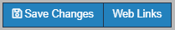
11. Once you have created the Shorts, you will need to nest them into a show or event (click here to learn how to build an Event or Show).

Add the Short to the Show:
12. Once you have created your Show/Event, click Event in the menu and select Shows or Events to the side of the screen.
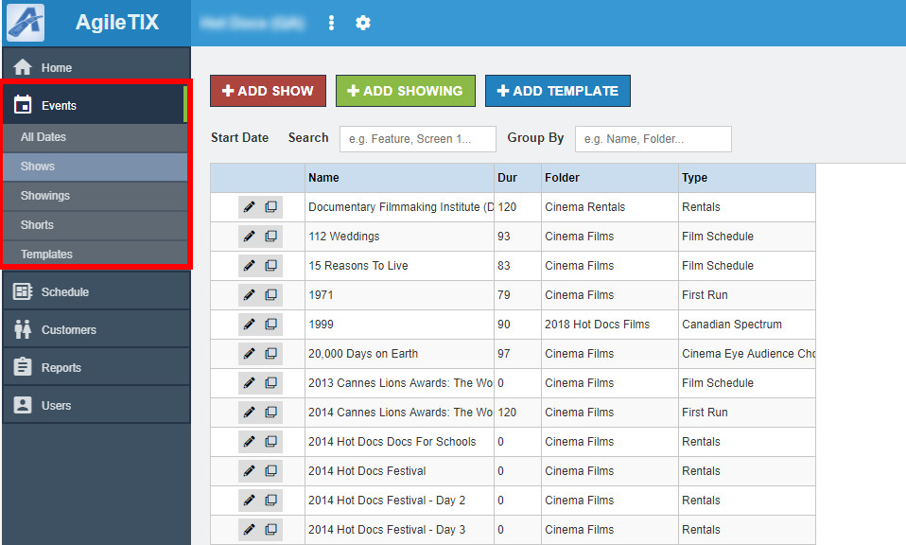
13. Click the Edit button next to the Show to which you would like to add the Short(s) and click Manage.
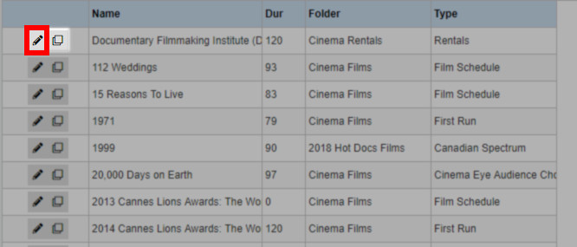
14. You will now be in the Show Edit page. Scroll down to the Included Shorts section.
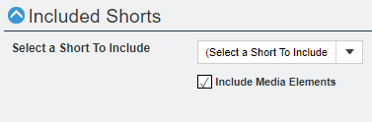
15. If you wish to include the images and trailers that you added when building the Short film, check the box next to Include Media Elements. This will add the images and trailers to the carousel on the full-length show.
16. Next, select the Shorts you wish to include in this Show from the drop-down.
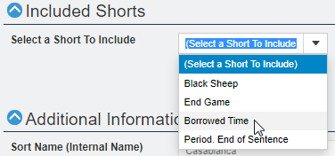

17. Once you have added your shorts, click the Save Changes button at the bottom of the screen.

