Once you have received your welcome email and login credentials, you can edit and add important information about your organization. Follow the steps below to add your information. NOTE: It is very important that you fill out this information. It will enable both your customers and Agile to find your organization's contact information.
1. In your internet browser, go to Agile's Web Portal-- portal.agiletix.com
2. Log in using your Username, Password, and Domain name.
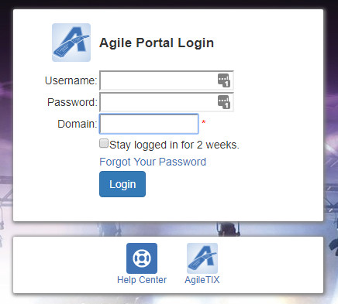
3. At the top left of the screen, you will see your Organization's Name. Click the Gear icon to open up your organization's information screen.

4. In Properties, you can update your Organization's Address and add an Administration Email. The Administration Email will appear on any email notifications that your customers will receive (i.e. info@sandbox.com, etc.).
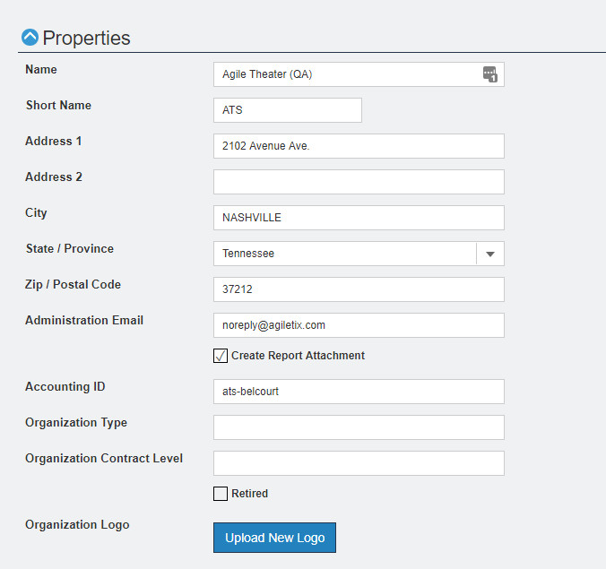
5. Click the Upload New Logo button. This image will appear on your print-at-home tickets. Image size should be 400 pixels wide by 534 pixels high at 72 dpi.
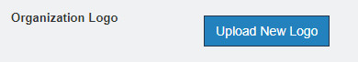

6. Next, open up the Customer Service Contact menu. This is where you will add the name, email address, website address, and contact phone number for the person that handles customer service inquiries for your organization.
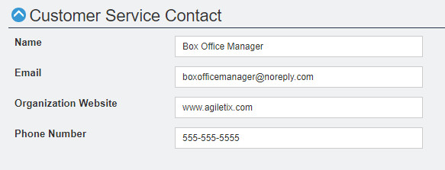

7. Billing Contact is where you will enter the contact information on who should receive the invoice or checks, how the checks should be made out, and the address where it should be mailed.
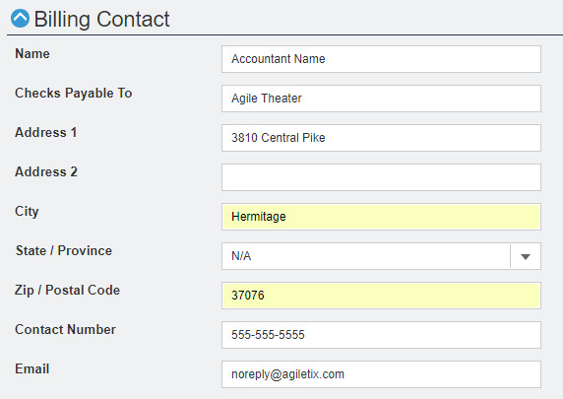
8. Once you have finished entering this information, click the Save Changes button.

