1. Log into the Agile Web Portal at portal.agiletix.com
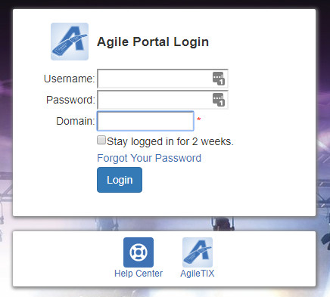
2. On the left side of the screen, select the Users icon.
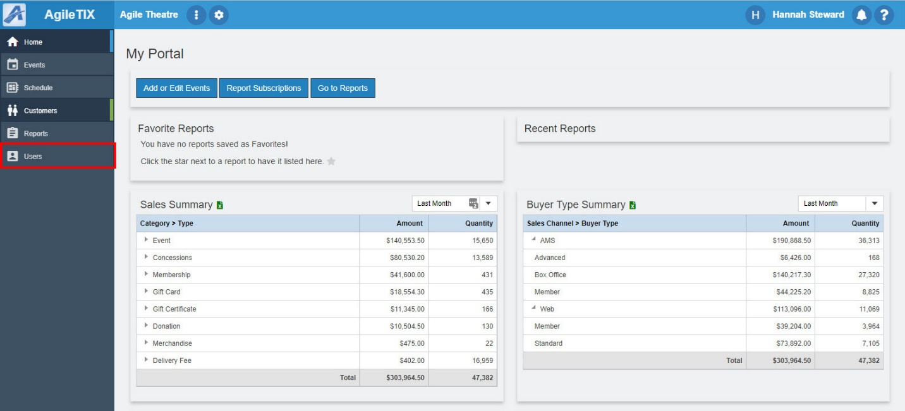

3. Click the Add New User icon in the upper left-hand corner.

4. Enter the Full Name of the individual.
5. Enter user's AKA Name, Email Address, and Phone Number.
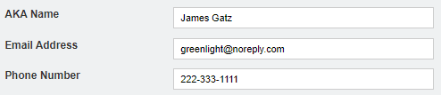
6. Give the new user a Username. Note: You will not be able to change the username after it is assigned.
7. Give the new user a Temporary Password. When the user logs in for the first time, they will be prompted to change their password. The new Password must contain at least one uppercase alphabetic character, one numeric character and one of the following special characters: !#$%&@. The Password must also be between 8 to 15 characters in length.
8. Check the Require Password Change at Next Login box. This will make the user create a new secure password that only they will know.
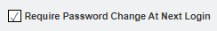
9. As the account administrator, you must assign the new user a Security Role. This will determine what level of permissions the user has within the software.
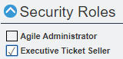
10. Once you have entered all the information above, click Save Changes to create your new user.

