Specifying A Membership Type For Membership/Pass Entry Scans
In Gate Control, you can create a Membership Entry that will allow you to scan Membership Cards or Passes for access and entry to your event.
1. Open the Gate Control Folder.
2. Create your Gate Control Batch(s). Click here for further instruction if necessary.
3. Once you have the Gate Control Batch(s) open, select the Event Batch that you want to create and add the Membership Entry.
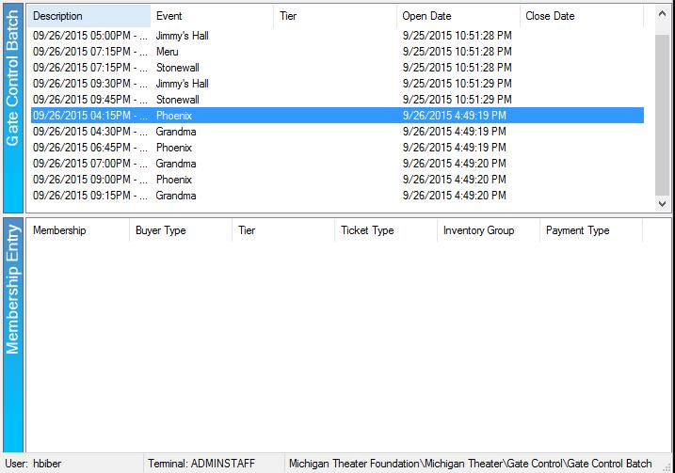

4. In the Membership Entry field, right-click and select New.
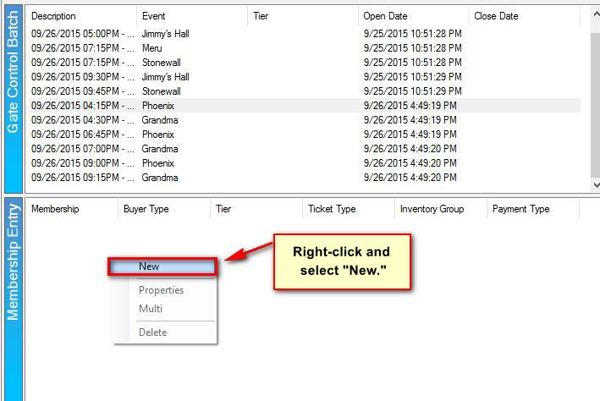
5. The Gate Control Batch Membership Scan window will appear.
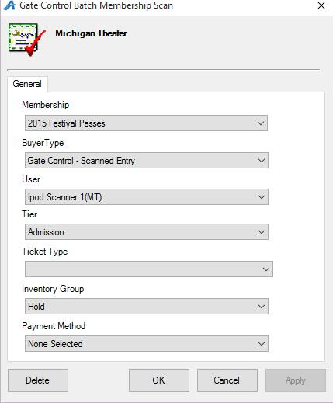
6. In the Membership drop-down, select the Membership or Pass Program.
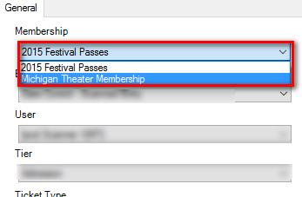
7. The Buyer Type should be pointing to Gate Control - Scanned Entry, the User should be pointed to one of the scanners for your organization, and the Tier should be pointed to the Tier Level from which you want to pull inventory.
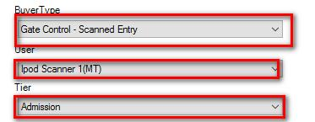
8. Select the correct Ticket Type for entry.
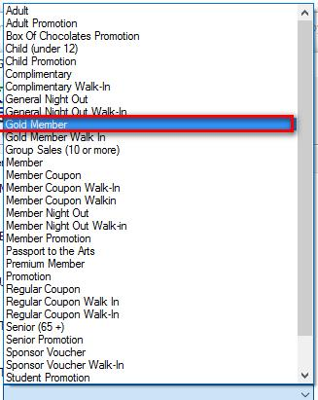
9. In the Inventory Group drop-down, select the proper Inventory type.
10. You can Choose a Payment Method if applicable, but most organizations keep None Selected as the default.
10. Once all information has been completed, click Apply and then OK.
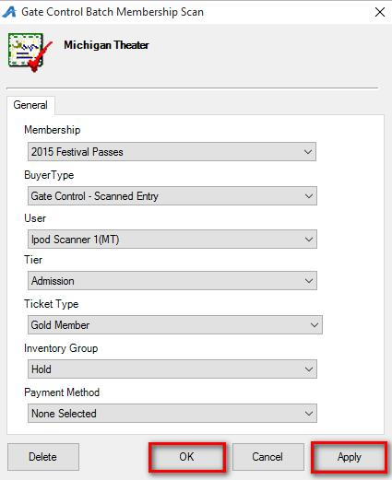
NOTE: At this point, run a test by scanning a Member Card or Pass to make sure that the permissions are set up correctly. If the test scan is successful, you can then move to the next steps to copy the permissions to additional Gate Control Batches.
11. If there is more than one Gate Control Batch, you can copy the completed Membership Scan to all the remaining batches. Right-click on the Membership Entry and select Multi.
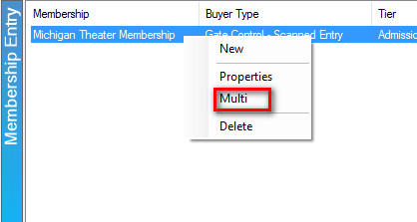
12. Click the radial button next to Copy.
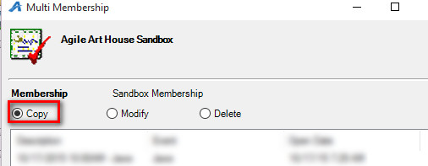

13. Select the Event(s) to which you want to copy this permission.
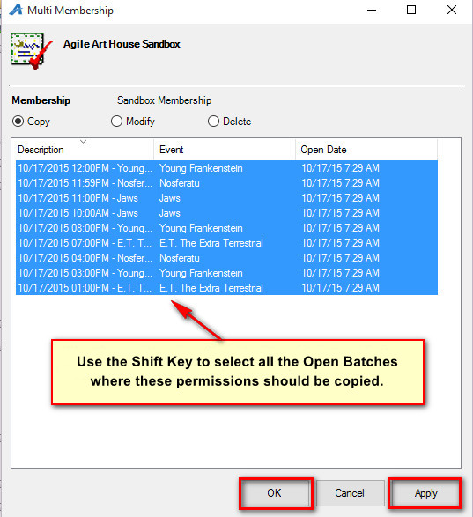
14. Click Apply to copy to the remaining open Gate Control Batches.
15. Click OK once the copy process has completed.

