Pulling A Cash Out Daily User Batch Report
Clients can pull Daily User Batch reports from the reporting portal. Follow these steps:
1. Open portal.agiletix.com .
2. Login with your user information.
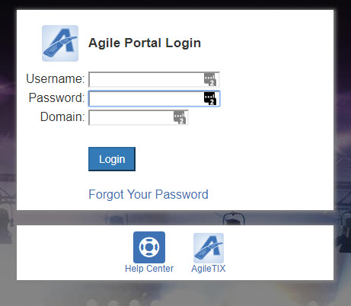
3. Select Reports from the menu.
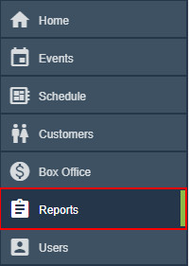
4. Open the Accounting category.
5. Select Agent Cash Out/User Batch Audit.
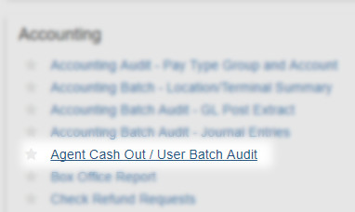
6. Choose the User from the drop-down menu.
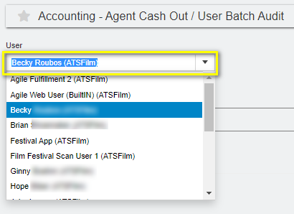

7. Choose the User Batch date that you wish to pull.
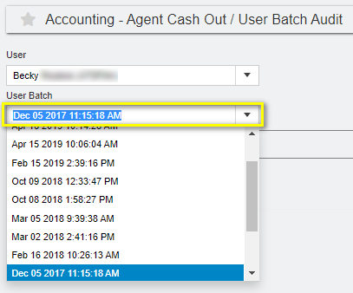
8. Check Include Sales by Event/Item Details. This will pull all of the detail information that this user sold.
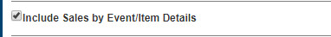
9. Click on the PDF button to pull the report.
10. Save to your computer.

