Customer Search and Management in Web Portal

You may now search for and manage customer records in Web Portal.
1. First, go to portal.agiletix.com.
2. Log into your account with your Username, Password, and Domain.
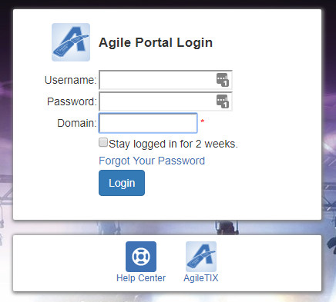

3. Click the Customer Icon on the left side of the screen.

4. To Search for an existing customer, enter the name of the customer or a Keyword such as an address, phone number, or email address. Or, if you need to create a new customer, click Add Customer at the bottom of the page.
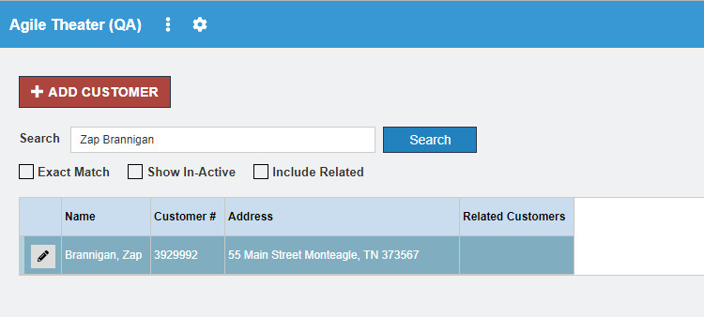

5. A list of matching criteria should appear.

6. Click the Pencil icon next to the customer name to edit.
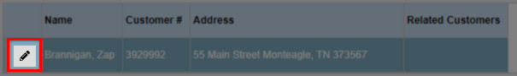

7. From this page, you are able to edit customer information by clicking on the field you want to edit.
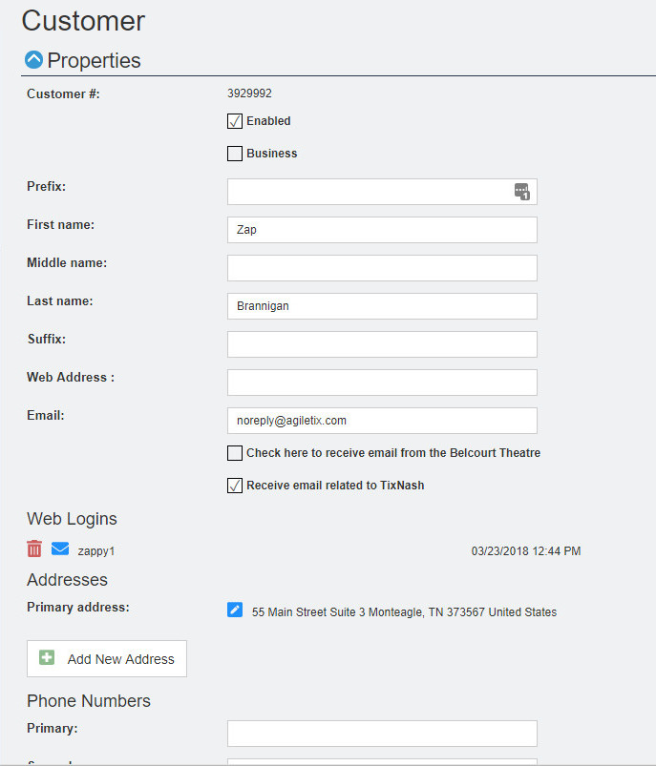

8. You can upload an image that can be used on memberships cards and festival passes. Click the upload button and select the image from your computer.
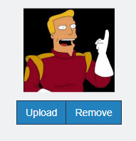

9. If the Customer does not have an online account but wants to create one, click the Send Account Create Email button to email them the account link.
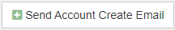

10. If they already have a Web Login but have forgotten their password, click the envelope button to send them the password reset email.
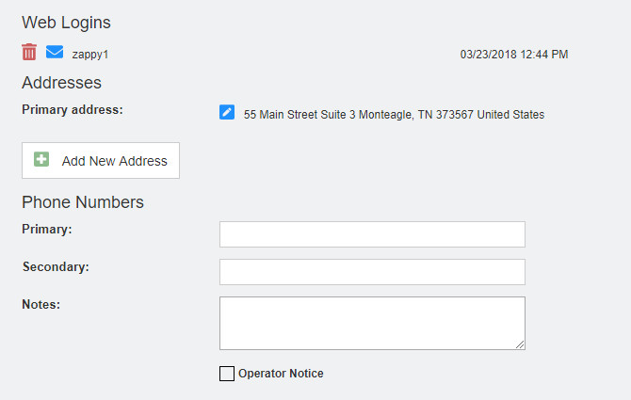

11. You can also view and edit Questions that have been set up.
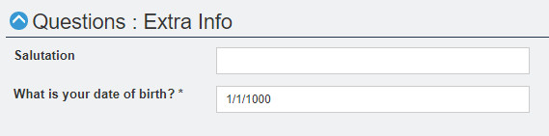

12. From this page, you can also view and add memberships. (Click to learn more about Adding and Managing Memberships in Web Portal)

13. Customer Relationships can be established on this page. Relationships can be a spouse, child, co-worker, etc. Click Add New Related Customer to search for a customer record. This ties them together as a household or contact.
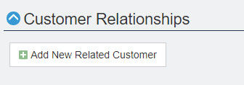
- Click the Search Bar and enter the customers' name in the search field.
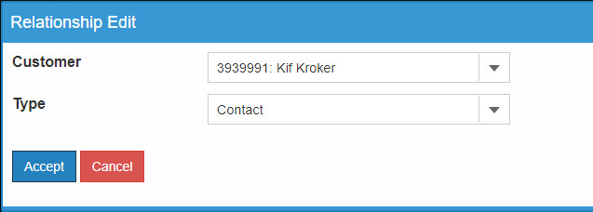

- From the drop-down, select the Relationship Type. (i.e. Contact, Sold For, or Business). NOTE: Additional Types can be added if needed. Contact your Client Support Rep for more information.
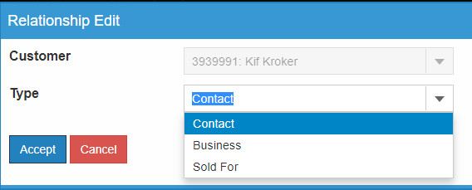

14. To assign a touch point to a customer record that you need to assign to a member of your staff, click the Add New Touch Point icon.
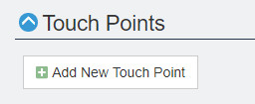
- On the Touch Point page, enter in the subject of your touch point, the type of touch point, and to whom this task should be assigned.
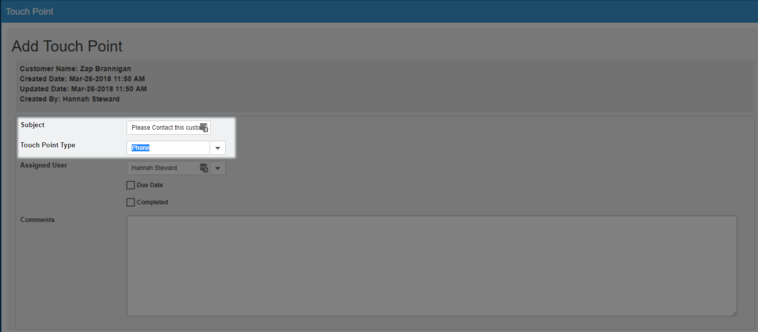

- If you want to add a due date for this task, check the Due Date box, and enter the due date and time in the box that appears.
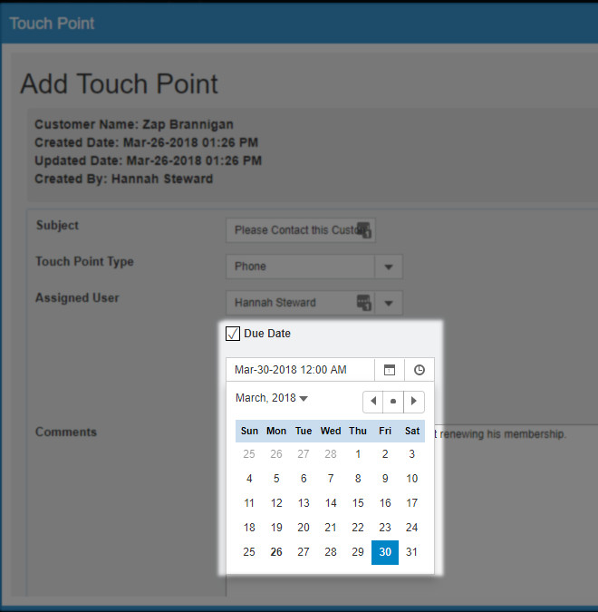

- If you have contacted this customer by the assigned due date, you can click the box next to Completed.
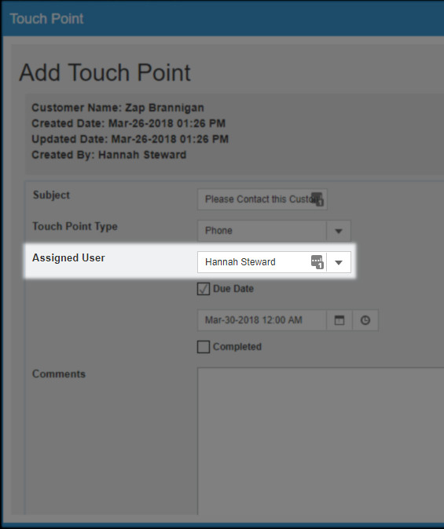

- If you have any other comments or notes to take about this customer, you can put them in the comment box under the touch point screen. Click Apply to save.
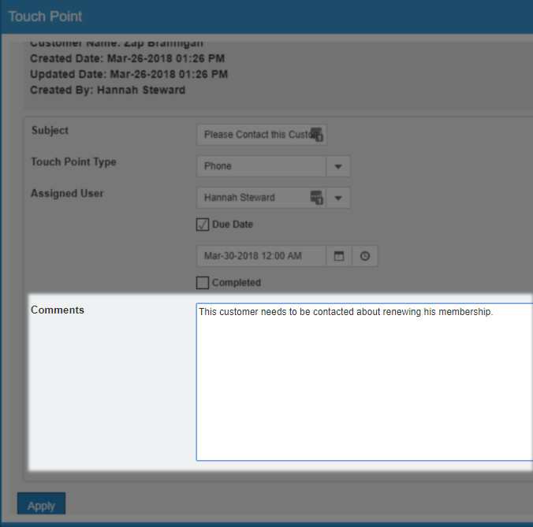
14. From this Page, you can also manage the Account Benefits for a customer/member (Click to learn how to Add and Manage Account Benefits in Web Portal).
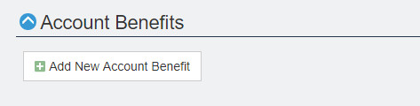
15. In Orders, you can review the order history in that customer's record along with a summary of that activity for that order.
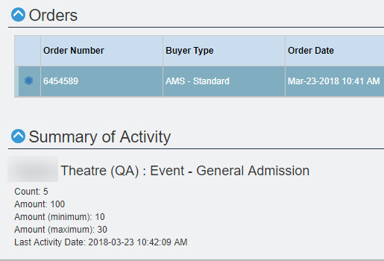
16. Once you have made all the necessary changes to the customer's record, click the Save Changes button at the bottom of the screen.
