Customer Import Instructions
Clients of Agile now have the ability to import customer lists directly into the system.
1. Log in to Administration.
2. Select the House icon .
3. Open the Customer Relations folder and select the Import button.
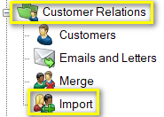
4. Select the Import Example button at the bottom of the screen.
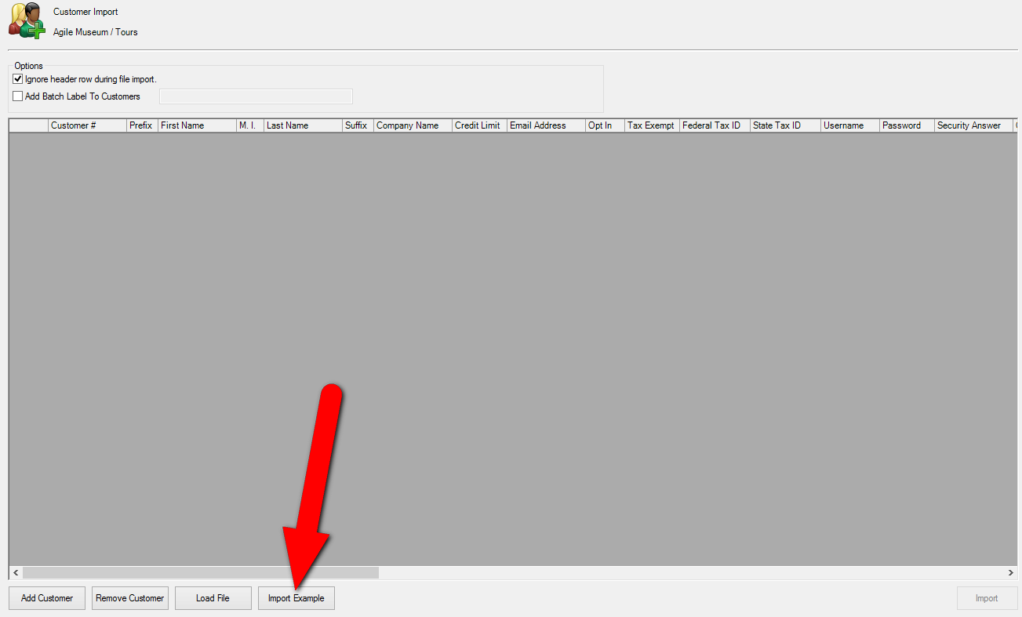

5. A pop-up window will appear. Save the Customer Import Example spreadsheet to your computer.
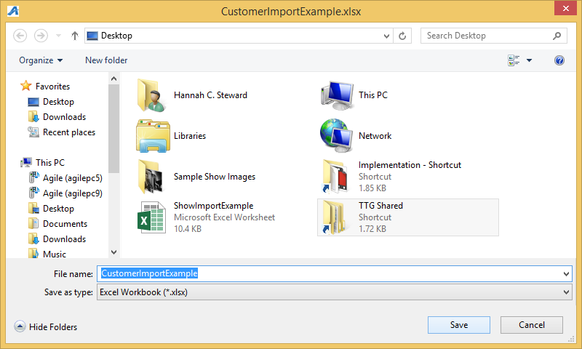
6. Open the Customer Import Example spreadsheet and fill in the information under each column.
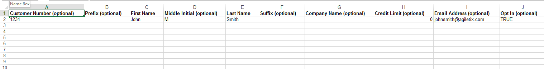
Note: Not all of the columns are required. Those that are optional are marked in the header.
You must have the information in the required fields filled out in order to successfully import your list. Once this is done make sure that you Save and Close the spreadsheet.
7. Go back into Administration and open up the Customer folder and click Customer Import.
Note: the Ignore header row during file import is checked by default. Keep this checked in order to successfully import your spreadsheet.
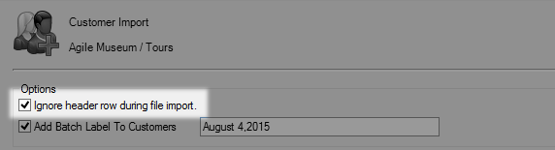
8. If you wish to add a batch label to your Customer Records check the box next to Add Batch Label to Customers then add the title of the label in the field provided.
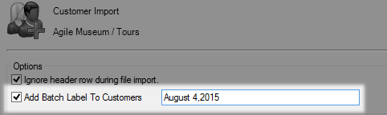
9. Click the Load File button and choose your completed spreadsheet.
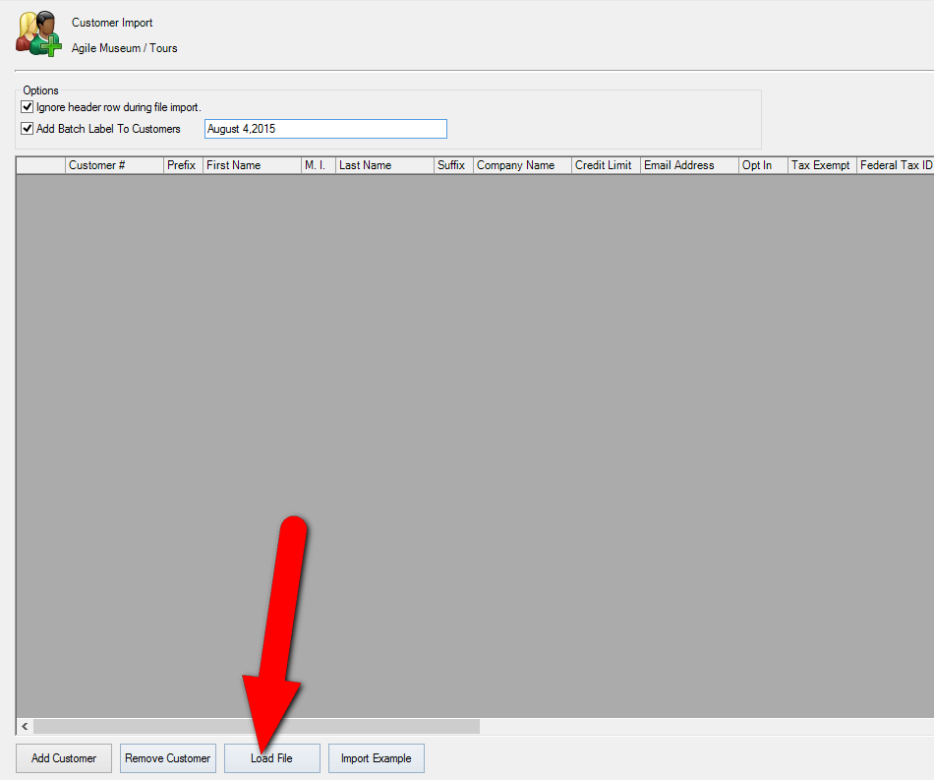
10. All your customer information will appear within the window. It is recommended to scroll through what is shown and check for any errors before proceeding.
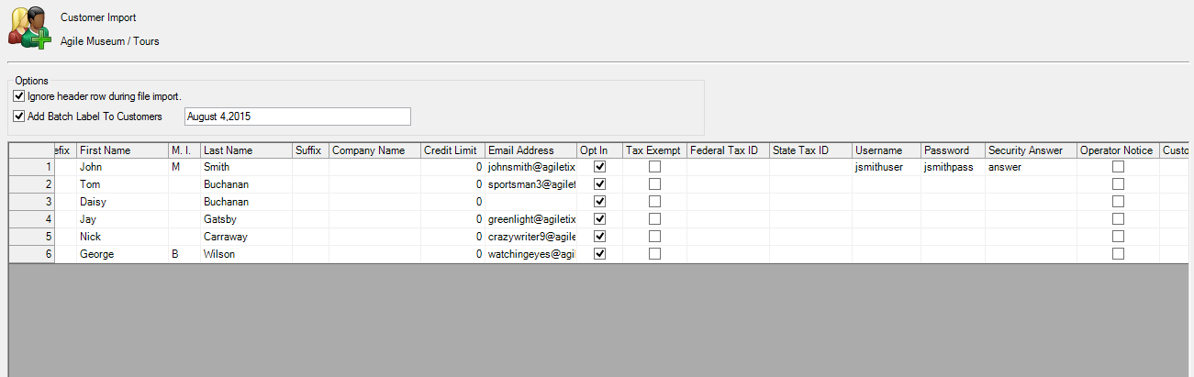
Note: If you do see any errors you can make the necessary correction on the Customer Import page. Simply click the field that needs to be changed and type in the changes.
11. Once everything is correct click the Import button in the bottom right corner.
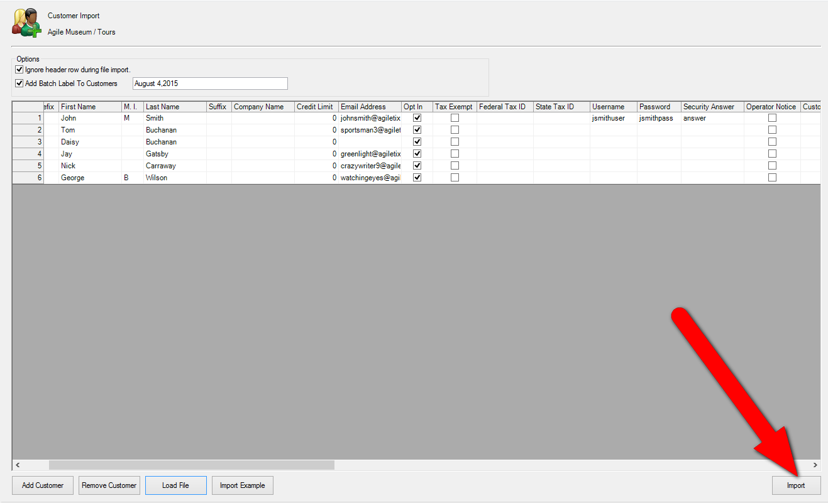

12. The progress pop up will appear.
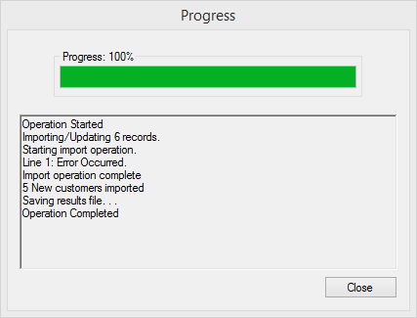
13. Once you have reached 100% the Save Import Results pop up will appear. This will tell you about the results of your import (i.e. if there were any errors or if it was successful). Save this spreadsheet to your computer for future reference.
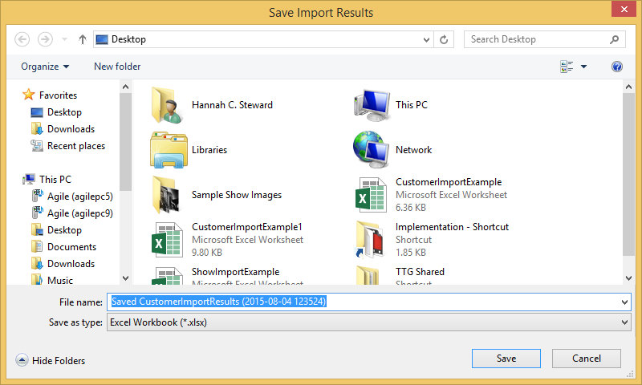

14. Now you will be able to look up the Customer records you just imported.
