Creating a Donation
1. Log in to Administration.
2. Click the House icon .
3. Open the Accounting folder and click the Donations icon.
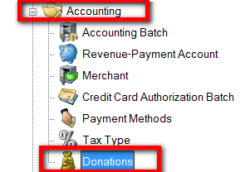
4. Right-click and select New.
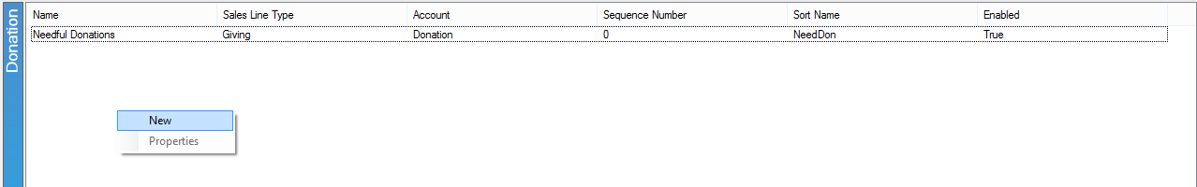
5. In the General tab:
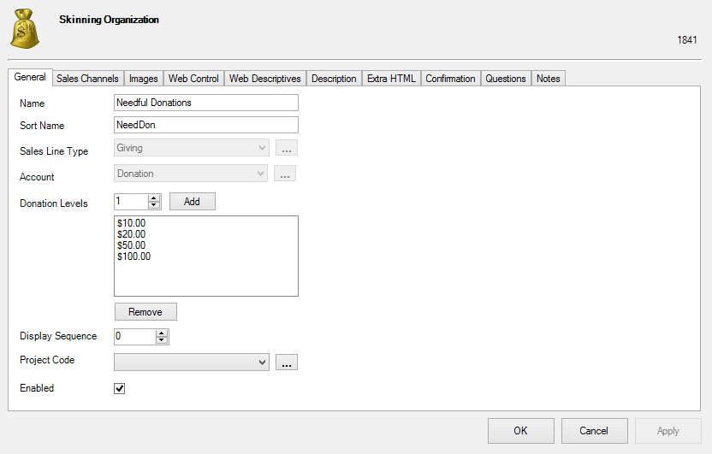
A) Name: Name of the donation. This will be visible online to customers.
B) Sort Name: Name of the donation. Donations will be sorted online with these names.
C) Sales Line Type: Either select a pre-existing type that best fits the donation from or create a new type by clicking on the ellipses.
D) Account: Either select the correct Revenue-Payment Account or create a new one by clicking on the ellipses.
E) Donation Levels: Enter in the different levels of the donation available. Click "Add" or "Remove" to edit these.
F) Display Sequence: Places the donations in a specific order.
G) Project Code: Either select the correct item from the list or create a new one by clicking on the ellipses.
H) Enabled: Make sure this is checked to make the donation available to customers.
Note: Allow 12 month pledge is an option only available to Donor Perfect clients and will allow donations to be divided between 12 months. The minimum pledge amount can also be specified.
6. In the Sales Channels tab, select the appropriate Sales Channels.
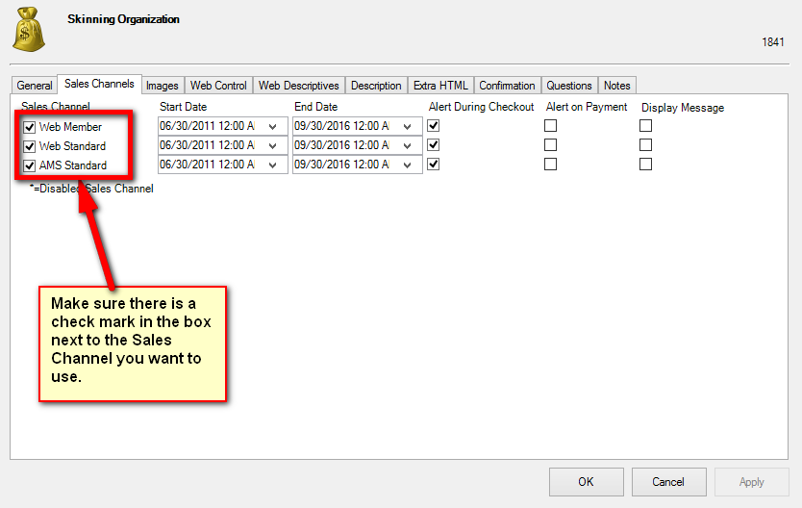
7. The Start and End Dates can be specified for a later on-sale date.
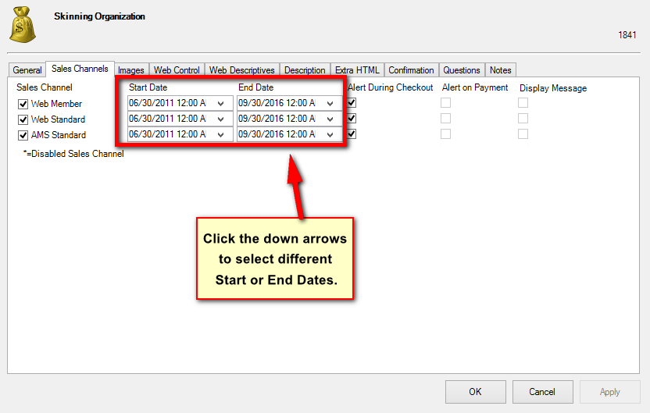
- If Alert During Checkout is selected, this will allow a prompt during AMS and online sales.
- If Alert on Payment is selected, this will allow a prompt during the final payment process on AMS and Online sales
8. In the Images tab, you are able to add an image for online viewing.
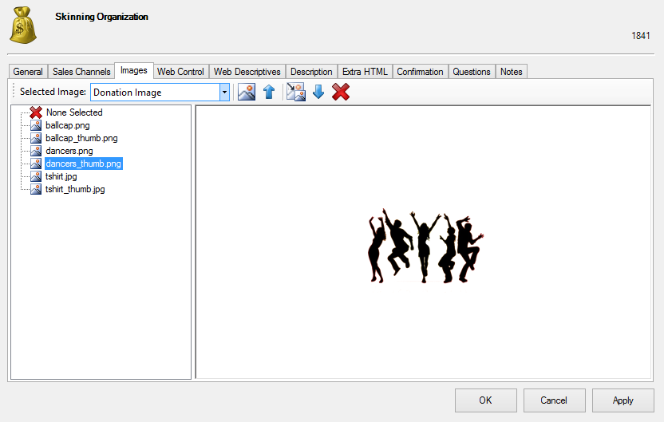
9. Web Control tab:
- "Allow Open Amount Entry Box" allows customers to enter in any amount.
- "Allow Order Round Up Box" allows the customer to round up their uneven purchase total amount by making a small donation.
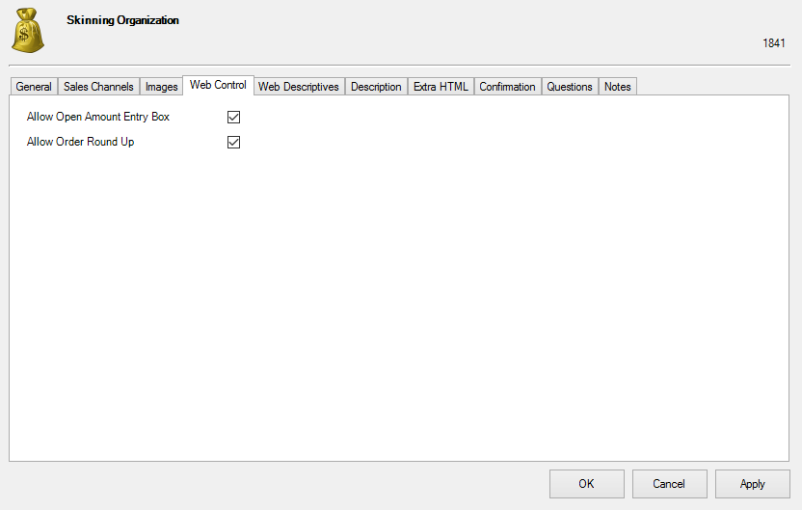

10. Web Descriptives tab:
-Secondary Text: Text in this area will be placed between the name of the donation and the Short Description on the donation page. (Some organizations put a short thank-you message here. Others choose to leave Secondary Text blank.)
-Short Description: Recommended to enter a short descriptive that will be seen under Donation Fund Name (more info will appear when longer descriptions are necessary).
-Selection Prompt: Text which appears on your web page above the dollar values.
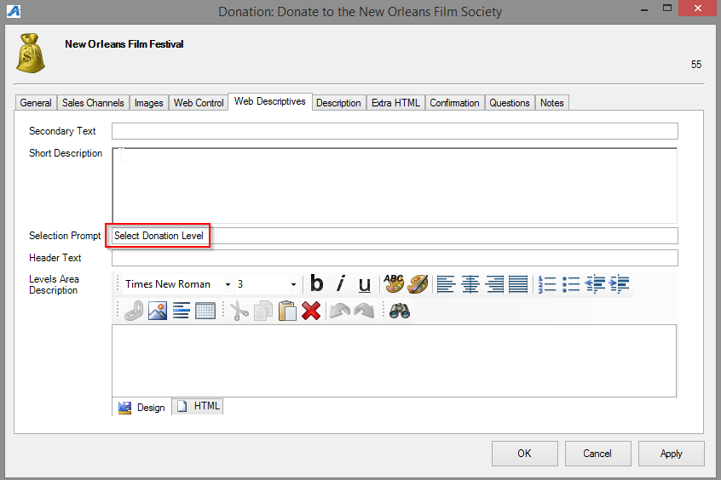
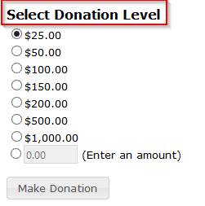
-Levels Area Description: allows you to present important information alongside Donation Levels as in image below.
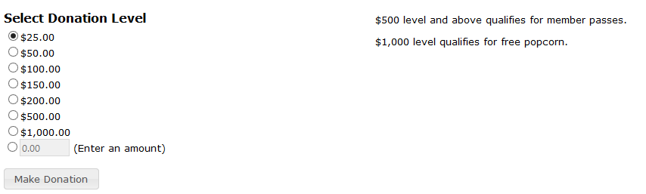

11. Description tab: enter in more information regarding the donation.
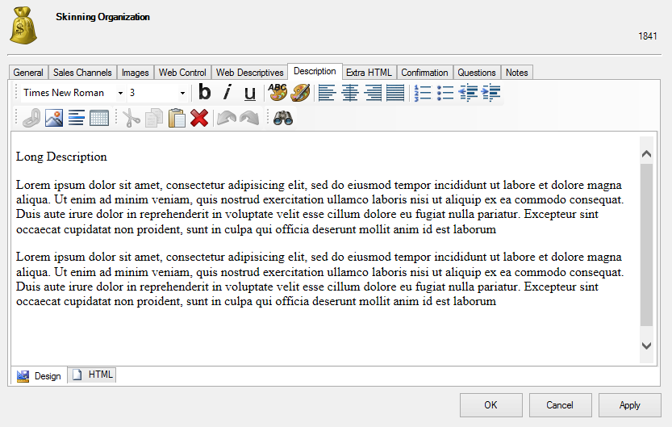
12. Extra HTML tab: can include more information about the donation.
13. Confirmation tab: include information specific to the donation that you want added in the confirmation email.
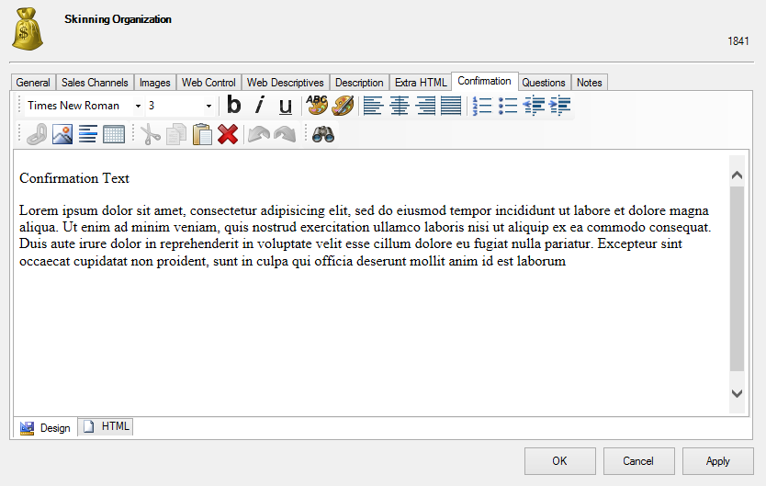
14. Questions tab: add questions in here to be asked of the customer. Move the questions from the "Available Questions" column to the "Selected Questions" column. For more information see Creating Order Questions.
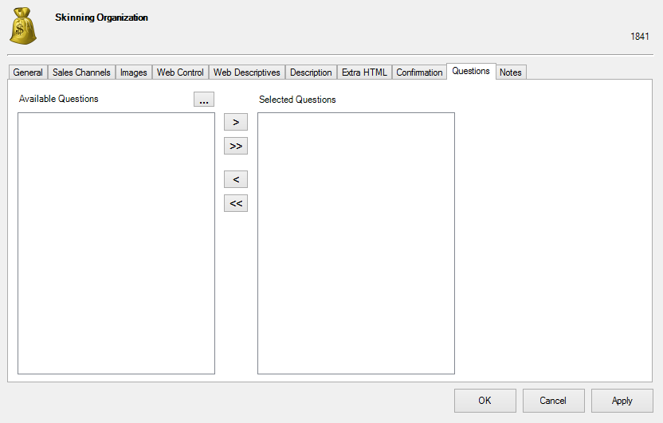
Note: The Donor Management tab is for Donor Perfect clients only. Select the correct options from the drop-downs. These items draw from your Donor Perfect items. You can add new campaigns by clicking on the green plus sign.
15. Notes tab: this area is for internal use only and will not be seen by the customer.
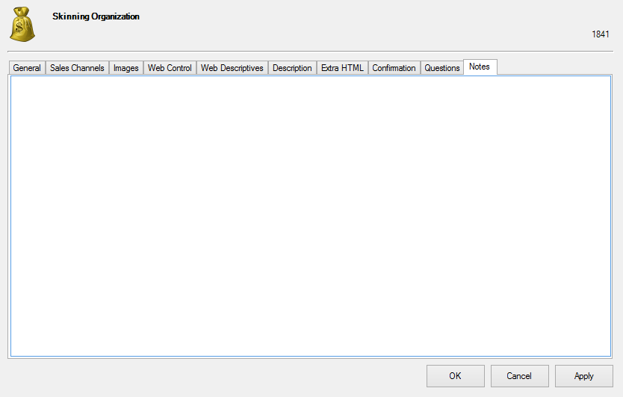
16. Once you have finished filling out the information in each tab, click Apply to save your changes and OK to close the window.

