Create an Agile List: Event/Show Entry Point
1. Login to Administration.
2. Select the Corporate Organization (the house icon).
3. Open the Web folder.
4. Select the Entry Points icon.
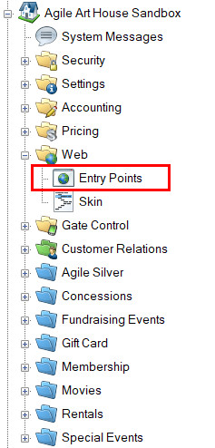
5. Highlight and select the Entry Point Group that you will be creating the URL under.
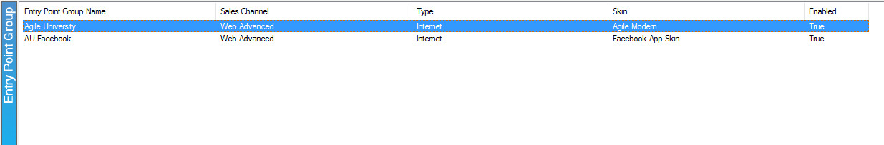
6. In the Entry Point field, right-click, select New, Agile List, and then Event/Show.
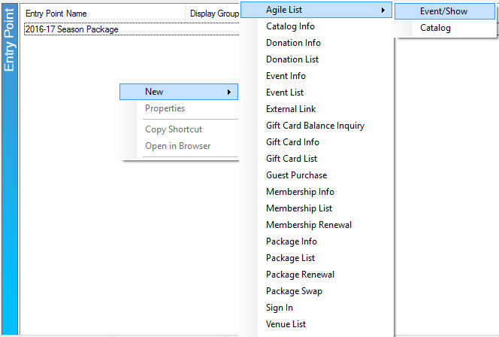

7. Fill out the following areas on the General tab (not all will be applicable to your needs):
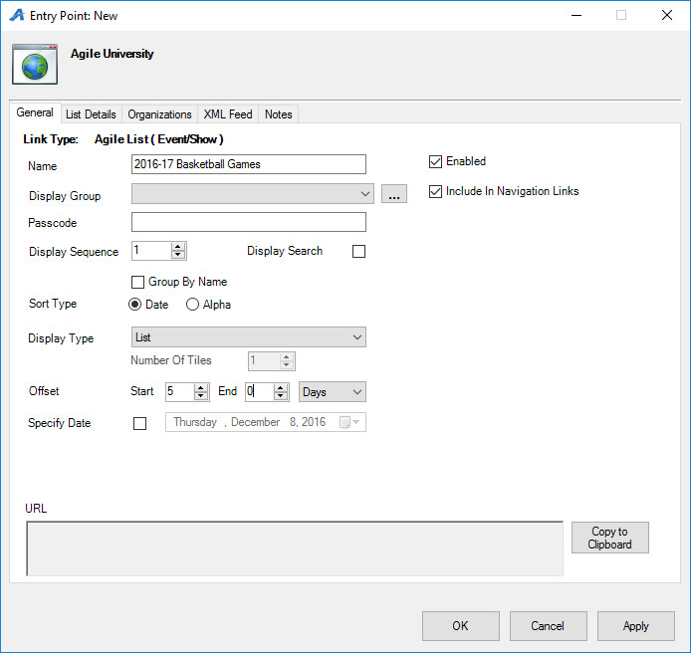
- Name the URL (remember this will show up in your navigation menu. Keep it simple).
- You can select or create a Display Group if you want it to be a part of a specific group on your navigation menu.
- Add a Passcode only if you need the URL to only be available to customers who enter the passcode. Leave blank if the URL can be accessed by the general public.
- Display Sequence sorts what order it appears in online.
- Display Search will add a search bar to the page.
- Sort Type determines how the events/shows are sorted online. Date sorts from the soonest date to the latest. Alpha sorts in alphabetical order. Group By Name allows the events/shows to be grouped together, instead of individual listings for each showing.
- Display Type determines how the events/shows are viewed online.
- Offset puts a limit on how far in the future events should be available for online viewing.
- Specify Date determines the date in which the offset will begin (if used). We recommend using this option with film festivals or a series of events that has a specific showing date. This is not recommended for a continual event/show listing (i.e. Art Houses).
8. The List Details tab gives you control over what pieces of information is listed about each film or event. Check the boxes on the left-hand side to enable the list. Filters allow the customer to sort the listings online by Custom Property (click here to learn more about Custom Properties). To enable these, select the filter(s) needed and move over into the Selected Filters column.
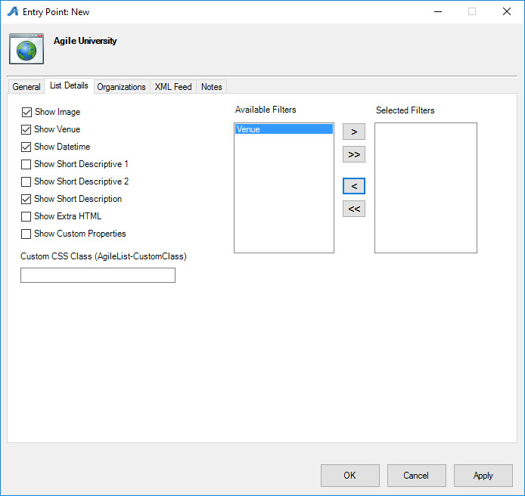

9. The Organizations tab determines which sales folder(s) appear in the list online. (Note: this may need to be updated yearly if your events/films are seasonal.)
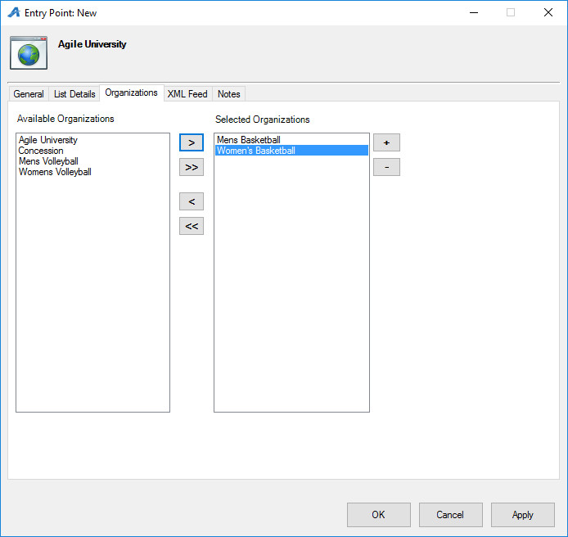

10. The XML Feed tab provides the XML Feed for your organization's website, if you choose to use XML Feeds instead of Agile pages.
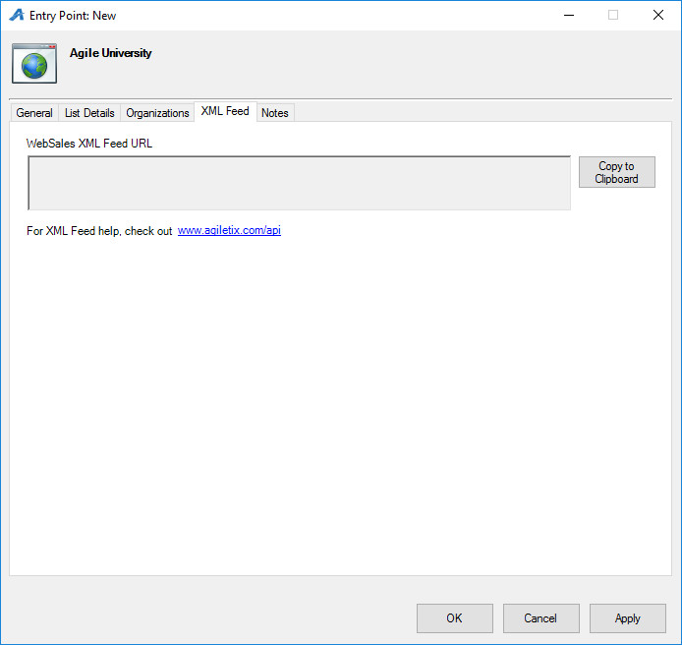

11. The Notes tab is for internal use only. We recommend adding details here about how this URL is being used.
