A Template holds Tier/Inventory and Event Price information about different ticket types and prices. It connects this information to specific showings/screens/events of a given venue. Storing this information in Template enables users to send available ticket quantities and prices for multiple showings, events, and venues to the Show/Event folder. For events/shows that occur multiple times, like a weekly or matinee discount, Template is a useful, time-saving tool. A ‘special’ event that occurs only once does not require a template, in best practice.
Part I – Creating A Template
1. Log in to Administration.
2. Select the Corporate Organization icon. 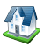

3. Select the Sales Organization folder (such as Events, Films, etc.) for which you will build the template(s). (Image 1)
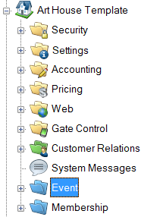
Image 1

4. Select the Template icon.
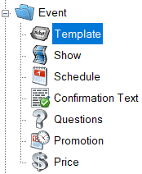

5. In the Template field, right-click and select New (Image 2)
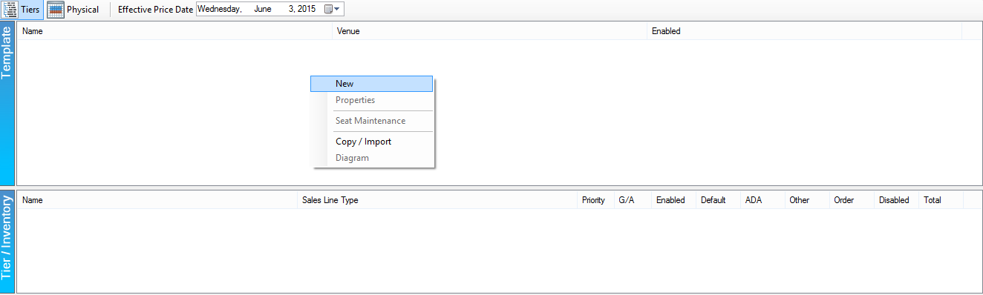
Image 2
6. The Template: New window will open to the General tab. (Image 3)
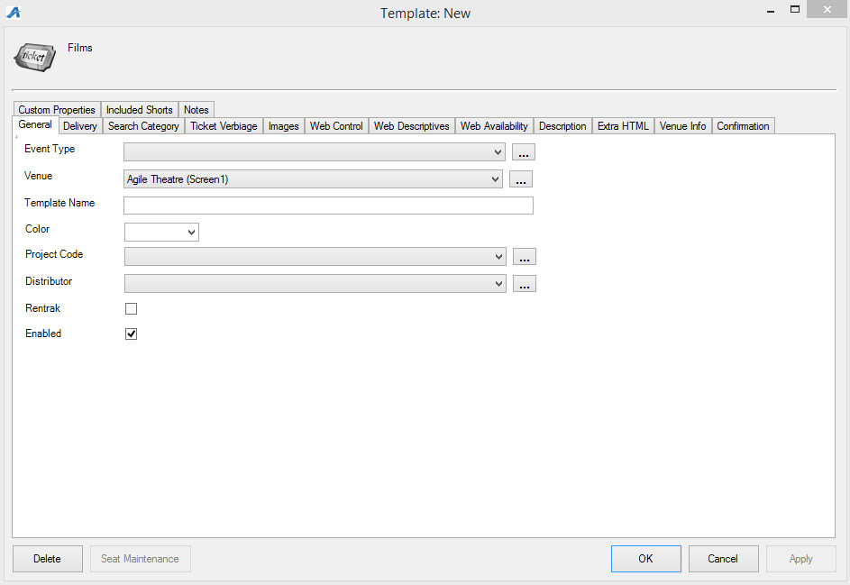
Image 3
A. Event Types - Generic names that tag the type of event by genre. Select the Event Type from the drop-down menu. (Image 4)
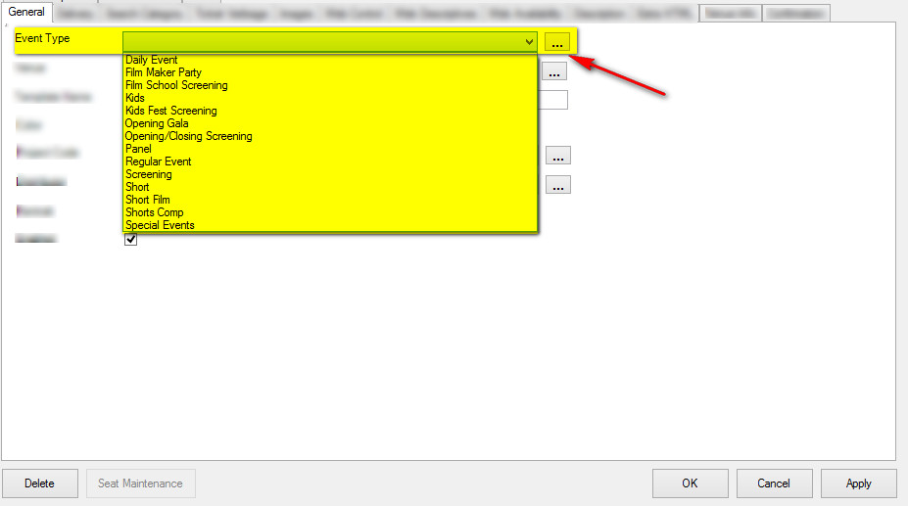
Image 4
NOTE: To add an Event Type to the drop-down list, click the ellipsis button . Type in the new Event Type in the proper field and click Add New. When you have finished adding the new Event Type to the Event Type List, click OK. (Image 5)
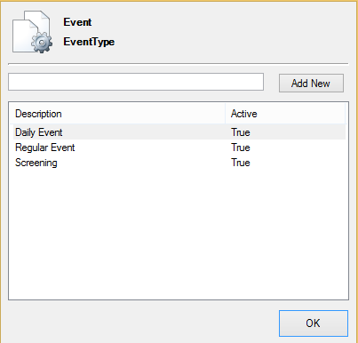
Image 5
B. Venue - This is the list of venue names that will associate the physical address of the venue with the location's directions. (Image 6)
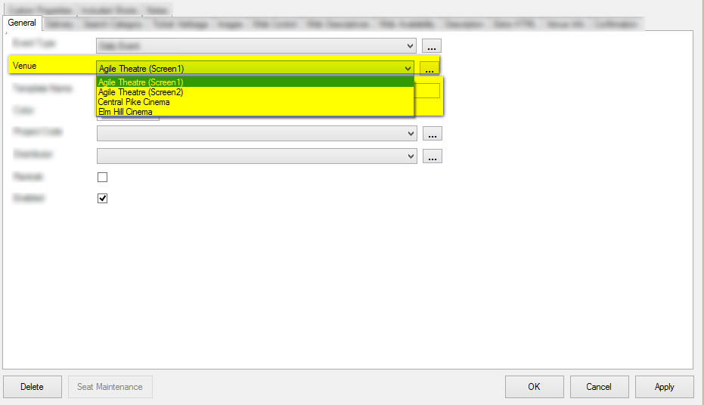
Image 6
NOTE: If the name of your Venue does not appear in the drop-down list, click the ellipsis button to add venue information. See Adding a Venue Address.
C. Template Name – This name should reflect how this template will be used. (i.e. Regular Price Movies-Theater 1, Special Event Concert Template, etc.) (Image 7)
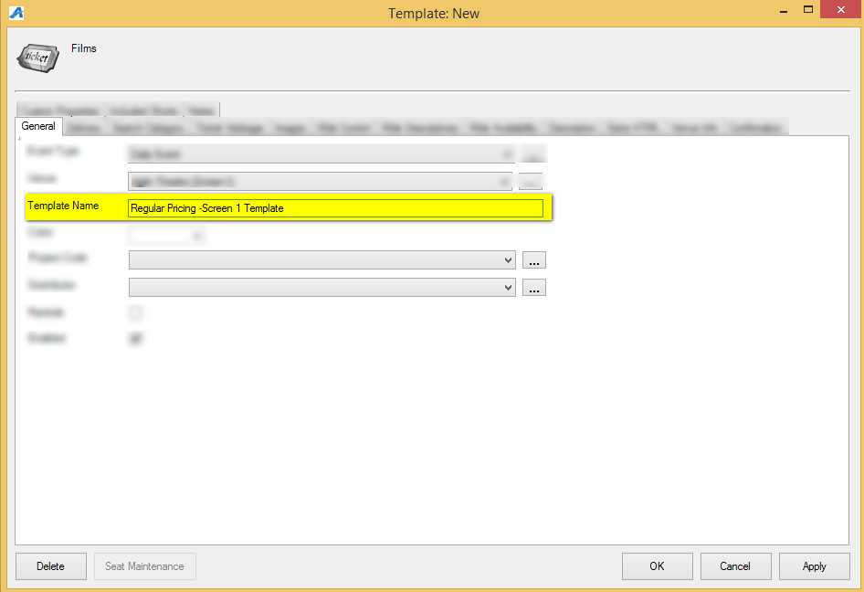
Image 7
D. Color - You can assign a color to this template that will allow you to color-code based on your needs both in POS and online. (Image 8)
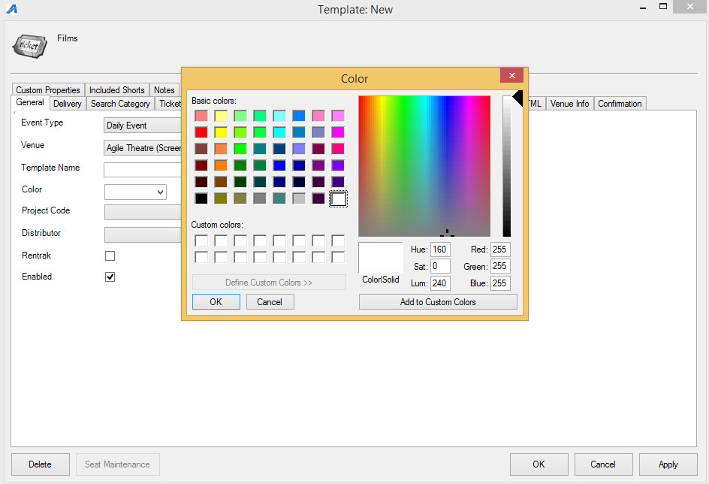
Image 8
E. Project Code - This can be a customized code that would be used for internal reporting. (Image 9)

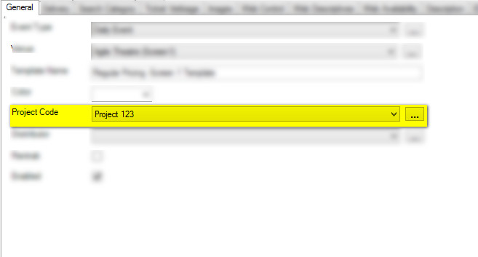
Image 9
NOTE: Distributor menu and Rentrak box do not need to be used on a Template. They can be assigned to an actual show once built, if needed.
8. Next, you will select the Delivery tab. (Image 10)
Image 10
9. Delivery Methods allow your customers to choose how they will receive their tickets. Check mark your organization’s preferred Delivery Methods. Start Days allows you to dictate to the system how many days before the event you would like this delivery method available to be available to customers. Cutoff Days tells the system when to turn this option off prior to the event. (Image 11)

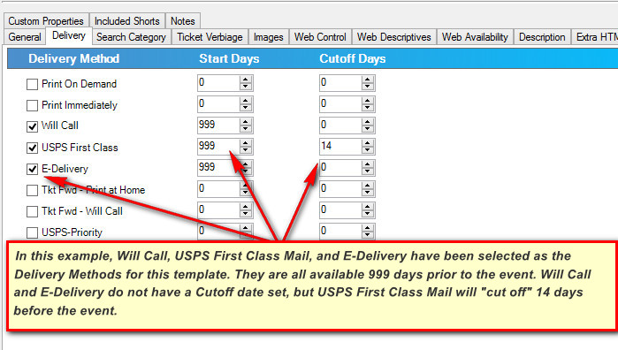
Image 11
10. Next, you will click the Web Control tab. (Image 12)
Image 12
11. In the Web Control tab, select the Ticket Search Type. The Ticket Search Type allows you to choose how the customer searches for tickets online. (Image 13)
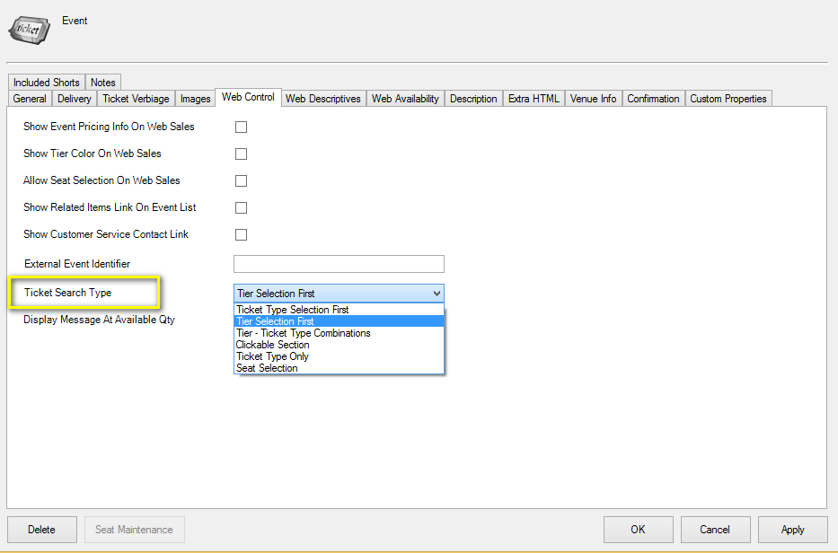
Image 13
12. If you are building a General Admission Template, you will want to uncheck the box next to Show Tier Color On Web Sales. (Image 14)
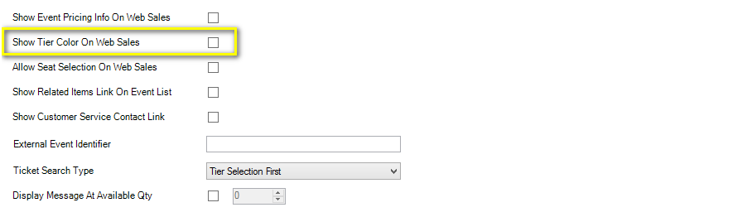
Image 14
13. Checking Show Customer Service Contact Link will allow you to publish a customer service link with Box Office contact information. (Image 15)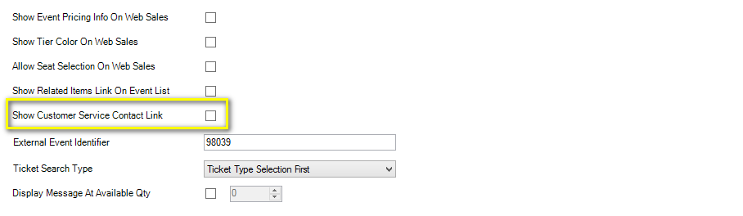
Image 15
14. Checking Display Message at Available Qty will make a display message appear when this quantity of tickets has been reached. This is typically used to show customers a specific message or piece of information once a show has been sold out. Later in this article you will learn how to create and edit this message. (Image 16)
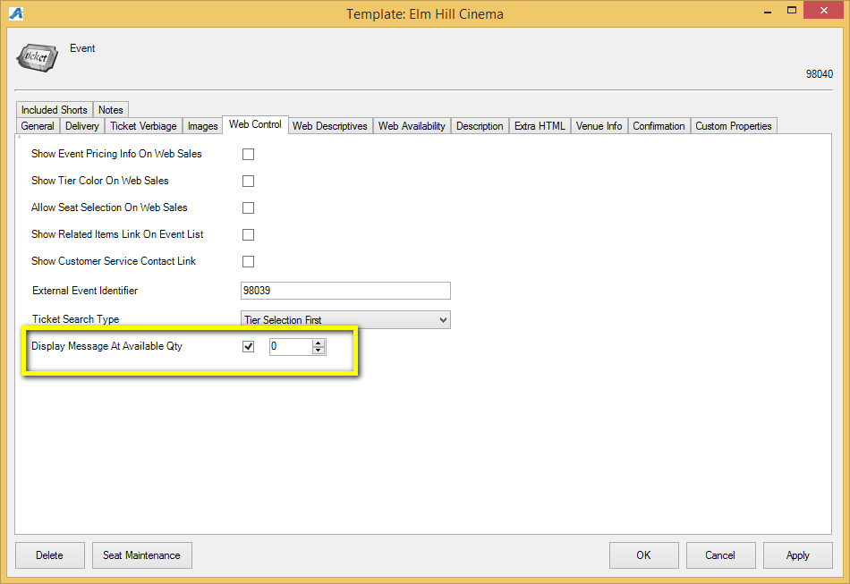
Image 16
15. Click Apply to save your changes and OK to close the window.

Part II - Creating Your Tier Inventory
16. Next, right-click in the Tier Inventory box and select New Tier. (Image 17)
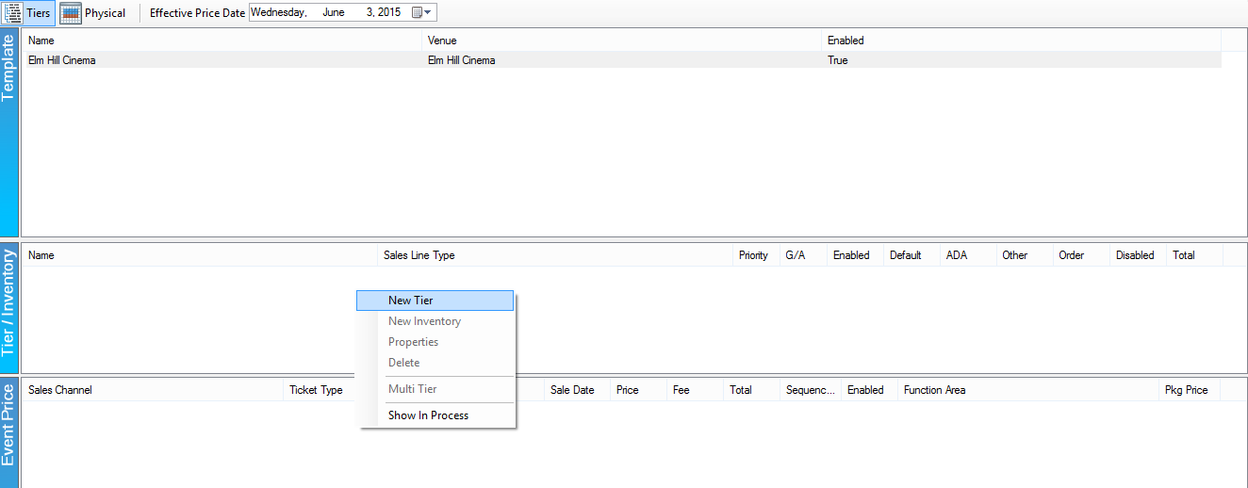
Image 17
17. From this menu you will enter your Sales Line Type. If you do not have any Sales Line Types, click the off to the side to create them. You will also want to enter your Tier Name on this screen (i.e. General Admission, balcony, etc..). (Image 18)
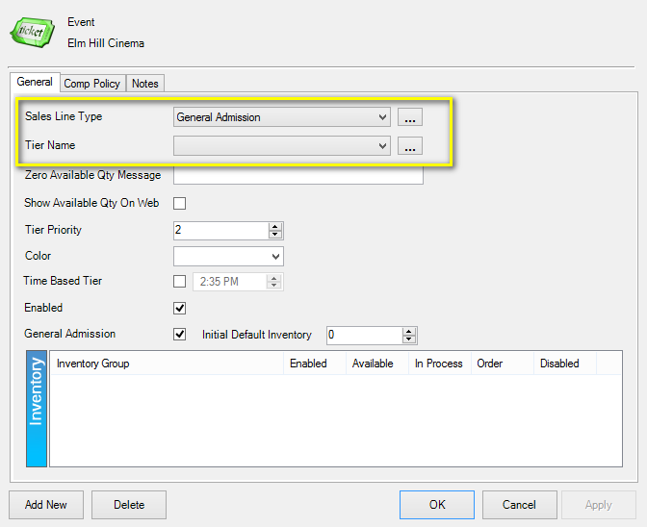
Image 18
18. In the Zero Available Qty Message box, you may enter the message that will appear if all of your seats have been sold (This is optional. There are other areas that you can display this message). (Image 19)
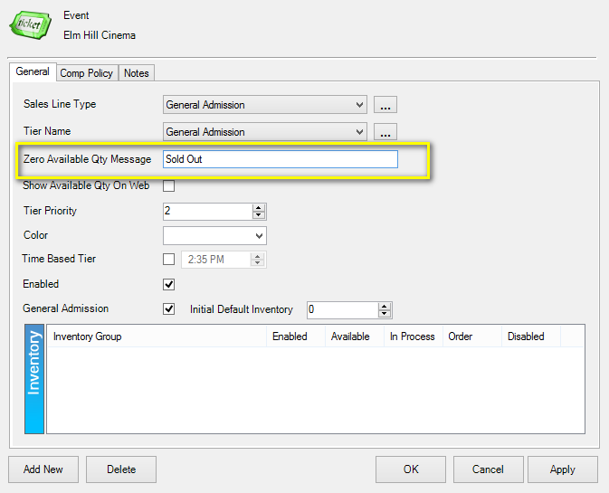
Image 19

19. When creating a General Admission tier, you will need to enter your total capacity into the Initial Default Inventory. (Image 20)
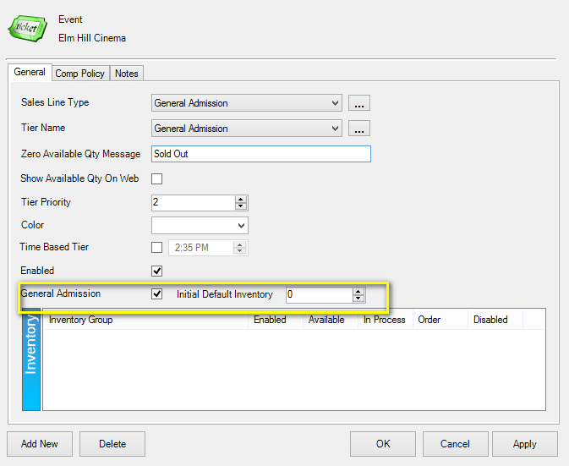
Image 20
20. If you have multiple tiers (i.e. both General Admission and VIP), you can assign a higher Tier Priority to a particular tier. You can also assign a color to any of the tiers in this screen. (Image 21)
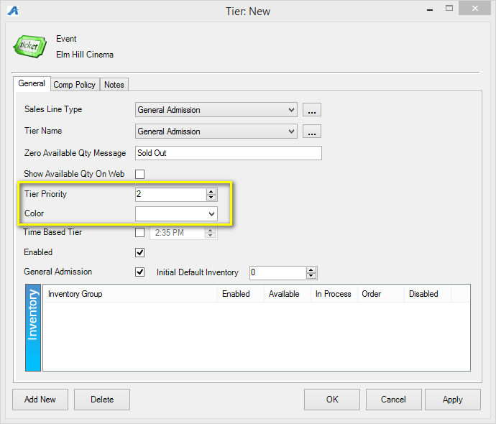
Image 21
21. Once you have completed creating your Tier Inventory, select Apply and then Ok.
Part III - Creating Prices for Your Template
22. Your next step is to create the pricing for the template. You will start by selecting the tier in the Tier Inventory box. Then right-click in the Event Pricing and select New. (Image 22)
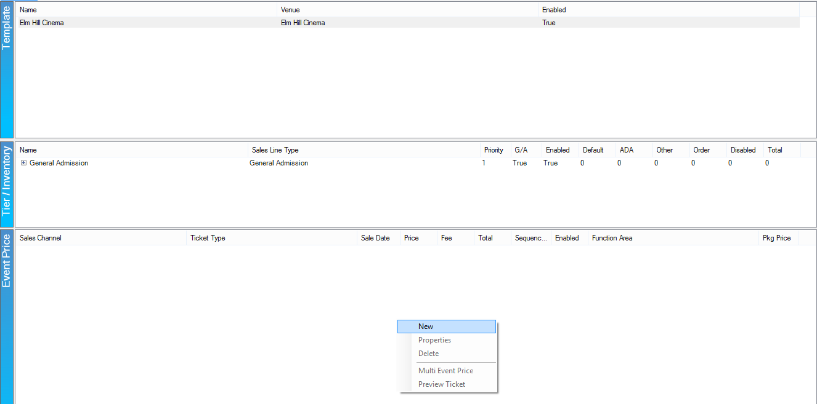
Image 22
23. In the Event Price screen, right-click in the large white box and select New Price. (Image 23)
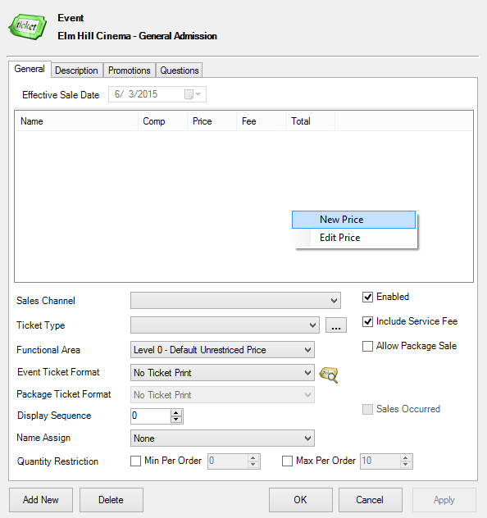
Image 23
24. Name your Price (e.g. Special Event - Adult, Template 1 - Student, Matinee Child, etc.). Then, select Apply and OK. (Image 24)
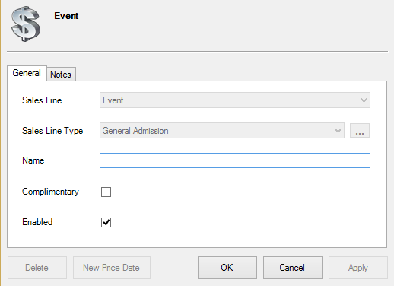
Image 24

25. You will then right-click within the Distributions area and then select New. (Image 25)
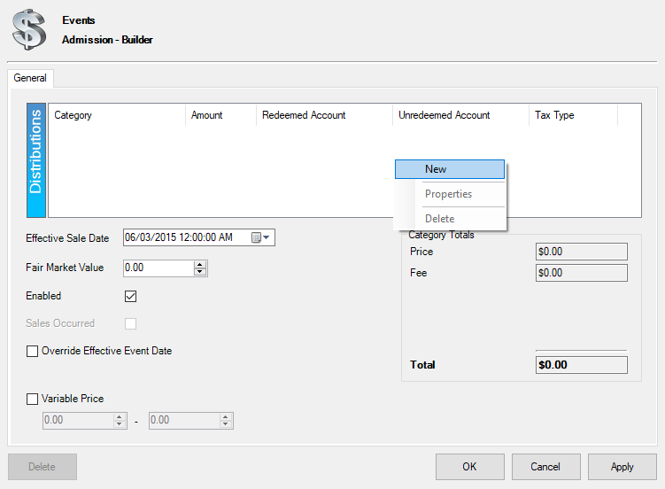
Image 25
26. You will then select your Price Category, add the price Amount for your tickets, and select the Revenue Accounts to which that price is assigned. Then, select Apply and OK. (Image 26)
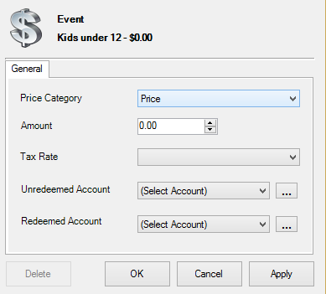
Image 26
27. If you do not have any selections under Unredeemed Account or Redeemed Account, click the and fill out all the information. (Image 26)
NOTE: Unredeemed Account and Redeemed Account are generally set up in advance with the client's accountant. If you need a new Unredeemed/Redeemed account, please check with your system administrator and/or your company’s accountant for proper distribution.
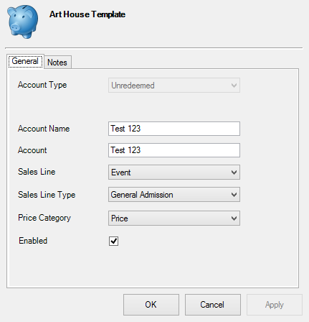
Image 26
28. Once you have filled out all of the ticket price information, click Apply and OK. (Image 27)
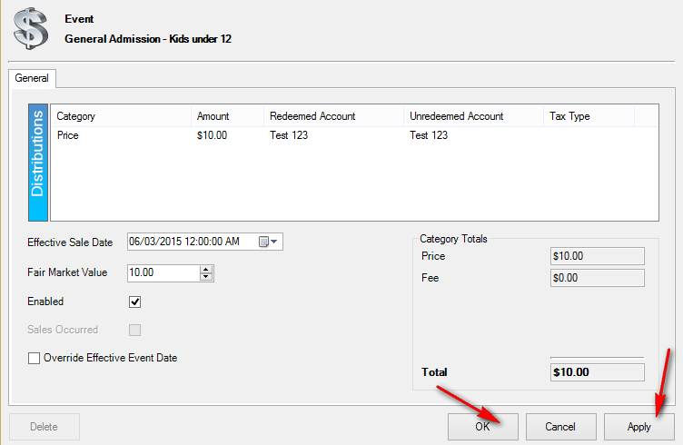
Image 27
29. On the Event Page, select a Sales Channel from the drop-down menu (i.e. Web Standard, AMS-Box Office, etc.). Add a price for every Sales Channel for which the price should be available. (Image 28)
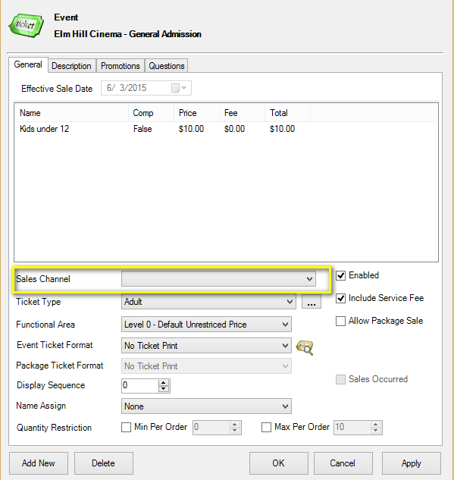
Image 28
30. You will need to select the Ticket Type. If you do not have any ticket types, select the and add them. (Image 29)
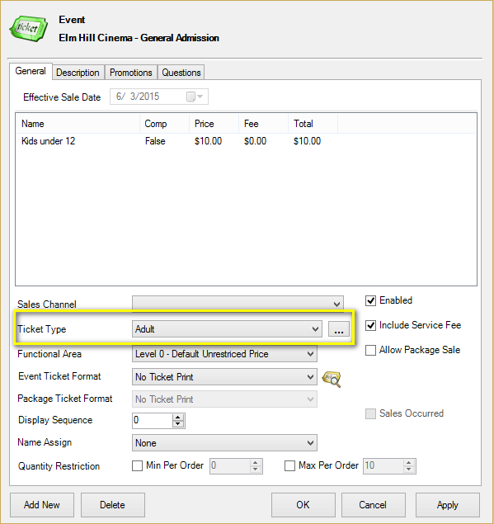
Image 29
31. The Functional Area determines who has the ability to sell or buy these tickets (i.e. Level 0 - Default Unrestricted Prices are available for everyone to purchase, but Level 1- Restricted Price(s) are generally hidden from view unless a permission or benefit is set for purchase). (Image 30)
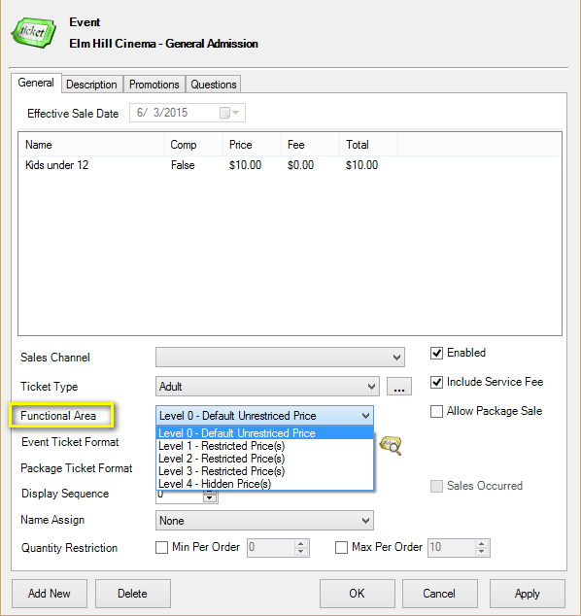
Image 30
32. Select the Ticket Format and Display Sequence. (Image 31)
NOTE: Ticket Formats are preset formats that select information to print upon the ticket. Display Sequence allows you to determine in what order the list of prices appears on the Box Office screen and online.
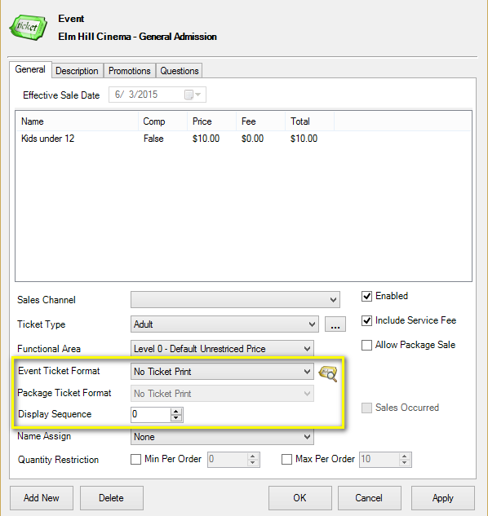
Image 31
33. Click Apply to save this price. If it needs to be available on another Sales Channel, click the Add New button and select that Sales Channel. Then, click Apply. Do this for all pricing that needs to be built. Once you have built the price on every relevant Sales Channel, select OK.
Once you have added all your pricing to your template, you are ready to create individual events and showings.

