Building a Package

Packages allow you to bundle multiple events together as one item so that the customer can purchase all the items for one price.
1. Log In to Administration.
2. Choose the Sales Organization folder where you wish to build the Events and Package.
3. If your Sales Organization folder does not have the Package option listed, you will need to add the option in Tree Management.
- Right-click your Sales Organization folder. In the new window, select the Tree Management tab.
- Checkmark Packages. Select Apply to save your changes and OK to close the window.
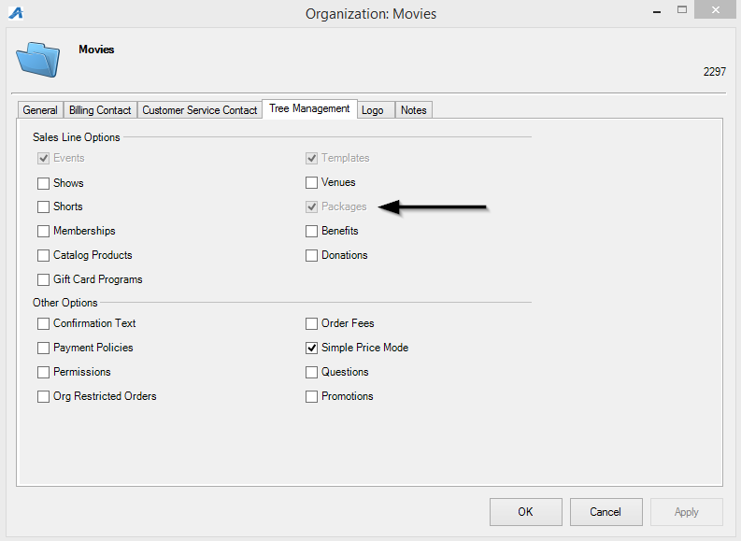

4. Individual Shows or Events must be built first and must include prices that Allow Package Sale.
- Prices can be built with a dedicated package Ticket Type or on the regular event price if the price correlates with the total sum of the package prices once bundled.
- The Price can be built with dollar amount split across all events or made as $0 and build the package price as a Catalog Component later in the process.

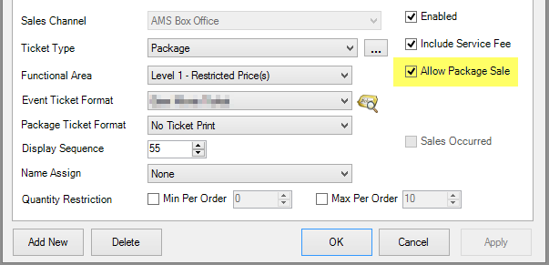
Once you have all your individual shows, events, or items built, you are now ready to start creating your Package with the Components.
5. Click the Package icon, then right-click and select New.
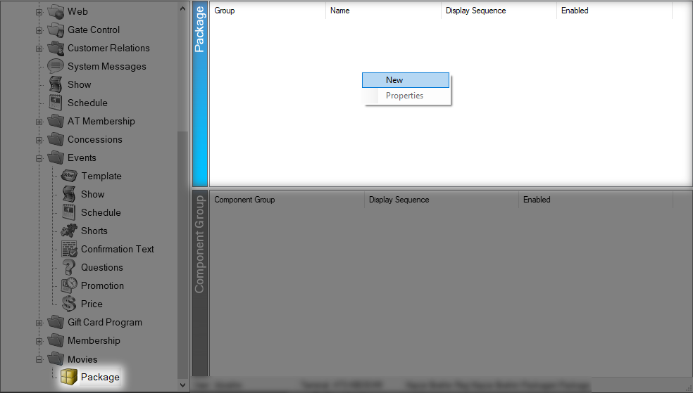
6. Select the Package Group from the drop-down. Enter the Name and External Name of the package. (External Name is what will appear online; Name is what will appear in AMS).
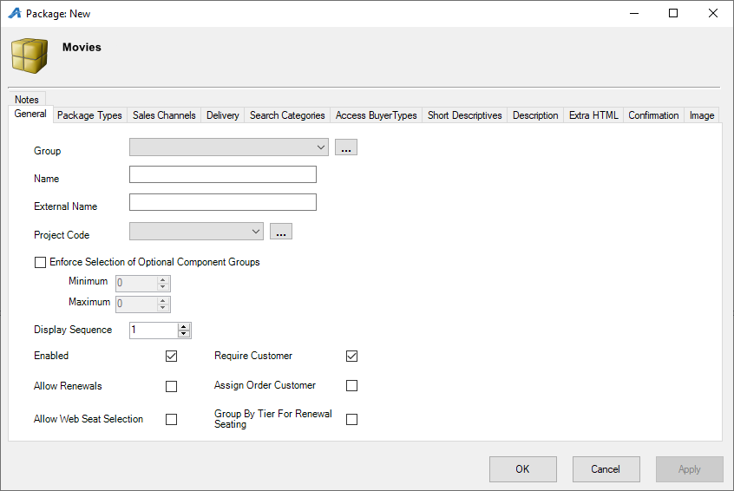
- The Enforce Selection of Optional Component Groups allow you to sell a package when not every event is required but do require a certain number of events to be picked to make the package. Make sure to set the Minimum and Maximum to use this feature.
- Allow Renewals should be check if this package is being renewed year after year.
- Require Customer should always be checked when selling a package in order to store important customer data for the multiple events.
7. The Package Types tab is where you will build the package names and create the Marketing Price. Note: the marketing price is only for display. The price of the Package will be calculated with the individual Event Component prices or by the Catalog Component. (Image 5)
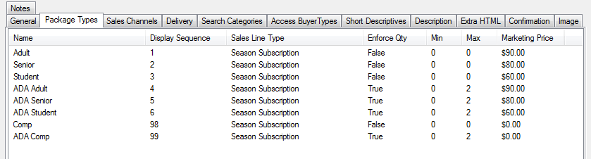

If you are unable to select the Sales Line Type when trying to create a Package Type, please contact your Agile Support Agent.
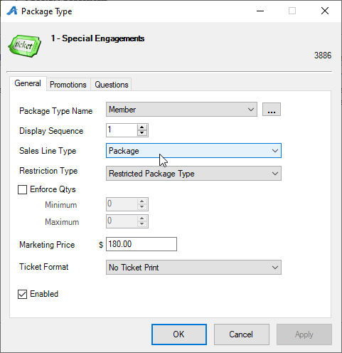
8. Click the Sales Channels tab to set the package on sales dates and times.
9. Click the Delivery tab to choose delivery options for the package.
10. Access Buyer Types allows you to choose the different buyer types that will be allowed to sell this package. (This is a required function.)
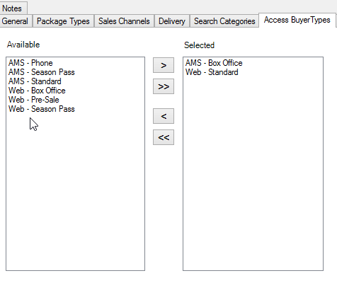
12. The Short Descriptive tab is where you will be able to put a short synopsis or description of what is available through this package.
13. The Description tab is where you will place a longer description about the package.
14. The Extra HTML tab allows you to add a long description information for this package.
15. The Confirmation tab is where you can add any information that you would like the customer to know when they complete the order (i.e. Thank you for purchasing this package. Season Packages will be mailed on 1/1/2222).
16. Click the Image tab to upload any marketing image for the package.
17. Once you have your Package information completed, click Apply to save your changes and OK to close the window. Then, right-click in Component Group and select New to add the individual components to the package.
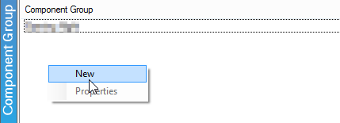
18. Name the Component Group. (i.e. Show 1)
19. Set the Enforce Component Quantities (if needed) and Display Sequence for this Component Group.
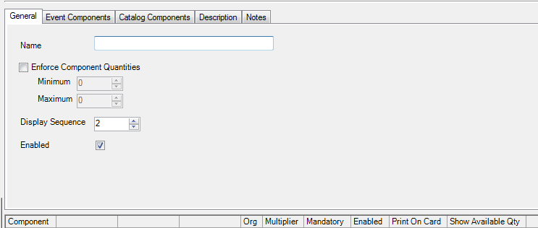
20. Click Apply to save information on the General tab.
21. Click the Event Component tab to define your package:
- Select Sales folder containing the single events
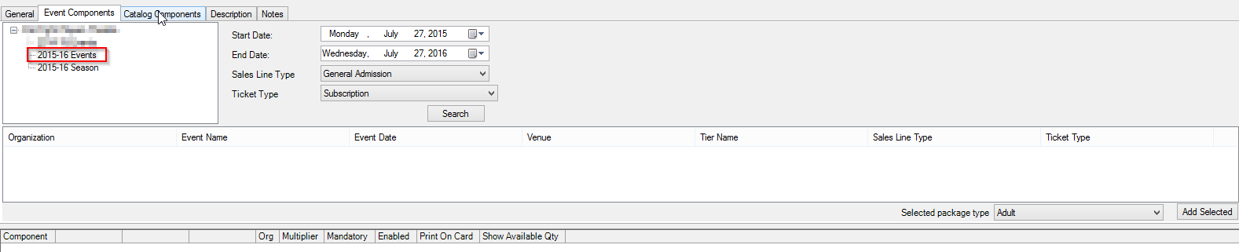
- Use Start Date & End Date of the individual events to search for events within those dates.
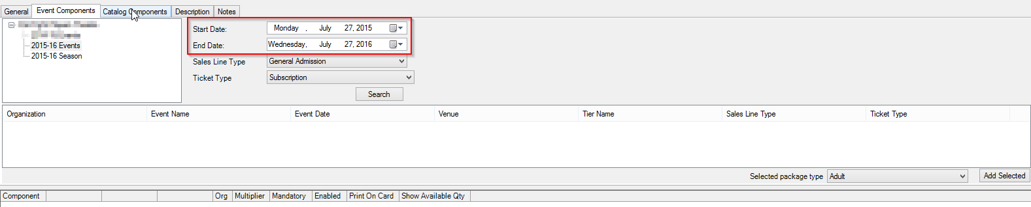
- Select the Sales Line Type from the drop-down menu.
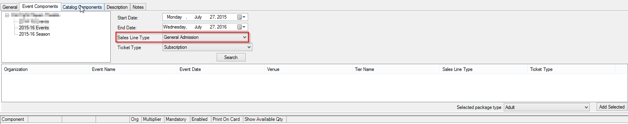
- In the Ticket Type drop-down, select the ticket type associated with the package price
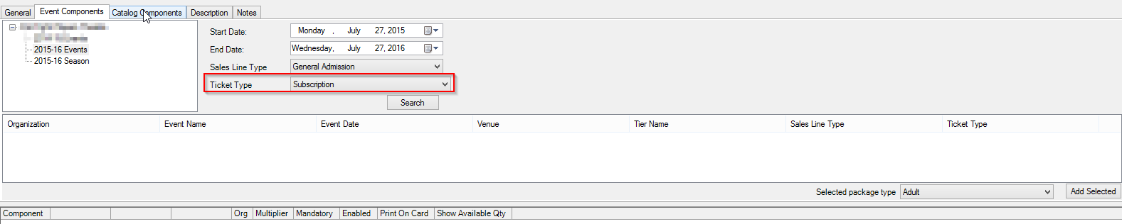
- Click the Search button to populate the list of events with that ticket type.
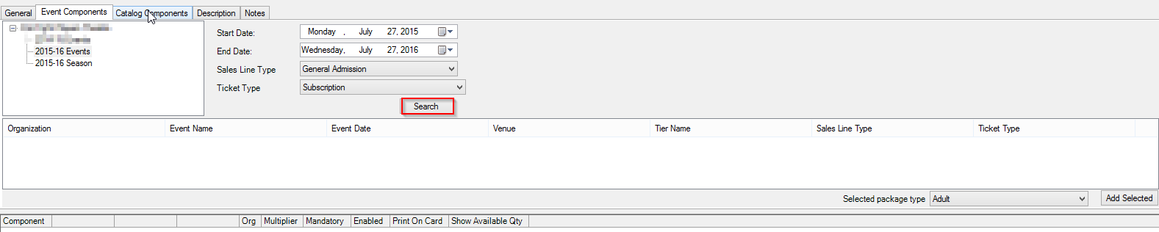
- Select each of the events that will be bundled in this Component Group.
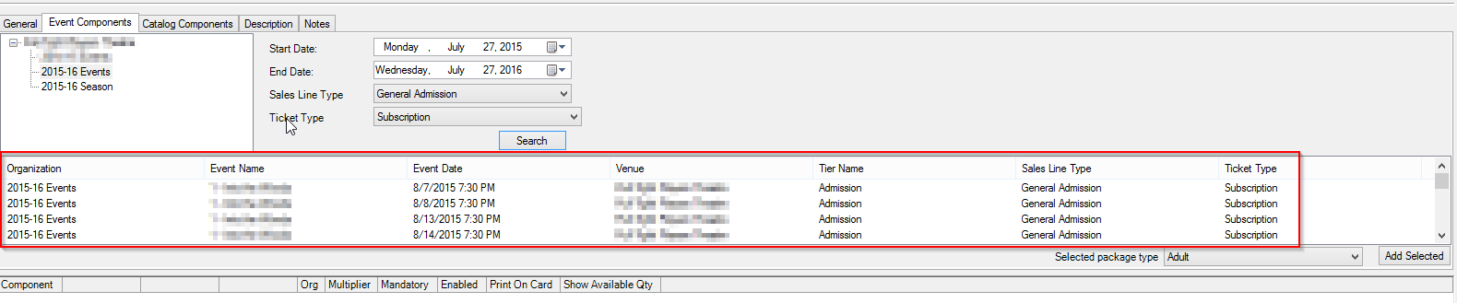
- At the right side of the event list, choose the Selected Package Type from the drop-down menu and click the Add Selected button.
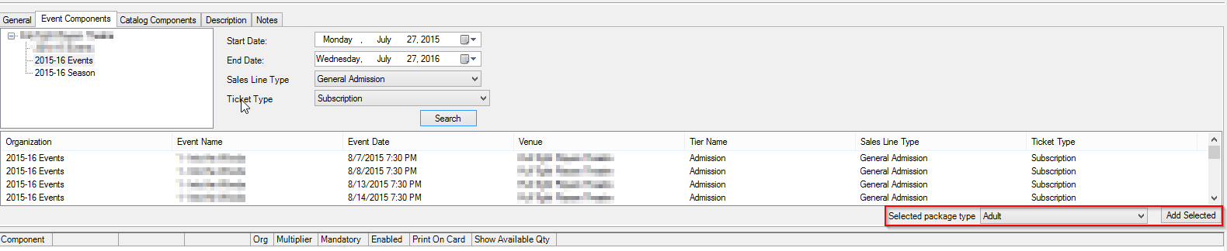
- The Package Type and the Event Component Ticket Type will appear in the Component table.
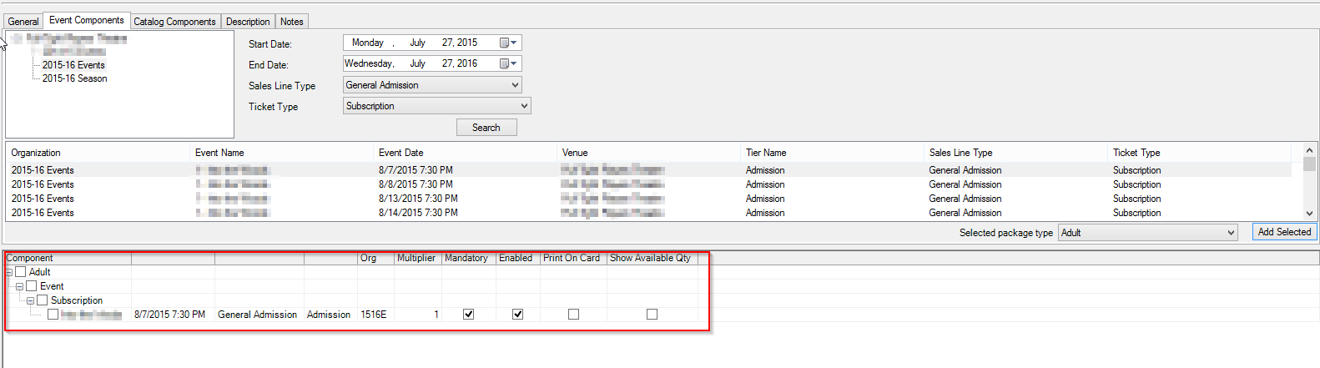
- Select Apply to save the changes. (If you want to see the pricing for this grouping and each sales channel, choose the Buyer Type from the drop-down next to Show Prices for.
- If you made a mistake and need to delete a component, checkmark the box next to component and Click the Delete Selected Components button.)
*Skip to Step #24 if not using the Catalog Component feature*
22. A Catalog Component can be added to be included in package. Click the Catalog Components tab and select the Sales Line Type and the Catalog Product Price Type to search for the items.
23. At the right side of the item list, choose the Selected Package Type from the drop-down menu and click the Add Selected button.
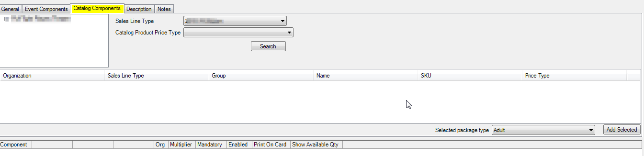
24. Once you have added all the components, you are now ready to place your package on sale.
Create an Entry Point to place your package on sale on your website. See How to Create a Package Entry Point.

