Scanning and Selling Tickets with AgileTIX Application

The AgileTIX scanning application is currently offered only on iOS devices.
1. Visit the Apple App store. Search for AgileTIX and install the application.
2. Select the AgileTIX icon on your device.
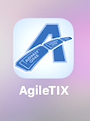
3. Login to the Application using your Agile Ticketing Solutions Username, Password, and Domain.
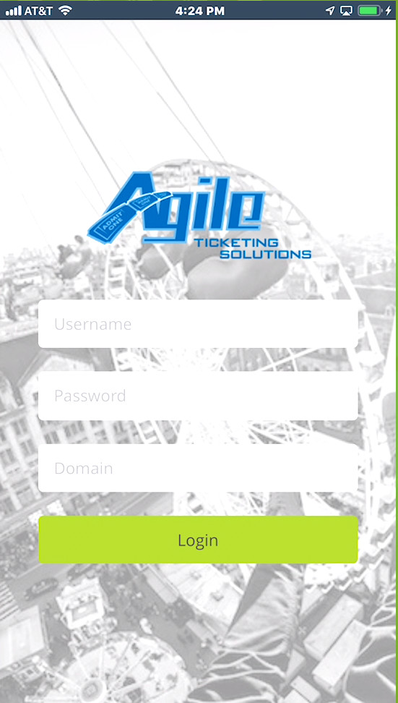
4. Once logged in, you will see a list of scan batches. If the batch is already attached to a specific event, you will be presented with the scanning screen. If the batch you select is a "Daily Batch," you will be presented with a list of all Events/Showtimes that fall within the batch's range of days. In that case, you should either select the "All Events" option or one of the specific Events or Showtimes for scanning.
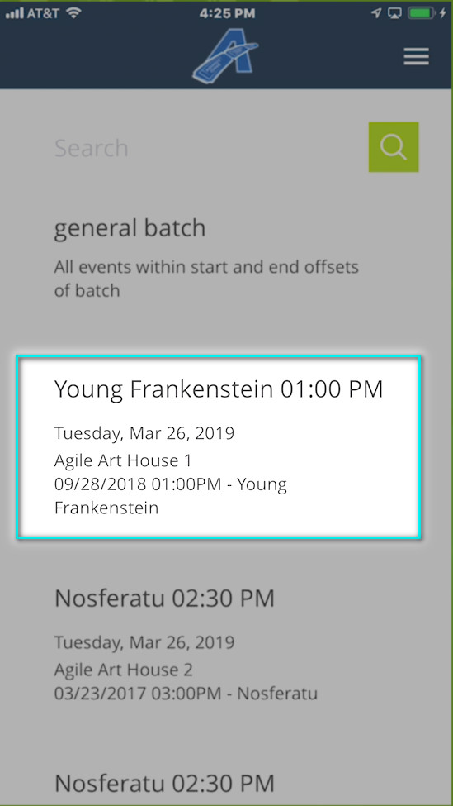
5. To scan tickets, select the Press to Scan button.
If you are using only an iPod, iPad or iPhone, the camera will open, and you will be able to scan any barcode or QR code on the tickets.
If you are using a Linea Pro scan device, you will be able to use the scanner by pressing the "Press to Scan" button or the button on the right side of the device (You might have to press the button on the right of the device the first time to wake up the scanner before being able to scan).
6. Tickets that are valid will show a green "Tickets Valid" message on the device.
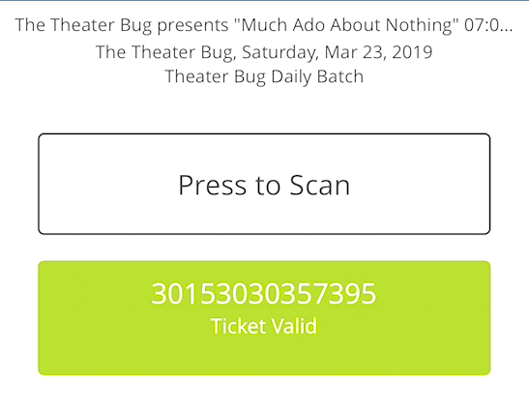
7. Tickets that are not valid will show you a red "Ticket Not Valid" message on the device.
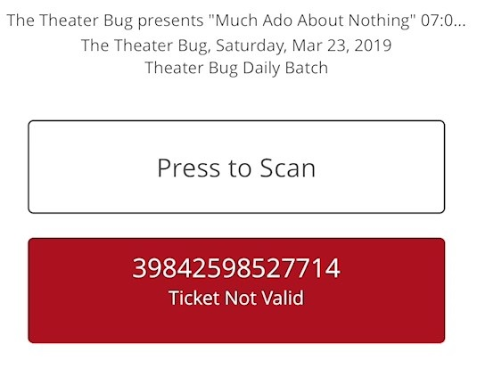
8. If you are going to sell tickets through the device, select the ticket icon at the lower-right corner of the screen. If the ticket icon is not enabled, there might be additional setup to do in the Agile Ticketing Solutions administration system to enable device-based purchasing.
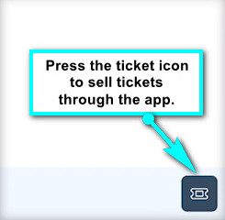
9. You will then see the event title at the top of the screen and the prices that are available to purchase for that event. (NOTE: At this time, selling tickets through a device is only available for General Admission events.)
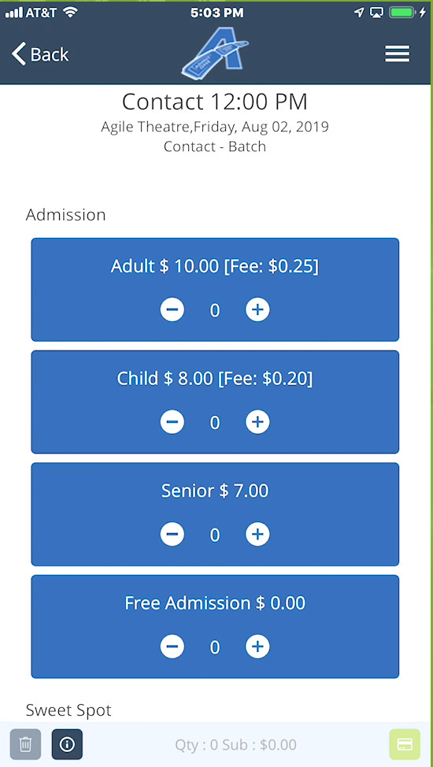
10. Use the plus symbols to add the number of tickets of each type which the customer wishes to purchase. If necessary, use the minus symbols to remove tickets from this stage of the order.
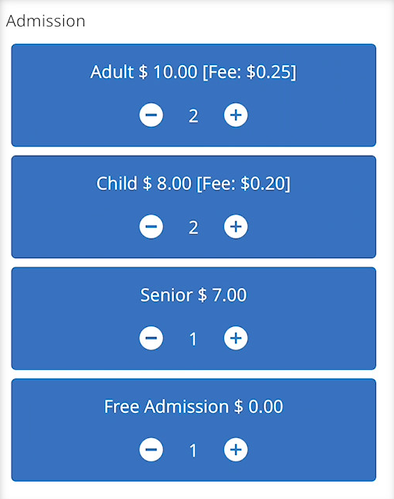
11. You will see both the number of tickets you have chosen and the subtotal of the order at the bottom of the screen.
12. When you are ready to process the payment, select the Green Payment icon in the lower-right corner of the screen.
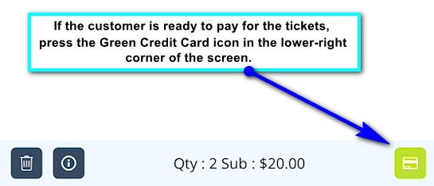
13. The device will then tell you when it is ready for you to swipe a card. To process credit card payments, either a Linea Pro or iMag II MSR device will be required. Swipe the card to process payment. Or, select "Cash" for a cash sale.
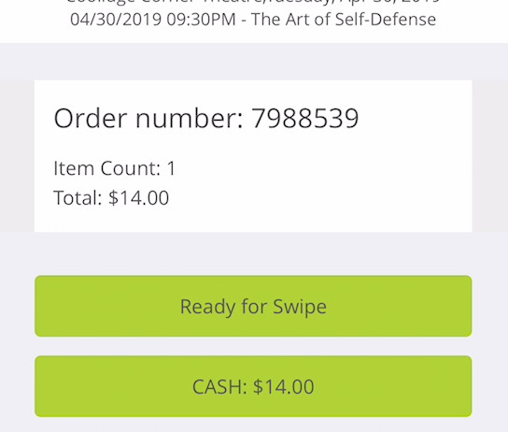
14. Once the payment has been processed, you will return to the main screen for sales.
15. If the customer would like a receipt, select the menu in the upper-right corner of the screen.
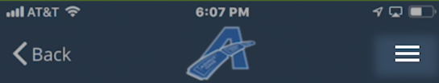

16. Select Recent Orders.
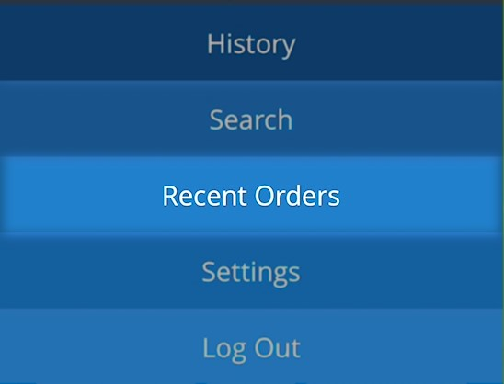
17. You will see the list of orders that you have completed. Select the @ symbol on the right side of the order information.
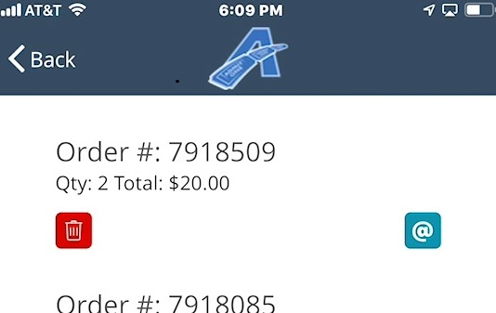
18. A pop-up field will open for you to enter the customer's email address.
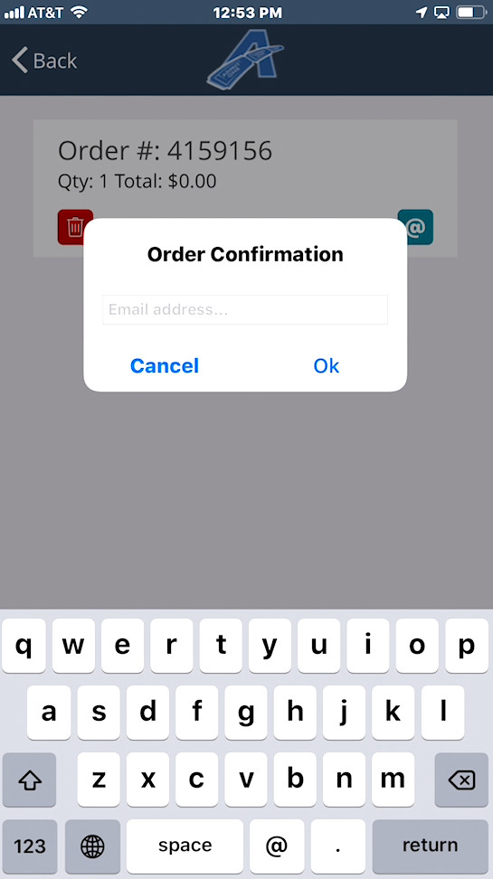
19. Select OK. An email will be sent to the customer.

