Creating a Gate Control Batch
1. Log in to Administration.
2. Click the house icon . Open the Gate Control folder and select the Gate Control Batch. (Image 1)
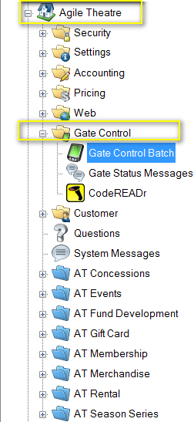
Image 1
3. Right-click in the Gate Control Batch area and select the type of batch you want to create. For this example, we will be creating a New Event Batch. (Image 2)
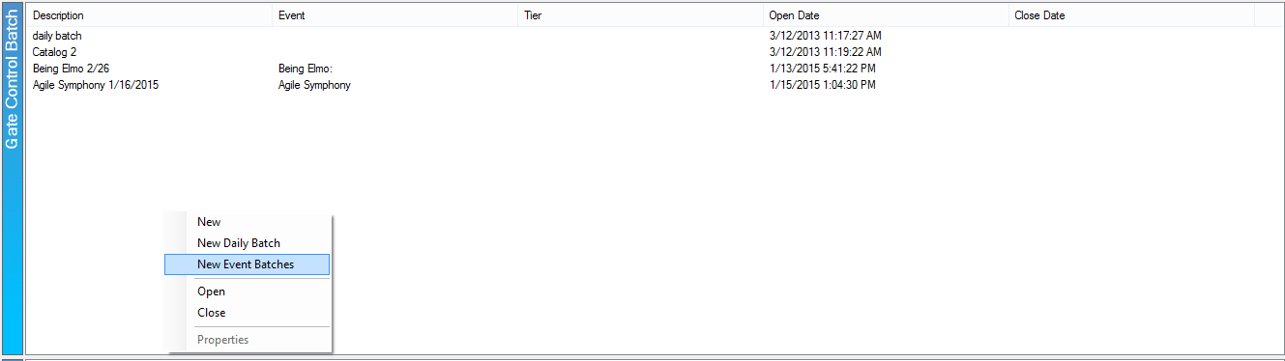
Image 2
4. In the Batch Type drop-down, you will see the different selections of Validation types. (Image 3)
- Live Validation is for scanners that are connected to the internet and scans are being recorded in the software immediately.
- On-Device Validation allows you to scan and validate tickets once you have downloaded your barcodes to the devices that will be scanning. For this procedure, you will need to be connected to the internet. On your scanning device, once the event has been selected, you will be prompted to download your data. If you are not prompted, select settings and then choose download. The device will then let you know how many barcodes have been downloaded. Once the data is downloaded the device will validate those specific barcodes as you scan. Any ticket sold after the download will work the same way as the On-Device Record. Once finished you will need to upload the barcodes back into Agile. You will need to connect to the internet, go to your settings, and select upload. The barcode data will be uploaded into Agile and you will be able to pull reports at that point.
- On- Device Record allows you to scan and track without having to be connected to the internet. The scans are stored on the individual device until you can have the scanner connected to the internet. Once connected to the internet, you will then be able to download all of the scan data into Agile.
For this exercise, we will create a Live Validation batch.
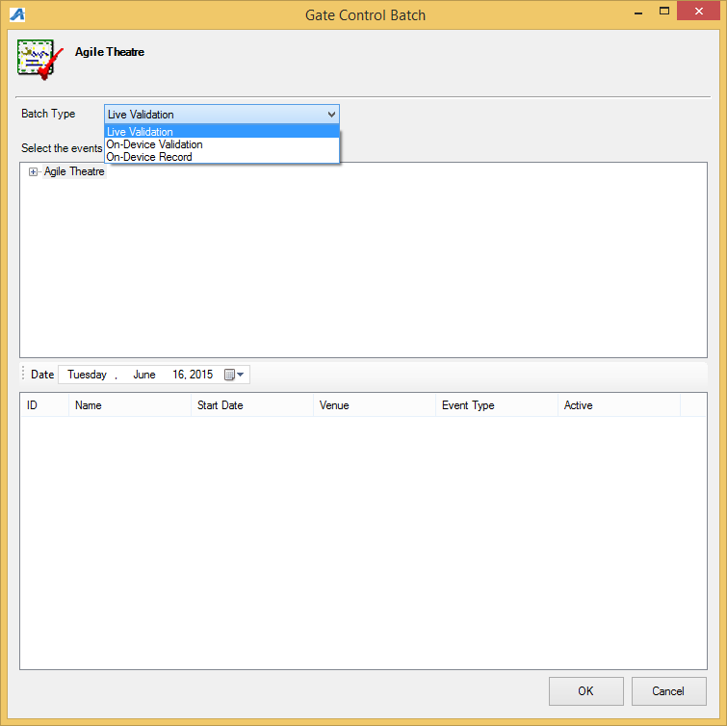
Image 3
5. Open the Organization Tree in the top screen and select the Sales Folder that has your events listed. In the lower screen, you will see the list of events. Select the event or events for which you wish to create a batch. Then click on OK to save the event batch. (Image 4)
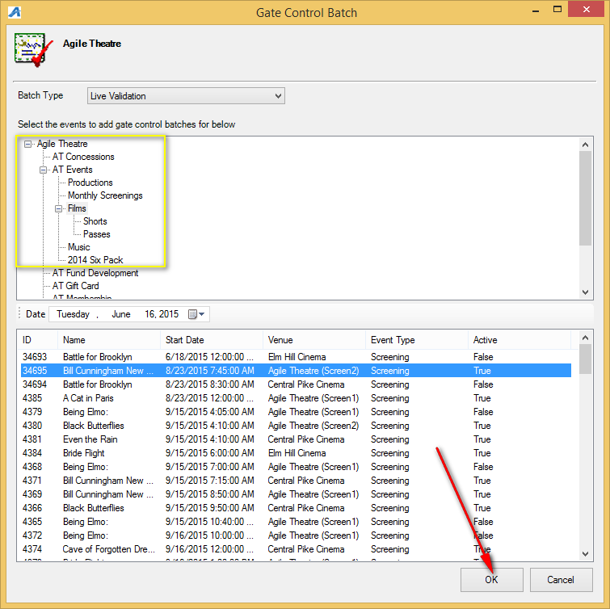
Image 4
6. To Open the batch, first select Show All in the drop-down menu. (Image 5)
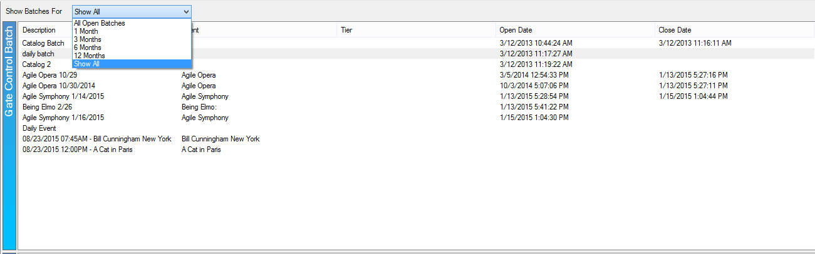
Image 5
7. You will then see the list of batches. Right-click the event batch and select Open. You are now ready to scan batches. (Image 6)
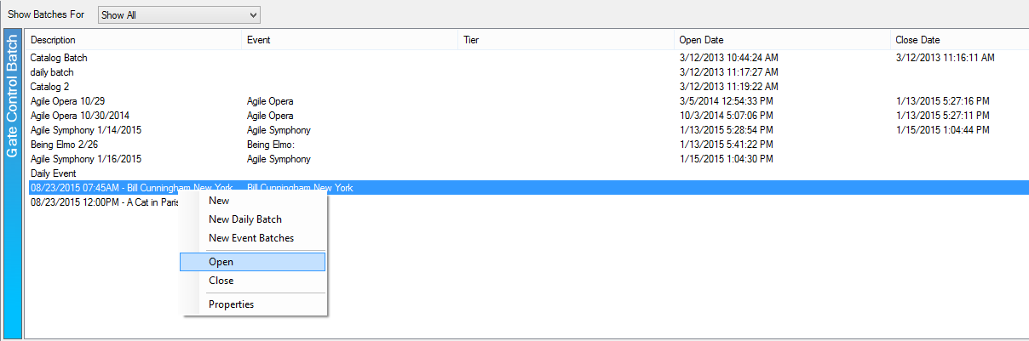
Image 6

