Membership Batch Fulfillment
1. Log In to Sales.
2. Make sure that you are cashed in before starting the fulfillment process. See "How to Cash In and Use AMS Sales to Create a Daily User Batch" for further instructions.
3. Select Support Functions from the menu at the top of the screen. Hover the mouse over Fulfillment and select Membership. (Image 2)
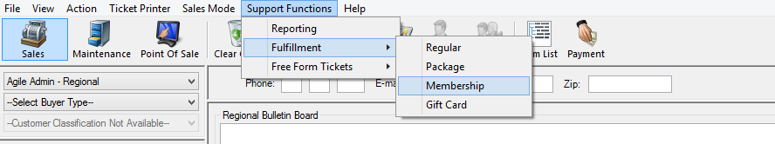
Image 2
4. Select the membership program that you want to print. (Image 3)
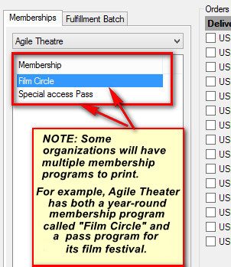
Image 3
5. Select all orders that need to be fulfilled. If you want to print the entire batch, click the Green Check Mark icon at the bottom of the screen. Otherwise, check the box next to each order needing to be fulfilled. (Image 4)
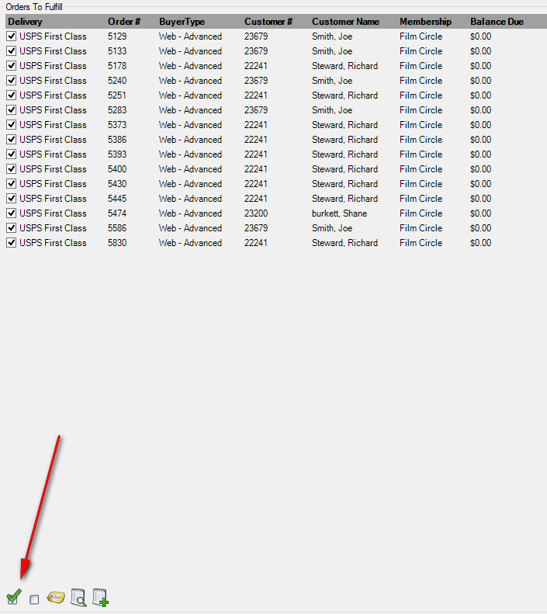
Image 4
6. Click the Ticket icon 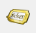 at the bottom of the screen.
7. The Fulfillment Options window will open. Uncheck the Print Payment Receipts box. Select the Print Membership radial button. From the list of Available Printers, select a printer and move it to the Selected Printers list. Click OK to start printing your membership cards/passes. (Image 5)
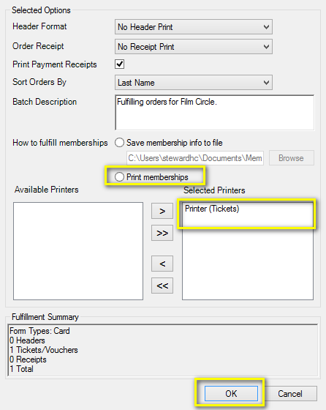
Image 5
8. Some organizations send new members Welcome Letters to thank them for their purchase, detail their benefits, and give them their membership card. To print the letters, switch to Administration. Click File, hover over Switch, and select Administration. (Image 6)

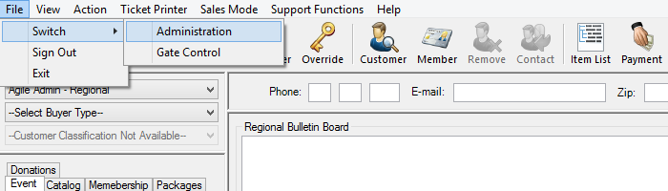
Image 6
9. Select the Corporate Organization icon . Click the Customer folder and select Emails and Letters. (Image 7)
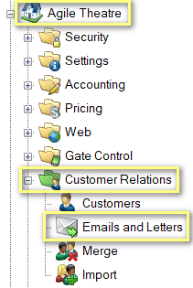
Image 7
10. In the Emails and Letters box, double-click the Welcome Letter. (Image 8)
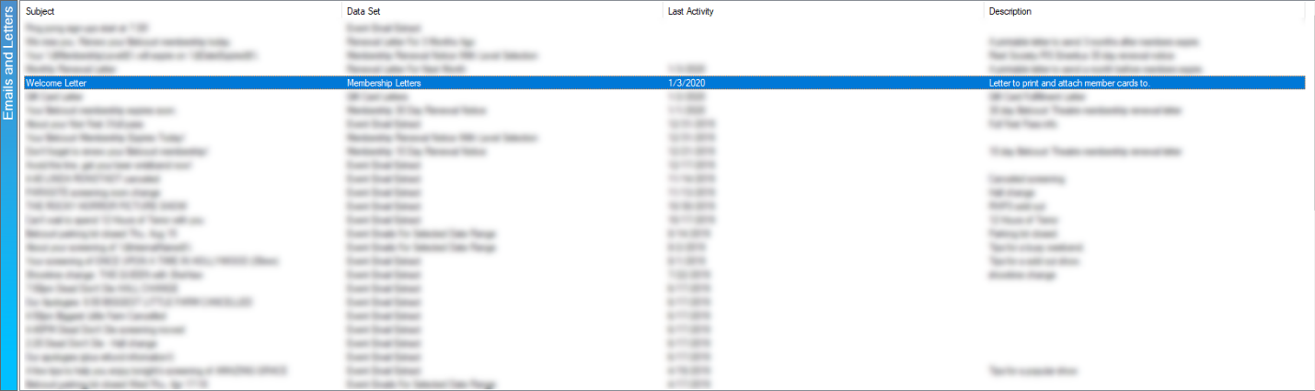
Image 8
11. In the Email / Letter pop-up window, click Set Parameters. (Image 9)
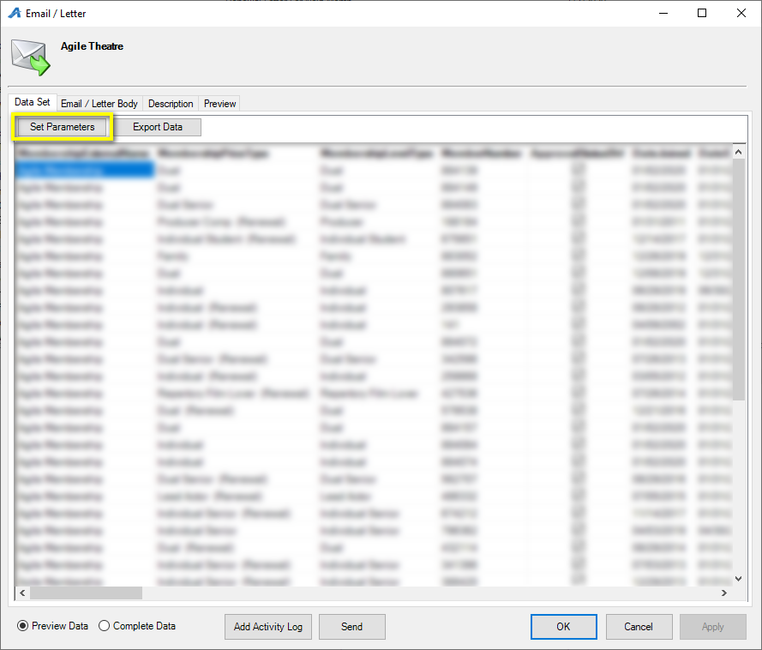
Image 9
12. In the Set Parameters pop-up window, select the batch that you printed in steps 2 through 6 and click OK. (Image 10)
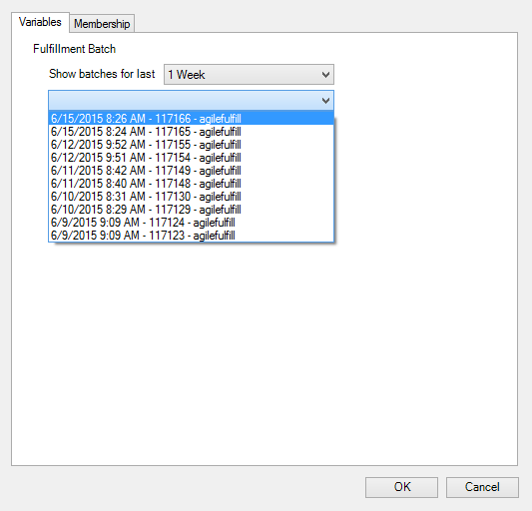
Image 10
13. Click the Preview tab. Then, select the Show All button. This will show all the welcome letters for this batch of fulfillment. Finally, click Print. (Image 11)
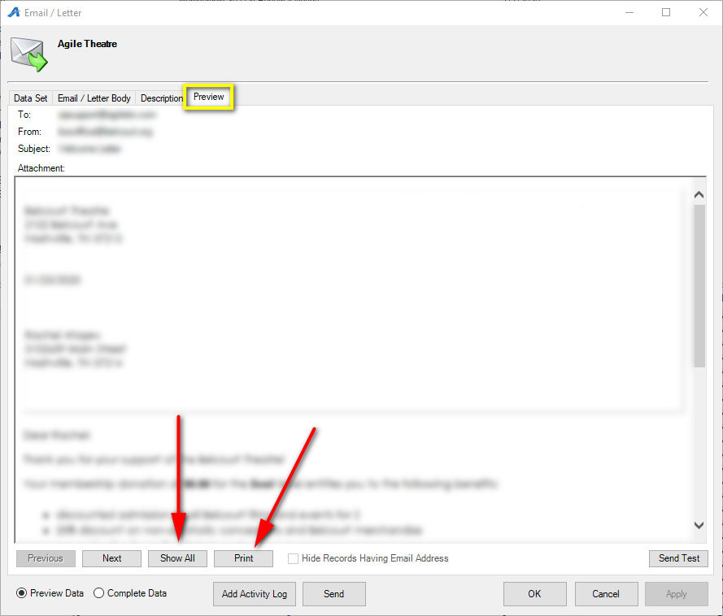
Image 11
14. A PDF of all the letters will open. Click the printer icon to print to your selected document printer.

