Express Sale in AMS allows box office staff to quickly sell tickets to a single show or event on the night of the show. In order for Express Sale to work, there must be a printer attached to the computer.
1. Login to Sales.
2. Cash In for the day. (Click here to learn how to cash in.)
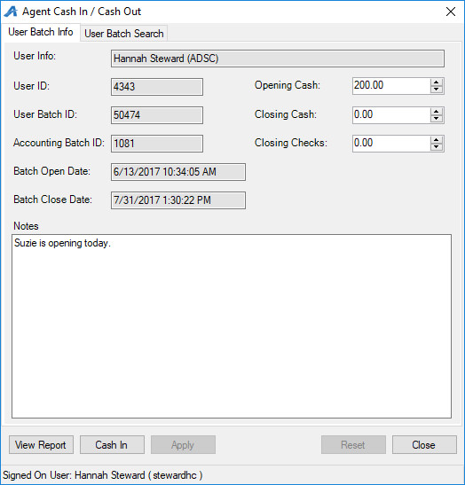
3. Select the Buyer Type from the drop-down menu on the left side of the screen.
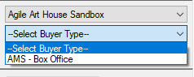
4. Click the Event tab and select the group that houses the event you wish to sell.
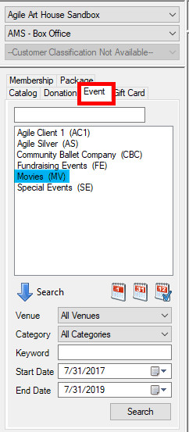
5. Select the Event. (Please note that if you have restricted prices to sell, you will need to check the Restricted Prices box before going into Express Sale.)
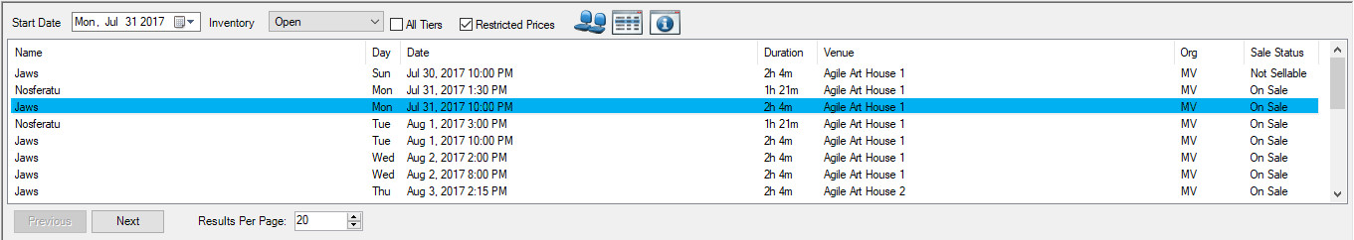
6. Once you have selected your event, click the Express Sale button at the bottom right of the screen.
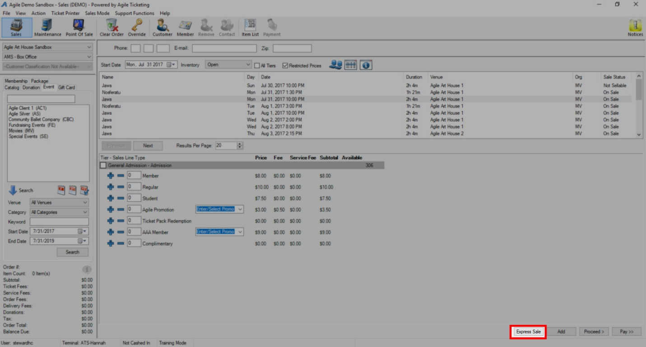
(Note: If the Express Sale button is not available, make sure that the Terminal ID is set up and that you have a printer assigned to that terminal. The Terminal and Printer are both set up in Administration in the Settings folder, under Location.)
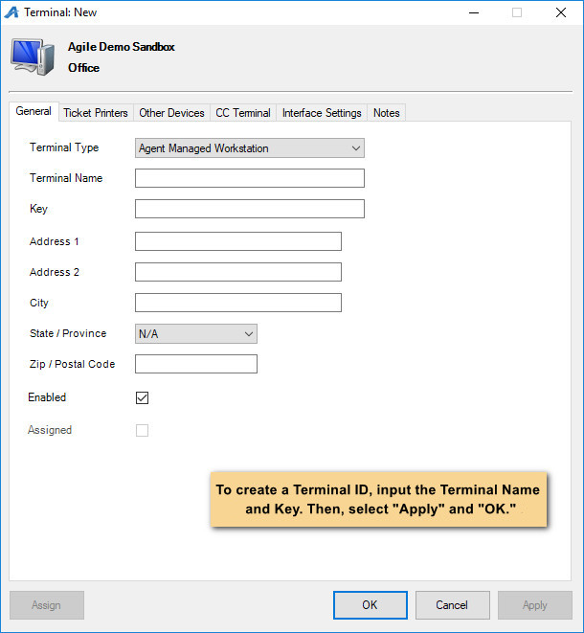
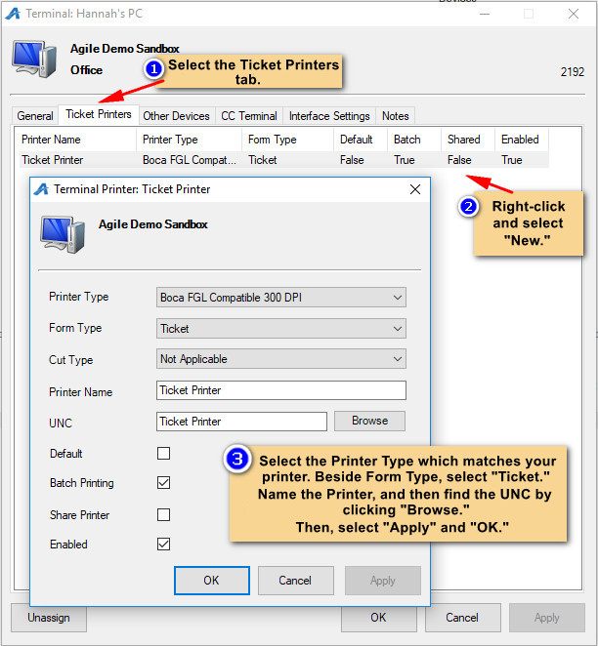
Then, make sure that the printer is selected in the Sales screen.
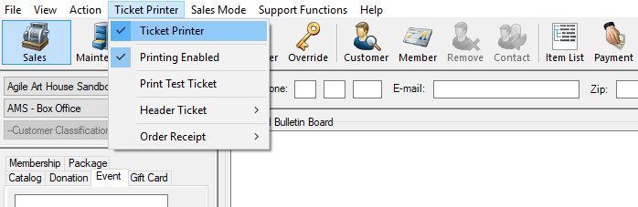
7. The Express Sale screen will allow you to only sell tickets for a single event which you have selected. From the Express Sale screen, you will enter the number of tickets you need to sell to a patron on the left-hand side of the screen. Then, click the green +Add button.
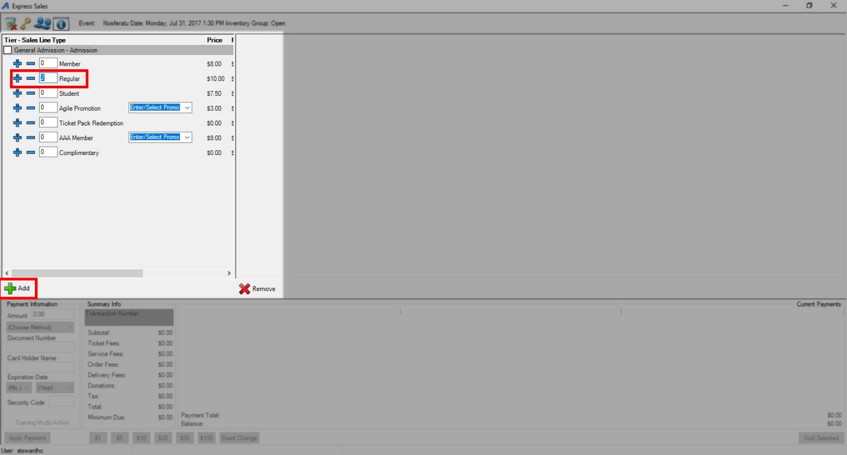

8. At the right of the screen, you should now see the order information. The Payment information is on the bottom right of the screen. If a credit card swipe is attached to the computer, you may swipe the card.
If you do not have a credit card swipe, choose the payment method from the drop-down menu and enter in the required information. If the patron is paying with cash, select the $ icons at the bottom of the screen based on the cash amount paid. Click the Apply Payment button to complete the transaction.

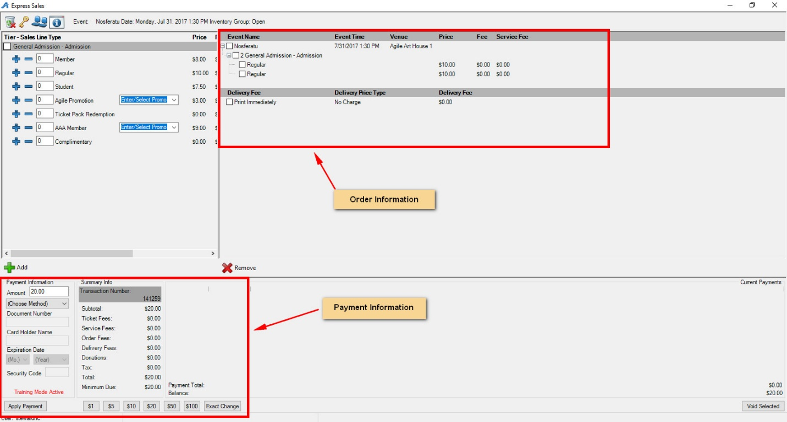
9. If you need to clear an order, you must do so before you process the payment. Click the Trash icon at the top of the screen.
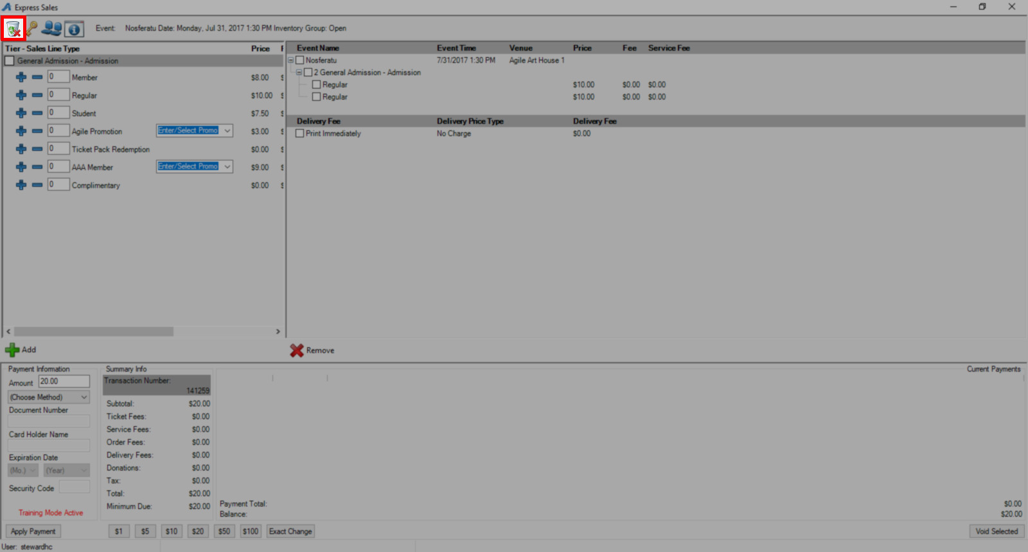
10. If you need to sell a reserved seat, click the seat icon at the top of the screen. You will then be taken to the seating chart, where you can select your seats. Then, click Proceed.
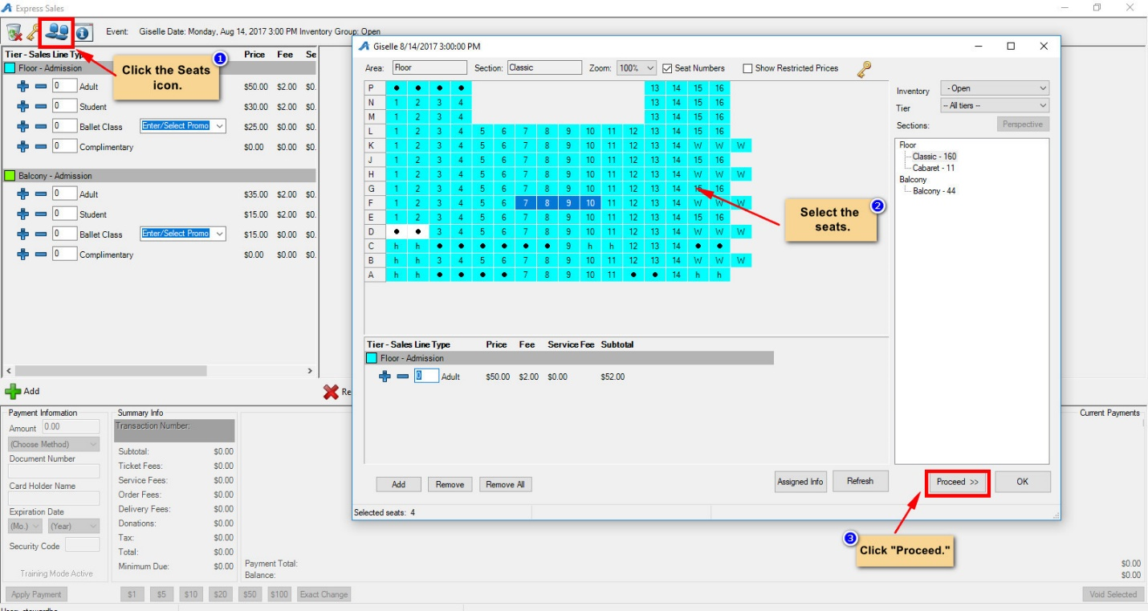
11. If you need to know any information about the event, you can click on the Information icon at the top of the screen. From here, you should see all the information about the event.
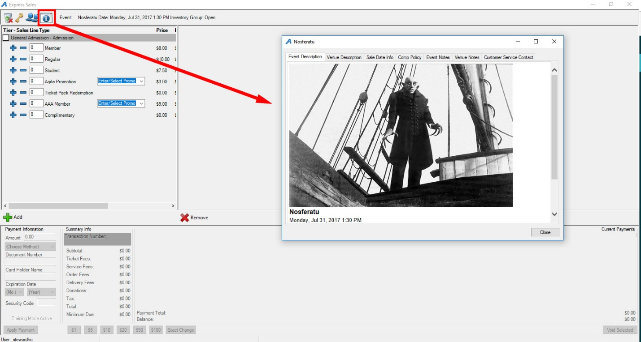
12. Once you have processed the payment, your screen should clear. You are ready to process your next order.

