Membership Renewal Emails
Agile Ticketing provides an automated email process to remind your members that their memberships are nearing their expiration date. Follow the instructions below to find out how to set up these automated emails.
1. Click the Customer Relations icon. Select Emails and Letters.
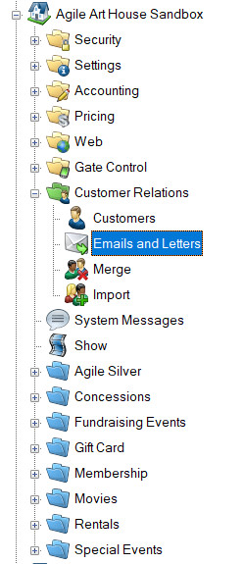
2. Right-click in the Emails and Letters section at the top of the page and click New. Select "Membership Renewal Notice with Level Selection" from the drop-down. Once that is selected, click OK.
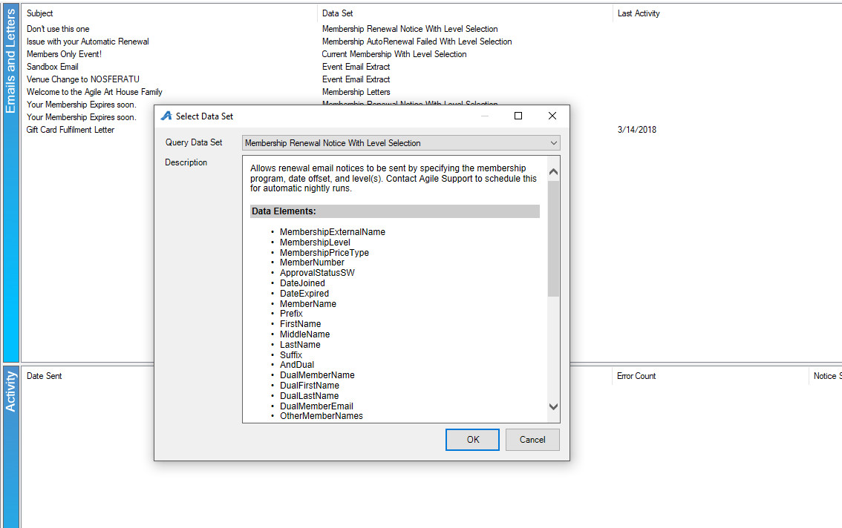
3. This will bring up the Email / Letter settings.
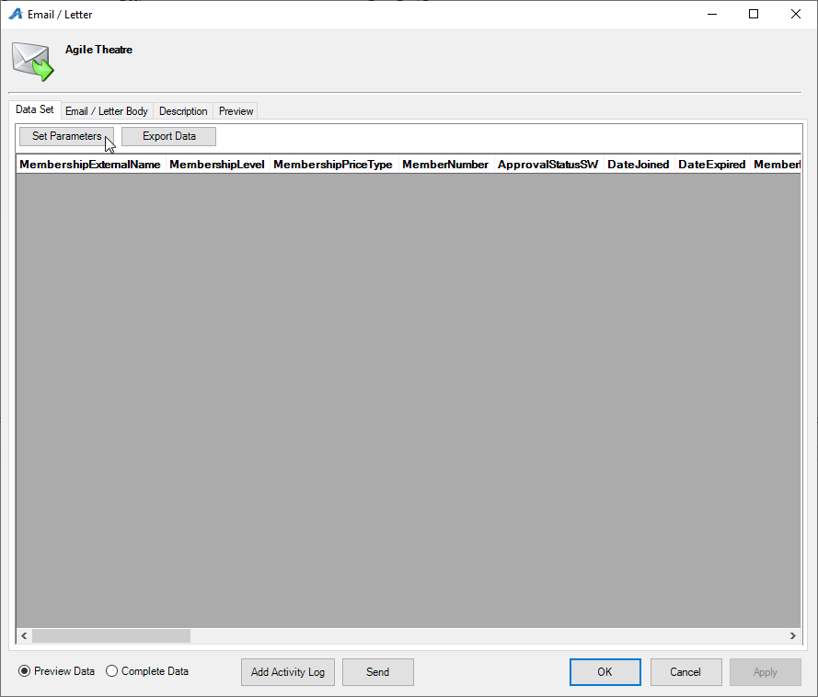
4. Click the Set Parameters button to define the criteria for this email. A pop-up will appear with several options needing to be set.
a. The Variables tab –
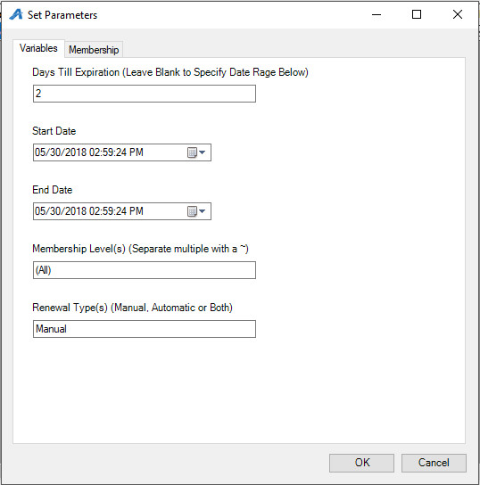
- Days Til Expiration – The number of days before expiration to send an email renewal notice. The number 15 will signal that people will receive an email on the 15th day before the membership expires. If you want to send a notice after expiration, a negative number can be used. The number -10 can be used to signal that customers will receive an email 10 days after their membership expires.
- Membership Level(s) – This will default to "(All)" and will return all levels. If you want to filter out selected levels, include them in a "~" delimited list. (e.g. The value "Regular" will return only levels defined as "Regular". The value "Regular~VIP" will return levels defined as "Regular" or "VIP".) You can also create an exclusion list to define all levels except the ones listed. (e.g. The value "!=Regular~VIP" will return all levels except those defined as "Regular or VIP.)
Membership tab – Select the membership program to use for the email.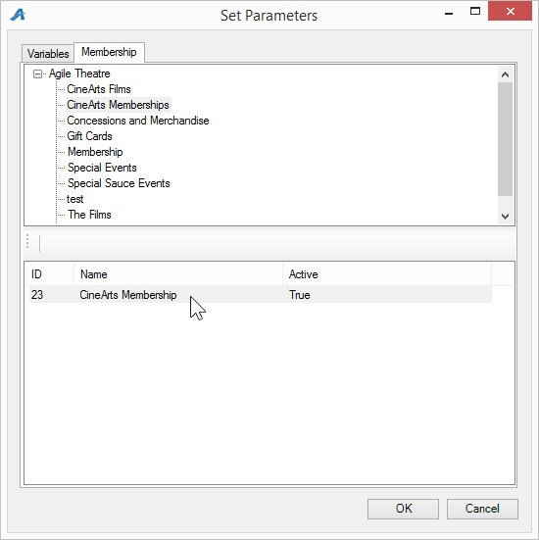
5. Once the proper parameters have been set, results will be returned to be merged in the email. For nightly emails like this one, each day new customers will be in the result set.
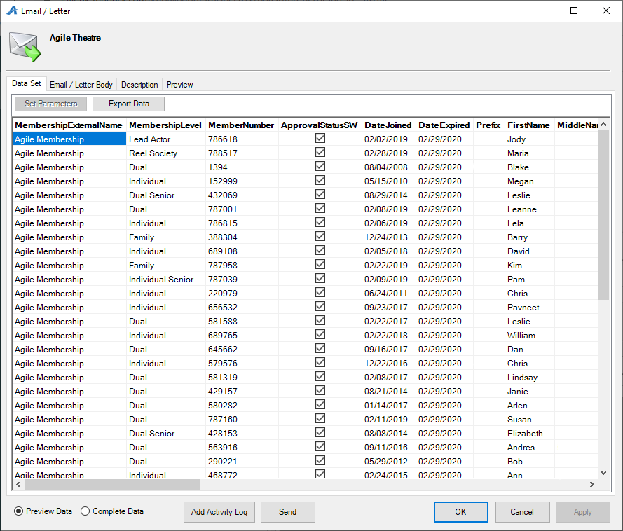
6. The email message is defined in the Email Body tab. Fields that can be merged in the email are available by right-clicking and choosing the Insert option.
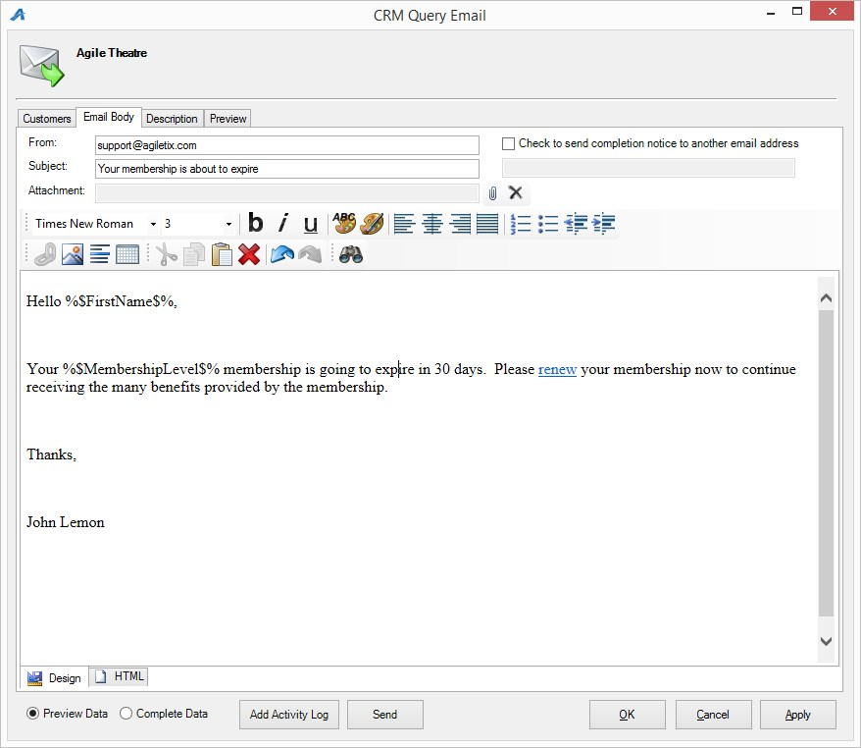
7. The Description tab is used to describe the email for internal reference purposes.
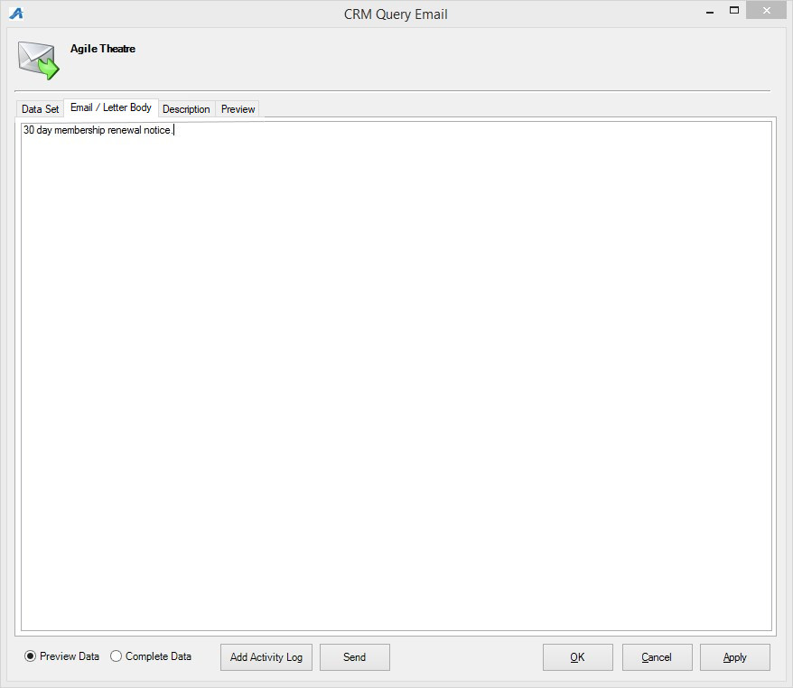
8. The Preview tab is provided to proof the look and feel of the email to make sure everything is ready to be sent. You will see several options on this screen.
- Previous and Next – Used to see the individualized email for each person.
- Show All – Will show every email so you can quickly scroll through them.
- Print – Some organizations will print letters to send to members. You can print your personalized correspondence by clicking this button.
- Send Test – Send the current email being previewed to a specified email address. This is useful to make sure that any links in the email work as expected. Send Test can serve as a final check before a bulk email is sent out.
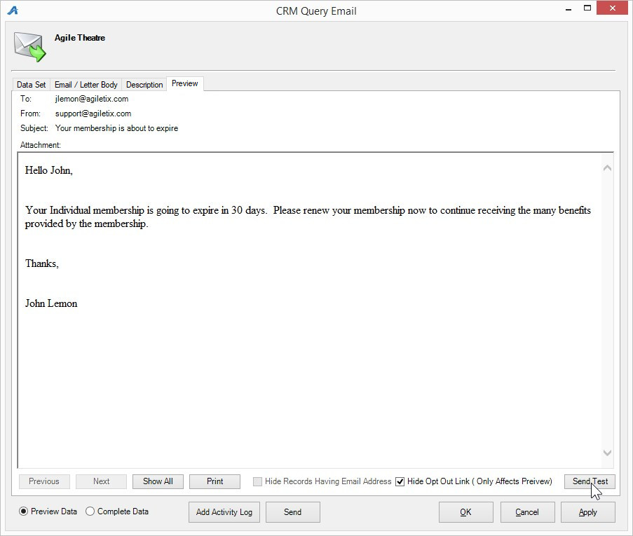

9. Nightly emails like this renewal email must be activated for our automated email process. Once your email is ready, please contact your support representative so that they can schedule these reminders for automatic delivery.

