Creating a Price and Creating a New Effective Price Date
On occasion, organizations will need to create a new price to go into effect on a specific date. Generally these are for price increases or even short periods when a regular price is discounted. Here are the steps to change the existing price:

- Open the Blue Sales Folder that has the price you wish to change.
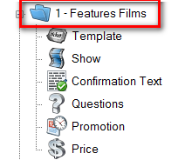
- Click the Price icon.
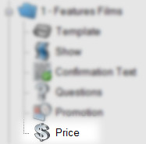
- Highlight the price that you wish to change.
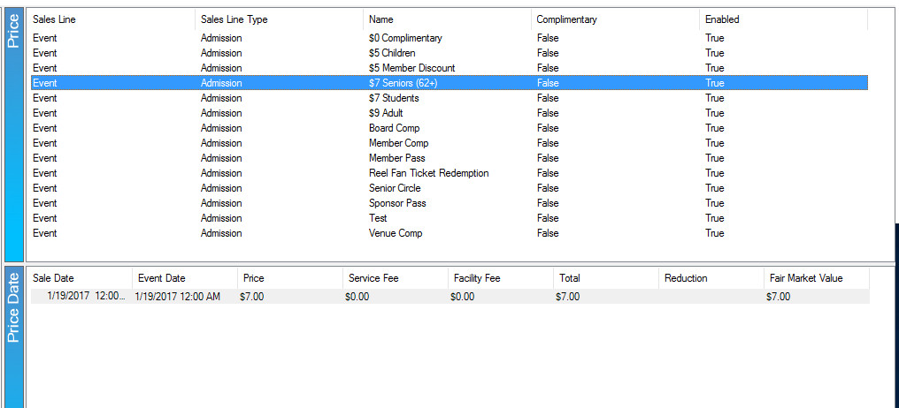

- In the Price Date field, right-click and select New. You will see the Price Distribution: New window appear.
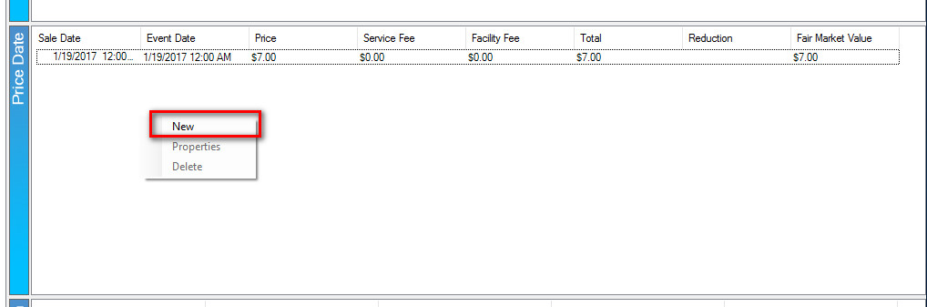
- Right click in the Distribution field and select New.
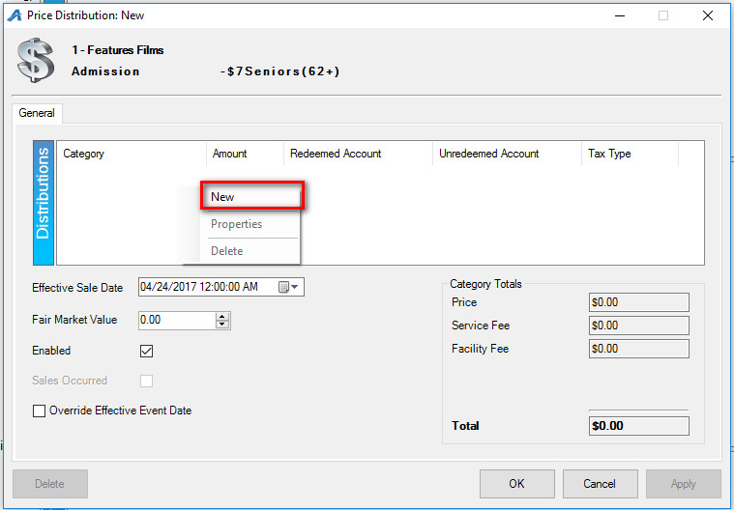

- Select the Price Category from the drop-down and add your price. Select the Revenue accounts from the Unredeemed Account and Redeemed Account drop-downs.
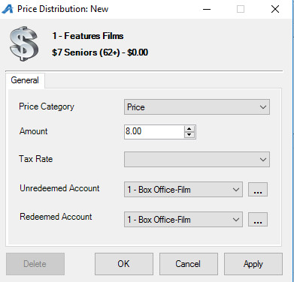
- Repeat Step 6 if you need to add additional fees or prices.
- Once all your Price Distributions have been added, click the Effective Sale Date to choose the date on which you want this price to take effect.

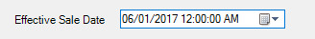

- Select Apply to save your changes.
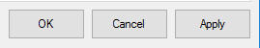
- The price will now change automatically on the date that you have chosen without you having to make edits to templates and/or events that have already been created. It will also allow you to keep historical pricing information on reports for past events.
