Adding a Zapier Filter step

- After setting up a Zap like the one described in https://support.agiletix.com/hc/en-us/articles/360000665143-Setting-up-your-Zapier-Agile-Integration, add a Filter step by clicking the Plus sign between the first and second steps of the Zap on the left-hand side and click the “Filter” option that appears:
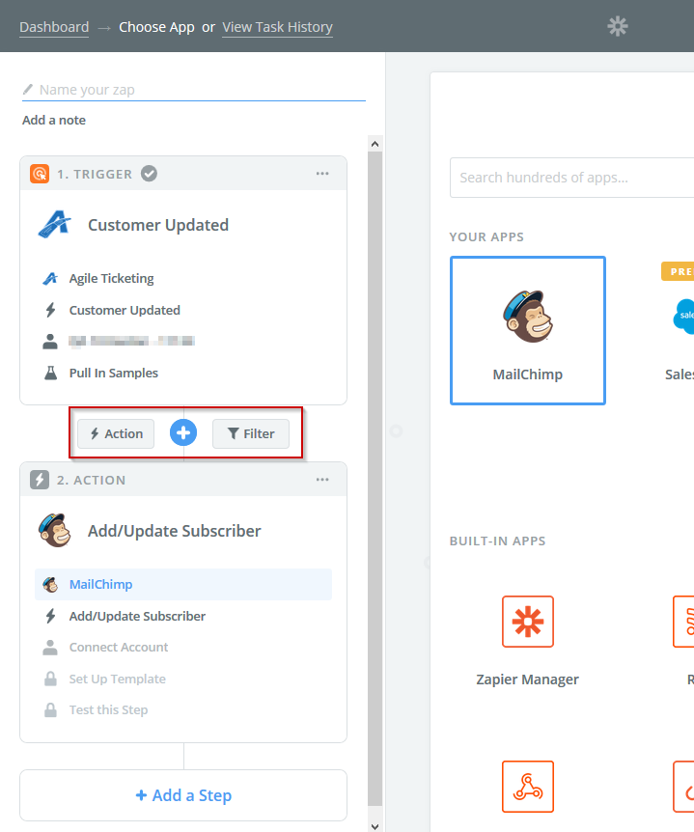

- Select “Only continue if…”, then continue.
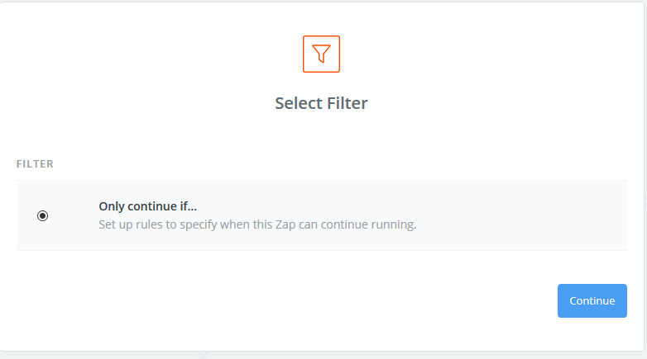
- Select the appropriate Marketing opt-in value in the left dropdown (either “Receive Regional Marketing Emails” or “Receive Corp Marketing Emails” ), and “(Boolean) Is true” in the right dropdown.
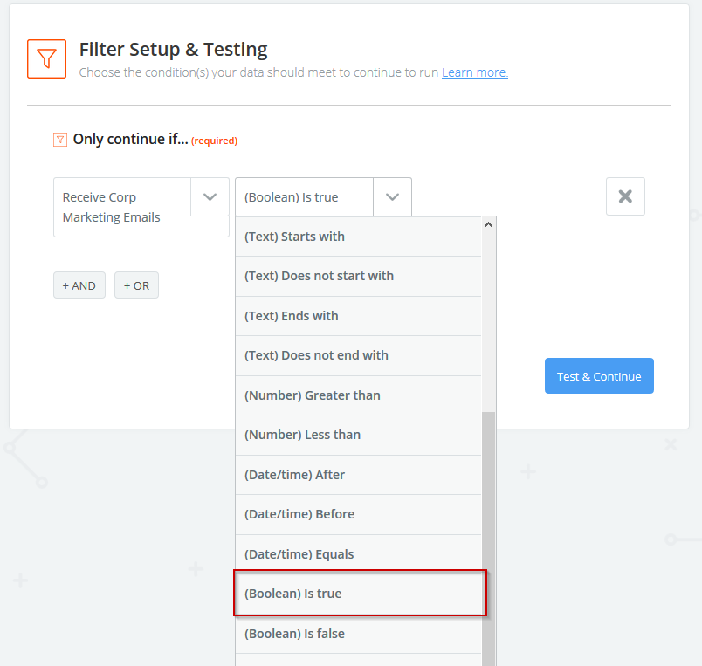
- If you wish to check against their opt-in values at both the Regional and corp level, click the “+ AND” button and repeat step 3 with the new dropdowns, this time using the other Marketing opt-in value
