Order Maintenance in Web Portal Box Office

1. Log into portal.agiletix.com
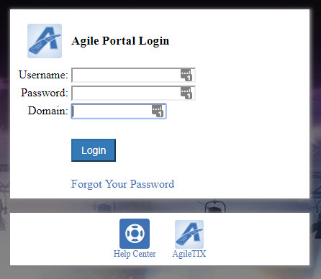
2. Click on the Box Office icon to the left of the screen.
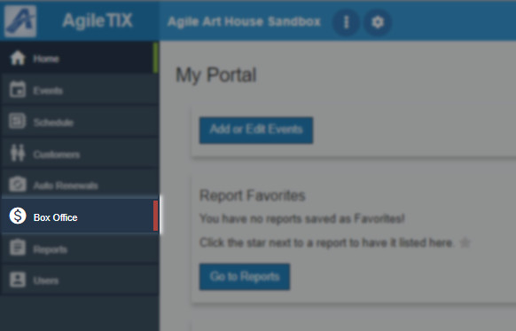
3. Enter your Username, Password and select the Terminal Key Name from the drop-down. NOTE: The Terminal Key Name is different from your Domain name. If you do not have a Terminal Key Name, please contact your Client Support Rep.
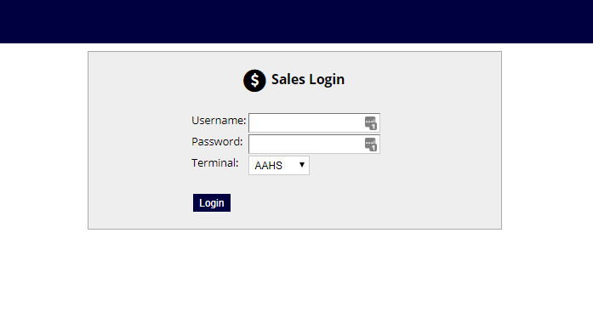
4. Once you are logged in, you will be prompted to Cash In. Click Yes to cash in. Enter in the Opening Cash and any other notes. Then click on the Save Changes button. This will tell the system that you are ready to start your shift and to process sales. By cashing in, the system will allow you to process and track all sales.
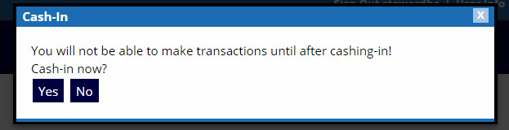
5. To look up an order enter the Order Number in the Order # box in the Last Orders section of the User Info page. Click Go to open up that order.
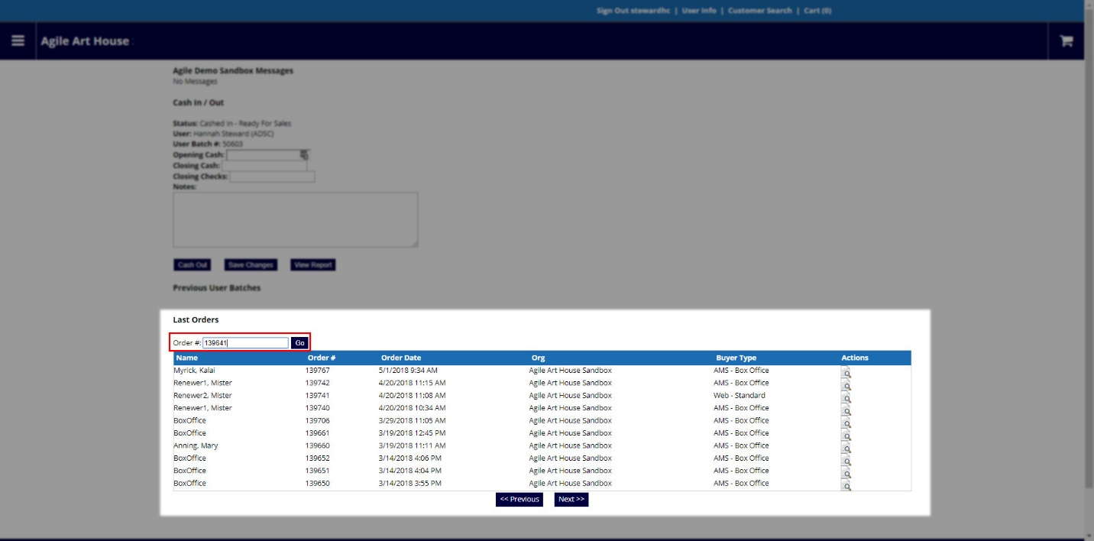
6. From the Order, you are able to print or resend the order confirmation.
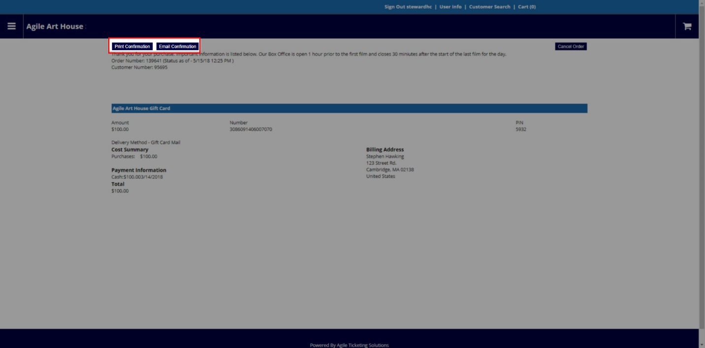
Processing a Refund
1. You can process a full refund in Web Portal Box Office. Follow steps 1 through 5 for Order Maintenance.
2. When on the order confirmation page, click on Cancel Order.
3. Enter the reason for the refund and then click Submit. NOTE: You can only refund or cancel an entire order in Web Portal Box Office.
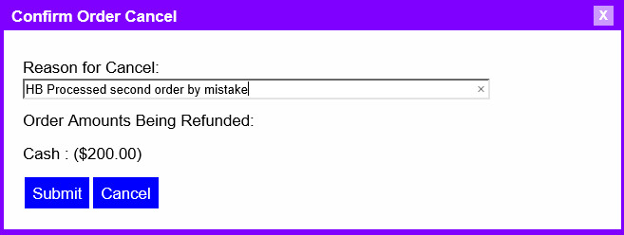
4. You will get a confirmation that the order has been successfully canceled.
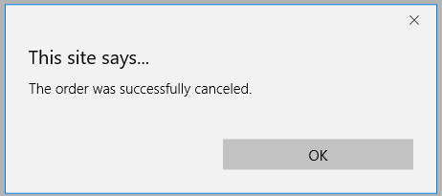
Order History in Customer Record.
If the order number is unavailable you are able to look up a customer's order history.
1. Click on the Customer Search at the top of the screen.
2. Search for the Customer by entering the First and Last name or the Customer number.
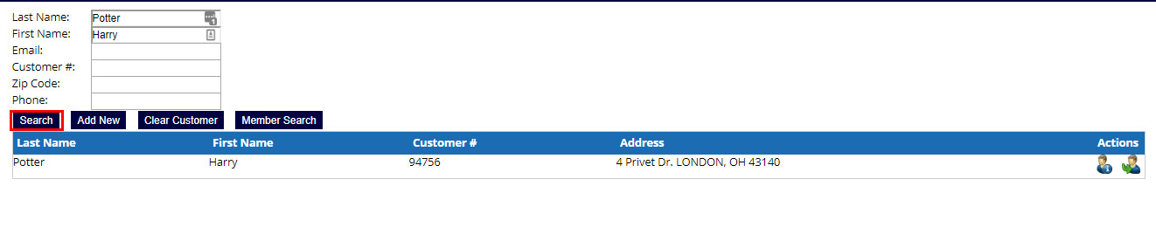
3. Once you have found the customer record you are looking for click on the Customer Information button.
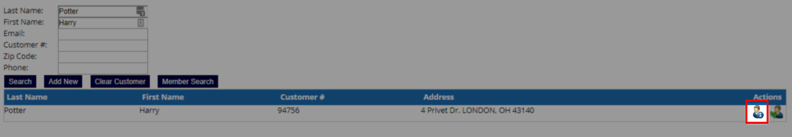
4. Once you are in the customer record click on the View Your Orders button to pull up all orders in that customer record.
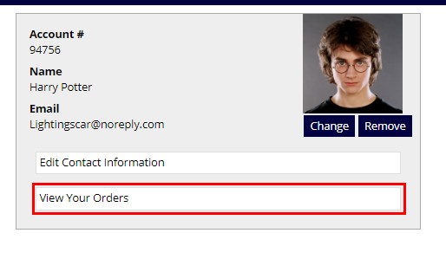
5. Click on the View Order Details button to open the order, and from here you are able to print or resend the order confirmation.

