Selling a Ticket in Web Portal/ Box Office
Web Box Office is an online Box Office solution that allows you to sell tickets, memberships and other items, as well as print tickets, collect customer information all from a direct web link using the Agile Web Portal.
1. Go to portal.agiletix.com and log in with your credentials.
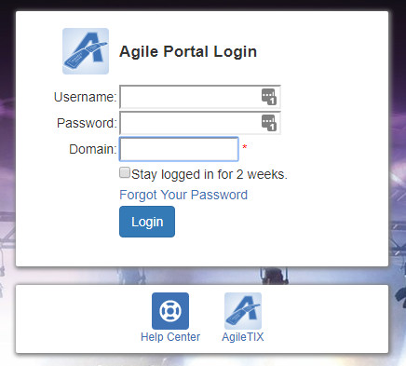
2.Once you have logged in, you will be on the Portal Dashboard
3. Click on the Box Office icon.
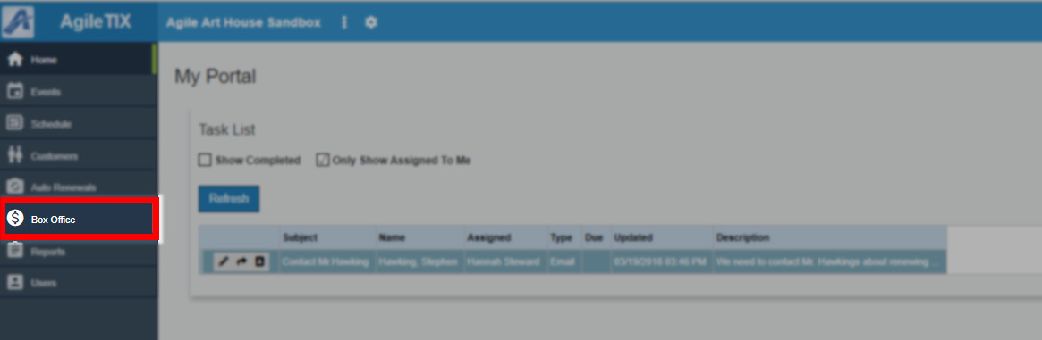
4. You will then be directed to the Sales Login Page.
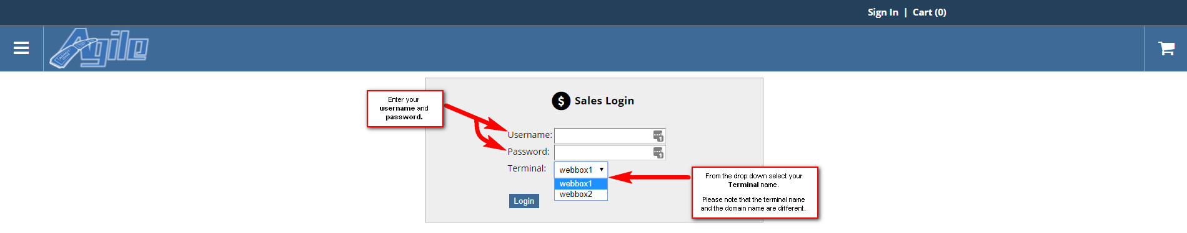
5. Enter your Username, Password and Terminal Key Name that you received from your Agile Client Support Rep. NOTE: The Terminal Key Name is different from your Domain name. If you do not have a Terminal Key Name, please contact your Client Support Rep.
6. Once you are logged in, you will be prompted to cash in click yes to cash in. Enter in the opening cash and any other notes. Then click on the Save button. This will tell the system that you are ready to start your shift and to process sales. By cashing in, the system will allow you to process and track all sales.
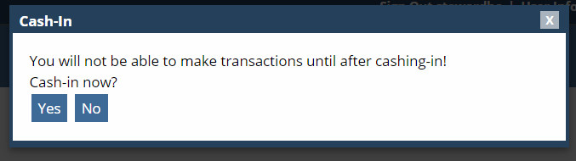
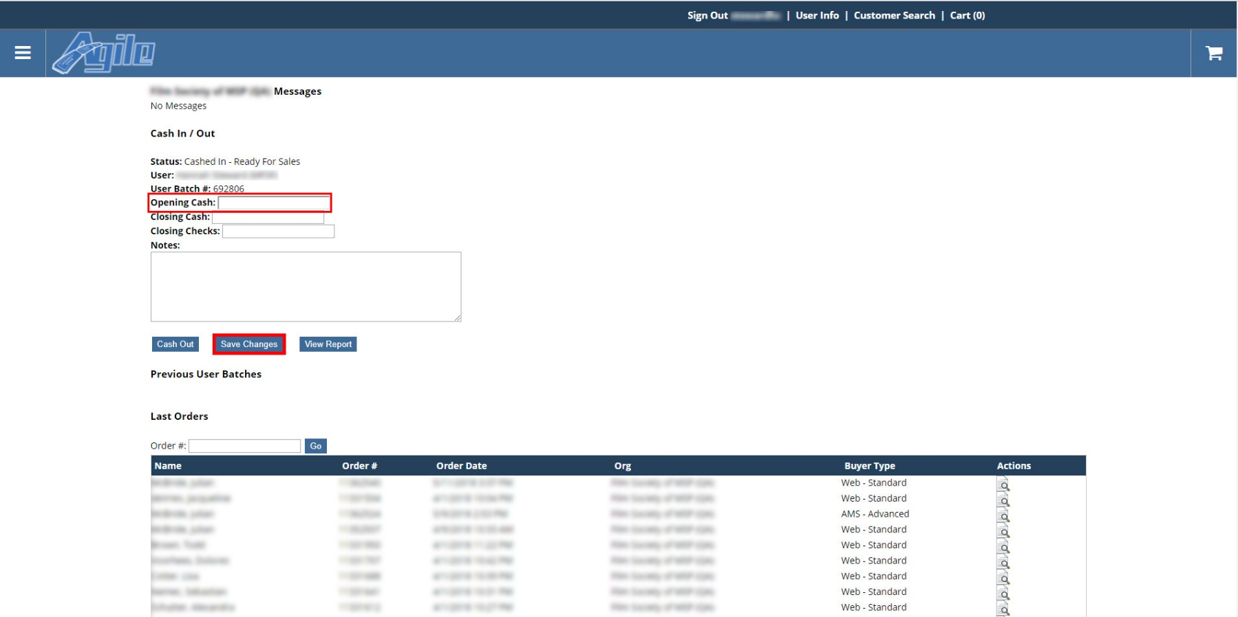

7. After you are cashed in, click on the menu icon in the top left of the screen. Select one of the Event URL's from the menu bar. Events/Film Lists can be in either Alphabetical Order or in Date Order. (In this example, we have a Film List view in Alphabetical Order and a Schedule View which is in Date Order).
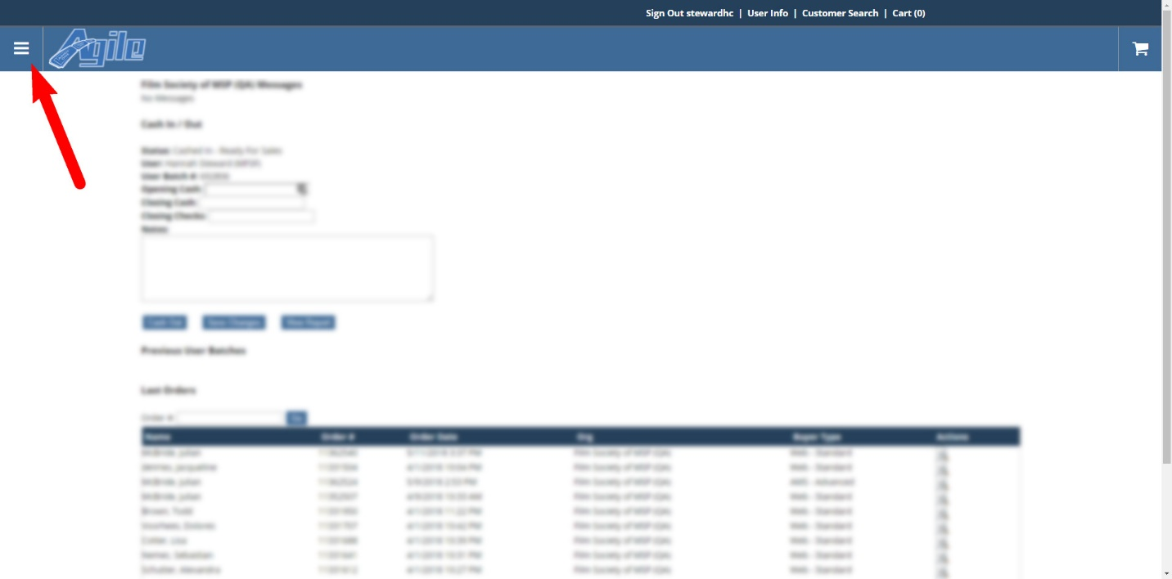
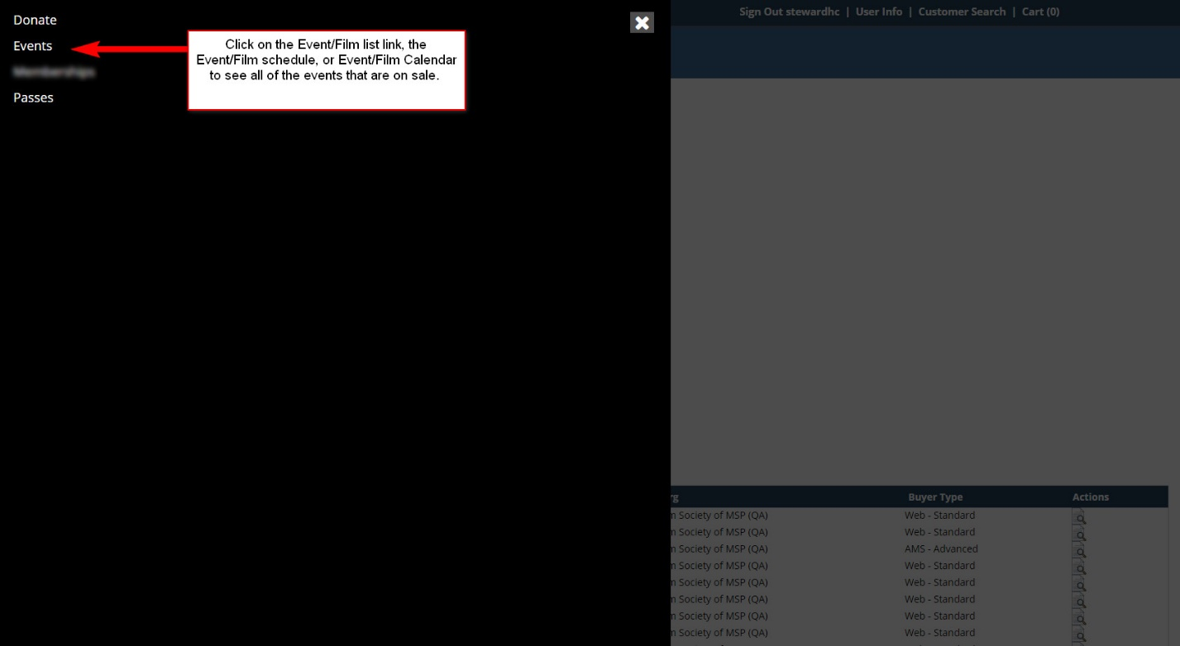

8. Choose the event that the customer wishes to purchase.
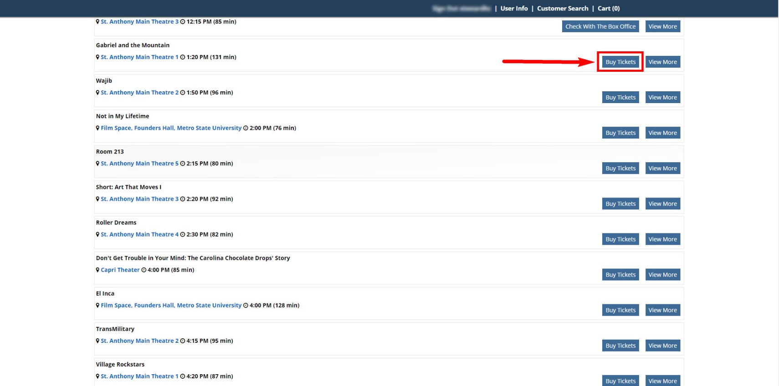
9. Click on the Buy Tickets button and enter the number of tickets the customer wishes to purchase. You can Continue Shopping for other events or proceed to check out.
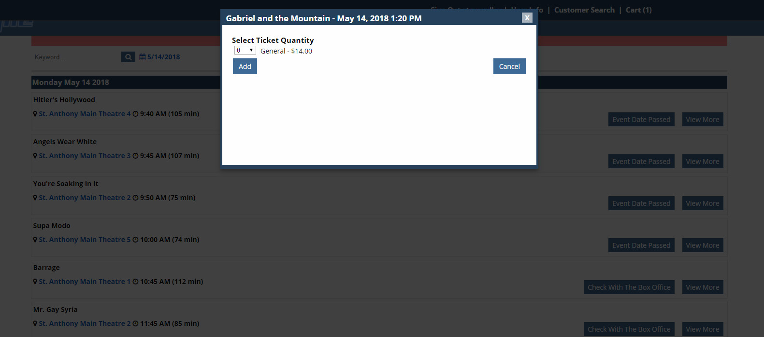
10. When you have all items in the shopping cart you will either click on Proceed to Check out or click on the Shopping Cart icon at the top of the screen.
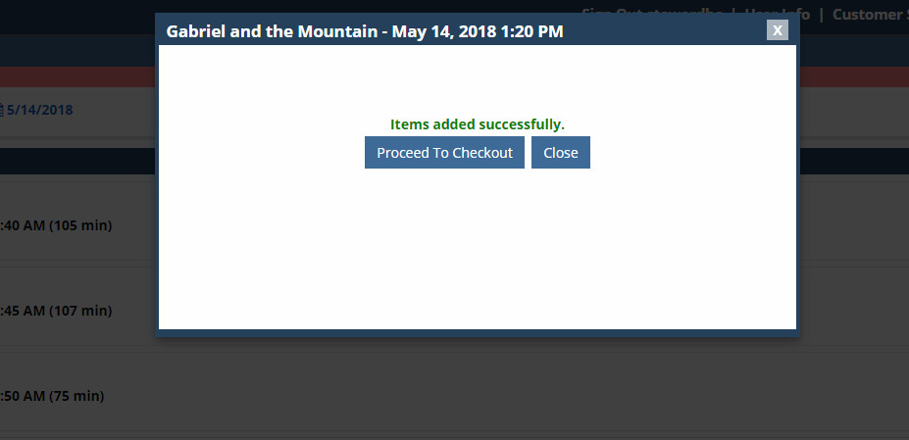
11.Choose the Delivery Method for these items
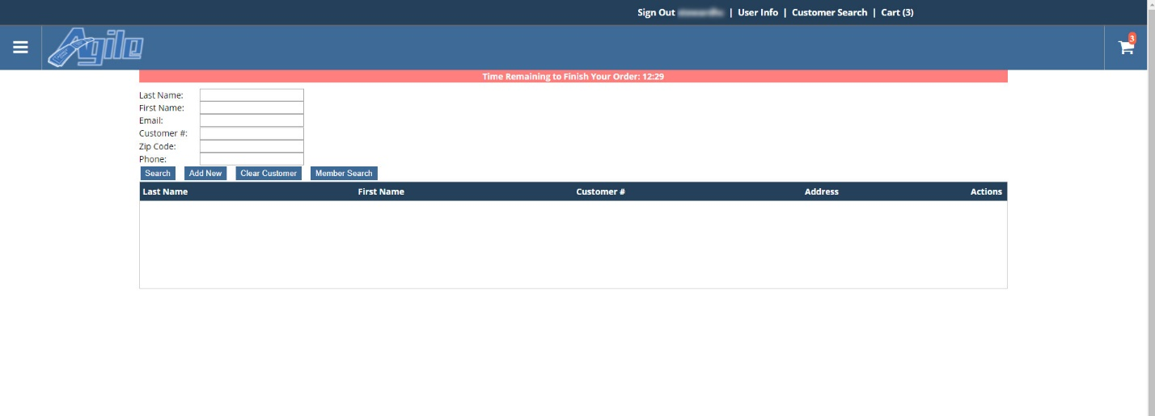

12. Enter the customer's name.
A. Click on the Search button at the bottom of the page, and then click on the customers name.
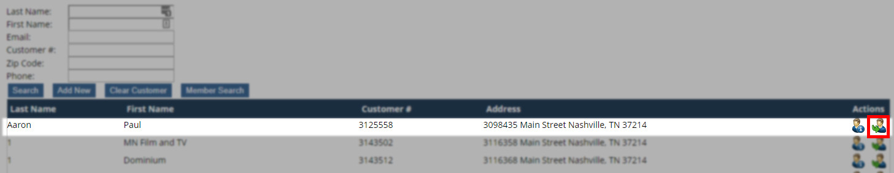
B. If No Customers Found appear, click on Add New and enter in the customer's information.
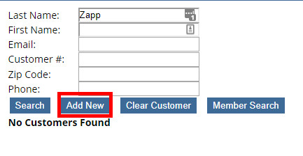\
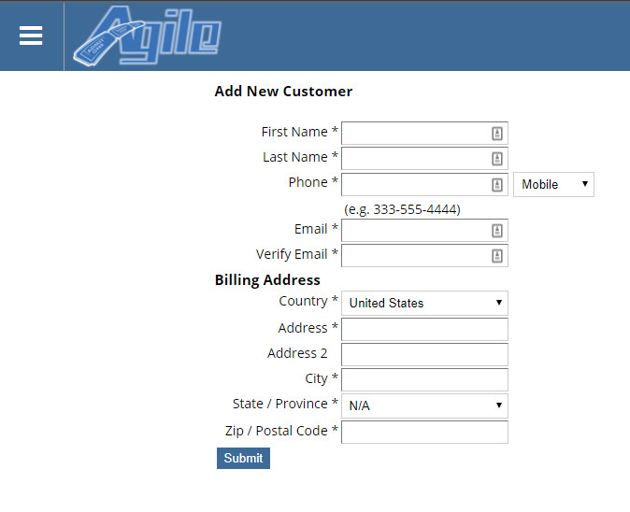
13. Once you have associated the order with a Customer Record, click on Checkout.
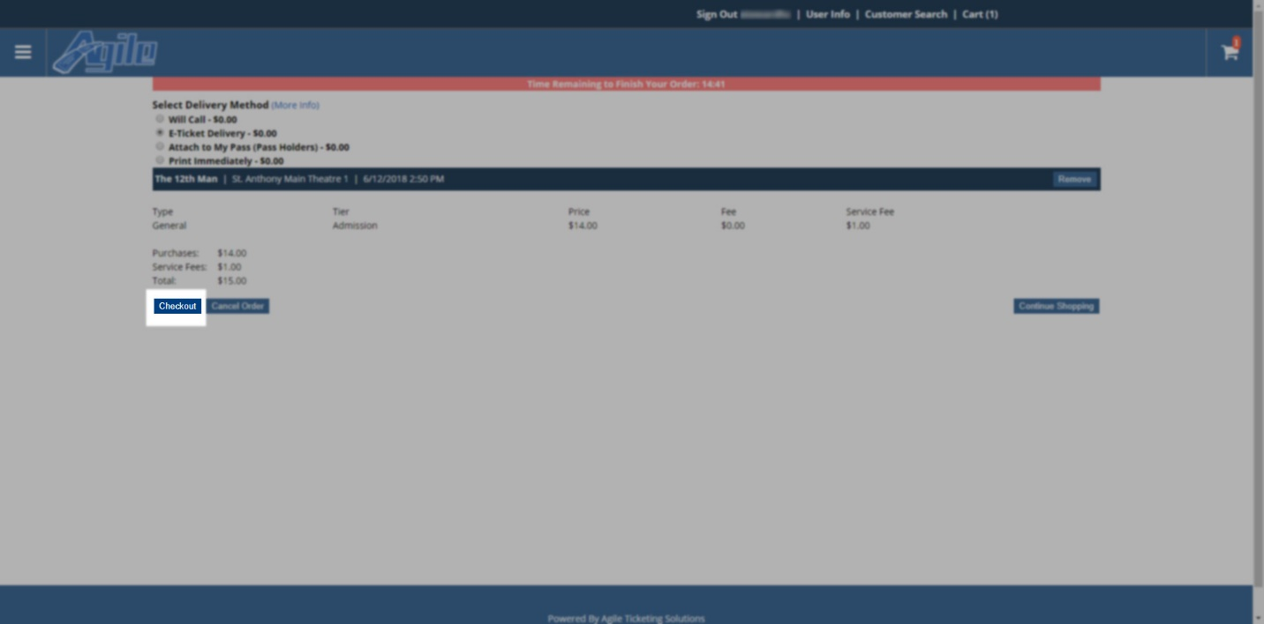
14. On the payment page, confirm that the Billing and Shipping Address is correct and then select the Payment Type (Cash, Check, Visa, etc.) and enter the Payment Information.
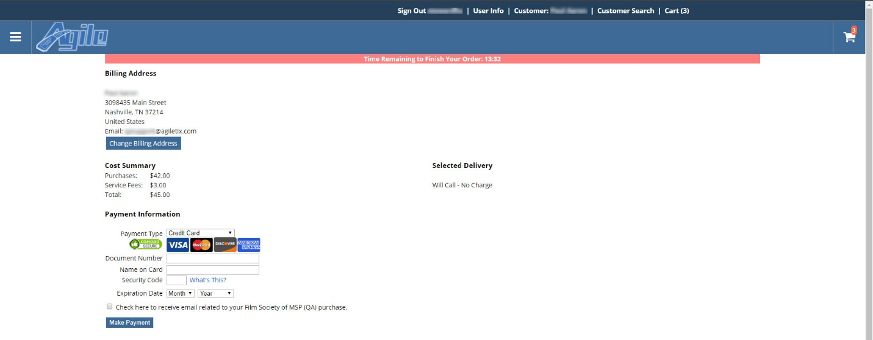

15. After entering the payment information, click Make Payment.
16. You will receive a confirmation page that will allow you to either Print or Email the PDF Print At Home Tickets OR Print or Email the Order Confirmation.
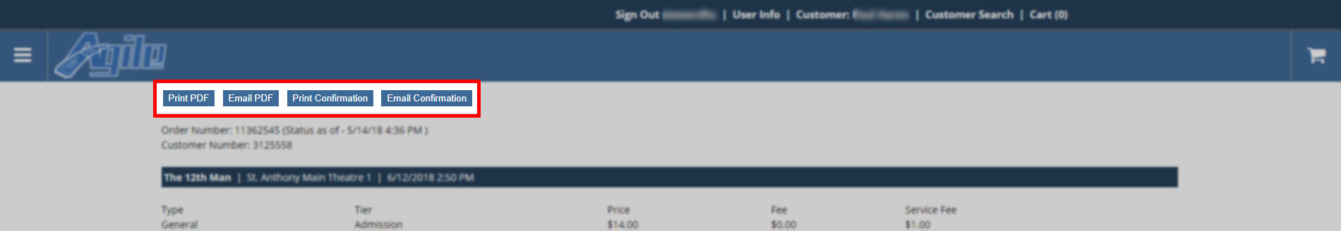
17. Once you Have completed this order, you can then click on User Info at the top of the screen to return to the main sales window and start your next sale.

