**Credit Card Chargeback Report**

Agile clients now have a way of pulling a transaction report that can be used to dispute any chargeback transactions that you receive from your merchant service provider.  This report pulls the confirmation that was sent to the client, the request and response data for when the transaction was processed, the IP address for where this transaction was processed (this is helpful for online fraudulent charges) and the terms and conditions for your organization. Below are the steps on how to find the order information and pull the report.

1. On the **Chargeback Notification** that was mailed to you from the **Merchant Services Dispute Resolutions Department**, identify the **Cardholder Account #.** This number will help you search for the transaction in Agile.
2. Log In to **Agile** and click on the **Maintenance** icon.

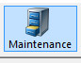

1. In the **Document #** field, enter the **Cardholder Account #** and then check mark the box next to **Credit Card.**Click on the **Green Checkmark** next to the **Document #** field.  This will pull a list of all orders that were processed with this credit card.

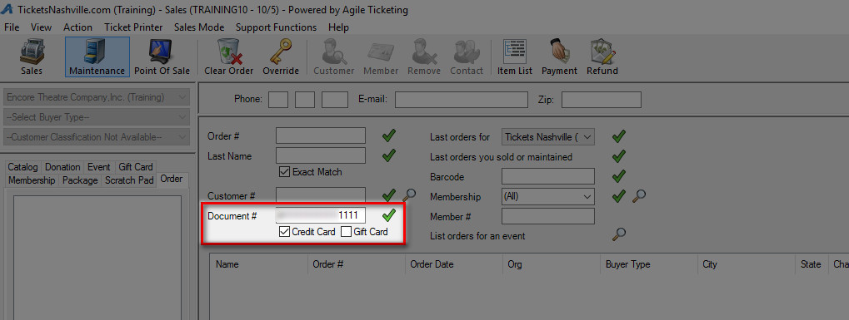

1. Make note of the **Order Number** for this transaction as you will need it to pull the report.  NOTE: You may want to open the order to confirm the date, time and amount of the order match the information on the Chargeback notification.

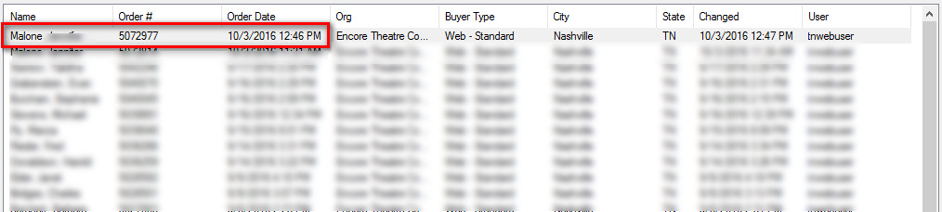

1. Next, select **Support Functions/Reporting** to open up the reporting portal.

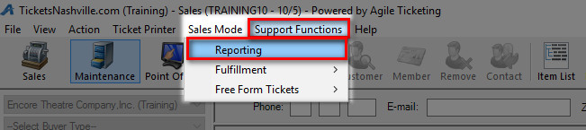

1. From the reports menu, select **Orders** and then select **Credit Card Chargeback Details.**

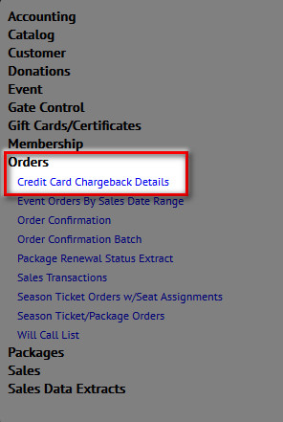

1. Enter the **Order Number** in the **Order Number** field. Enter the **Case Number** that is listed on the **Chargeback Notification** (this will show up as part of the report). Select **Save as PDF** and then click **GO** to run the report.

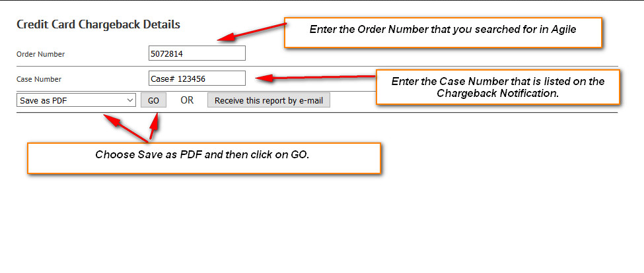

1. The first page pulls the order confirmation that was sent to the customer.  It will have the customer's detailed information along with a list of items that they purchased.  It will also have the Response Data that is sent to the merchant processing company for approval.

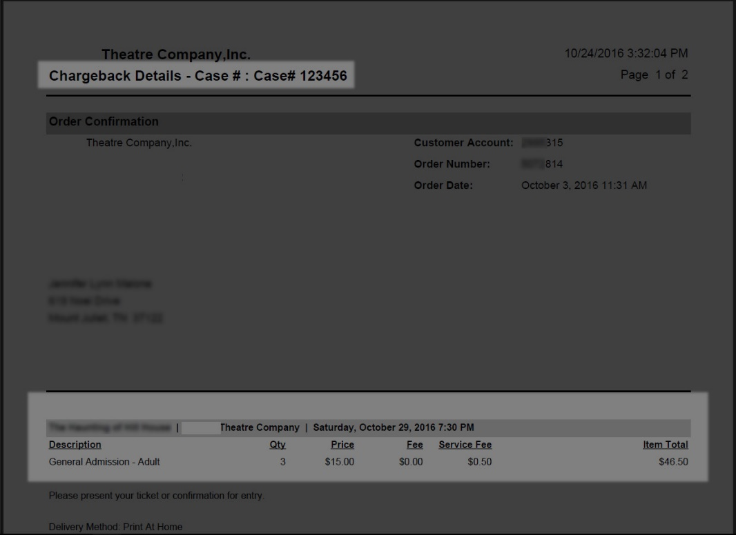

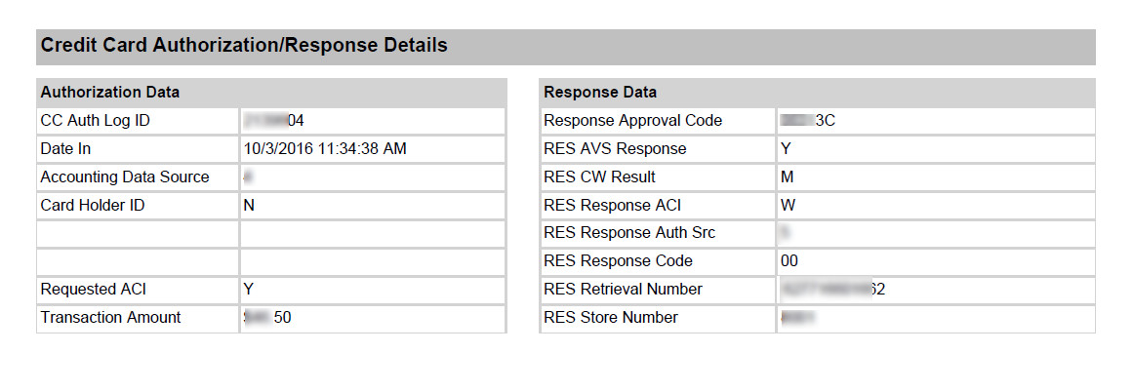

1. The report continues with the Response Data including the IP Address of the computer that order was processed on.  This is extremely helpful for chargebacks where the customers reported the card as stolen.  The IP address will help the issuing bank with valuable information that can be used to pursue and prosecute anyone who has used a stolen credit card information. It also includes your organization's terms and conditions which should include refund policy information.

