Selling Concessions using the POS
1. Log into Sales.
2. Click Point of Sale icon 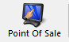 in top toolbar.
3. Once you are in the Point of Sale click on the Action icon at the top of the screen
4. From the Action drop down click on Cash In/Out.
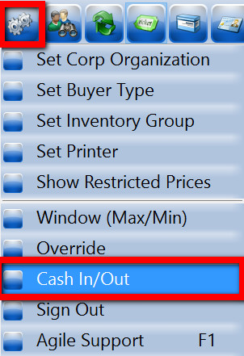
5. In the Cash In/ Out pop up click the Cash In button at the bottom of the window.
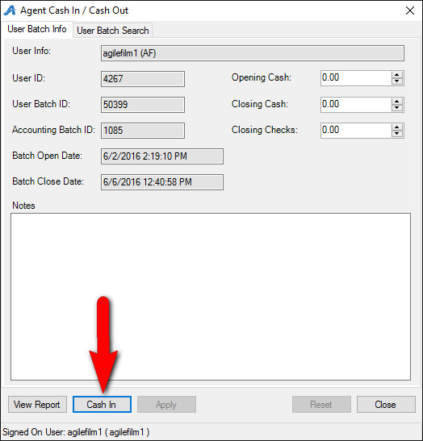
6. Once you Cash In for the day, click on the Catalog icon 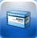at the top of the screen.
7. Multiple Sales Line Types will appear in the top window. These Sales Line Types separate the different catalog items into their own categories that will allow us to sell different types of catalog items.
8. Select the Catalog Group that you wish to sell from (for this example we will be choosing Concessions).
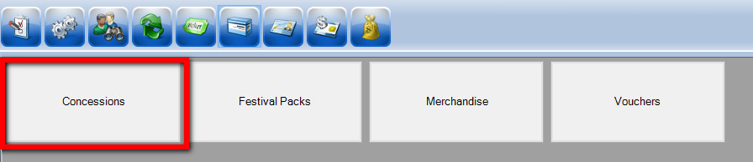
9. Next you will see all of the Product Group Names (i.e. Popcorn, Non-Alcoholic Beverages, Beer Wine, Candy, etc.). Click on the Product Group that you wish to sell. You will see the list of prices at the bottom of the POS Screen for the items available in that group.
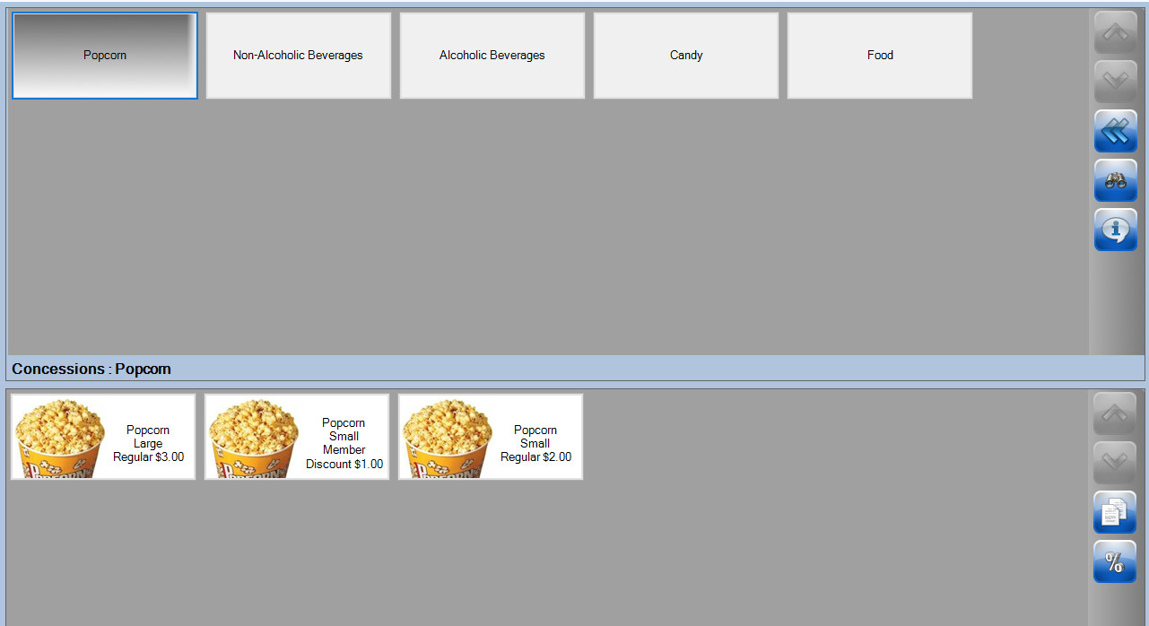
10. Click on the Item you wish to sell and it will added to the Item Summary located at the bottom right of the screen. Confirm the order with the customer before entering payment.
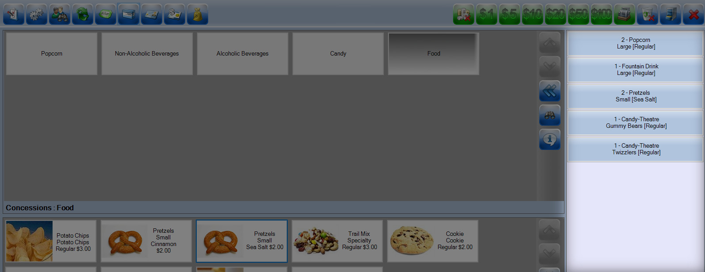
11. Once the order has been confirmed, click on the “Enter Payment” icon.
NOTE: If you have a Credit Card swipe attached to your terminal (either on mounted on your POS terminal OR via a USB swipe, you can swipe the credit card instead of clicking on the Enter Payment button. All the credit card information will populate and automatically finalize the order. For cash or check transactions or to manually enter in the credit card, follow the steps below.
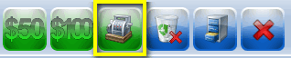
- In the pop up window, you will see the Amount Due and the Choose Method drop down menu. Select the payment type that corresponds with how the customer wishes to pay (Example: Cash, MasterCard, Visa, Gift Card, etc.).
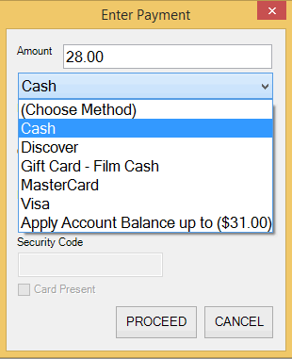
- Click Proceed to complete the payment transaction and finalize the order.
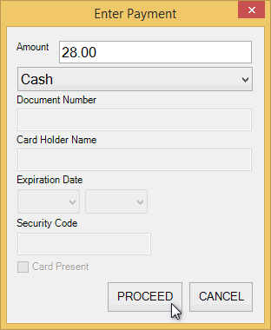
12. Once the transaction is completed, the Item Summary in the lower right corner of the POS screen will turn yellow and Last Order will appear. This confirms that the last order you processed is completed.
