Building Reserved Seating Chart
1. Log in to Administration
2. Select the Corporate Organization icon.
3. Select the Sales Organization folder then either the Template or the Event level. NOTE: Once your seating chart is built you will be able to copy up to the Physical Template in the Corporate Information area (not required). (Image 1)
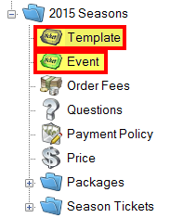
Image 1
4. You will need to set up your Template or Event with Tiers first. See How to Build a Venue Template.
Important Notes for Reserved Seating Chart:
- The Reserved Seating Template should never have the General Admission box checked under the Tier. The General Admission box is always checked by default, so make sure to un-check this box before you continue with building Tier Name(s). (Image 2)
- Seating maps DO NOT work with GA/Reserved Tier combinations.
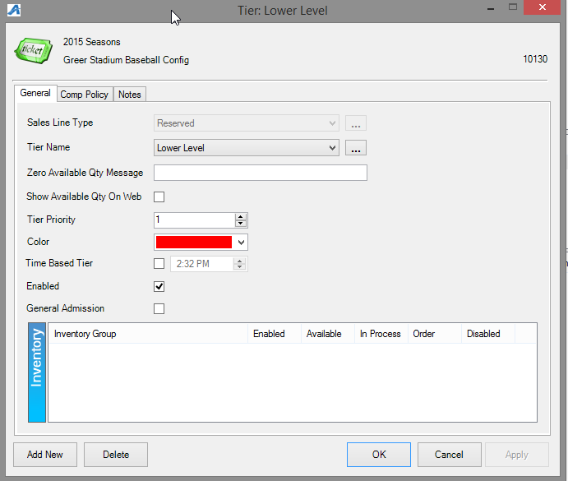
Image 2

5. Once you have added your Tier Name(s), the map will be created under the Physical icon. (Image 3)
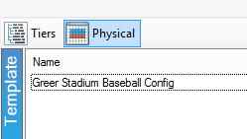
Image 3

6. Under Area right click New
- Enter your desired Area Name and Display Sequence number (order of priority in which the Tiers display on your seating chart). Click Apply. (Image 4)
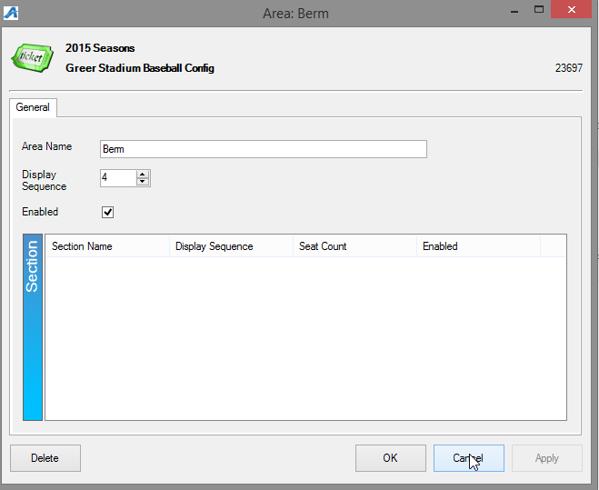
Image 4
7. Right click in the Section area and select New (Image 4)
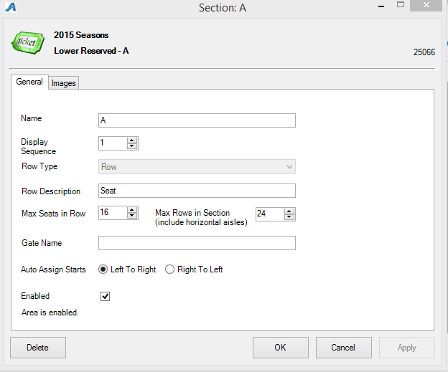

Image 5
- A. Name the Section you will be creating. (Image 5)
- B. Display Sequence refers to display order for that section. (Image 5)
- C. Row Type - This is where you select how the seats will appear on the seating chart (i.e. in a Row, at a Table, etc. ). (Image 5)
- D. Row Description Describes the grouping of tickets available on the seating chart (i.e. Seats, Table, Admission, etc.). (Image 5)
- E. Max Seats in Row refers to number of spaces available in each row. NOTE: refers to the entire section (include aisles or separations in calculation). (Image 5)
- F. Max Rows in Section refers to total number of Rows including aisles and separations for the section (include aisles or separations in calculation). (Image 5)
- G. Gate Name allows the customer to know what door/gate to enter for the particular section (if applicable). (Image 5)
- H. Auto Assign Starts allows you to assign the seat numbers according to how they appear at the venue. (i.e. Seat numbers flowing 1 - 10 with number 1 being on the left side of the row; Seat numbers flowing 10 - 1 with number 1 being on the right side of the row). (Image 5)
8. Once the section is setup, right click on the section name and select Seat Maintenance. (Image 6)
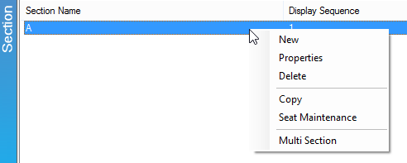

Image 6
9. Begin filling in the squares on the left side of the screen with the Row numbers or letters by clicking in blank space then enter the name of the Row (Image 7). Note that the top of the screen refers to the back of the map.
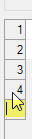 (Image 7)
- A. Right click in the space next to Row to Assign Seat Numbers. (Image 8)
Image 8
- i. Seat Numbers can be numbered sequentially in ones, twos, threes, etc. (See example images 9 & 10).
- ii. Seats can be numbered from the left or from the right.
- iii. If the venue has an even or odd numbered section (i.e. seats number 2, 4, 6, 8) you can preset Skip Seats to allow for proper number sequence.
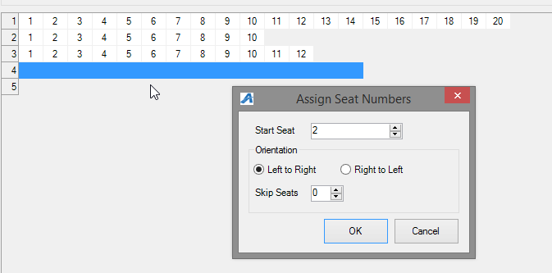
Image 9
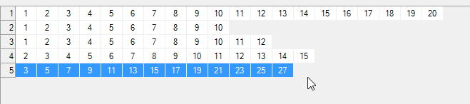
Image 10
- B. Once entered, highlight the seats again and right click on Create Subsection to create a Subsection Priority (this helps when auto assigning online for best available seats). Set 1 for the first priority, 2 for the second priority, etc. (Image 11)
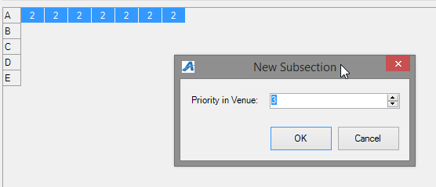
Image 11
- C. Next set your Inventory Group/Tier (multiple rows can be set at one time by the click and drag method over each seat included). (Image 12)
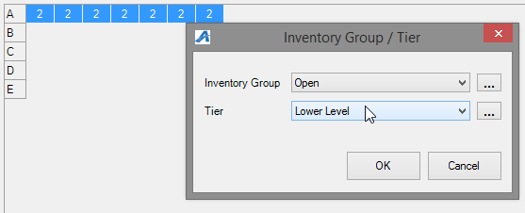

Image 12
- D. Apply and Save changes.

*Also if you were building a reserved map with tables AND seats you will want the tables to each be their own Section and then customer is able to pick a table with specific Seat. (Image 13)
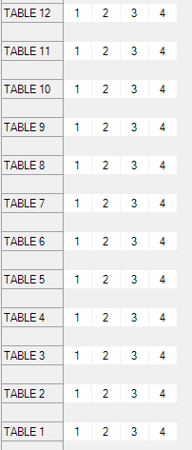Image 13

The following steps apply if you would like your seating chart to be Clickable online (this simply means a person will see your map image on the web and be able to click a specific seat to purchase).
10. Right click on section name, choose Properties, Images, then in drop down select 1) Manual Seating Image, click the 2) blue upload arrow if image has not yet been loaded, then 3) Add Image Map to begin node creation. (Image 14)
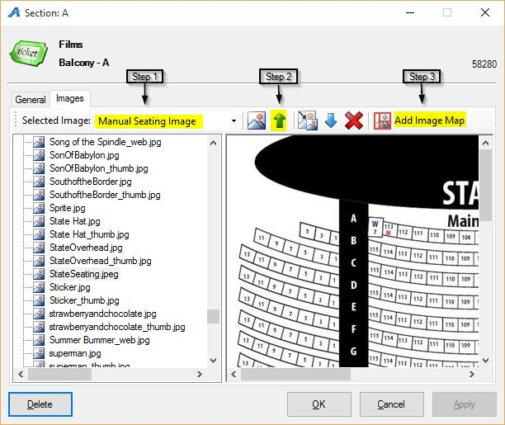
Image 14
11. Next the Image Map Editor window will appear. (Image 15)
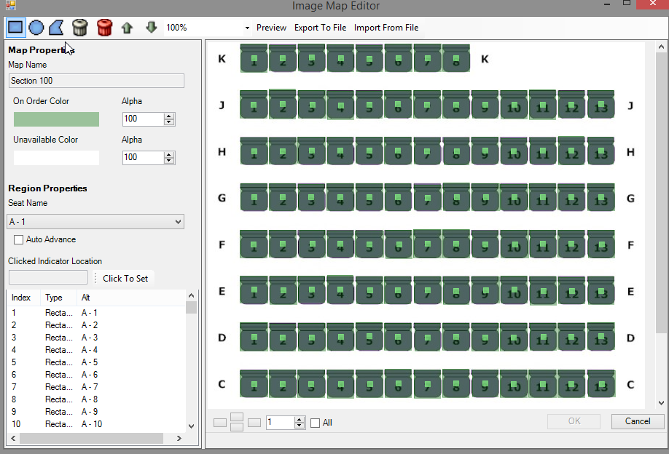
Image 15
- Choose from top menu bar whether your seats are shaped like a rectangle, circle, or polygon.
- In the bottom left box you will choose the first seat row and number, outline the same seat on the image by clicking & holding down the mouse until the entire seat is highlighted. This creates the node.
- Use the Zoom feature in top bar to make image appear bigger for easier selection.
- The On Order Color and Unavailable Color will help in designate Open and Sold seats when a customer is looking at the seating chart online.
- The Export To File can be used if you want to save node details to a xml file then later can be used to Import From File (ex. this is helpful if you need to make changes for the same map previously added to other templates or events).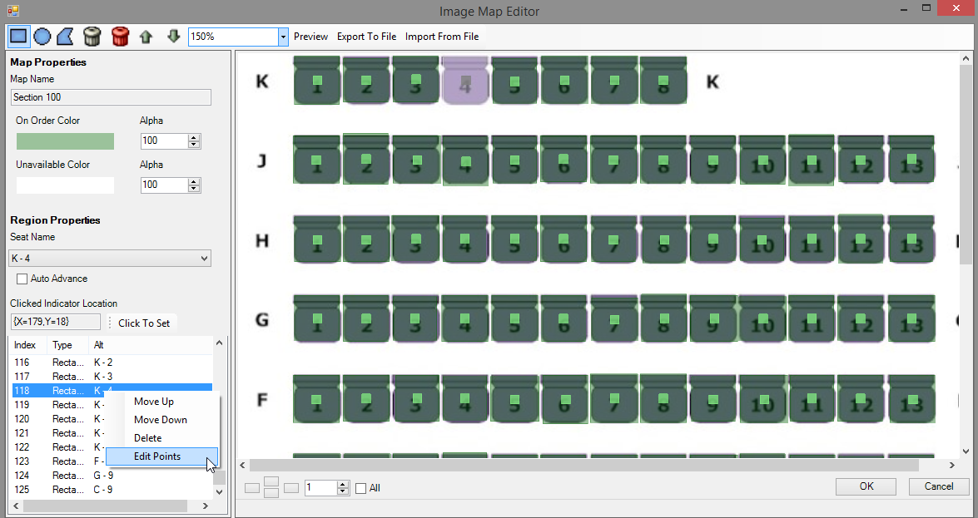
Image 16
- Right click on a Seat one by one if you need to delete, move, or edit points of your node.
12. In order to save changes click OK on Map Editor window then Apply in the next window. *We recommend doing this often in order to limit the loss of large amounts of node creation/edits.
13. We always recommend double checking your work in AMS as well as view the new Seat Map online before copying or setting event on-sale to public.

