Building Reserved Table Map
Reserved table maps are best applied to a setup where customers are purchasing whole tables and not specific seats at a table. If the latter is the case, we recommend building as Reserved Seat Map and using each Table # as a Section and then assigning a Row and Seat.
1. Log in to Administration
2. Select the Corporate Organization icon.
3. Select the Sales Organization folder then either the Template or the Event level. Once built here you can then copy up to the Physical Template under the Corporate Information area (if desired). (Image 1)
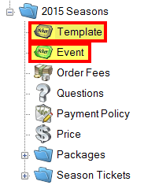
Image 1
4. You will need to set up your template or event with tiers first. See How to Build a Venue Template but stop at step 21.
NOTE: Important items for building a Template or Event
- The template cannot have General Admission button checked under the Tier. The General Admission box is check by default, so make sure you un-check the General Admission box before creating your seating chart..
- Table map seating does NOT work with GA.
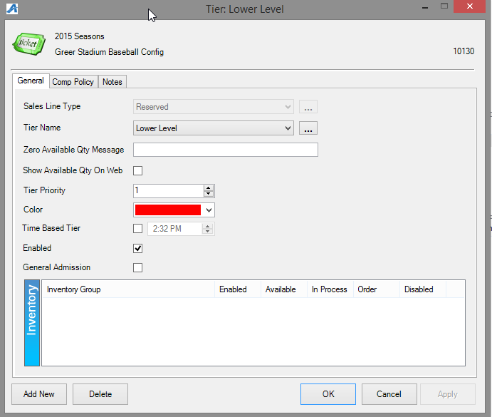
Image 2
5. The map will be built under the Physical tab. (Image 3)
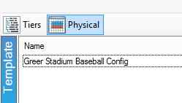
Image 3
6. Under Area right click and select New
- Enter the desired Area Name and Display Sequence number and click Apply. (The Display Sequence number allows you to choose the order of which the Area should display on the Seating Chart.)
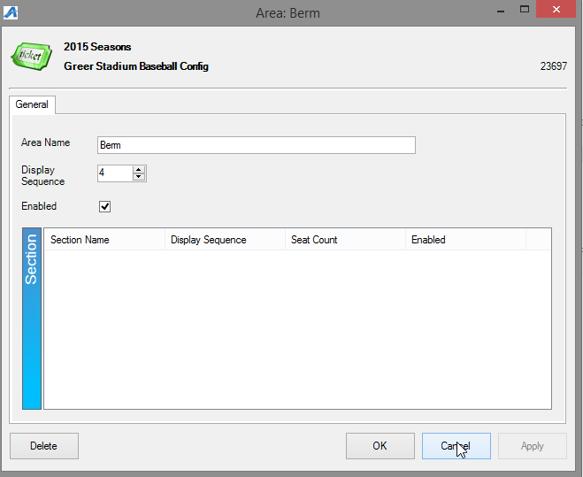
Image 4
- In Section area right click and select New.
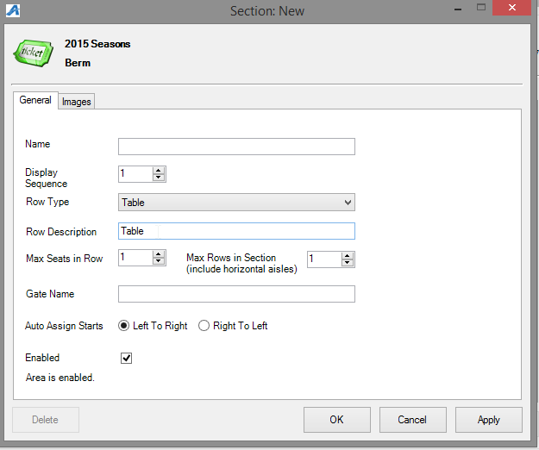
Image 5
A. Enter the Name of the Section.
B. Display Sequence refers to display order. (Image 5)
C. This is where you select Table for your Map Type. (Image 5)
D. Name or number your table in the description. (Image 5)
E. Max Seats in Row refers to most number of seats in a table. (Image 5)
F. Max Rows in Section will determine number of columns you can build later. (Image 5)
7. Hit Apply and OK.
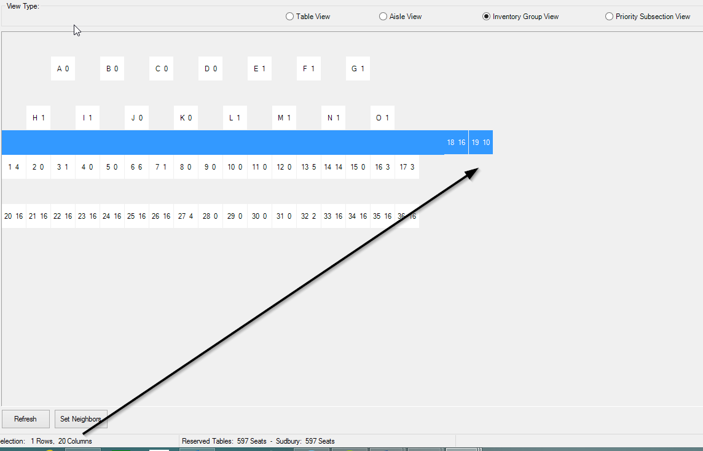
Image 6
8. Right click in Section on the Section Name to Properties then Images tab select Manual Seating Image in the Selected Image drop down box. (Image 6)
- Here you will Upload local image which will be the overlay map image viewed on the web. (We recommend this image to be clearly labeled with coordinating table names.) (Image 7)
- Upload and Save.
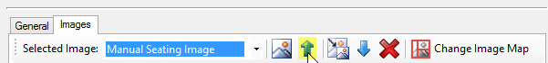
Image 7
8. To build the physical map right click and choose Seat Maintenance. (Image 8)
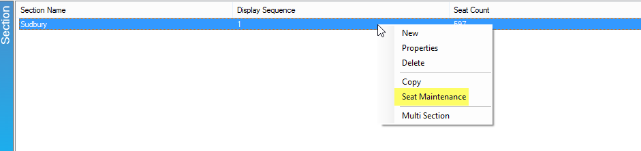

Image 8
9. There are two ways to enter in the tables names:
Option A:
1) Right click on the square you want your first table to be and select Create/Modify (Image 9)
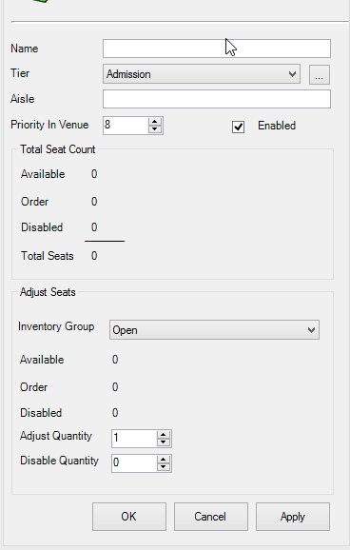
Image 9
- Name: Enter in the name of your table here (i.e. Table A or Table 1)
- Tier: Select the correct Tier for this table.
- Aisle: Mainly shows up on ticket formats to direct customers to what aisle to use to get to their seat. (this is optional)
- Priority In Venue: Sets the priority of when tables are sold if using auto-assign.
- Adjust Seats: Choose the correct inventory group from the drop-down, then enter in the number of available seats in the Adjust Quantity box, then if applicable, the number of disabled quantity in the Disable Quantity.
2) Click Apply, then OK.
Repeat the bullet points above for each table.
Option B:
1) Highlight the entire area of the map, right-click and select Assign Table Names.
- Name: enter in the name of the tables followed by a '%' sign. For example, if 'Table %' is entered in, then the table names will be Table A, Table B, Table C, etc.
- Choose either Numeric or Alpha if for the table names.
- Left to Right assigns the tables from the left to the right.
- Spacing: How many spaces are left in between each table. Note: It's always recommended to create a space between your tables (i.e. Table A [space] B [space] C). This helps ensure the auto-seat function will work properly. Once created, and if using auto-seat, set your ‘neighbors’ by assigning which tables are near in case of spill-over from table to table.
- Up to Down assigns the tables from the top to the bottom.
- Spacing: How many spaces are left in between each table.
- Start Value: Enter in the character the first table should begin with.
- Click Apply, then OK.
2) With the same area highlighted, right click and select Set Priority. If different priorities should be set, a smaller area may be selected and different priority numbers entered.
3) With the same area highlighted, right click and select Set Inventory Group Tier. Select your Inventory Group and your Tier, and hit OK.
4) With the same area highlighted, right click and select Manage Inventory. Select the Inventory Group you want to add. Then select the table you want to adjust the inventory for and edit the number in the Adjust tab. Then hit Adjust. When you are done hit Close.
5. Hit Apply and OK.
The following steps apply if you would like your seating chart to be Clickable online (this simply means a person will see your map image on the web and be able to click a specific table to purchase). While they can select the table, the actual seats at each table will be unassigned seat numbers.
10. Right click on section name, choose Properties, Images, then in drop down select 1) Manual Seating Image, click the 2) blue upload arrow if image has not yet been loaded, then 3) Add Image Map to begin node creation. (Image 10)
- Choose from top menu bar whether your tables are shaped like a rectangle, circle, or polygon.
- In bottom left box you will choose the table and number, outline the table on the image by clicking & holding down the mouse until the entire table is highlighted. This creates the node.
- Use the Zoom feature in top bar to make image appear larger for easy selection.
- The On Order Color and Unavailable Color will help in designate Open and Sold tables when a customer is looking at the seating chart online.
- The Export To File can be used if you want to save node details to a xml file then later can be used to Import From File (ex. this is helpful if you need to make changes for the same map previously added to other templates or events).
- Right click on a table one by one if you need to delete, move, or edit points of your node.
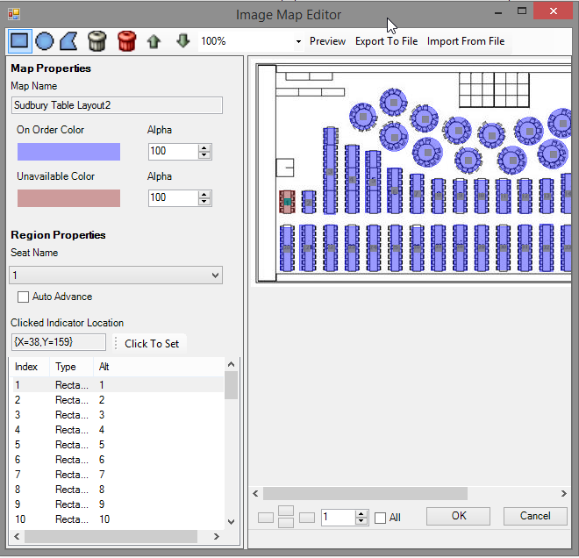
Image 10
11. In order to save changes click OK on Map Editor window then Apply in the next window. *We recommend doing this often in order to limit the loss of large amounts of node creation/edits.
12. We always recommend double checking your work in AMS as well as view the new Table Map online before copying or setting event on-sale to public.

