Adding a Venue Address
1. Log in to Administration.
2. Click on the Corporate Organization icon.
3. Select the Corporate Information folder.
4. In the Corporate Information folder click the Venue icon. (Image 1)
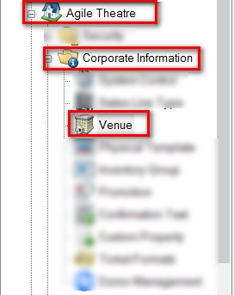
Image 1
5. Right click in the Venue area and select New.(Image 2)
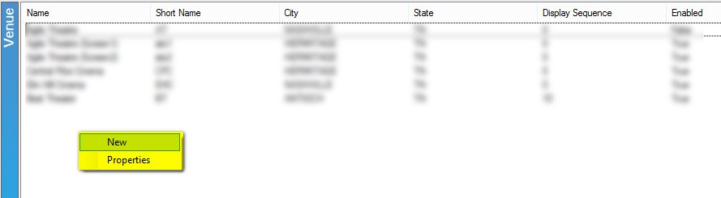
6. The Venue:New window will appear. This is where you will input all of the information about the venue.
GENERAL TAB
A. Internal Name is the name that will appear in AMS Sales at the Box Office. (Image 3)
B. External Name is the name of that will appear to the customers online. Make sure to use the proper name of the venue hear. (Image 3)
C. Short Name this is an abbreviated name for the venue.(Image 3)
D. Address 1 & Address 2, City, State and Zip/Postal Code should be the physical address of the venue.(Image 3)
E. Display Sequence should be the order you want the venue to display online. (Image 3)
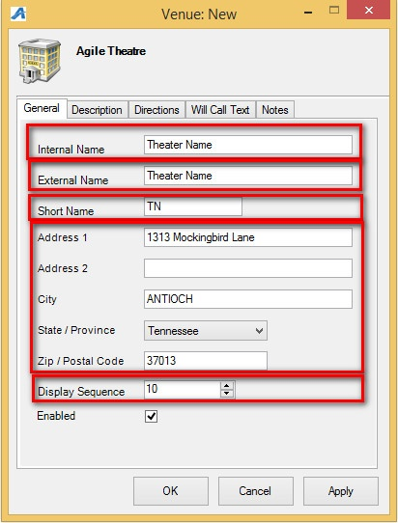
Image 3
DESCRIPTION TAB
7. The Description Tab allows you to add any descriptive information about the venue.(Image 4)
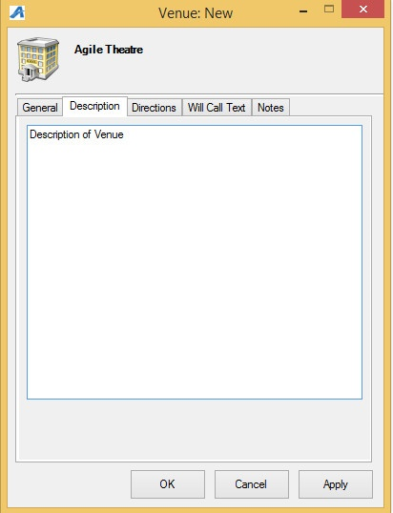
Image 4
DIRECTIONS TAB
8. Directions URL allows you to embed a map link to your venue.(Image 5)
9. Directions Text allows you to add step by step directions to the venue. (Image 5)
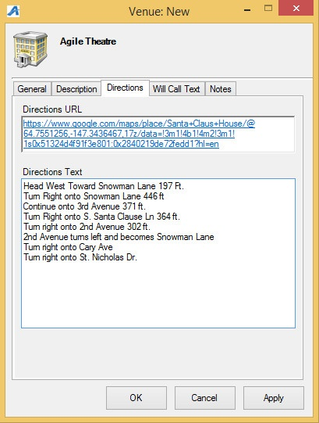
Image 5

WILL CALL TEXT TAB
10. Add Will Call information that will appear on the confirmation email when a customer makes a purchase (i.e. Will Call opens two hours prior to show time. Must bring a picture ID, etc.) (Image 6)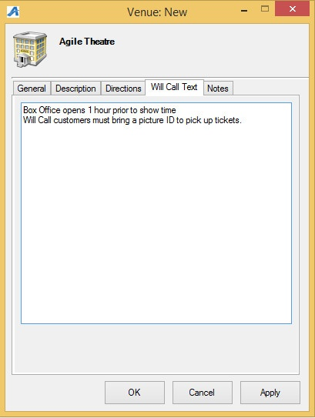
Image 6

