Creating a Service Fee
1. Log In to Administration. (Image 1)
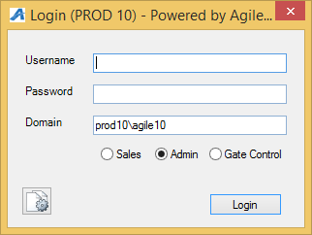
Image 1
2. Select the corporate organization. Open Pricing folder and select the Service Fee icon. (Image 2)
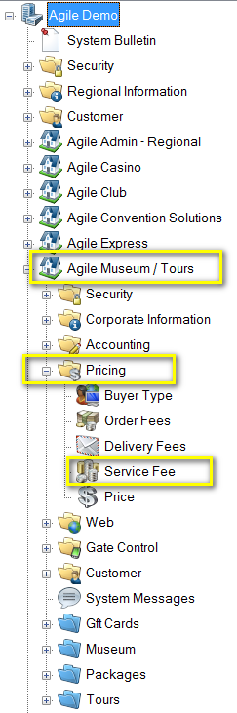
Image 2
3. Right click in the Service Fee area and select New. (Image 3)
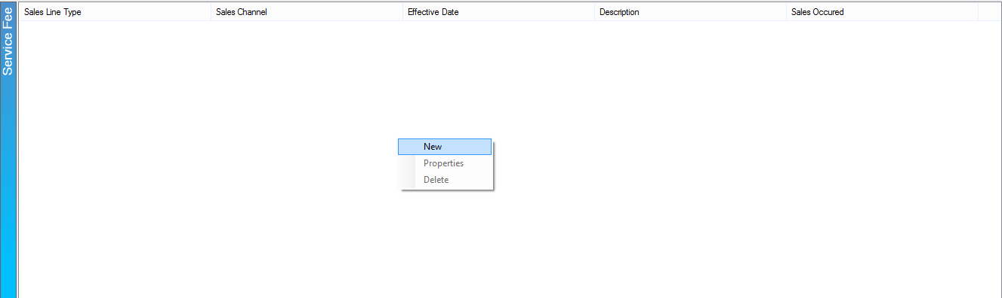
Image 3
4. In the new screen you will need to select Sales Line Type, Buyer Type, and Description. Once those fields have been filled out right click in the lower area and select Add Price Point. (Image 4)
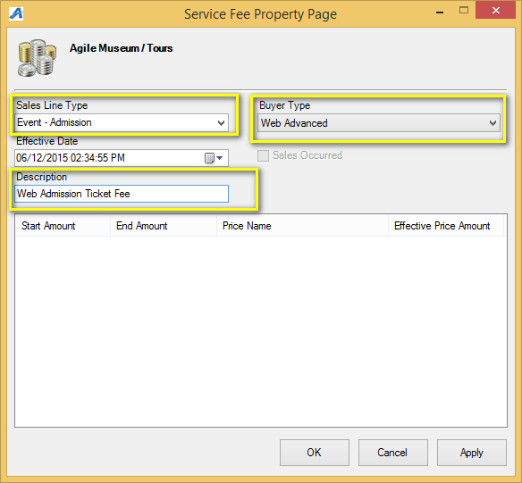
Image 4
5. In the next screen you will need to add the beginning Price Point Amount. Right click in the window and select New Price. (Image 5)
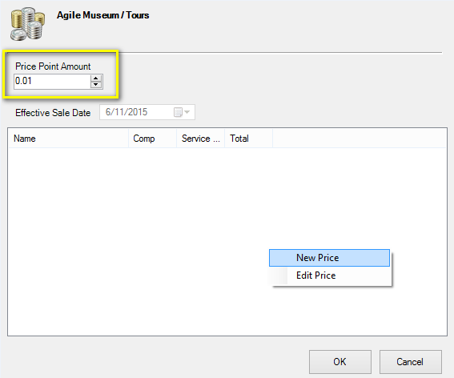
Image 5
6. A new screen will appear and this is where you will name you new price. You will then click Apply and OK. (Image 6)
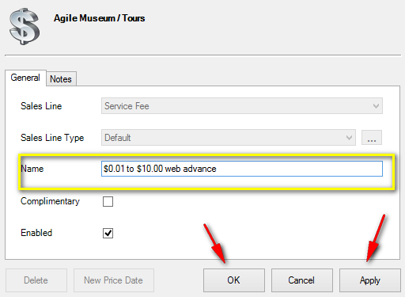
Image 6
7. The Price Distribution screen will appear open. Right click within the window and select New. (Image 7)
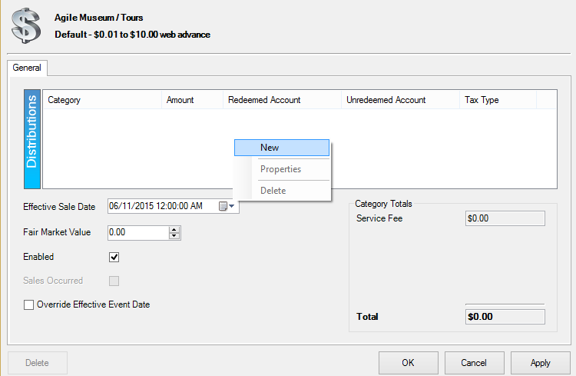
Image 7

8. Enter the Amount,and select the Unredeemed Account and Redeemed Account. You will then click Apply to save and Ok to close the screen. (Image 8)
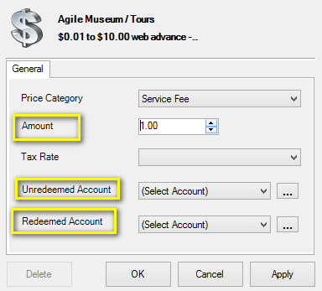
Image 8
9. You will now be able to see your price set up in the Price Distribution screen. Click OK to close the screen. (Image 9)
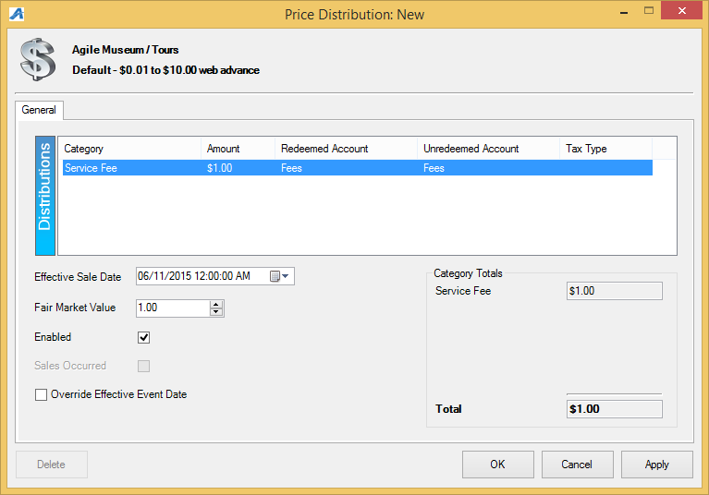
Image 9
10. You will see the first price point in your Service Fee list if you need to add another price point repeat steps 4 through 8 to add additional pricing . (Image 10)
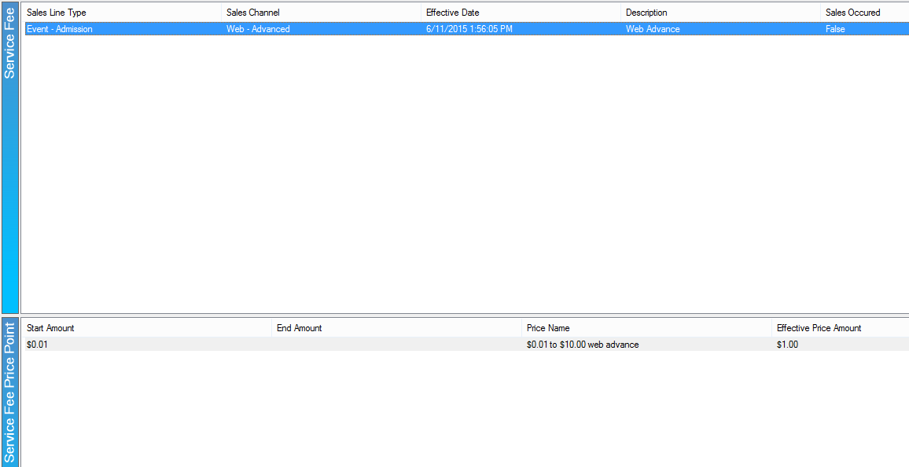
Image 10

