Creating User Names For Your Staff

As a System Administrator, you are able to set up your staffs' Agile log in information and assign permissions to their user role.
1. In Administration, Click on the Corporate Organization icon (see image) to see all of your administrative folders.
2. Click and open the Security folder.
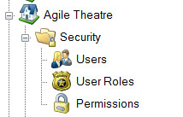
3. Under the Security folder, select Users.
4. Right click and select New.
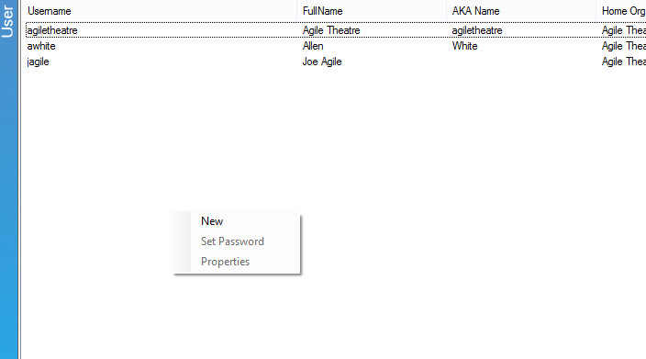
5. The User: New pop up screen will appear.
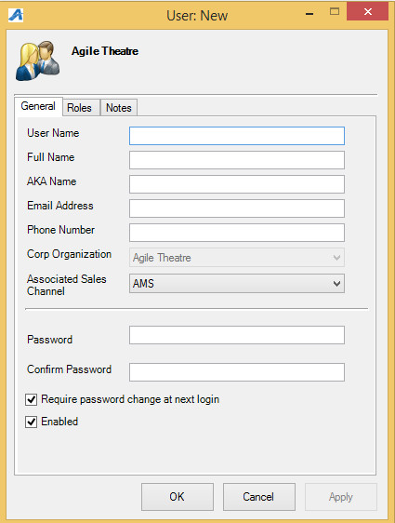
6. Create a User Name.
NOTE: Usernames must be at least 6 characters long. (For this example we used the first initial of his first name and his entire last name).
7. Next, Enter their Full Name
8. Enter their Email Address
9. Create a Password.
NOTE: You should create a temporary password when you are setting up a new user. Make sure to have Require password change at next login checked (see image). This will force the user to create a new password that only they will know. Passwords must be at least 8 characters long, and must have at least (1) uppercase alphabetic character and at least on numeric character. They will be required to change their password every 90 days.
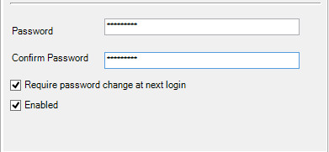
10. Once you have their user information filled out on the General tab, click on the Roles tab.
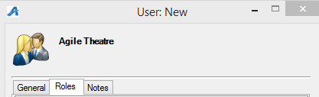
11. You will see a list of Roles to choose from. Check the appropriate Role for this user (i.e. System Administrator, Manager, Cashier, etc.).
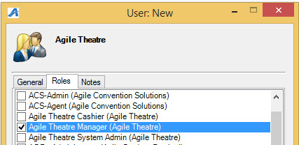
12. Once you have completed filling out this form, click Apply and then OK to close the screen.
13. Your staff member is now ready to log in with their new credentials.

