Catalog Items can be used to create Merchandise or Concessions inventory to sell through AMS. Use these steps to create concession and merchandise items in Administration.
1. In Administration, click on your Corporate Organization icon.
2. Click on your Sales Organization icon that has been set up for your concessions or merchandise items. NOTE: Check with your system administrator to confirm which Sales Organization(s) these items need to be built.
3. Once you are in the correct Sales Organization folder, double click on the catalog icon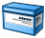 to start entering your items.
4. The Product area is where you will input all of the different types of items. To add an item; right click in white space and select New (See Image 2).
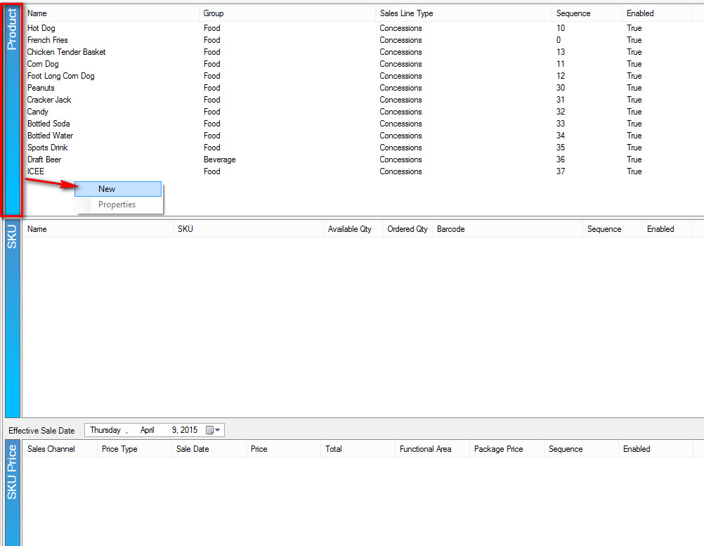
Image 2
5. A Catalog Product window will appear. (See Image 3).
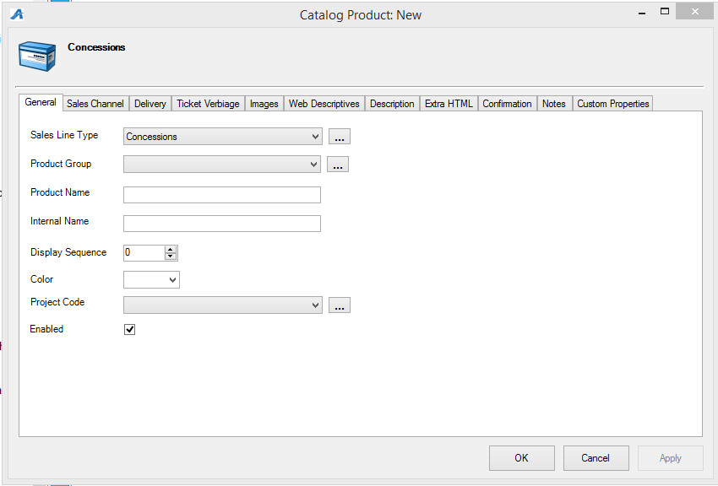
Image 3
A. General Tab
Sales Line Type: A Sales Line Type defines the actual items being sold. A Sales Line Type is established under a sales line to define what is being sold regardless of the underlying mechanics (Sales Line) being used to process the sale. Select the correct Sales Line Type from the drop down. If there isn't a category in the drop down, click on the Ellipsis button to the right of the drop down and create a new Sales Line Type category. (See Image 4).
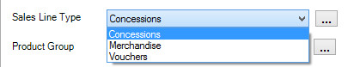
Image 4
Product Group: Product Group allows you to group like items together (i.e. Popcorn, Cookies, Candy are all items that can be grouped together under the Product Group "Food" )(See Image 5).
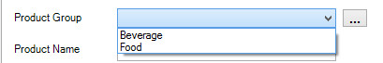
Image 5
Product Name: This is the actual name of the item. The Product Name should be the true title or name of the item that will appear if you sell this item online.
Internal Name: This is the name of the item that will appear in AMS or in the POS screen at the box office or concessions stand.
Display Sequence: Display Sequence allows you to assign a sort order number to list the item in the box office or online.
Color: You can assign a color to an item that will designate the item button on the POS screen. (i.e. T-shirts are assigned the color blue and the button on the POS screen will appear blue).
B. Sales Channel Tab
This is where you will select the on sale Start Date and End Dates as well as selecting the Sales Channels that you want the items to be available for purchase. Check mark the Sales Channel(s) and set the dates and times for sales (See Image 6).
NOTE: If this is a concession item, AMS Box Office will be the only box you want checked as most organizations do not sell concession items through the web.
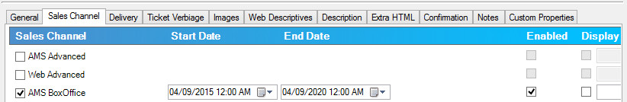
Image 6
C. Delivery: move the desired forms of delivery from the left side to the right side by selecting them and then clicking on the ">" to move it over or by simply double clicking the item.
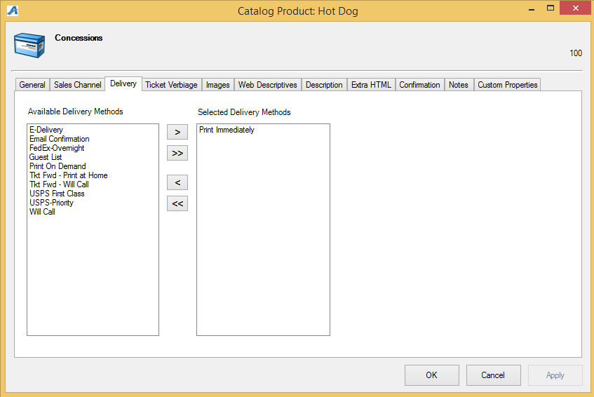
NOTE: Concession items should be set to Print Immediately since this is the default and the customer will get the item at the time of order. Merchandise ordered online may require the item to be mailed, so you will need to select the proper form of delivery for those items.
D. Ticket Verbiage: This tab is generally not used for merchandise or concessions. If you are using catalog for ticketing items, please contact your system administrator about your verbiage needs.
E. Images: Upload a picture of the item as a visual aid. Images uploaded in the product setup will appear both online and as an image on the POS button for that item. (See Image 7).
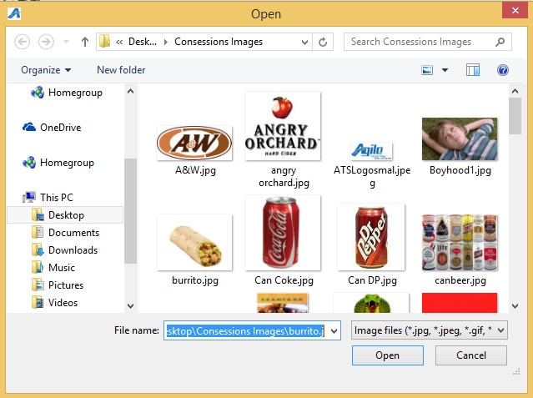
Image 7
F. Web Descriptives: If selling merchandise online you would add a description of the item here (See Image 8).
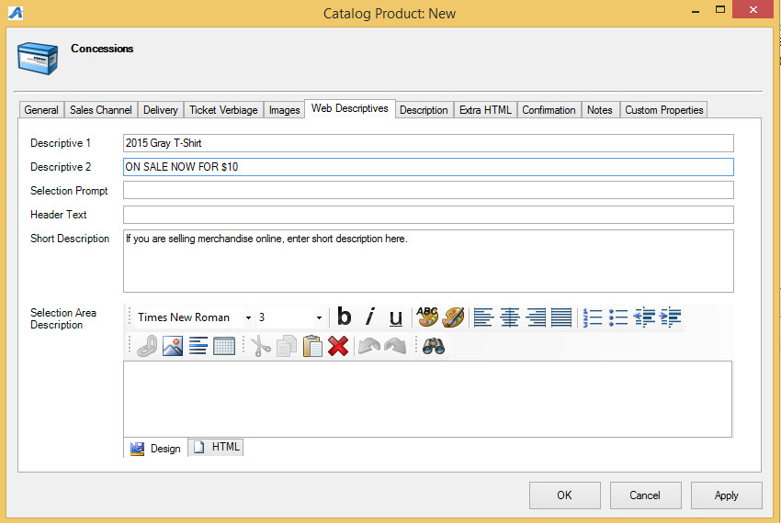
Image 8
G. Description: You can add a longer description here about the product (See Image 9).
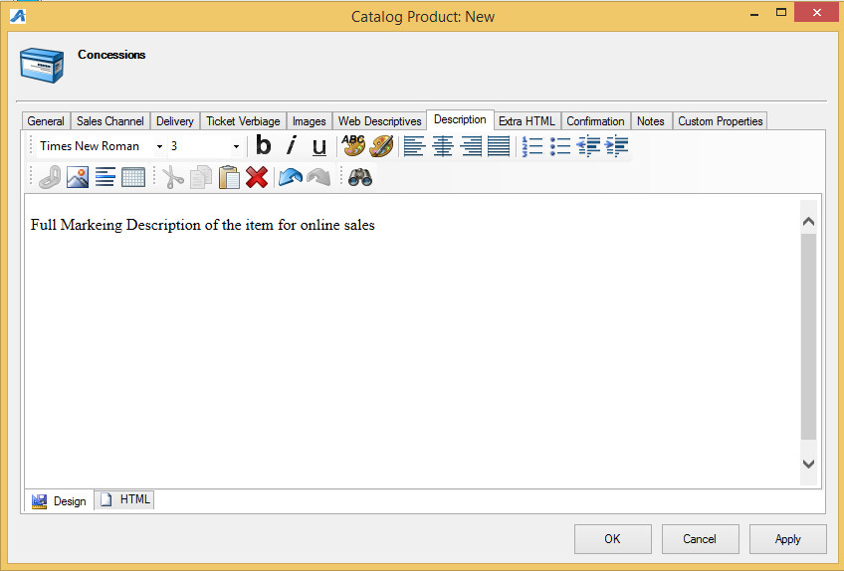
Image 9
H. Extra HTML: This are allows you to have more description text if you use all of the character limitations in the description area. (See Image 10).
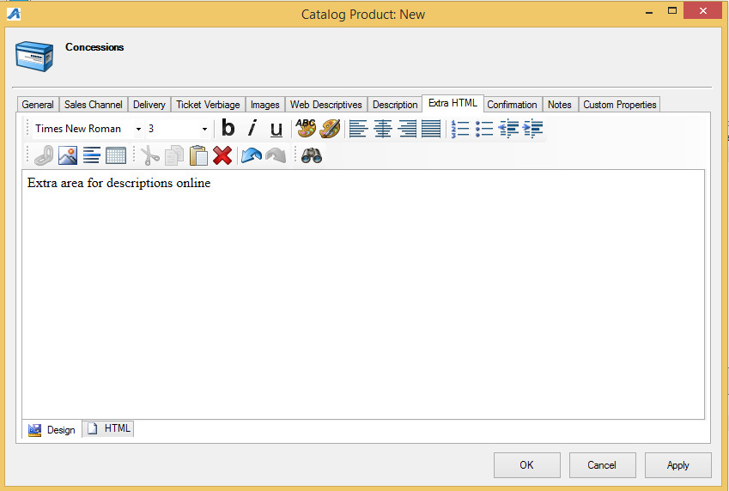
Image 10
I. Confirmation: This is where you can add information about the item which will be emailed to the customer once an order has been finalized (generally only used for items sold online) (See Image 11).
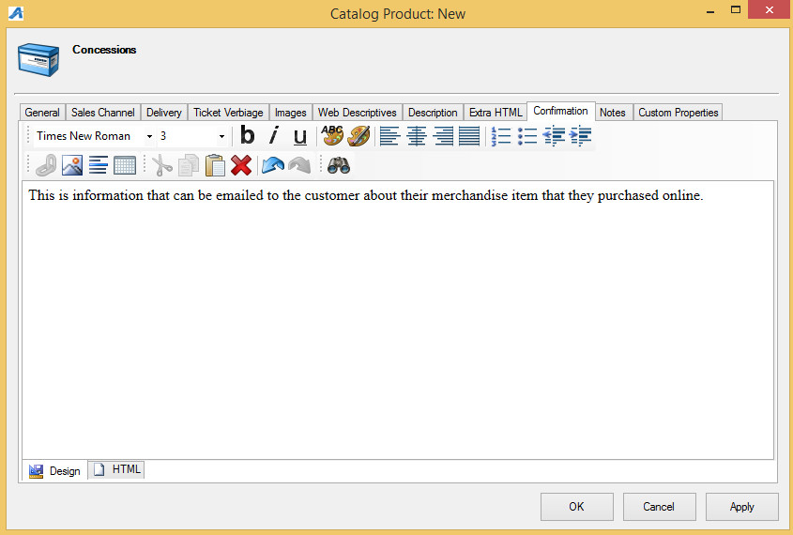
J. Notes: The Notes tab allows you to add any special notes about the item. Notes only appear in the Administration area. Customers do not see these notes.
K. Custom Properties: This is generally used for events or shows. If you think you will need to use Custom Properties for catalog events, please contact your System Administrator for further instructions.
Once you have completed the product information, you are ready to set up the SKU/ Inventory.
6. Highlight the item in the product area and then right click in the SKU section and select New (See Image 12).
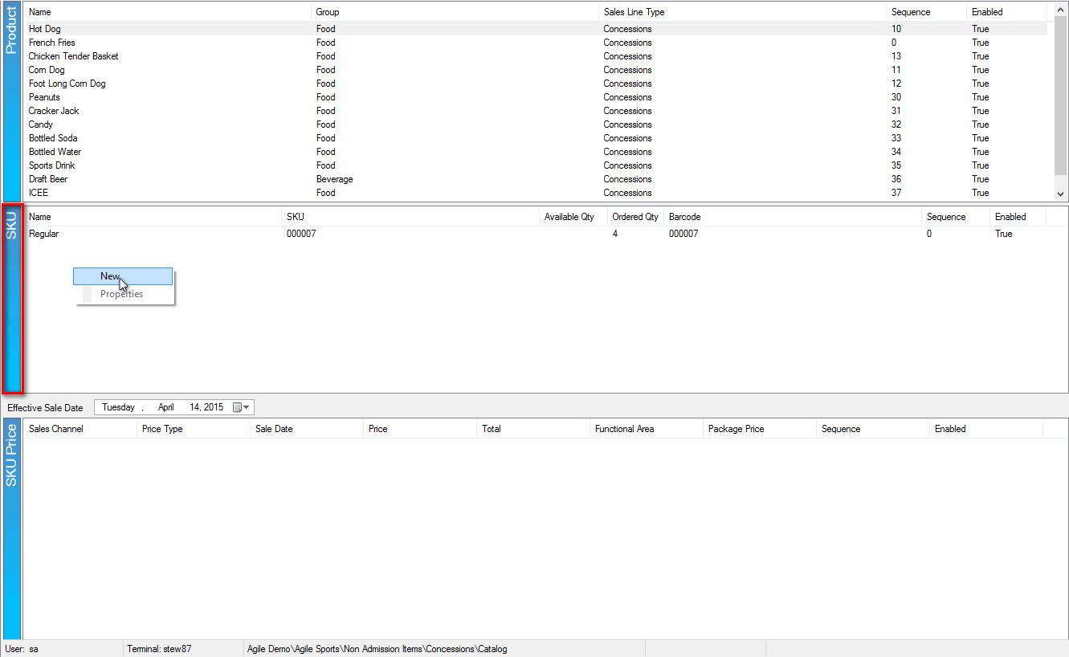
Image 12
7. The Product SKU window will appear. (See Image 13).
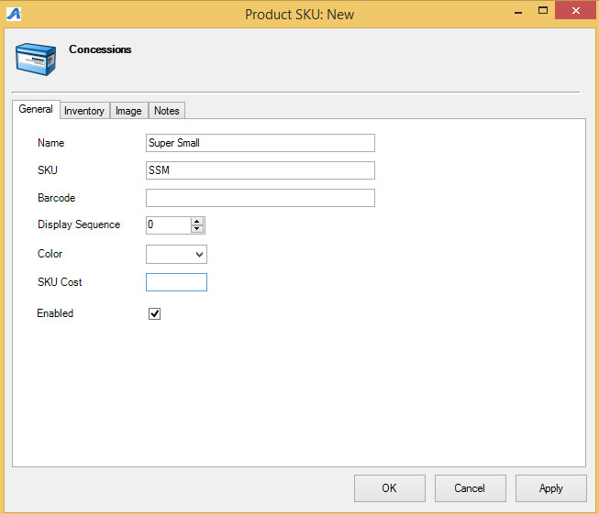
Image 13
A. General Tab
This is where you will name the specific grouping for this item (i.e. Small, Medium, Large, 16 oz, 24, oz. etc.)
B. Inventory:
This is where you will set up inventory for your item
(See Image 14).
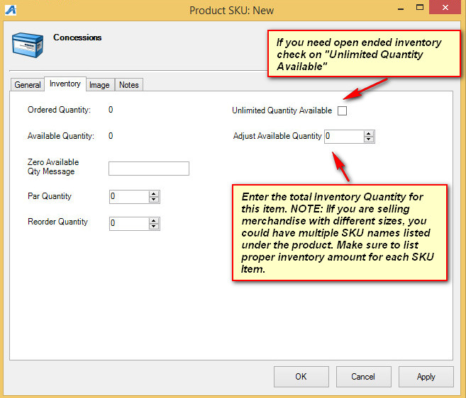
Image 14
C. Image: You can upload a picture of the item as a visual aid on the POS screen.
D. Notes: This is where you can put information or notes just for your staff (i.e. Vendor information on where you order this item when you are out of inventory).
9. The SKU Price is where you will create the prices for each item you wish to put on sale (See Image 15).
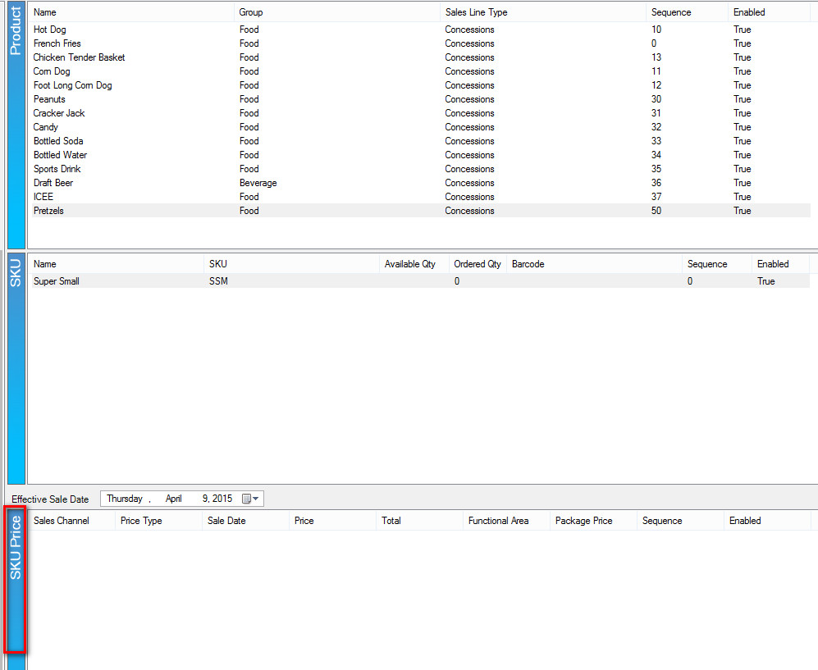
Image 15
10. Highlight the Product and SKU for the item that needs prices built. In the SKU Price right click and select NEW. (Image 16)
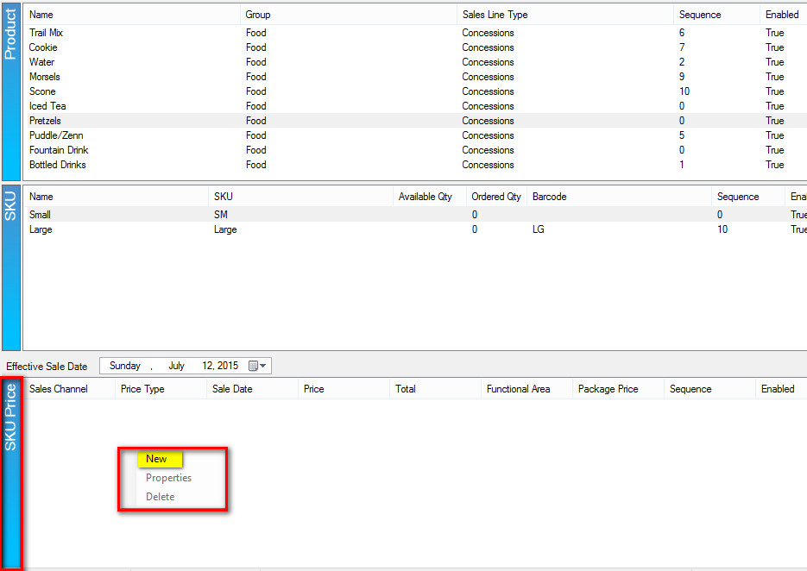
11. The Product Price window will appear. In the Product Price List select the price that you would like to add OR right click and select New Price to create a new price for your product. (Image 17)
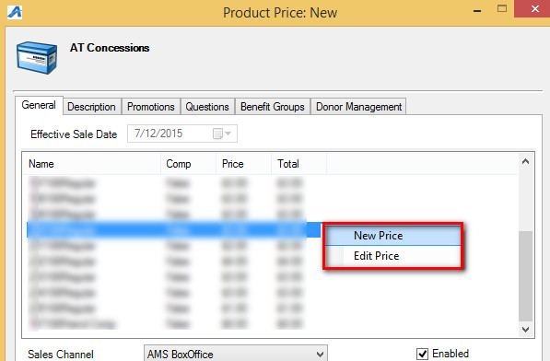
12. If building a New Price, the Price: New window will appear. Name the Price and click OK.
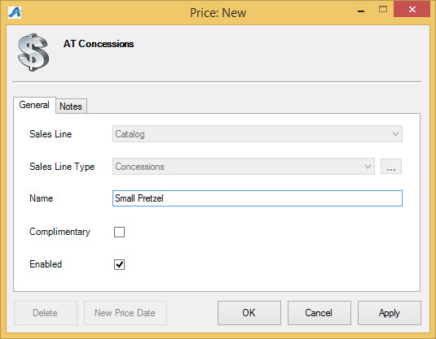
13. In the Price Distribution pop up window, right click in the Distributions field and select New.
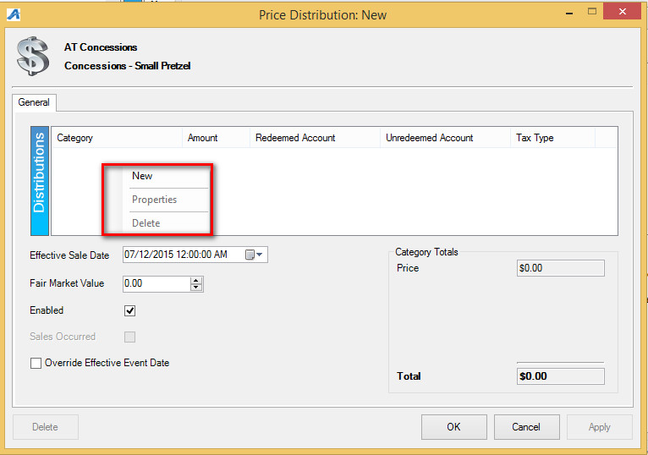
14. In this window, you will need to select the Price Category, add the Price Amount and then assign to the Redeemed and Unredeemed Distribution Accounts. NOTE: If you are required to collect sales tax, you will also want to choose the Tax Rate when building a price. Click OK.
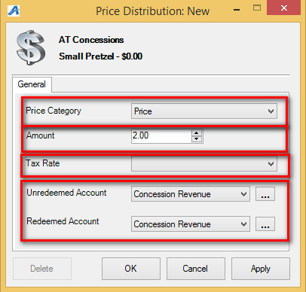
15. In the Price Distribution screen, confirm that the price is correct, the Effective Sales Date is selected to the correct date and then click OK to close this screen.
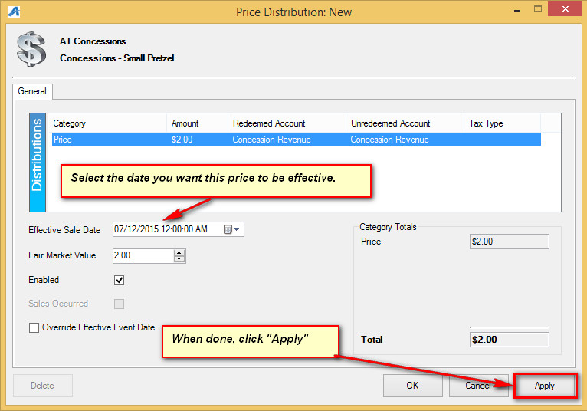
16. Highlight the price from the Product Pricing list.
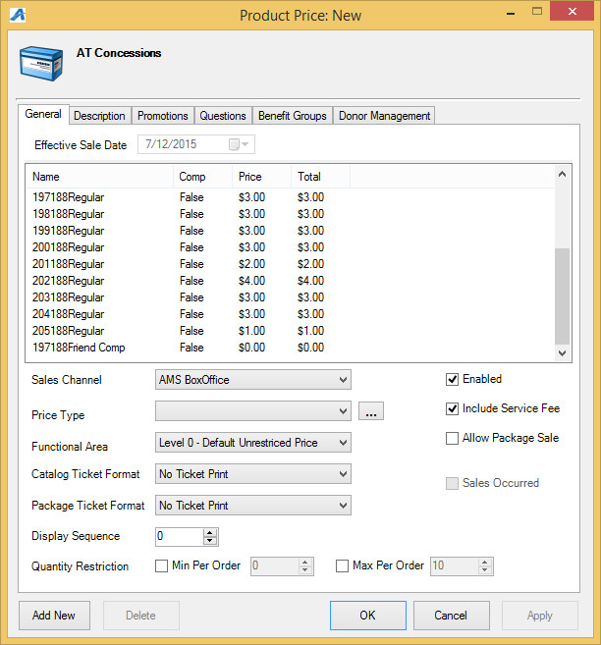
17. Choose the Sales Channel, the Price Type, and the Display Sequence to complete building the Product Price. Click OK to close the window.
