How to Password Protect your Entry Point URL
Clients can now password protect a specific Entry Point URL. This will keep the specific URL hidden from general public view while allowing you to proof and perform live tests for this specific Entry Point when you enter the password.
- Log into Administration
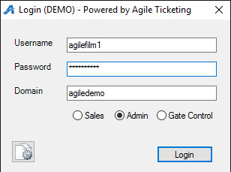
- Click on the Corporate Organization icon
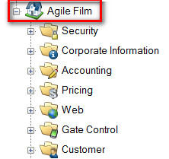
- Select the Web folder
- Click the Entry Point icon
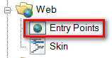

- Select and highlight the Entry Point Group
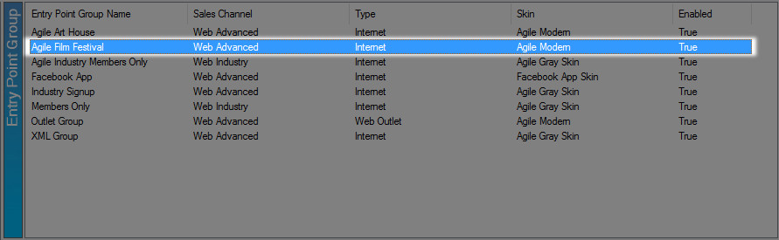
- Right click and select Properties on the Entry Point you wish to password protect.
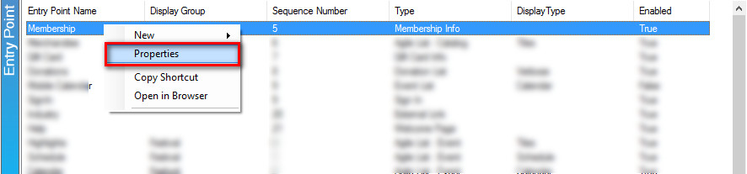
- In the Passcode field, enter the password that you wish to use during the testing process. The password must be between 6 and 16 characters long.
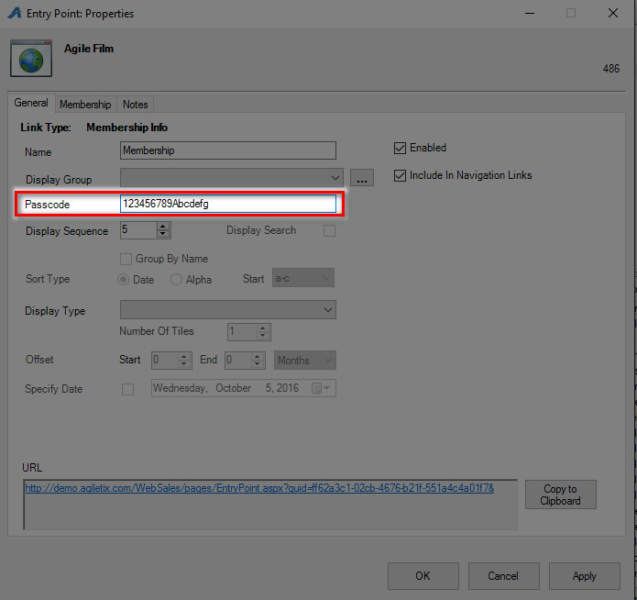

- Once completed, click Apply and OK to save and close the window.
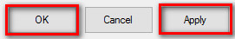

- When you are ready for your Entry Point to be available without the Password, simply repeat Steps 1 through 6 and then remove the Password from the Passcode field.

