How to Password Protect your Entry Point Group

You can now password protect your Entry Point Group so that any of your live Entry Point URL's can be hidden from general public view while still allowing you to proof and perform live tests on your online ticketing pages by entering in the password.
- Log into Administration.
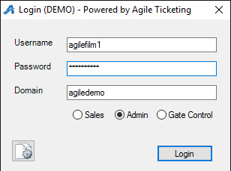
- Click on the Corporate Organization icon.
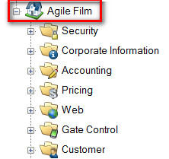
- Select the Web folder

- Click the Entry Point icon
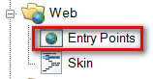
- Right click and select Properties on the Entry Point Group you wish to password protect.
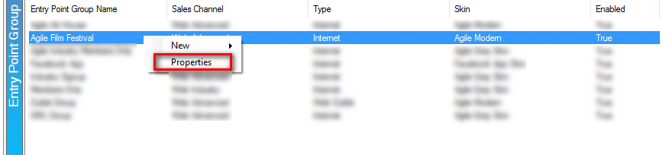
- In the Passcode field, enter the password that you wish to use during the testing process. The password needs to be between 4 and 10 characters long.
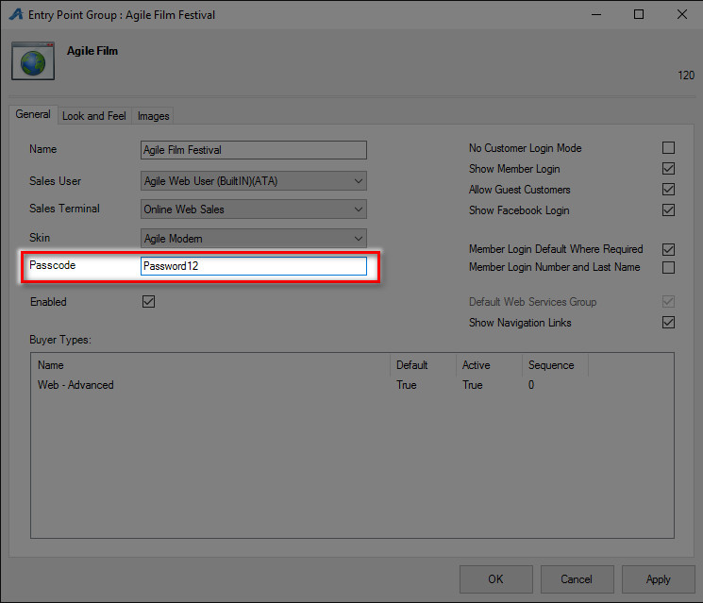

- Once completed, click Apply and Ok to save and close the window.
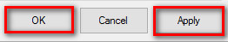
- When you are ready for your Entry Point Group to be available without the Password, simply repeat Steps 1 through 5 and then remove the Password from the Passcode field.

