Cashing Out in AMS Sales and close out a Daily User Batch
Each organization has their own cash handling policies. The cash handling information listed below, along with the instructional steps on closing out your Daily User Batch at the end of your shift, are suggested best practices that Agile has found to be useful for our clients. ALWAYS follow your own organizations policies and procedures when handling cash. If you do not know what your organizations policies are, contact your manager for standard operating procedures.
- Ping your Cash Drawer to count total cash in the drawer (Agile recommends pulling the drawer out of the register and counting the money in a secure room away from customers).
- Click on Action in the menu at the top of the screen. Then select Agent/Cash In/Out (see image 1).
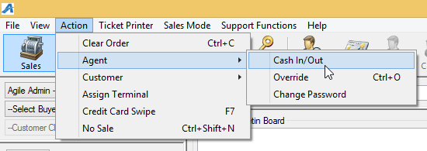
Image 1.
- The Agent Cash In/Cash Out pop up screen will appear (See Image 2).
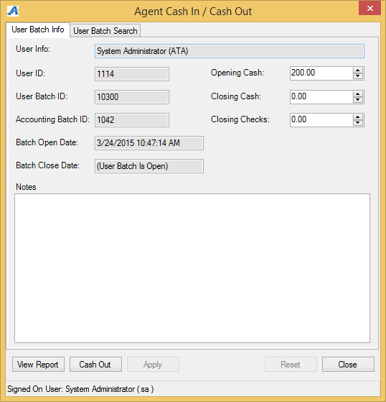
Image 2.
- Once counted, enter the total cash that is in your drawer in the Closing Cash field at the top of the screen (See image 3).
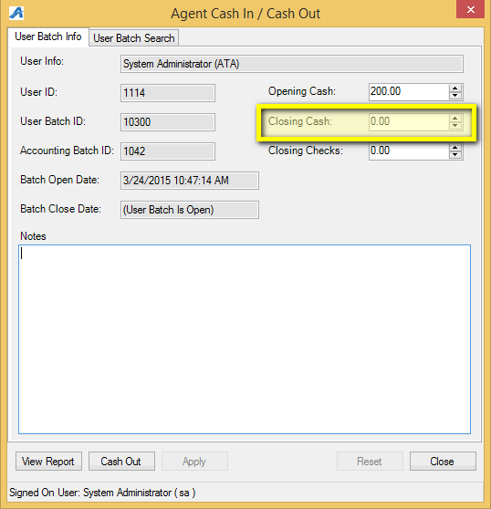
Image 3.
- If you took any checks as payment, enter those in the Closing Checks filed (See image 4).
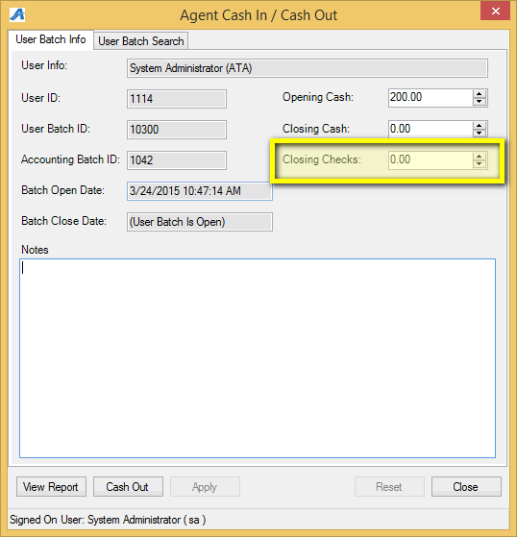
Image 4.
- Once you have entered your closing information, click on Apply at the bottom of the screen to save your information (See image 5).
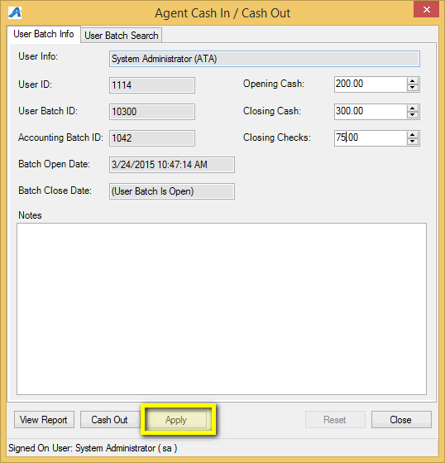
Image 5.
- Click View Report to open your User Batch Audit report for the day (See Image 6).
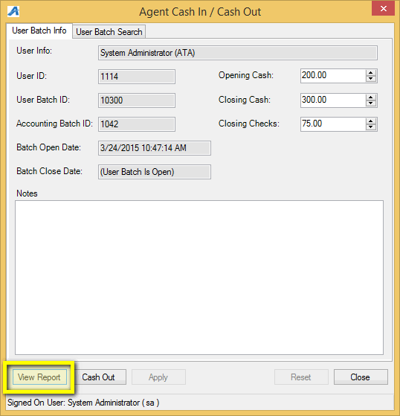
Image 6.
- At the top of the User Batch Audit report, you will see the Reconciliation summary that will show your Opening Till, your Closing Till, Total Sales ,Total Cash to be accounted for, and if you are over, short or balance (See image 7).
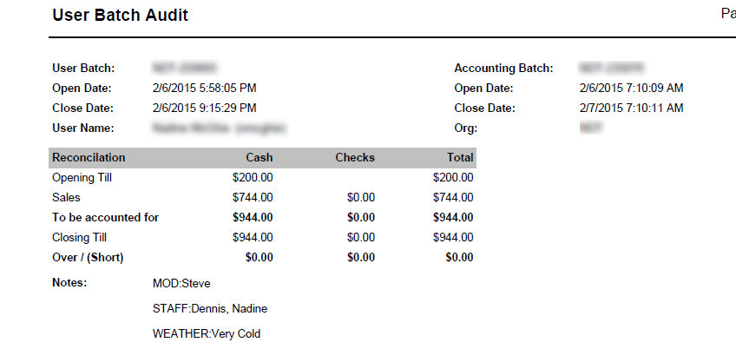
Image 7.
NOTE: If your drawer does not balance, it is recommended you figure out why and type in the notes field the reasoning and also explain to your supervising manager why you are not balanced.
- Once you balance, go back to your Cash In/Out window and click on the "Cash Out" Button (See image 9).
