Re-sending Print at Home Tickets
1. Log in to Sales.
2. Select Maintenance.
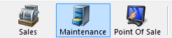
3. Search for the customer by entering the Order # or the customer’s Last Name. Then click the appropriate green check mark.
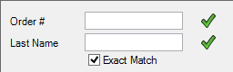
4. Double click the correct order to bring up the customers purchased contents on the Item Summary page.
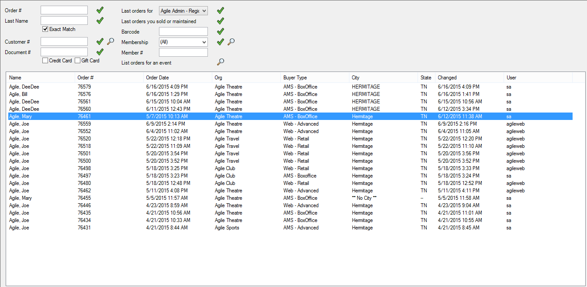

5. Once in the Item Summary page, select the tickets you would like to email out.
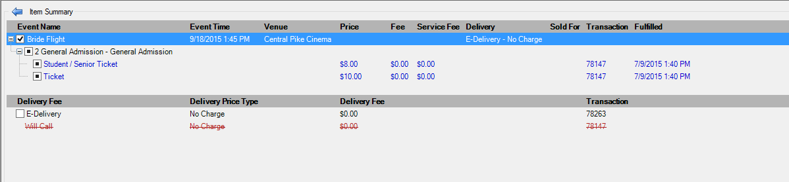
6. Then at the bottom of the page, select the Print at Home tickets button.
7. The Print At Home Options will pop up. The customer's email address should automatically populate in the Send To field if it has been entered in the customer record. If the email address does not appear, you can enter the email address prior to sending the confirmation. In the area labeled Message you can write a customize message that will be included on the print at home tickets for that customer only.
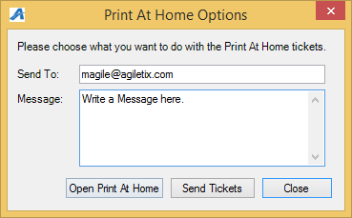
8.If you wish to see the print at home tickets before you send it out click the Open Print At Home button.
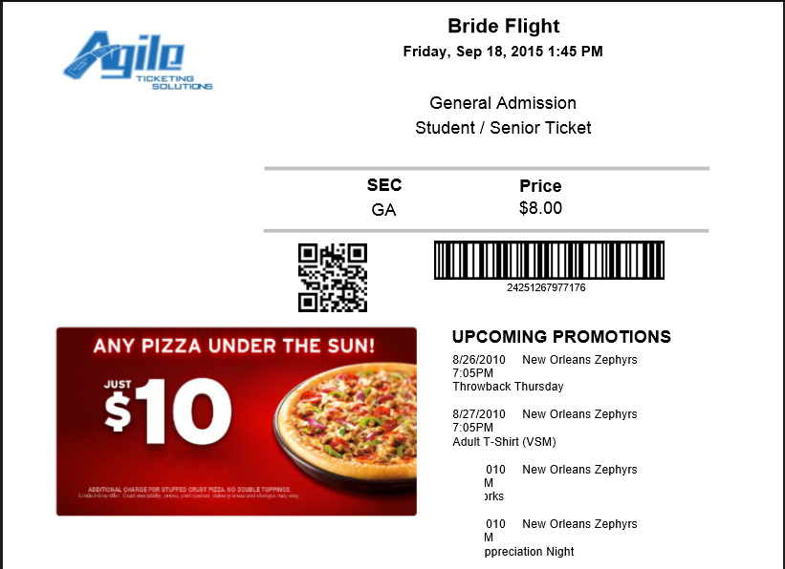
9. To send the Print At Home Tickets, press the Send Tickets button.
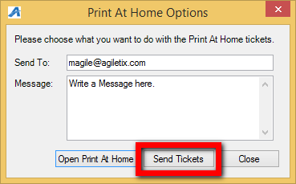

8. You will see a pop up that confirms that the email was sent. (Image 8)
