Exchange/Sell Tickets for an Event Passed
1. Log in to Sales.
2. If making an exchange, click on Maintenance 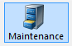and search for the Order Number you need to exchange. Otherwise go to step 3.
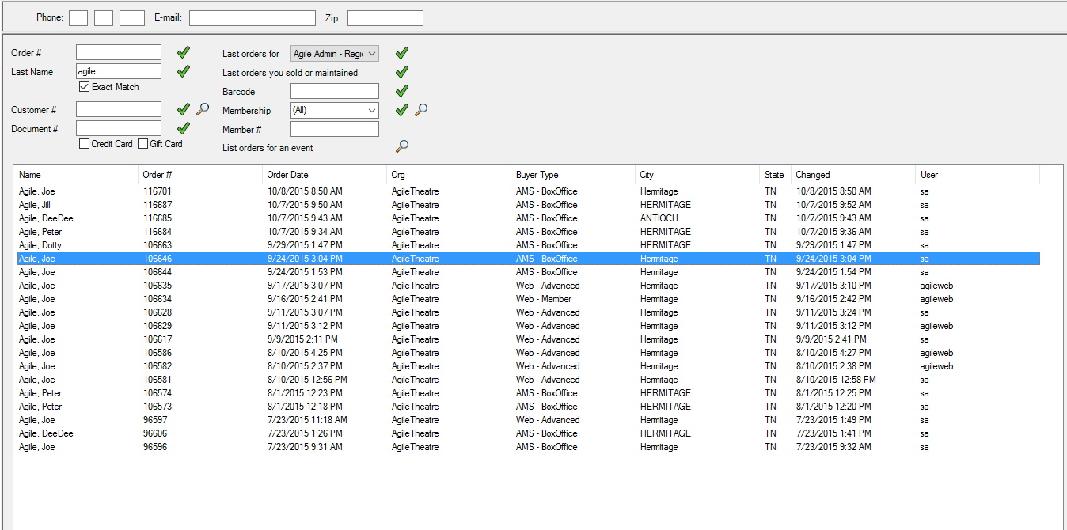
3. Click on the Event tab and the correct heading below.
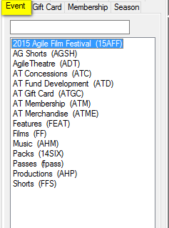
4. In the Start Date, back date it so it catches the event.
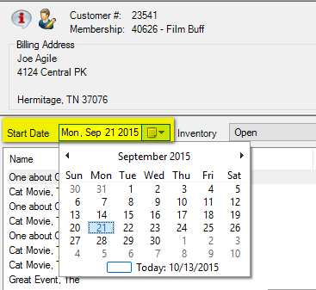
5. Click on the event and at the bottom of the screen, click Allow Sale.
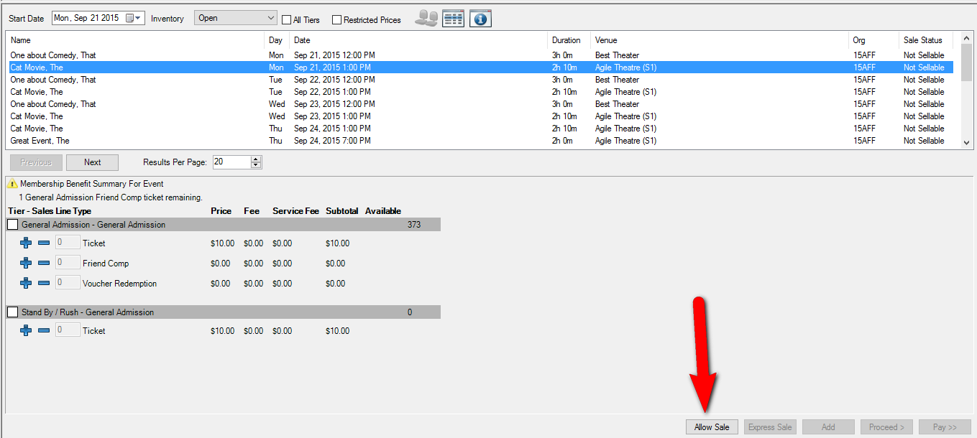
6. Complete the sale as normal. See Exchanging Tickets or Selling Tickets in AMS for more information.

