Selling Tickets in AMS
These instructions will show you how to process a ticket order using Sales in the Agile app. Before you get started, make sure that you have the Agile software downloaded on your computer and that you have gotten your log in credentials from your system administrator.
- Log In to the Sales app.
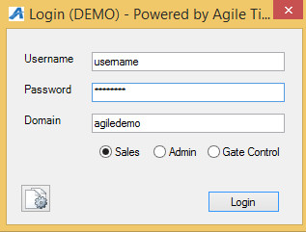
- Before you can start processing sales, you will need to “Cash In”. To cash in, select “Action” from the menu at the top of the screen. Click "How To Cash In and Create a Daily User Batch in AMS" to learn more about cashing in.
- Click on the “Sales” Icon at the top left of the screen.
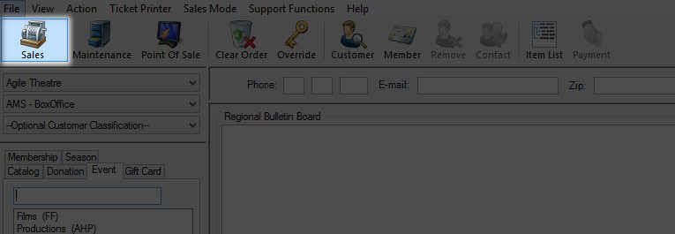
- Select your Buyer Type. 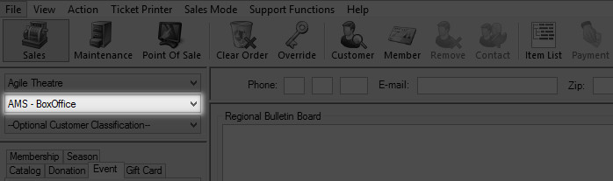
- Select the item tab that you would like to sell. For Example, I would like to sell tickets to a movie, so I would select the “Event “tab.
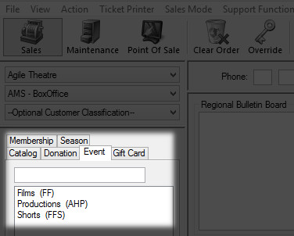
- Under the Event Tab, there will be a list of sales organizations that you can select from. For this purpose I will be selecting “Films”.
- Select the event that the customer is wanting to purchase.
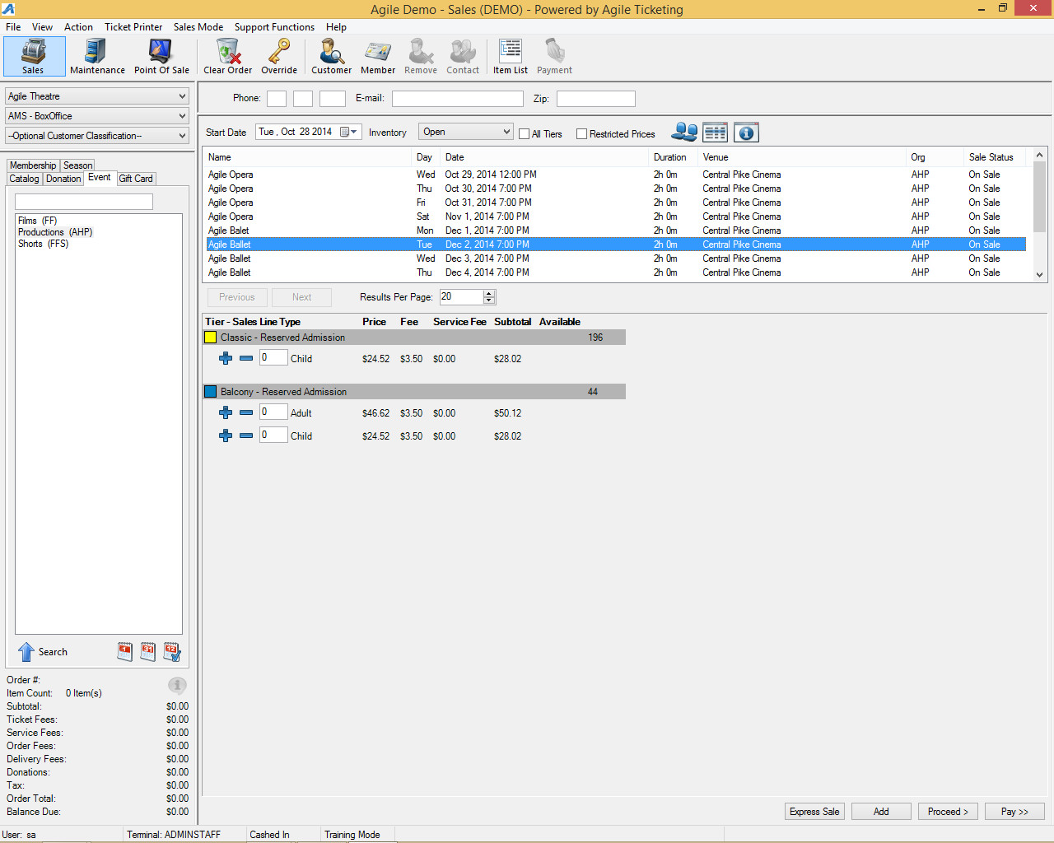

- Once the event is selected, you will see the list of prices available for this performance. In this example, the events are General Admission Seating.
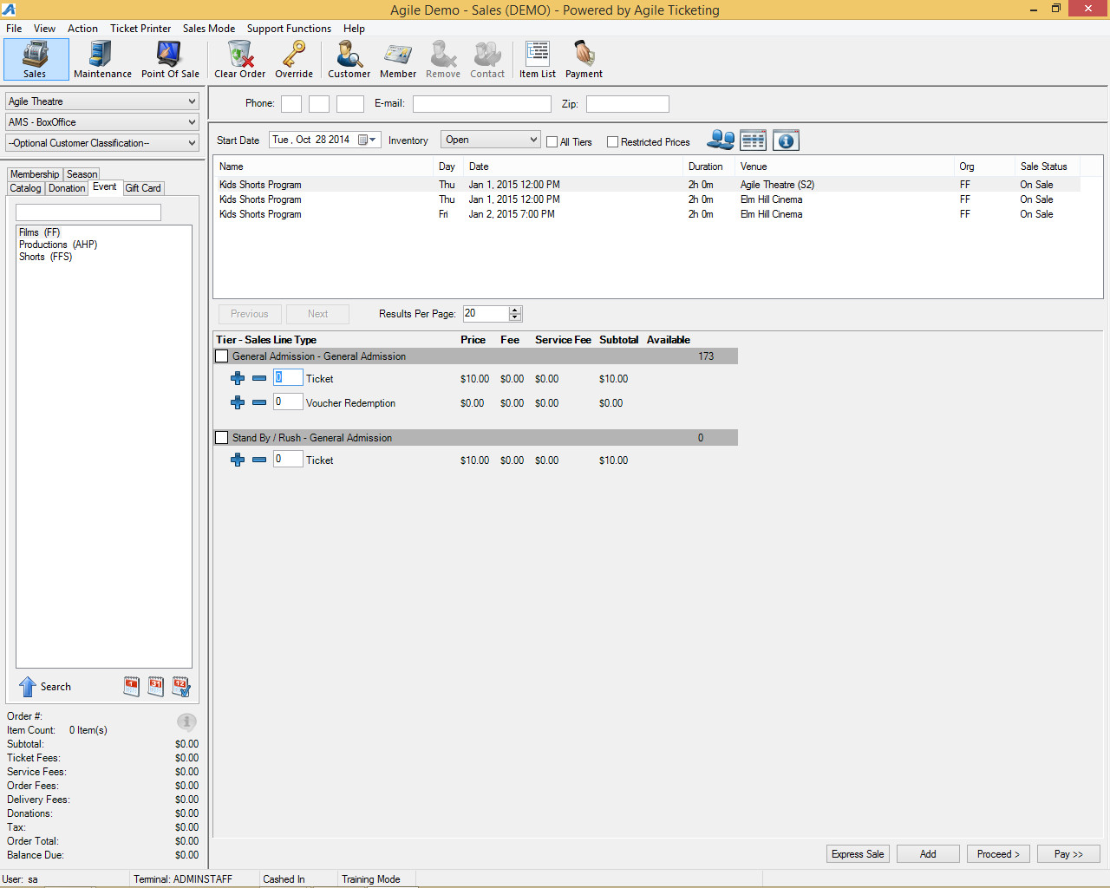

- Select the number of tickets the customer is wanting to purchase and then click on the “Add” button. 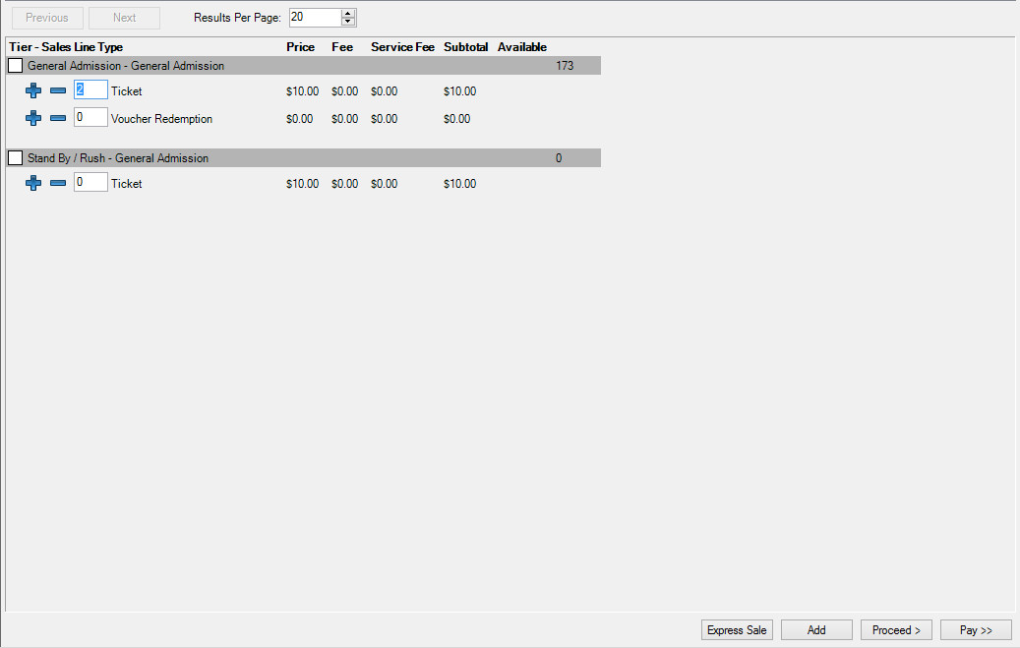
- If the customer is purchasing more than one event, you can select another event by choosing the sales organization again and add tickets to the cart.
- For this example, I will be choosing a reserved seating event under "Productions". 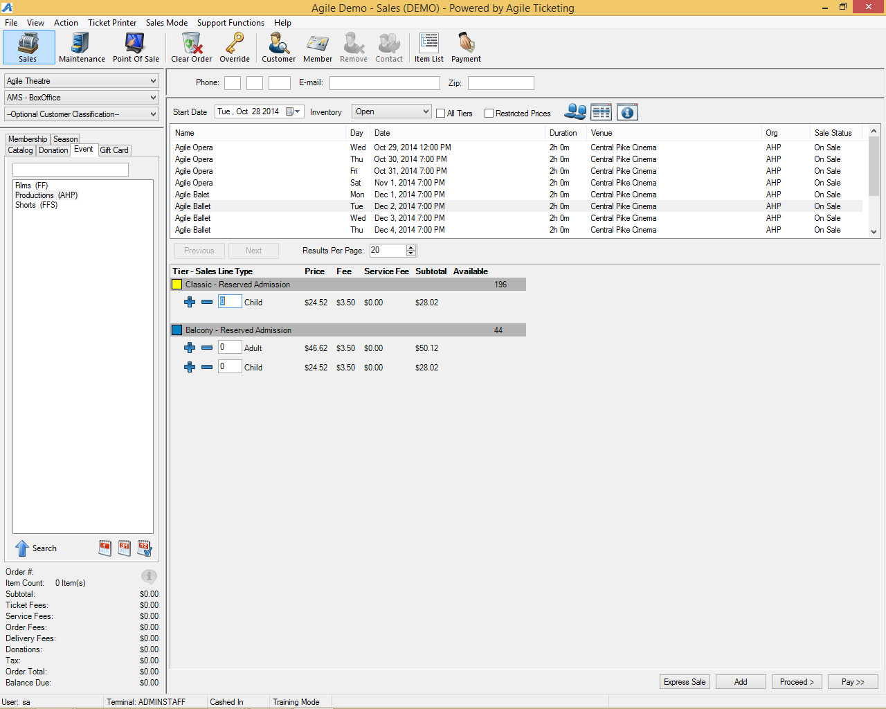
- Select the event that the customer is wanting to purchase.
- In area above the list of event, you will see a “blue seat” icon. Click on this icon to pull up the reserved seating chart. 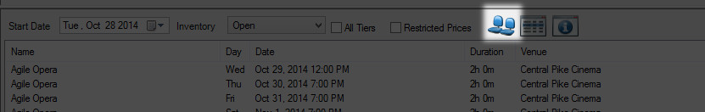
- Over to the right of the screen you will see the different sections that are available for purchase. In this example, I’m going to select "Classic" section.
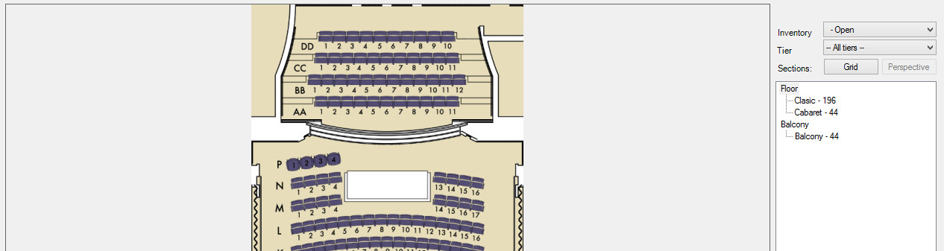
- In the seating chart you will see the row letters to the left of the screen. You will also see the seat numbers for each seat in that row.
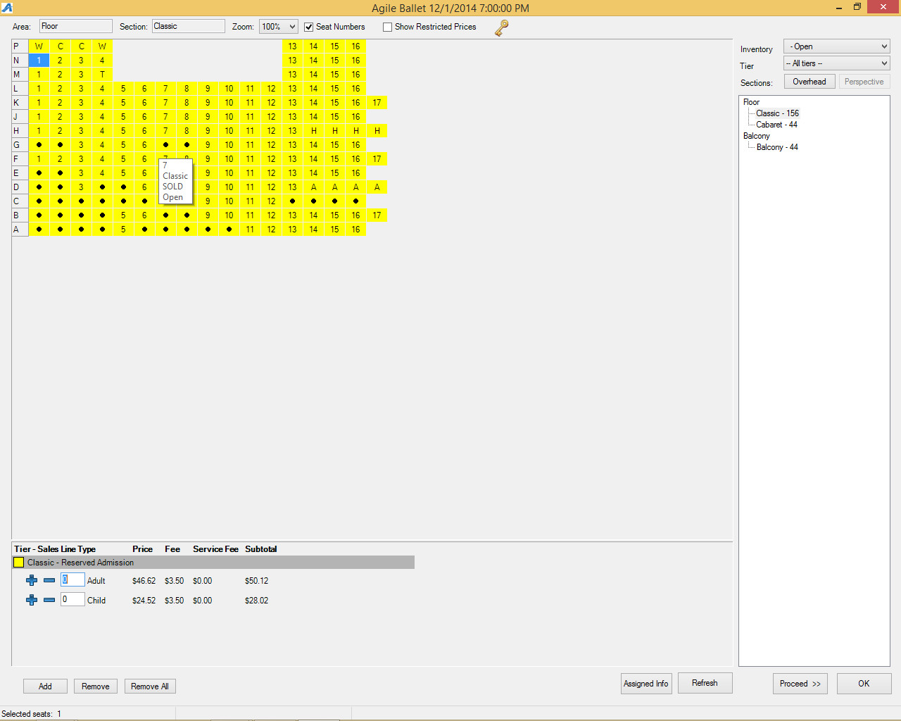
- If there is a solid black dot in one of the seating squares, this means that the seat is already sold to another customer.
- If you see letters in the square where seat numbers are, these are seats that are put on hold for various reasons. In this example the “A”’s are Artist holds, the lower case “h” is House or Venue holds.
- You will also notice that there are holds at the “rear” of the seating chart. These holds are for patrons that have ADA requirements. The “C” stands for Companion Seating, the “W” stands for Wheelchair Seating” and the “T” stands for Transferable/Mobility Impaired seating. Each venue or organization has their own list of holds that they need. If you need more information about these holds, please speak with your system administrator about accessing hold seats.
- To select reserved seats, simply select the number of seats using your curser. Once they have been selected, you will then enter the number of tickets in the pricing area and add to their cart. 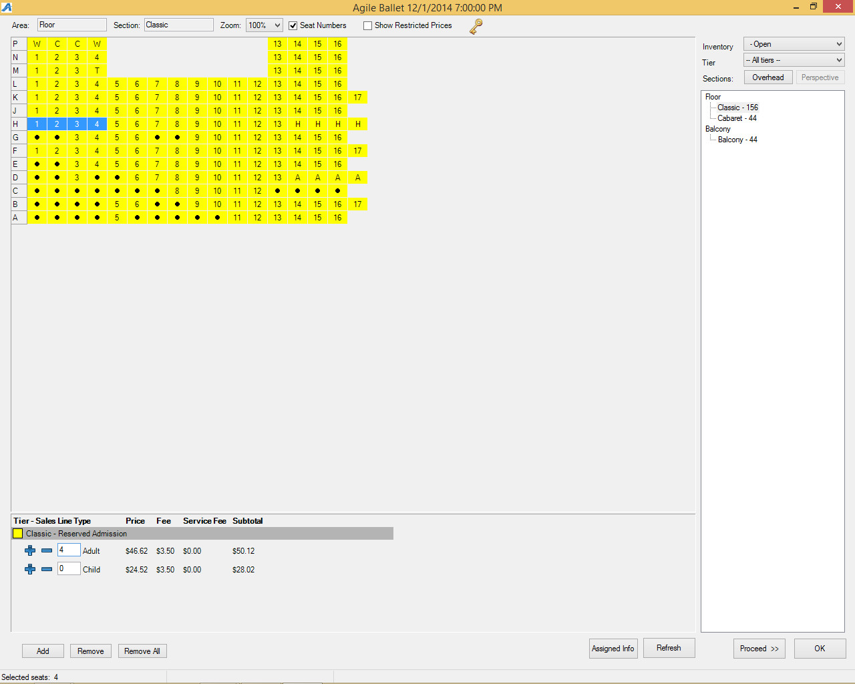
- When you have all of the tickets that the customer is purchasing in the shopping cart, you can then click on proceed to get to the item summary screen.
- The item summary screen is where you can confirm all the items that they are wanting to purchase as well as to confirm the delivery method for the tickets.
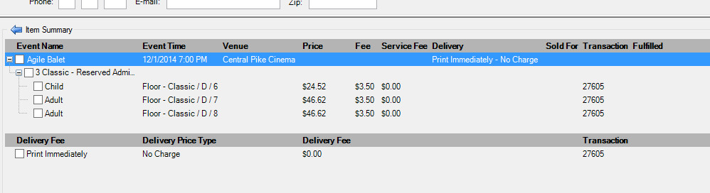
- If the customer is at your window and will want to take the tickets with them, you will leave the delivery method as “Print Immediately”
NOTE: Must have a ticket printer attached to the computer in order to print tickets.
- If the customer wants to hold them at Will Call or they want you to email them via the Print At Home option, you can click on the “Change Delivery” icon at the bottom of the screen and change the delivery method in the drop down. (HTS20 and HTS21)NOTE: You must associate the order with a customer account in order to please tickets on Will Call or to email the Print At Home tickets.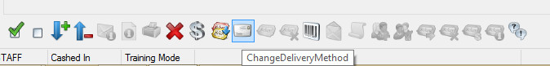
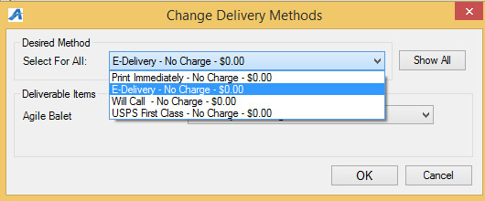
- When everything on the item summary page is completed and ready to be finalized with payment, click on the “Proceed” screen to get to the payment screen.
- On the payment page, you will see the total amount due is populated. If the customer is paying with cash or check, select that payment type from the drop down and click Apply Payment to complete the order.
- If they are paying with a credit card and you have a credit card swipe attached to your computer, all you will need to do is swipe the credit card and the card information will populate and start the authorization process. If you do not have a card swipe, you can manually enter the credit card information and then click “Apply Payment” to authorize the credit card.

