Adding a Membership Price
1. Log in to Administration.
2. Click on the Corporate Organization icon.
3.Open the Membership sales organization folder and click on the Membership icon.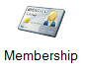
4. Select the correct membership and right-click in the Membership Price field, then select New.
5. In General tab:
- Select the price in the list pricing list. If a new price needs to be created, right-click in the price list field and select New Price. Enter in the name of the price. Click Apply to save the name and then OK.
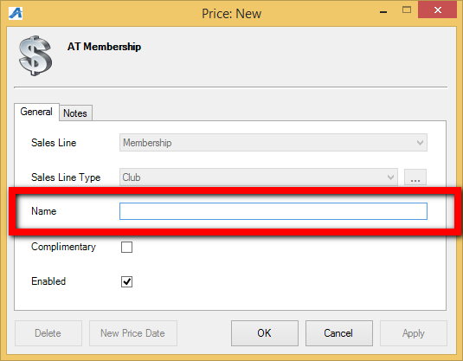

- Right-click in the Distributions box and click New.
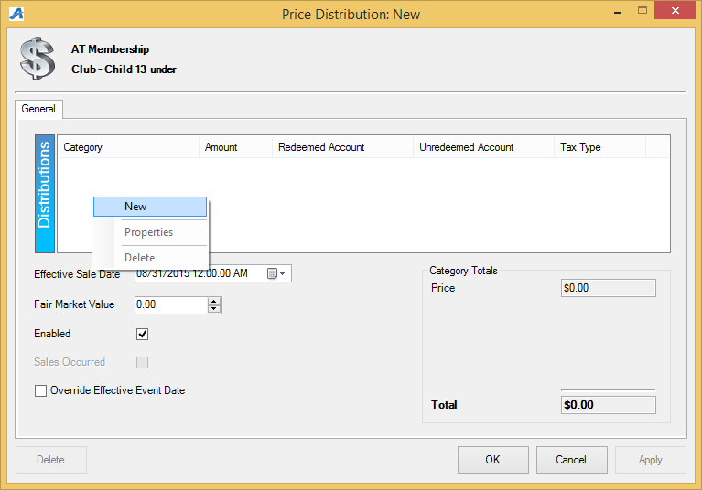

- Enter in the Price and select the correct Unredeemed and Redeemed Accounts. (Unredeemed and Redeemed Accounts are preset revenue accounts that report the monies to certain GL accounting codes) Click Apply and then OK.
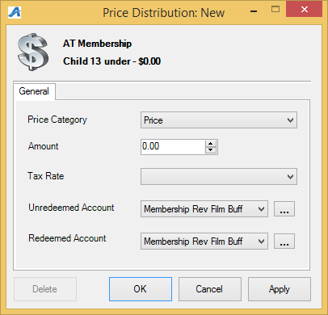

- Click Apply then OK in the Price Distribution window.
- Select the price from the price list.
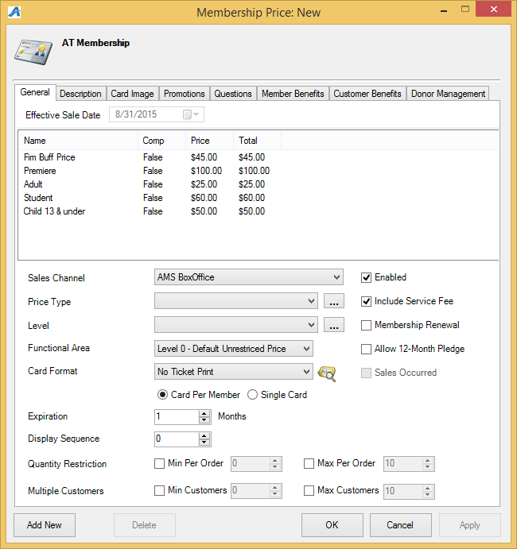
- Sales Channel: select a sales channel the membership will be sold through. NOTE: Most memberships will have the prices available through multiple sales channels. 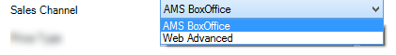
- Price Type: this is the name of the membership, and will appear online. If the name of the membership price type is not listed in the drop down, click on the ellipsis button to create the new membership Price Type name.
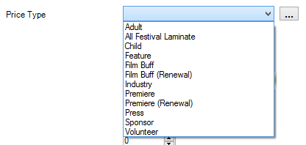
- Level: This should be a generic name of the membership. (i.e. there may be multiple versions of the same memberships: complimentary, discounted, dual, etc. but they are all the same membership level). If the Level name is not listed, click on the ellipsis button to create the new Level name
.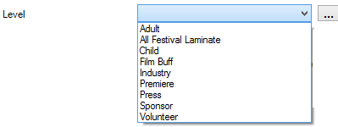
- Functional Area: Choose the appropriate restriction level for this membership. Most membership prices are listed at a Level 0 so customers and cashiers have access to those prices both in the box office and online. Restricted prices are generally set for complimentary type of memberships that restricts access to these prices.
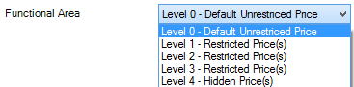
- Card Format: Choose the card format for the membership to print on.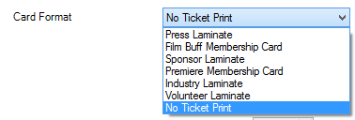

- Card Per Member: Will allow for multiple cards to be printed with the same member number whereas a Single Card will only print one card, regardless of the number of members on the membership.
- Expiration: Enter in the number of months the membership should be good for from the date of purchase.
- Display Sequence: use this to select the appearance and order the memberships prices should appear, both in AMS sales screen, POS sales screen and online.
- Quantity Restriction: enter in the numbers if there is a limit on how many memberships can be purchased.
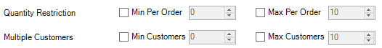
- Multiple Customers: enter in the number of customers that can be on the membership.
- If the membership is a Renewal, then make sure Membership Renewal is checked.
- If the membership can be paid for over 12-month period, check Allow 12-Month Pledge box. NOTE: This is for Donor Perfect clients only.

6. In the Description tab: Enter in specific information about this membership price. This will be displayed online.
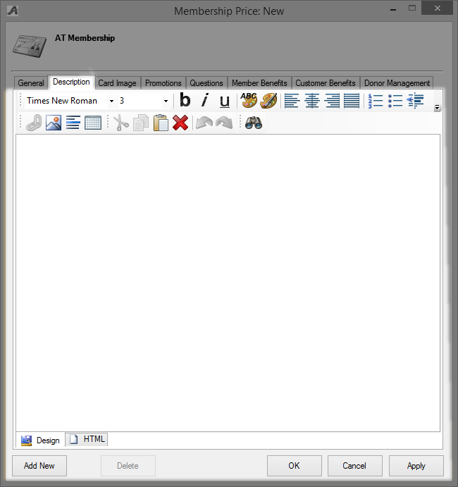

7. Card Image tab: if the membership should have an specific image on the card, add it here.
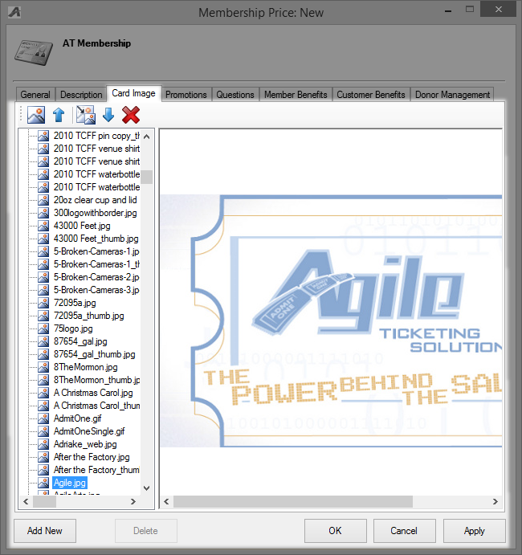

8. Promotions Tab: add specific promotion codes to the selected promotions column if they apply to this membership. 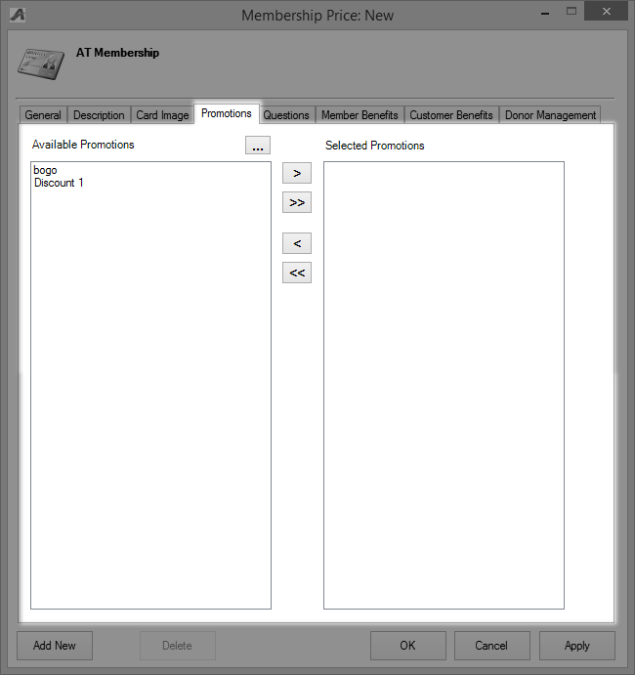

9. Questions Tab: add specific questions to the selected questions column if they apply to this membership. For more information see Creating Order Questions.
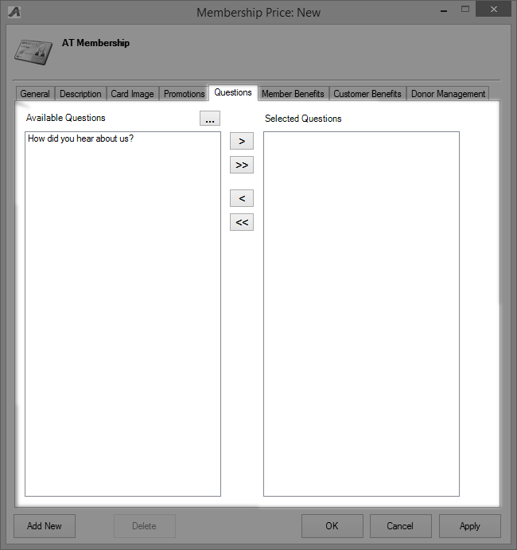

10. Member Benefits tab: right-click and select New. Select the correct benefit group from the drop-down menu. THIS STEP IS VERY IMPORTANT. If the Benefit Group is not added to the price, then members will not be able to access any of their benefits online.
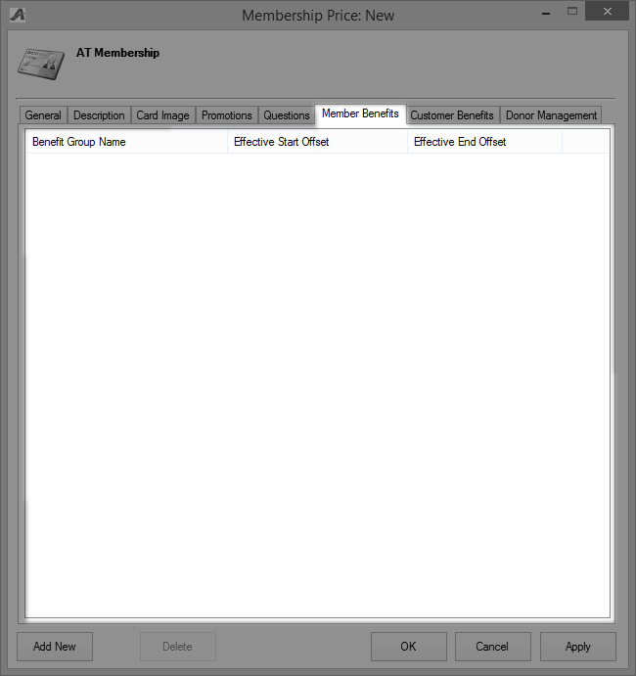

- Enter in the Effective Start/End Offset dates. If a membership is effective for 12 months, enter in 12 in the Months box of the Effective End Offset.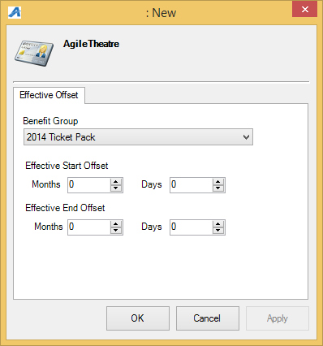

11. Customer Benefits tab: right-click and select New. Select the correct benefit group from the drop-down menu. Enter in the Effective Start/End dates. Check Attach to Memberships
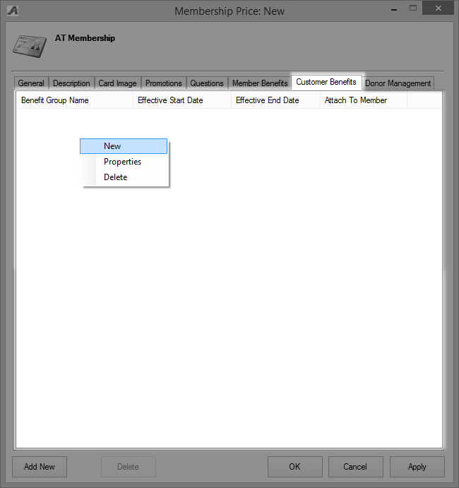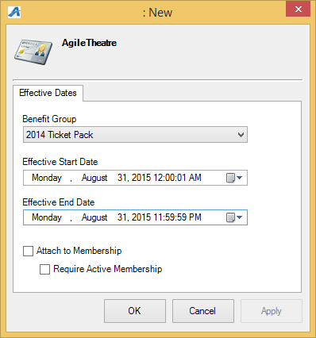
12. Donor Management tab: see Setting Up The Donor Perfect Integration on donor management specifications located on the Agile knowledge base.

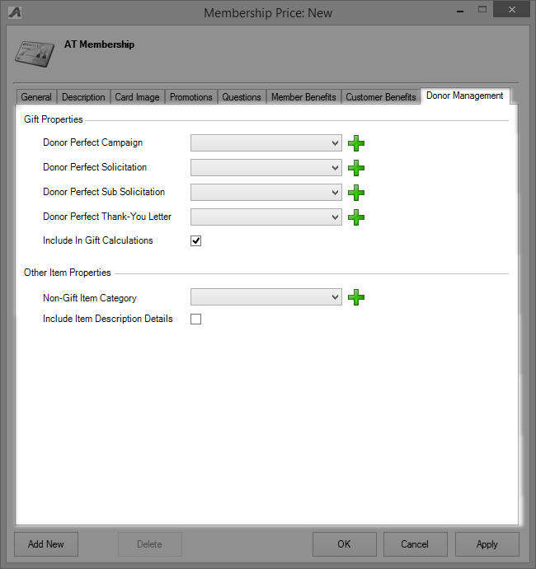

13.Click Apply to save and OK to close the screen.

