Selling a Membership in AMS
- Log in to Agile Ticketing Solutions with your username and password. If you haven’t received your user credentials, please contact your system administrator to set up your username and password.
- Make sure that you are cashed in before starting sales for the day.
- Click on the “Customer” icon to search for a customer account.
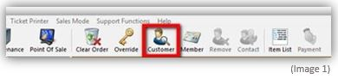
- Search to see if they already have a customer record. You can search by Last Name, Email address, or Customer Number to see if their customer record is already on file. A list of customer records will appear if they are already in the system. Double click on their customer record if their name appears in the list.
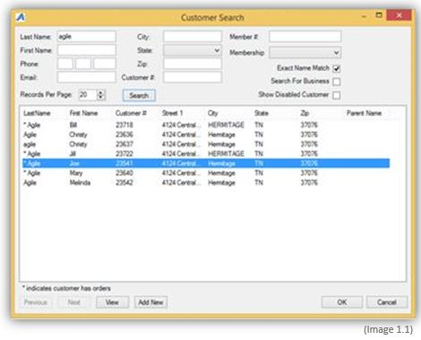

- If the customer is new, you will need to create a new customer account by clicking on “Add New”.
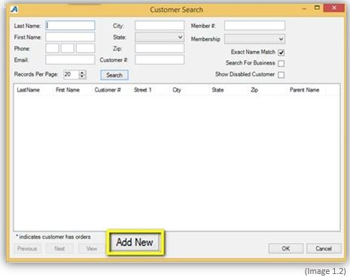
- Once you click "Add New" the Quick Add Customer box will show up where you will fill in the customer's information. Once you have captured all of the customer's information, click on "OK"
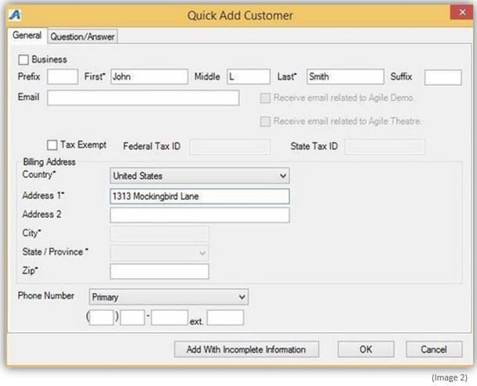
Note: Everyone is a customer but not all customers are members.
- Once you have selected a customer’s account, select the “Membership” tab on the left side of the screen. Then you will need to select the membership program from the list underneath. This will allow you to see all the membership programs to choose from.
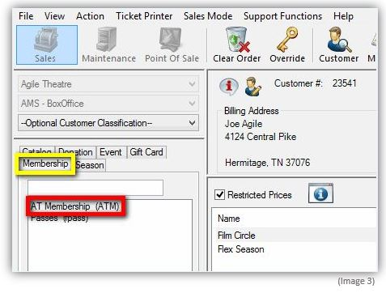
- Choose the membership program on the right. When selling a membership, make sure your restricted prices is checked in order to see all pricing options.
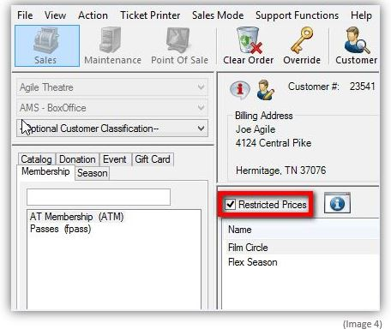
- Select the membership price you want to sell to the customer. Then add the quantity of memberships the customer wants to purchase.
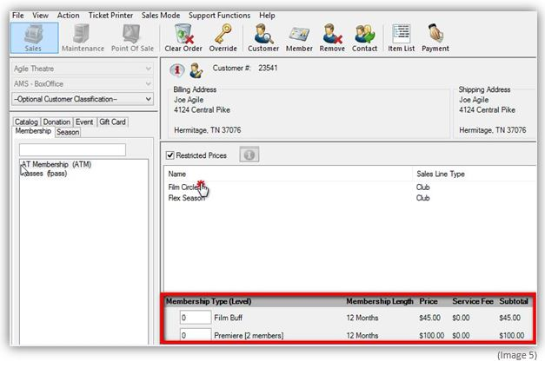
Note: If you are adding a membership for the first time, make sure not to select a membership category with renewal in the price name.(See instructions on "How To Renew A Membership")
- After selecting the membership type and quantity, click “Proceed” in the lower right corner.
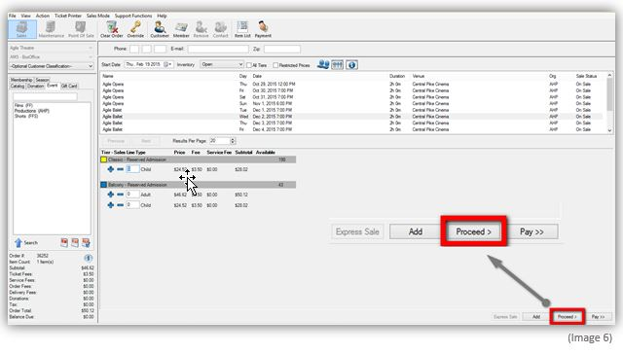
- A window will pop up asking you to assign the membership to the member’s name. Click on the name for the account you are working on and then click “OK”.
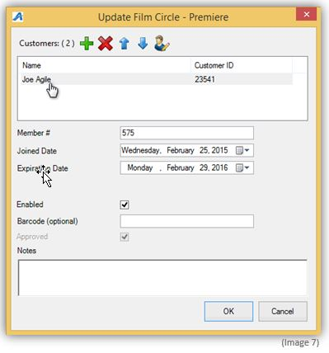
Note: Some memberships allow more than one person to be assigned to it. Make sure to click the plus sign to add a second customer to those memberships that allow multiple members.
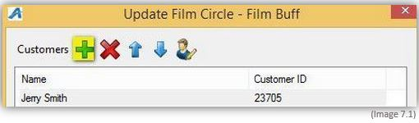

- The next screen is an Item Summary screen where you can review your order before processing a payment and finalizing an order.
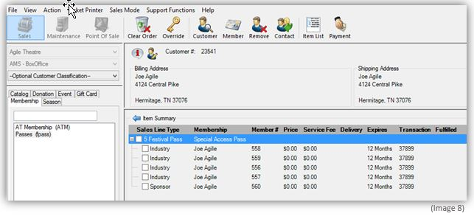
- Once you confirmed everything on the Item Summary screen is correct, click “Proceed” in the lower right hand corner.
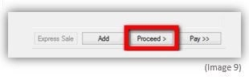
- The Change Delivery Methods window will pop up. Select the delivery method desired and then click “OK” .
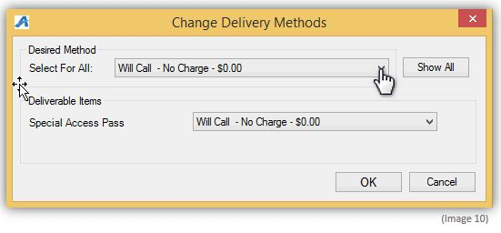

- On the payment screen select the payment method. (Example: Cash, MasterCard, Visa, Gift Card, etc.)
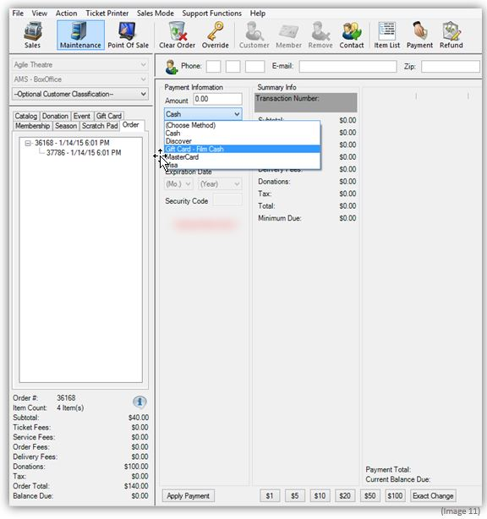
Note: If you are using a POS station or have a USB Credit Card swipe attached to your terminal, you can swipe the credit card and all the credit card information will populate and automatically finalize the order.

- Click “Apply Payment” to complete the order.
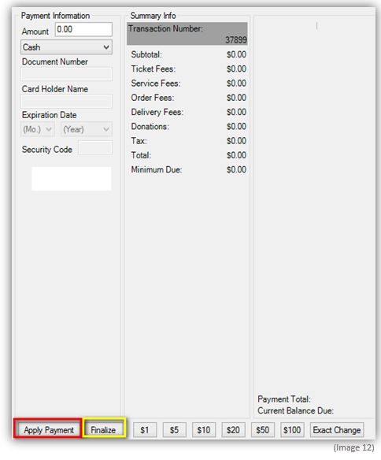
Note: If there is no balance due on the order or you are processing a comp membership type, then you will only need to click "Finalize" to complete the transaction.
- Once the order has finalized, the Order Confirmation page will pop up.
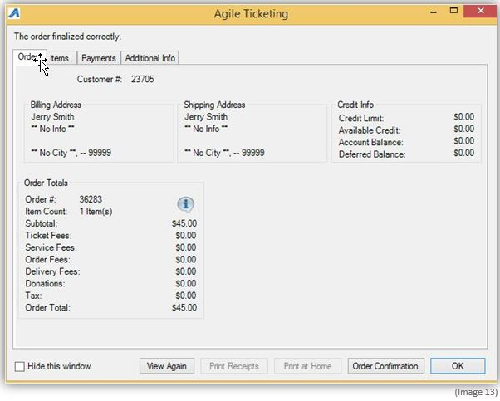
- Click "Order Confirmation" to start the confirmation process.
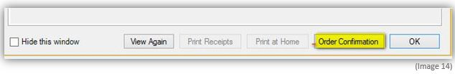
- Once you click Order Confirmation the Order Confirmation Options box will pop up. Make sure the email address is correct, add any message you want to appear on the confirmation email and click "Send Confirmation" to email them their confirmation receipt.
