Upgrading a Membership
1. Log In to Sales.
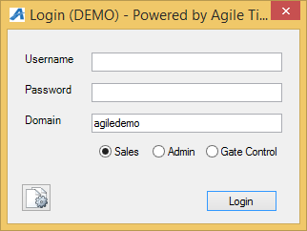
2. Select Maintenance and look up the order by inputting the customer's Last Name, Order # or Member #. Then select the order you want to work with.
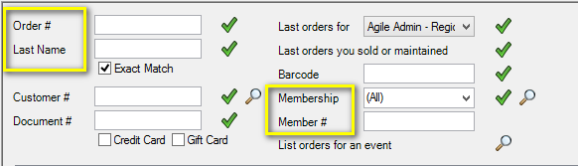
3. Double click the order that you want to change and go to the Order Item Summary.
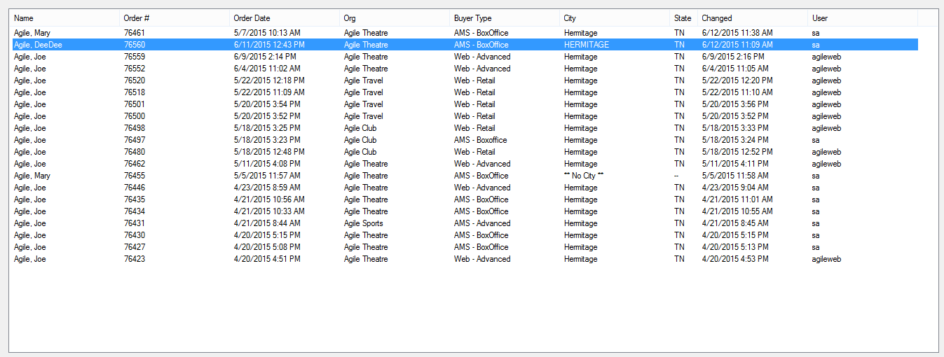

4. In the Order Item Summary click the price of the membership you wish to update.
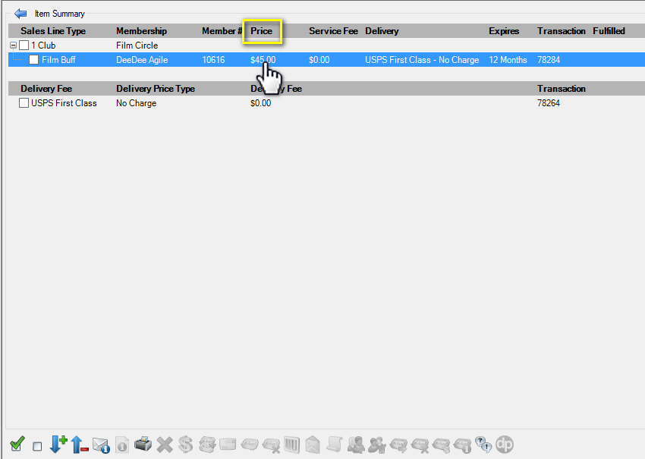

5. The Change Price widow will popup. Select the New Price under Selectable Prices.
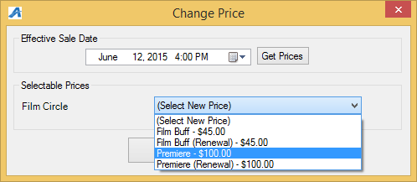

6. Once you have selected the new price, you will see the updated membership type in the Item Summary screen. Click Proceed to move to Payment window.
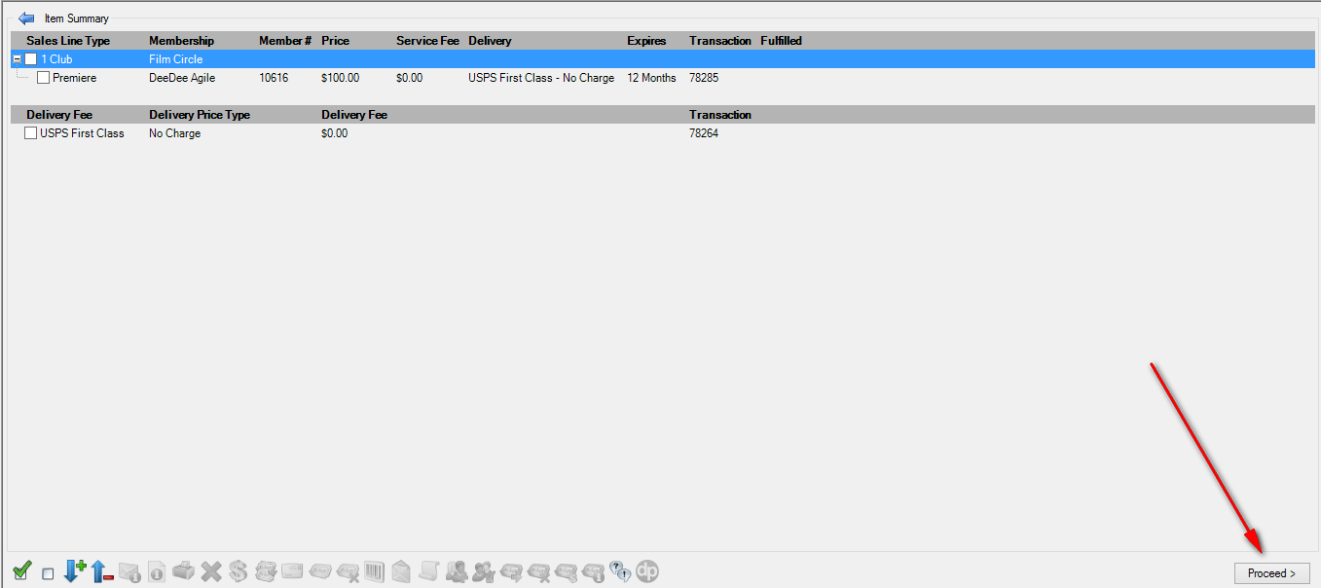
7. If this is an even exchange and no money is due, click Finalize to complete the changes made. If there is a balance due or a refund owed to the customer process the payment/refund to finalize the order.
