Renewing a Membership in POS
1. Log in to Agile Ticketing Solutions with your username and password. If you haven’t received your user credentials, please contact your system administrator to set up your username and password.
2. Make sure that you are cashed in before starting sales for the day. See "How to Cash In Using POS" for further instructions.
3. You will need to set the buyer type before you start processing sales for the day. To do so, click on Action (the gears icon) at the top of the screen and select “Set Buyer Type” (See Image 1.0). A screen will appear where you can choose the buyer type (See Image 1.1).
NOTE: If your company has multiple Corp Organizations, you will need to select which one you are working with before you can select buyer type.
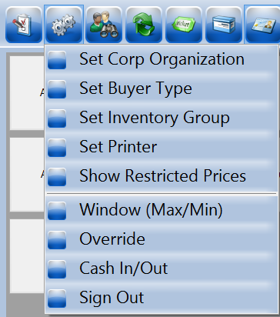
Image 1.0
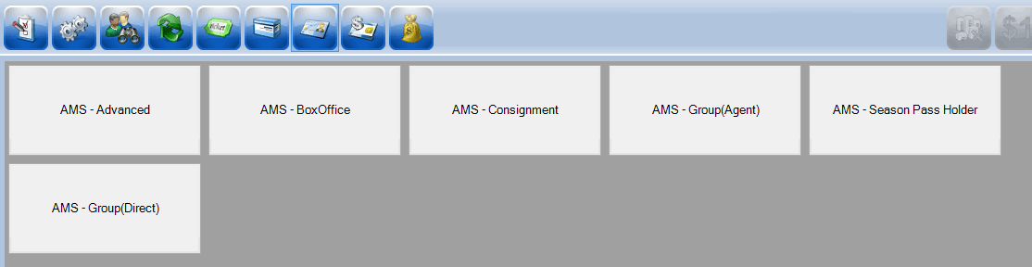Image 1.1
4. Select "AMS - Box Office."
5. Click on the “Customer” icon to search for a customer account (See Image 2).
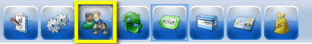
Image 2.
6. Search by name or member number to pull up a customer’s account. A list of customer records will appear if they are already in the system. Double click on the customer record if their name appears in the list (See Image 2.1).
NOTE: If a Customer is a member, their member number and membership type will appear right below their name.
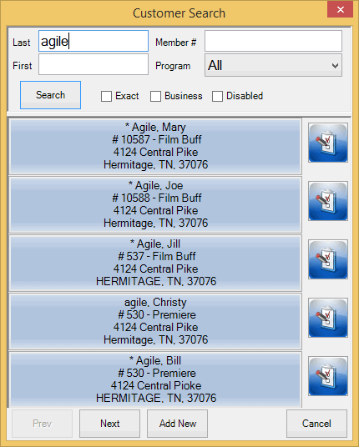
Image 2.1.
NOTE: You will know you are in a customer’s account when you see a name listed in the lower right corner (See Image 2.2).
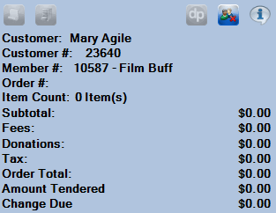
Image 2.2
7. Once you are in the customer’s account, select the “Membership” icon in the upper portion of the screen (See Image 3). This will allow you to see all the membership programs to choose from. Select the Membership Program from the list underneath (See Image 3.1).
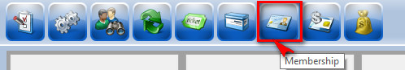
Image 3.
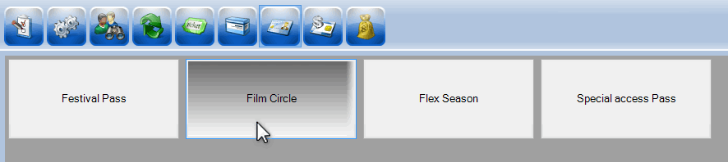Image 3.1.
8. Once you select the Membership Program, the Membership Price Types will be listed at the bottom of the screen. Select the Membership Price Type that the customer wants to renew. (See Image 4).
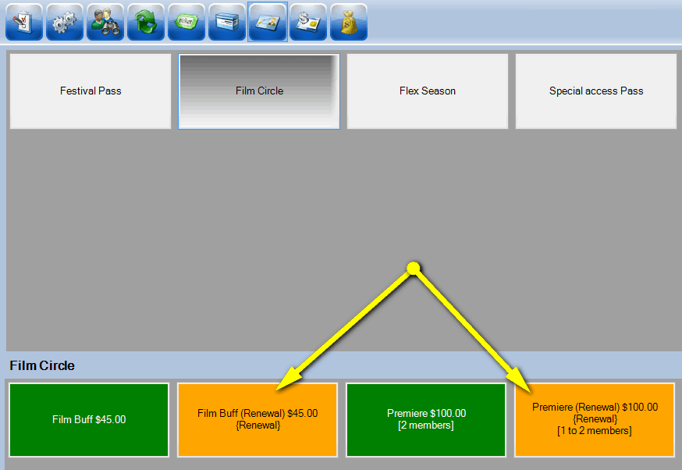Image 4.
NOTE: Make sure to select a membership category with Renewal in the price name.
9. A window will pop up asking you to assign the membership to the member’s name. Click on the name for the account you are working on and then click “OK” (See Image 5).
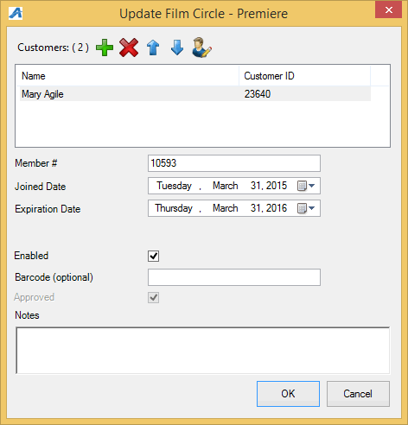
Image 5.
NOTE: Some memberships allow more than one person to be assigned to the membership type. Make sure to click the "+" plus sign to add a second customer to those memberships that allow multiple members (See Image 5.1).
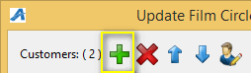
Image 5.1
10. To confirm an order, view the Item Summary section to at the right side of the screen to make sure the order is correct (See Image 6).
Image 6.
11. Once an order has been confirmed, swipe the customer's credit card if you have a Credit Card Swipe attached to your computer OR click on the “Enter Payment” icon to manually enter the payment information (See Image 7).
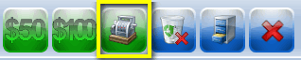
Image 7.
12. A screen will pop up asking you to change delivery method. Select desired method and click on “OK” (See Image 8).
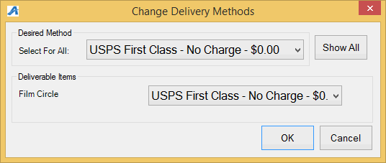Image 8.
13. The Method of Payment window will pop up and ask you to Choose Method of payment (See Image 9). Select the payment type that corresponds with how the customer wishes to pay (Example: Cash, MasterCard, Visa, Gift Card, etc.).
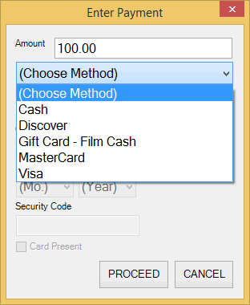
Image 9.
NOTE: At this point, if you have a USB Credit Card swipe attached to your terminal, you can swipe the credit card and all the credit card information will populate and automatically finalize the order.
14. Click “Proceed” to complete the order (See Image 10).
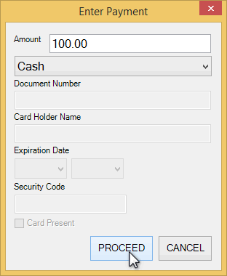
Image 10.
15. You will know the order is complete when the window in the lower right corner turns yellow and says “Last Order” at the top of that window (See image 11).
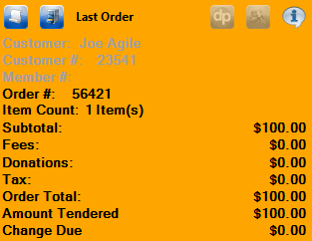
Image 11.

