- Log in to Agile Ticketing Solutions with your username and password. If you haven’t received your user credentials, please contact your system administrator to set up your username and password. Make sure that you are cashed in before starting sales for the day. See "How to Cash In Using POS" for further instructions.
- You will need to set the buyer type before you start processing sales for the day. To do so, click on Action (the gears icon) at the top of the screen and select “Set Buyer Type” (See Image 1.0). A screen will appear where you can choose the buyer type (See Image 1.1).
NOTE: If your company has multiple organizations, you will need to select which one you are working with before you can select buyer type.
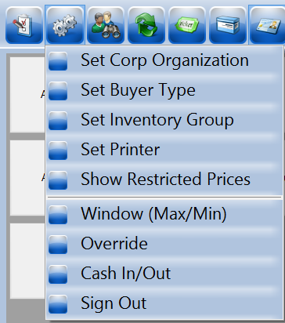
Image 1.0
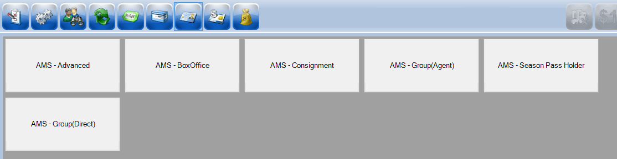Image 1.1
- Select "AMS - Box Office."
- Select the “Event” icon in the upper portion of the screen (See Image 2). This will allow you to see all the events that are on sale (See Image 2.1).
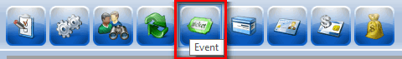Image 2
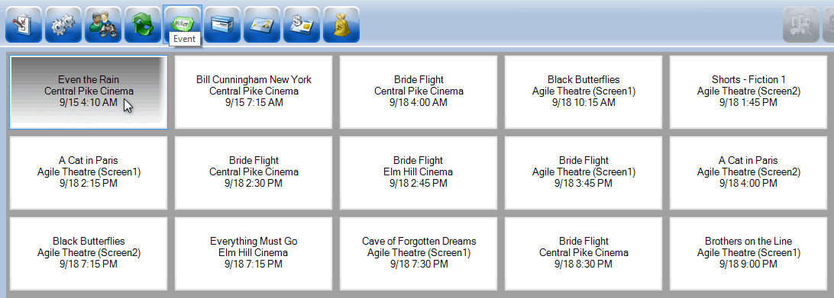Image 2.1
- Click on the event you are wanting to sell a ticket for. The ticket types will be listed in the bottom section of the screen. Select the admission price you want to sell to the customer (See Image 3).
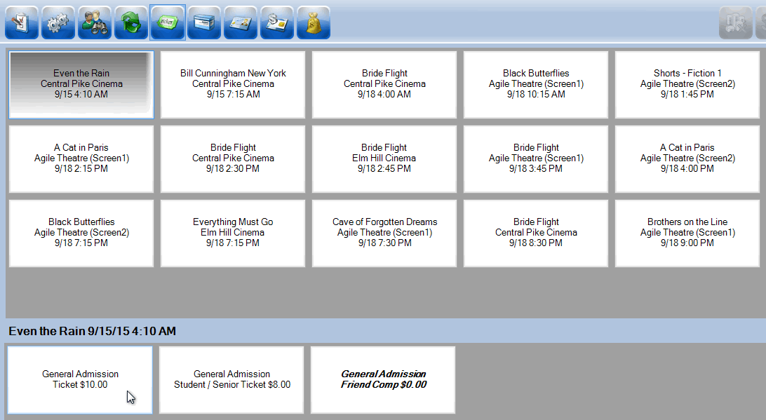Image 3
- If you are selling more than one ticket in an order, click on the ticket type for each ticket you are selling. (i.e. If you need 2 adults and a student ticket, click on the General Admission ticket twice and the General Admission Student/Senior ticket once.)
- To confirm an order, view the Item Summary section to at the right side of the screen to make sure the order is correct (See Image 4).
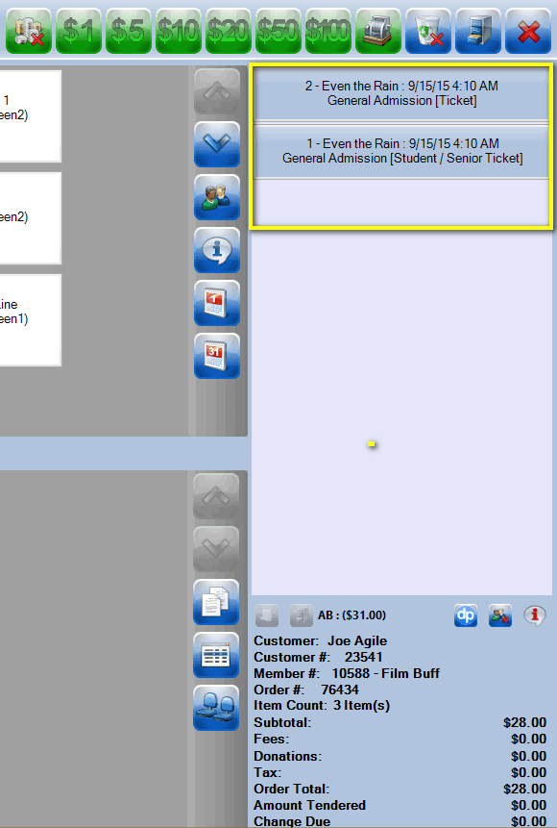
Image 4
- Once an order has been confirmed, click on the “Enter Payment” icon (See Image 5).
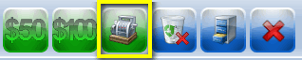
Image 5
- A screen will pop up asking you to enter the customer's information so you can tie the ticket purchase to their account (See Image 6).
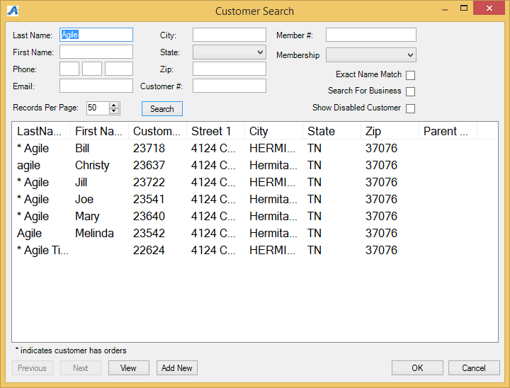
Image 6
- A screen will pop up asking you to change delivery method. Select desired method and click on “OK” (See Image 7).
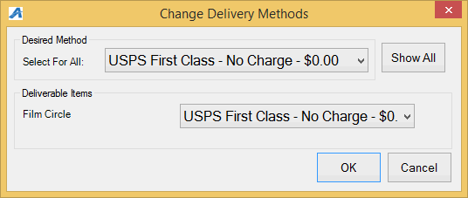Image 7
- Another screen will pop up asking you to choose the method of payment (See Image 8). Select the payment type that corresponds with how the customer wishes to pay (Example: Cash, MasterCard, Visa, Gift Card, etc.).
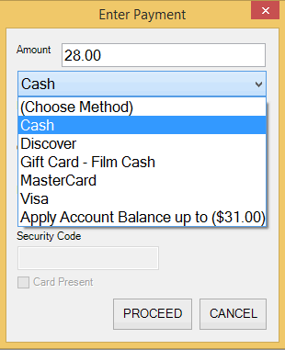
Image 8
NOTE: At this point, if you have a USB Credit Card swipe attached to your terminal, you can swipe the credit card and all the credit card information will populate and automatically finalize the order.
- Click “Proceed” to complete the order (See Image 9).
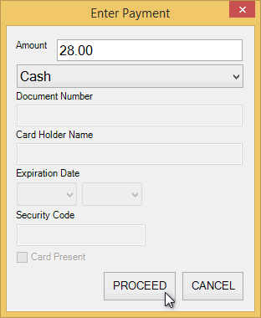
Image 9.

- You will know the order is complete when the window in the lower right corner turns yellow and says “Last Order” at the top of that window (See image 10).
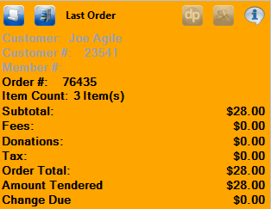
Image 10.

